Assignment 1: Analyze a given business scenario and create an ER diagram that includes entities, relationships, attributes, and cardinality. Ensure that the diagram reflects proper normalization up to the third normal form.

Scenario:

A university wants to keep track of students, courses, and enrollments. Students enroll in courses, and each course can have multiple students. Professors teach courses, and each course is taught by one professor.

Step 1: Identify Entities

Entities are the main objects of the scenario that we need to keep track of. In this scenario, we have:

* Student
* Course
* Enrollment
* Professor

Step 2: Identify Relationships

* Student enrolls in Course
* Course is taught by Professor

Step 3: Identify Attributes

Below are the attributes for each entity:

Student: StudentID, FirstName, LastName, DOB, Email

Course: CourseID, CourseName, Credits

Enrollment: EnrollmentID, StudentID, CourseID, Grade

Professor: ProfessorID, FirstName, LastName, Email, Department

Step 4: Determine Cardinality

Cardinality specifies the numerical relationships between entities:

Student enrolls in Course: A student can enroll in many courses, and a course can have many students (Many-to-Many).

Course is taught by Professor: A course is taught by one professor, but a professor can teach many courses (One-to-Many).

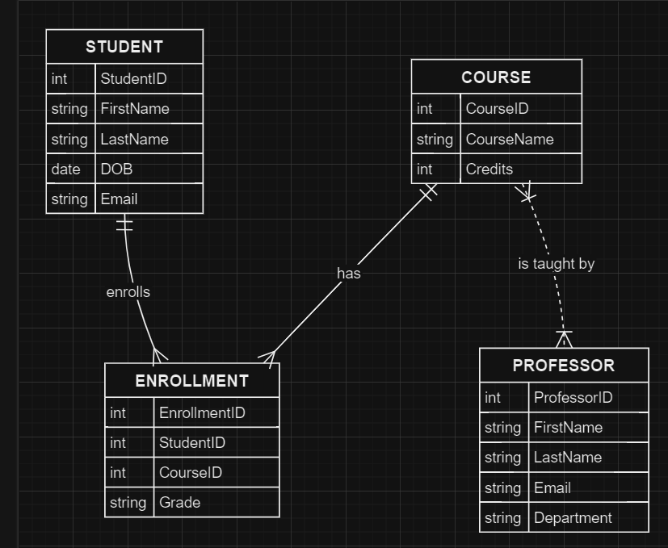

Step 5: Create ER Diagram

1. Student (Entity)

Attributes: StudentID (Primary Key), FirstName, LastName, DOB, Email

1. Course (Entity)

Attributes: CourseID (Primary Key), CourseName, Credits

1. Professor (Entity)

Attributes: ProfessorID (Primary Key), FirstName, LastName, Email, Department

1. Enrollment (Entity)

Attributes: EnrollmentID (Primary Key), StudentID (Foreign Key), CourseID (Foreign Key), Grade

Relationships:

"enrolls": A many-to-many relationship between Student and Course through Enrollment. Each student can enroll in multiple courses, and each course can have multiple students.

"has": A many-to-many relationship between Course and Student through Enrollment.

"is taught by": A one-to-many relationship between Course and Professor. Each course is taught by one professor, but each professor can teach multiple courses.

Normalization Up to Third Normal Form (3NF)

First Normal Form (1NF): All attributes are atomic, and there are no repeating groups.

Second Normal Form (2NF): The table is in 1NF, and all non-key attributes are fully functionally dependent on the primary key.

Third Normal Form (3NF): The table is in 2NF, and all attributes are only dependent on the primary key.

In this scenario, all attributes are directly dependent on their respective primary keys and are atomic, so the design is normalized up to 3NF.

Additional Details:

Primary Key attributes are underlined.

Foreign Key attributes are marked as FK.

Diamond shapes represent relationships and include relationship names ("enrolls", "has", "is taught by").

Rectangles represent entities (Student, Course, Enrollment, Professor).

Ovals represent attributes connected to their respective entities.

This ER diagram provides a clear and detailed representation of the university scenario, capturing entities, relationships, attributes, and cardinality, and ensuring normalization up to the third normal form.