Assignment 2: Design a database schema for a library system, including tables, fields, and constraints like NOT NULL, UNIQUE, and CHECK. Include primary and foreign keys to establish relationships between tables.

Tables and Fields for Library System

Books

book_id (Primary Key, INT, NOT NULL, AUTO_INCREMENT)

title (VARCHAR(255), NOT NULL)

author_id (Foreign Key, INT, NOT NULL)

genre_id (Foreign Key, INT, NOT NULL)

isbn (VARCHAR(13), UNIQUE, NOT NULL)

publish_date (DATE, NOT NULL)

copies_available (INT, NOT NULL, CHECK (copies_available >= 0))

Authors

author_id (Primary Key, INT, NOT NULL, AUTO_INCREMENT)

first_name (VARCHAR(50), NOT NULL)

last_name (VARCHAR(50), NOT NULL)

Genres

genre_id (Primary Key, INT, NOT NULL, AUTO_INCREMENT)

genre_name (VARCHAR(50), UNIQUE, NOT NULL)

Members

member_id (Primary Key, INT, NOT NULL, AUTO_INCREMENT)

first_name (VARCHAR(50), NOT NULL)

last_name (VARCHAR(50), NOT NULL)

email (VARCHAR(100), UNIQUE, NOT NULL)

phone (VARCHAR(15), UNIQUE)

membership_date (DATE, NOT NULL)

Loans

loan_id (Primary Key, INT, NOT NULL, AUTO_INCREMENT)

book_id (Foreign Key, INT, NOT NULL)

member_id (Foreign Key, INT, NOT NULL)

loan_date (DATE, NOT NULL)

return_date (DATE)

due_date (DATE, NOT NULL, CHECK (due_date > loan_date))

Relationships and Constraints

Books Table

book_id: Primary Key, uniquely identifies each book.

author_id: Foreign Key references Authors.author_id.

genre_id: Foreign Key references Genres.genre_id.

isbn: Unique identifier for each book.

copies_available: Must be a non-negative number.

Authors Table

author_id: Primary Key, uniquely identifies each author.

Genres Table

genre_id: Primary Key, uniquely identifies each genre.

genre_name: Unique name for each genre.

Members Table

member_id: Primary Key, uniquely identifies each member.

email: Unique identifier for each member.

phone: Optional, unique identifier for each member.

Loans Table

loan_id: Primary Key, uniquely identifies each loan.

book_id: Foreign Key references Books.book_id.

member_id: Foreign Key references Members.member_id.

due_date: Must be later than the loan_date.

**SQL Statements to Create These tables are given Below:**  
  
CREATE TABLE Authors (

author_id INT AUTO_INCREMENT PRIMARY KEY,

first_name VARCHAR(50) NOT NULL,

last_name VARCHAR(50) NOT NULL

);



CREATE TABLE Genres (

genre_id INT AUTO_INCREMENT PRIMARY KEY,

genre_name VARCHAR(50) UNIQUE NOT NULL

);



CREATE TABLE Books (

book_id INT AUTO_INCREMENT PRIMARY KEY,

title VARCHAR(255) NOT NULL,

author_id INT NOT NULL,

genre_id INT NOT NULL,

isbn VARCHAR(13) UNIQUE NOT NULL,

publish_date DATE NOT NULL,

copies_available INT NOT NULL CHECK (copies_available >= 0),

FOREIGN KEY (author_id) REFERENCES Authors(author_id),

FOREIGN KEY (genre_id) REFERENCES Genres(genre_id)

);

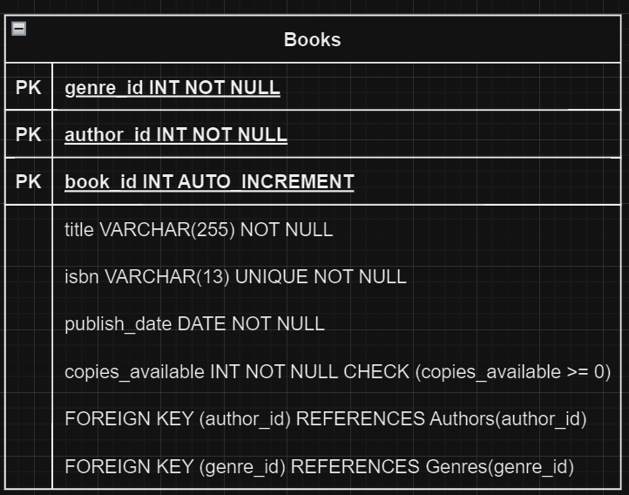

CREATE TABLE Members (

member_id INT AUTO_INCREMENT PRIMARY KEY,

first_name VARCHAR(50) NOT NULL,

last_name VARCHAR(50) NOT NULL,

email VARCHAR(100) UNIQUE NOT NULL,

phone VARCHAR(15) UNIQUE,

membership_date DATE NOT NULL

);

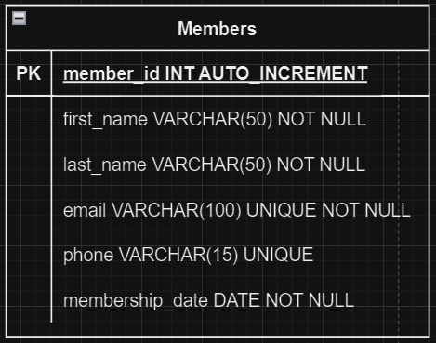

CREATE TABLE Loans (

loan_id INT AUTO_INCREMENT PRIMARY KEY,

book_id INT NOT NULL,

member_id INT NOT NULL,

loan_date DATE NOT NULL,

return_date DATE,

due_date DATE NOT NULL CHECK (due_date > loan_date),

FOREIGN KEY (book_id) REFERENCES Books(book_id),

FOREIGN KEY (member_id) REFERENCES Members(member_id)

);

