A PROJECT REPORT ON
COLLEGE ERP SYSTEM WITH SECURE PROCTORED EXAMINATION MODULE

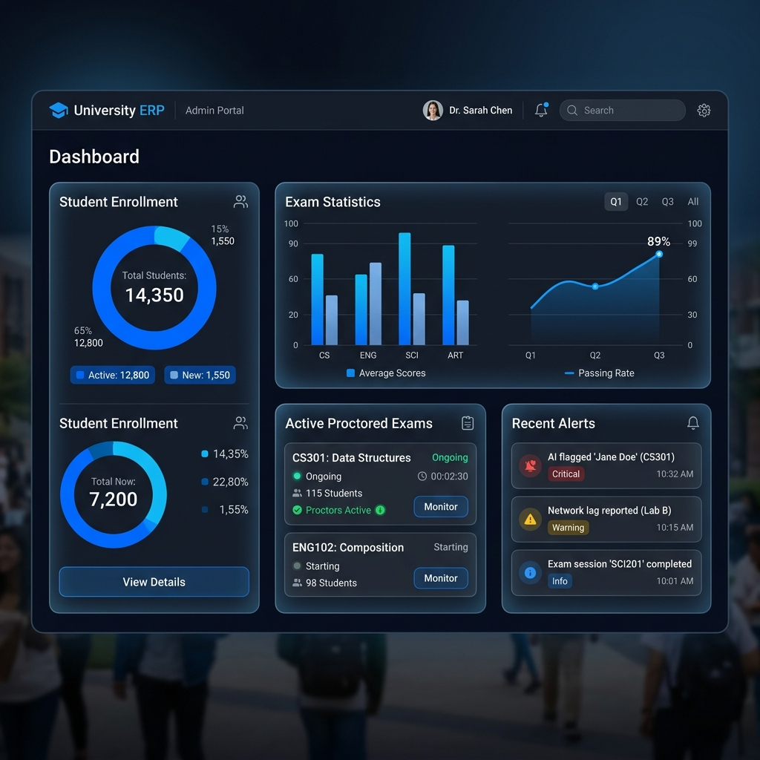

SUBMITTED IN PARTIAL FULFILLMENT OF THE REQUIREMENTS FOR THE DEGREE OF
BACHELOR OF ENGINEERING

SUBMITTED BY:
[STUDENT NAME 1] ([ROLL NO])
[STUDENT NAME 2] ([ROLL NO])

UNDER THE GUIDANCE OF:
[GUIDE NAME]
Assistant Professor

DEPARTMENT OF COMPUTER ENGINEERING
[COLLEGE NAME]
[UNIVERSITY NAME]
2025-2026

CERTIFICATE

This is to certify that the project entitled "COLLEGE ERP SYSTEM WITH SECURE PROCTORED EXAMINATION MODULE" is a bonafide work carried out by [STUDENT NAME 1] and [STUDENT NAME 2] in partial fulfillment of the requirements for the degree of Bachelor of Engineering in Computer Engineering of [UNIVERSITY NAME] during the academic year 2025-2026.

Guide  [GUIDE NAME] | Head of Department  [HOD NAME] | Principal  [PRINCIPAL NAME]

ABSTRACT
The College ERP (Enterprise Resource Planning) System is an integrated software solution designed to manage and automate various academic and administrative operations within an educational institution. This project focuses on building a robust, scalable, and secure platform that facilitates seamless interaction between students, faculty, and administration. A key highlight of this system is the 'Secure Proctored Examination Module', which utilizes WebSockets and real-time event tracking to prevent academic dishonesty during online assessments. The backend is engineered using Java Spring Boot with a Microservices-ready modular architecture, ensuring high availability and performance. The frontend is developed using React.js for a dynamic and responsive user experience. Security is handled via JWT-based stateless authentication, and Firebase is utilized for scalable cloud storage. The system also integrates automated email notifications, attendance tracking, and comprehensive dashboard analytics.

TABLE OF CONTENTS
1. Introduction
2. System Architecture & Tech Stack
3. Backend Engineering Deep Dive
4. Database Design
5. API Documentation
6. Implementation Details
7. Deployment & CI/CD
8. Conclusion & Future Enhancements
9. References

1. INTRODUCTION
1.1 Project Overview
In the modern era of digital education, managing institutional data manually is both inefficient and error-prone. The College ERP System aims to bridge this gap by providing a centralized platform for all academic activities. From student enrollment to examination management, the system provides a comprehensive suite of tools.
1.2 Problem Statement
Existing systems often lack real-time monitoring during online exams, leading to integrity issues. Furthermore, fragmented data across different departments makes administration challenging. This project addresses these issues by providing a secure proctoring environment and a unified data management system.

2. SYSTEM ARCHITECTURE & TECH STACK
2.1 Backend Architecture
The backend is built on a Layered Architecture (Controller-Service-Repository) using Java Spring Boot. This separation of concerns ensures maintainability and scalability.
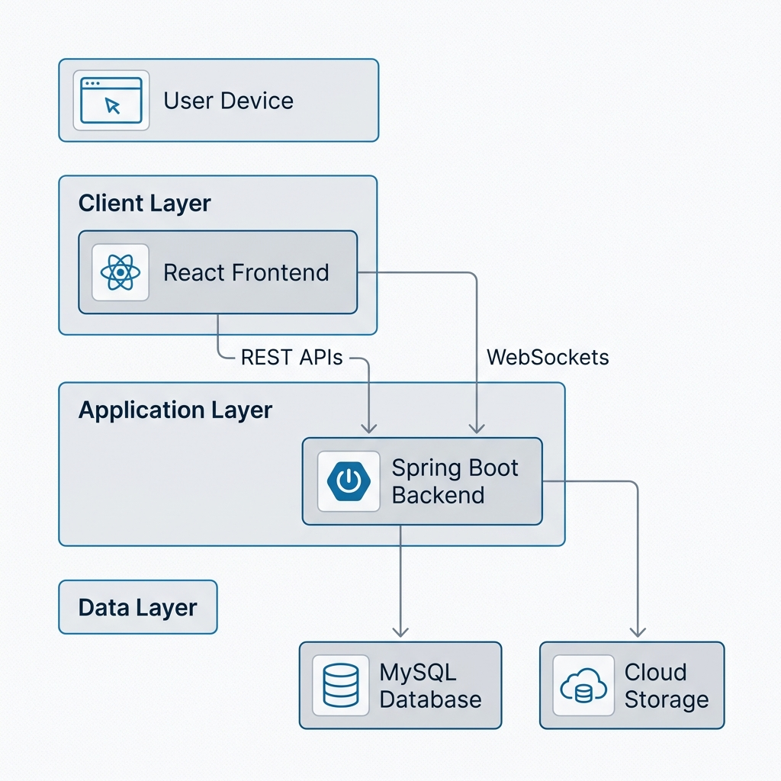
Figure 2.1: System Architecture Overview
2.2 Technology Stack
Layer | Technology
Frontend | React.js, Redux, TailwindCSS
Backend | Java Spring Boot, Spring Security
Database | MySQL / PostgreSQL
Cloud Storage | Google Firebase
Authentication | JWT (JSON Web Tokens)
Communication | REST API, WebSockets (STOMP)
Build Tools | Maven, Vite

3. BACKEND ENGINEERING DEEP DIVE
3.1 Request-Response Lifecycle
Every API request follows a strict lifecycle: Authentication Filter -> Controller Mapping -> Service Logic -> Repository Data Access -> DTO Mapping -> Response.
3.2 Authentication Flow (JWT)
We implement stateless authentication using JWT. Upon login, the server generates a token which is stored in the client-side (HttpOnly cookies or LocalStorage). Subsequent requests include this token in the 'Authorization' header.
3.3 Real-time Communication via WebSockets
For the proctoring module, WebSockets (using STOMP protocol) are utilized to transmit violation alerts from the student's browser to the teacher's dashboard in under 100ms.

4. DATABASE DESIGN
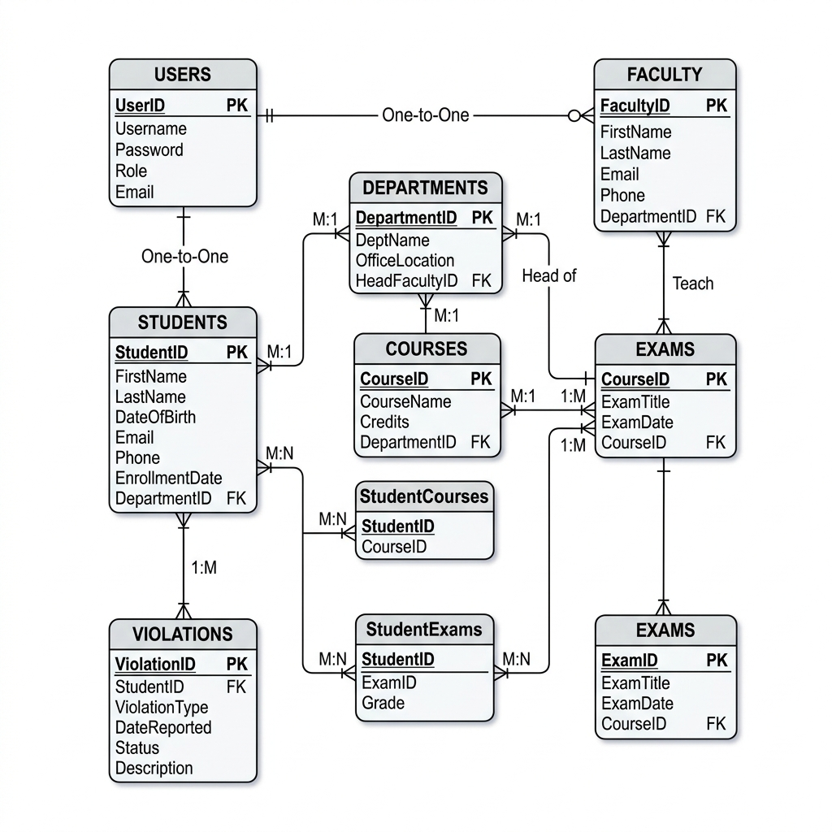
Figure 4.1: Database ER Diagram
4.1 Schema Overview
The database follows 3NF (Third Normal Form) to minimize redundancy. Primary tables include 'Users', 'Students', 'Professors', 'Courses', 'Exams', and 'Violations'.

5. API DOCUMENTATION
Endpoint | Method | Description | Auth
/api/auth/login | POST | User Authentication | None
/api/exams/start | GET | Fetch Exam Questions | Student
/api/proctor/report | WS | Real-time Violation Report | Student
/api/admin/users | GET | Manage User Accounts | Admin
/api/attendance/save | POST | Save Attendance | Professor

6. IMPLEMENTATION DETAILS
6.1 Backend Folder Structure
src/main/java/com/example/stud_erp/
├── controller/ # API Endpoints
├── service/ # Business Logic
├── repository/ # Database Interfacing
├── entity/ # JPA Models
├── security/ # JWT & Security Configuration
├── payload/ # DTOs & Request/Response objects
└── configuration/ # App Configs (WebSocket, CORS)
6.2 Error Handling Strategy
Global exception handling is implemented using '@ControllerAdvice', ensuring that the API returns consistent JSON error responses across all failure scenarios.

7. DEPLOYMENT & CI/CD
7.1 Deployment Architecture
The application is containerized using Docker and deployed on AWS EC2 instances. Static assets (React Build) are served via Nginx.
7.2 CI/CD Pipeline
GitHub Actions is used for CI/CD. Every push to the 'main' branch triggers automated tests and subsequent deployment to the staging environment.

8. CONCLUSION & FUTURE ENHANCEMENTS
The College ERP System successfully automates major administrative tasks and provides a secure environment for online examinations. Future enhancements include AI-based facial recognition for proctoring and mobile application integration for better accessibility.

REFERENCES
1. Spring Boot Documentation - https://spring.io/projects/spring-boot
2. React Documentation - https://reactjs.org/
3. JWT Guide - https://jwt.io/introduction/
4. WebSocket STOMP Protocol - https://stomp.github.io/

