Project Planning & Requirements Analysis
StudySync: A Smart Study Planner & Collaboration Platform
Week 1 Task - Junior Software Developer Intern
Prepared by: Vemula Vigneshwari
Date: 04 October 2026 | Version 1.0

Table of Contents
1. Project Overview
2. Objectives
3. Requirements Elicitation
4. User Stories, Use Cases and Assumptions
5. Scope Definition
6. System Architecture
7. Timeline and Milestones
8. Risk Analysis
9. Conclusion
10. References

1. Project Overview

1.1 Introduction
StudySync is a web-based application that helps students plan their studies, track assignments and exam deadlines, and collaborate with classmates in shared study groups. Many students rely on a mix of notebooks, chat groups and calendar apps, which causes missed deadlines, duplicated effort and poor visibility of progress. StudySync brings these needs into one simple platform.

1.2 Problem Statement
Students struggle to organize coursework across multiple subjects and to coordinate group projects. There is no lightweight, free, student-focused tool that combines task planning, reminders, progress tracking and group collaboration in a single place.

1.3 Target Audience
- Primary: college and university students (ages 17-25) managing several courses at once.
- Secondary: school students preparing for competitive exams, and study-group leaders.
- Tertiary: teachers or mentors who want to share deadlines and resources with a class.

1.4 Business Use Cases
- Campus-level adoption: a college deploys StudySync for its students to improve assignment completion rates.
- Coaching institutes use shared groups to post schedules, test dates and study material.
- Freemium model: core features free; premium analytics and larger group sizes as a paid tier.

1.5 Potential Benefits
- Fewer missed deadlines through automatic reminders.
- Better time management with visual progress dashboards.
- Improved teamwork through shared task boards and group chat.
- Data-driven insights on study habits that help students improve.

2. Objectives

2.1 Primary Objectives
- Deliver a working MVP within 12 weeks that supports task management, reminders and study groups.
- Provide a clean, responsive interface usable on phones, tablets and desktops.
- Keep user data secure and private through authentication and encryption.

2.2 Measurable Success Criteria (SMART)
Objective | Success Measure
Usability | 90% of test users can create a task and set a reminder within 2 minutes
Performance | Pages load in under 3 seconds on a standard 4G connection
Reliability | 99% uptime during the pilot period
Adoption | At least 100 pilot users registered within the first month after launch
Quality | Zero critical open defects at release; at least 70% automated test coverage on core modules

3. Requirements Elicitation

3.1 Elicitation Techniques
Requirements are gathered using techniques recommended in the Business Analysis Body of Knowledge (BABOK) and IEEE 830 / ISO/IEC/IEEE 29148 guidelines:
- Surveys / questionnaires: an online form for students to rank the features they need most.
- Interviews: short conversations with students, group leaders and a faculty member.
- Competitor analysis: review of existing tools such as Google Calendar, Trello, Notion and Todoist to find gaps.
- Prototyping: low-fidelity wireframes reviewed with users for feedback.
- Prioritization: MoSCoW method (Must, Should, Could, Won't) to rank features.

3.2 Stakeholders
Stakeholder | Role | Primary Interest
Students | End users | Easy planning, reminders, collaboration
Teachers / Mentors | Content sharers | Share deadlines and resources
Product Owner | Decision maker | Scope, budget and delivery
Development Team | Builders | Clear, testable requirements
System Administrator | Operations | Stability, security, monitoring

3.3 Functional Requirements
ID | Requirement | Priority | Module
FR-01 | Users shall register and log in using email and password (and optionally Google sign-in). | Must | Auth
FR-02 | Users shall create, edit, delete and complete tasks with title, subject, due date and priority. | Must | Tasks
FR-03 | The system shall send email / in-app reminders before task deadlines. | Must | Notifications
FR-04 | Users shall view tasks in list and calendar views. | Must | Tasks
FR-05 | Users shall create or join study groups using an invite code. | Must | Groups
FR-06 | Group members shall share tasks, notes and files within a group. | Should | Groups
FR-07 | The dashboard shall display weekly progress charts and completion rate. | Should | Analytics
FR-08 | Users shall set up a study timer (Pomodoro) and log study hours. | Could | Tools
FR-09 | Admins shall manage users and moderate reported content. | Should | Admin
FR-10 | Users shall search and filter tasks by subject, date or status. | Should | Tasks

3.4 Non-Functional Requirements
ID | Category | Requirement
NFR-01 | Performance | Page load under 3 seconds; API responses under 500 ms for 95% of requests.
NFR-02 | Security | Passwords hashed (bcrypt); HTTPS everywhere; protection against SQL injection and XSS; JWT-based sessions.
NFR-03 | Scalability | Support at least 1,000 concurrent users without redesign.
NFR-04 | Usability | Responsive design; WCAG 2.1 AA accessibility; learnable within 10 minutes.
NFR-05 | Availability | 99% uptime; daily automated database backups.
NFR-06 | Compatibility | Works on latest Chrome, Firefox, Edge and Safari, and on Android / iOS browsers.
NFR-07 | Maintainability | Modular code, documented APIs, coding standards enforced by a linter.
NFR-08 | Privacy | Compliance with applicable data protection laws; users can delete their account and data.

4. User Stories, Use Cases and Assumptions

4.1 User Stories
ID | User Story | Linked Req.
US-01 | As a student, I want to add assignments with due dates so that I never miss a deadline. | FR-02, FR-03
US-02 | As a student, I want to see my tasks on a calendar so that I can plan my week. | FR-04
US-03 | As a student, I want to join a study group so that I can share tasks and notes with classmates. | FR-05, FR-06
US-04 | As a group leader, I want to assign tasks to members so that work is divided clearly. | FR-06
US-05 | As a student, I want to see weekly progress charts so that I can improve my habits. | FR-07
US-06 | As an admin, I want to remove abusive content so that the platform remains safe. | FR-09

4.2 Use Case: Create Task with Reminder
Field | Description
Use Case ID | UC-01
Actor | Student (registered user)
Precondition | User is logged in
Main Flow | 1. User selects 'Add Task'. 2. System displays task form. 3. User enters title, subject, due date, priority and reminder time. 4. User clicks Save. 5. System validates and stores the task. 6. System confirms and shows the task in the list.
Alternate Flow | 3a. Required field missing - system shows an error and asks the user to correct it.
Postcondition | Task is saved and a reminder is scheduled

4.3 Use Case: Join Study Group
Field | Description
Use Case ID | UC-02
Actor | Student
Precondition | User is logged in and has a valid invite code
Main Flow | 1. User opens 'Groups' and selects 'Join'. 2. User enters invite code. 3. System verifies the code. 4. System adds user to the group. 5. Group tasks and notes become visible.
Alternate Flow | 3a. Invalid or expired code - system displays an error message.
Postcondition | User is a member of the group

4.4 Assumptions and Constraints
- Users have access to a smartphone or computer with an internet connection.
- The project is built by a small team (2-4 developers) using free or open-source tools.
- Email notifications use a free-tier third-party email service.
- The initial release supports English only.
- Budget is limited, so hosting is on a low-cost cloud platform.

5. Scope Definition

5.1 In Scope
- User registration, login and profile management.
- Task creation, editing, filtering, calendar view and reminders.
- Study groups with invite codes, shared tasks and notes.
- Progress dashboard with basic charts.
- Admin panel for user management and moderation.
- Responsive web application, testing, deployment and user documentation.

5.2 Out of Scope
- Native Android / iOS mobile applications (planned for a future phase).
- Video conferencing or live classroom features.
- Paid payment gateway and subscription billing.
- AI-based study recommendations.
- Multi-language support and offline mode.

5.3 Scope Summary
Feature Area | MVP (In Scope) | Future (Out of Scope)
Platform | Responsive web app | Native mobile apps
Collaboration | Group tasks, notes, files | Video calls, live whiteboard
Analytics | Basic weekly charts | AI-based recommendations
Monetization | None (free pilot) | Premium subscriptions
Localization | English | Multiple languages

6. System Architecture
StudySync follows a three-tier architecture: a React single-page frontend, a Node.js / Express REST API, and a PostgreSQL database. A notification service sends reminders by email.
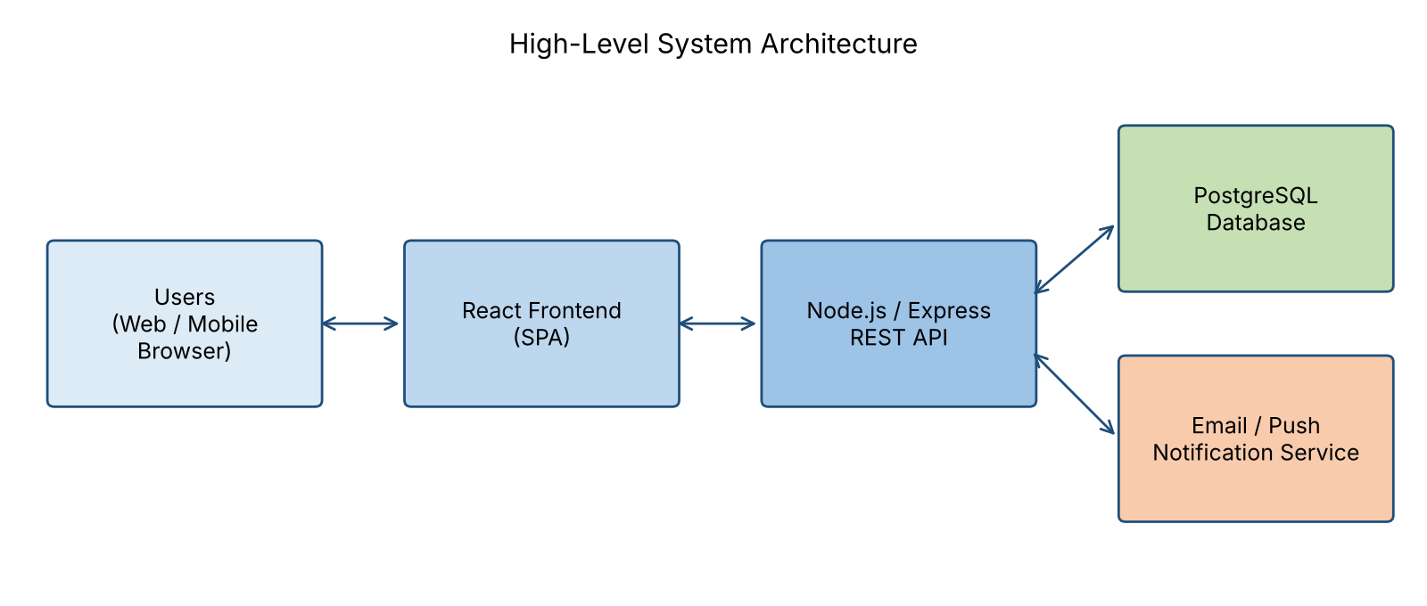
Figure 1: High-level system architecture

6.1 Proposed Technology Stack
Layer | Technology
Frontend | React, HTML5, CSS3 (Tailwind), Chart.js
Backend | Node.js, Express.js, JWT authentication
Database | PostgreSQL
Notifications | Nodemailer / SendGrid free tier
Testing | Jest, React Testing Library, Postman
DevOps | Git & GitHub, GitHub Actions (CI), Render / Vercel hosting
Design | Figma wireframes

7. Timeline and Milestones
The project follows an Agile (Scrum-style) approach with two-week sprints over a 12-week schedule.
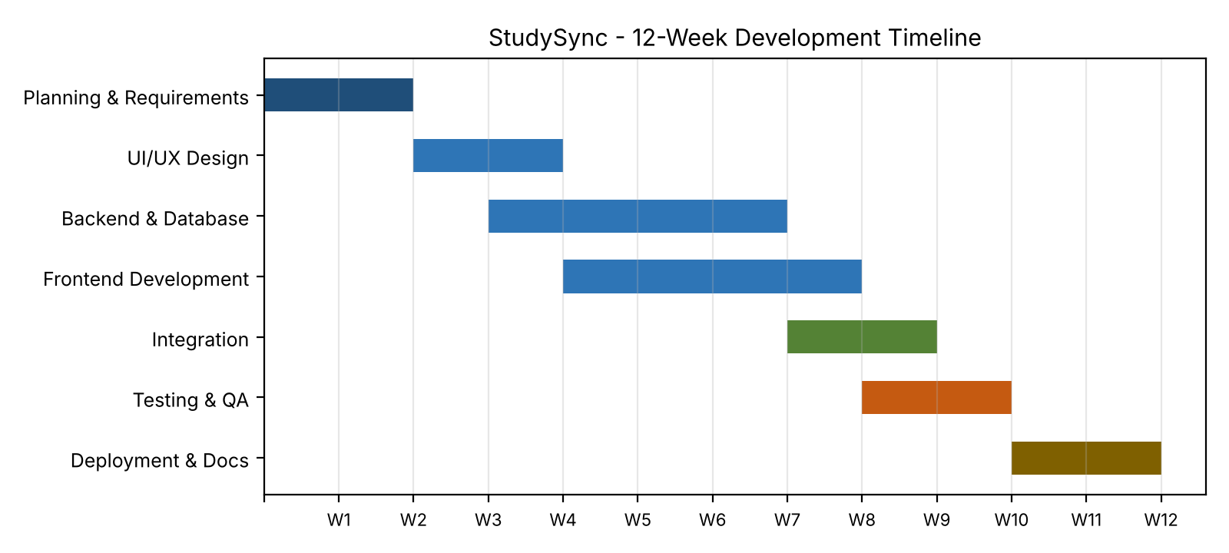
Figure 2: Tentative 12-week development timeline
Week | Phase | Deliverable | Milestone
1-2 | Planning & Requirements | Project plan, SRS document, wireframes | M1: Requirements approved
3-4 | Design | UI/UX designs, database schema, API design | M2: Design sign-off
4-7 | Backend Development | Auth, task and group APIs | M3: API complete
5-8 | Frontend Development | Responsive UI connected to APIs | M4: UI complete
8-9 | Integration | End-to-end working system | M5: Beta build
9-10 | Testing & QA | Test reports, bug fixes | M6: Release candidate
11-12 | Deployment & Documentation | Live deployment, user guide, final report | M7: Go-live

8. Risk Analysis
Risks were rated by Probability (P) and Impact (I) as Low, Medium or High.
# | Risk | P | I | Mitigation Strategy
1 | Requirements change frequently (scope creep) | High | High | Freeze scope per sprint; use a change-request process and MoSCoW prioritization.
2 | Schedule delays due to underestimated tasks | Med | High | Add buffer time; track progress in weekly reviews; reduce Could-have features first.
3 | Security breach or data leak | Low | High | Hash passwords, use HTTPS, validate input, run security checks before release.
4 | Team member unavailable | Med | Med | Cross-train members; maintain clear documentation and Git history.
5 | Third-party service limits or downtime | Med | Med | Use abstraction layers so providers can be swapped; monitor usage.
6 | Poor user adoption | Med | High | Run early surveys and pilots; collect feedback and iterate on usability.
7 | Performance issues under load | Low | Med | Database indexing, caching and load testing before launch.
8 | Budget overrun on hosting | Low | Med | Use free tiers; set usage alerts.

9. Conclusion
This document defines a clear plan for StudySync, covering the project overview, objectives, functional and non-functional requirements, user stories, use cases, scope, architecture, timeline and risks. Early planning and stakeholder-focused requirement gathering reduce rework, improve communication and increase the likelihood of delivering a useful, high-quality product on time. The document will be updated as feedback is received and will serve as the baseline for design and development in the following weeks.

10. References
- IIBA, A Guide to the Business Analysis Body of Knowledge (BABOK Guide).
- ISO/IEC/IEEE 29148:2018, Systems and software engineering - Requirements engineering.
- IEEE Std 830-1998, Recommended Practice for Software Requirements Specifications.
- Schwaber, K. & Sutherland, J., The Scrum Guide.
- W3C, Web Content Accessibility Guidelines (WCAG) 2.1.

