Implementation Roadmap & Code Structure Plan
StudySync: A Smart Study Planner & Collaboration Platform
Week 3 Task - Junior Software Developer Intern
Prepared by: Vemula Vigneshwari
Date: 04 October 2026 | Version 1.0

Table of Contents
1. Introduction
2. Implementation Roadmap
3. Sprint-by-Sprint Task Breakdown
4. Code Structure and Module Breakdown
5. Technical Guidelines
6. Design Patterns and Technology Justification
7. Potential Roadblocks and Mitigation
8. Maintainability and Extensibility
9. Documentation Plan
10. How the Parts Fit Together
11. Conclusion
12. References

1. Introduction
This document turns the StudySync requirements (Week 1) and system architecture (Week 2) into an actionable plan for implementation. It describes the order in which the software will be built, how the code will be organized into modules, the coding practices and design patterns that will be followed, and the risks that could slow development. Having this plan before any code is written ensures that every feature has an owner, a place in the schedule, and a clear connection to the rest of the system.

1.1 Inputs from Earlier Weeks
Earlier Deliverable | What This Plan Uses From It
Week 1: Requirements | Functional requirements FR-01 to FR-10, non-functional requirements NFR-01 to NFR-08, MoSCoW priorities, 12-week timeline
Week 2: Architecture | Layered modular monolith, module list (Auth, Task, Group, Analytics, Notification, Admin), PostgreSQL schema, Redis cache, external services

1.2 Team Assumptions
- Small team of 3 developers: one focused on backend, one on frontend, one on QA/DevOps, with all members contributing to design and code reviews.
- Agile approach with six two-week sprints; each sprint ends with a working, demonstrable increment.
- Git and GitHub for version control, issue tracking and the CI/CD pipeline.

2. Implementation Roadmap

2.1 Development Phases
The project is divided into six phases. Figure 1 shows how the phases overlap over the 12 weeks, with milestones M1 to M7 marked as diamonds.
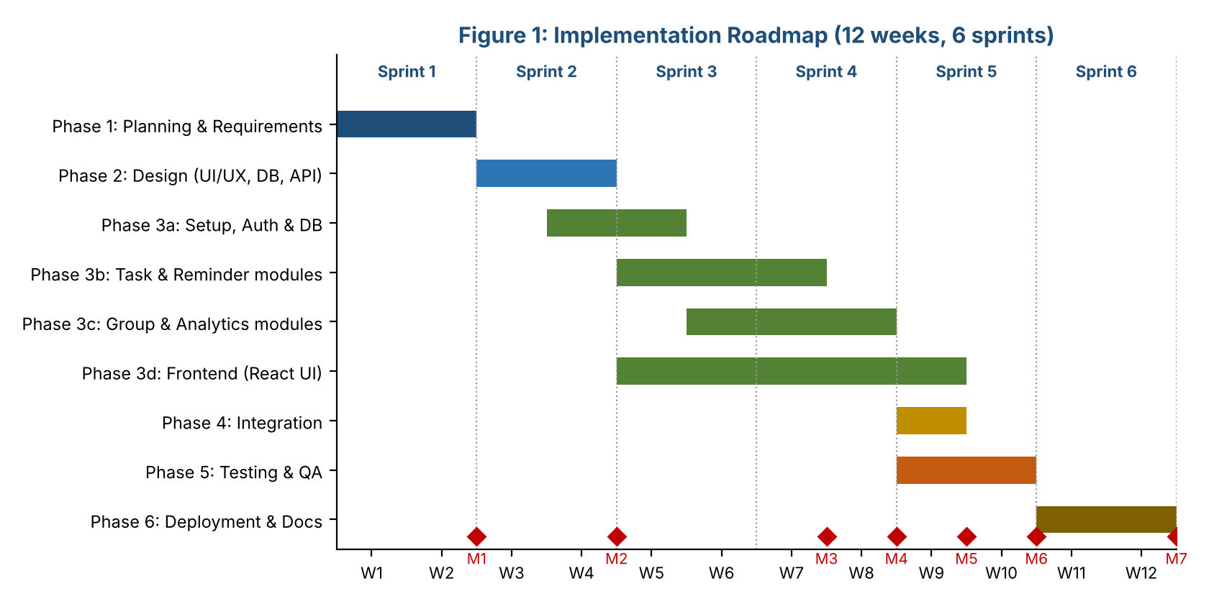
Figure 1: Implementation roadmap and milestones
Phase | Weeks | Main Activities | Exit Criteria
1. Planning | 1-2 | Requirements, scope, risks, wireframes | M1: Requirements approved
2. Design | 3-4 | UI/UX mockups, database schema, API contract, architecture | M2: Design sign-off
3. Coding | 4-9 | Project setup, backend modules, frontend screens, unit tests written alongside code | M3: Backend APIs complete (W7); M4: Frontend complete (W8)
4. Integration | 9 | Connect frontend to API, end-to-end flows, email integration | M5: Beta build
5. Testing | 9-10 | System, security, performance and user-acceptance testing, bug fixing | M6: Release candidate
6. Deployment | 11-12 | Production deployment, monitoring, user guide, final report | M7: Go-live

2.2 Build Order and Reasoning
Modules are built in dependency order so that every module can be tested as soon as it is finished:
- 1. Foundation: repository setup, folder structure, configuration, database connection, logging, error handling. Everything else depends on this.
- 2. Auth module: every other feature needs to know who the user is, so login and JWT come first.
- 3. Task module: the core value of the product, and the module that Notifications and Analytics depend on.
- 4. Notification module: built right after tasks, because reminders are triggered by task data.
- 5. Group module: extends tasks with sharing and membership.
- 6. Analytics and Admin modules: read-only or low-risk features that depend on stable task and user data.
- 7. Frontend: starts in parallel from Week 5 against mocked API responses and is connected to the real API during integration.

3. Sprint-by-Sprint Task Breakdown
Sprint | Weeks | Tasks | Deliverable
1 | 1-2 | Gather requirements, define scope, risk analysis, create repository and project board | Planning document
2 | 3-4 | Wireframes in Figma, ER diagram, OpenAPI specification, CI pipeline skeleton | Approved designs and API contract
3 | 5-6 | Project scaffolding, config and logging, database migrations, Auth module (register, login, JWT, Google sign-in), Task CRUD API, React app shell and login screens | Working login and task API
4 | 7-8 | Reminders and email integration, search/filter, Group module (create, join, share), Analytics endpoints, dashboard and calendar screens | All APIs complete (M3), UI complete (M4)
5 | 9-10 | Integration, automated tests to 70% coverage on core modules, security and performance tests, bug fixing, user feedback round | Release candidate (M6)
6 | 11-12 | Production deployment, monitoring and backups, user guide, API docs, final presentation | Live system (M7)

3.1 Example Task Breakdown: Task Module
Each feature is split into small tasks of at most one to two days so that progress is easy to track on the project board.
# | Task | Estimate | Depends On
T1 | Create tasks table migration and Task model | 0.5 day | Database setup
T2 | Implement TaskRepository (create, find, update, delete, filter queries) | 1 day | T1
T3 | Implement TaskService with validation and business rules (e.g., due date cannot be in the past) | 1.5 days | T2
T4 | Implement TaskController and routes with authentication middleware | 1 day | T3, Auth module
T5 | Write unit tests for TaskService and integration tests for the API | 1.5 days | T4
T6 | Build task form, list and calendar components in React | 3 days | T4 (or mocked API)
T7 | Connect reminder scheduling to the Notification module | 1 day | T3, Notification module

4. Code Structure and Module Breakdown

4.1 Repository Layout
The project is a single Git repository (monorepo) with separate frontend and backend folders:
studysync/
|-- backend/
| |-- src/
| | |-- app.js # Express app setup (middleware, routes)
| | |-- server.js # starts the HTTP server
| | |-- config/ # environment variables, DB and Redis config
| | |-- routes/ # URL -> controller mapping
| | |-- controllers/ # handle HTTP request/response only
| | |-- services/ # business logic (AuthService, TaskService ...)
| | |-- repositories/ # database queries (one per entity)
| | |-- models/ # entity definitions / ORM schema
| | |-- middleware/ # auth, validation, error handler, rate limit
| | |-- integrations/ # email, Google OAuth adapters
| | |-- jobs/ # scheduled jobs (reminder scanner)
| | `-- utils/ # logger, helpers, constants
| |-- tests/ # unit/ and integration/
| `-- package.json
|-- frontend/
| |-- src/
| | |-- components/ # reusable UI pieces (Button, TaskCard ...)
| | |-- pages/ # Login, Dashboard, Tasks, Groups, Admin
| | |-- services/ # API client (axios) functions
| | |-- hooks/ # custom React hooks (useAuth, useTasks)
| | |-- context/ # global state (auth)
| | `-- utils/
| `-- package.json
|-- docs/ # architecture, API spec, user guide
|-- .github/workflows/ # CI/CD pipeline
`-- README.md

4.2 Backend Layering Rules
Figure 2 shows how the backend folders depend on each other. Each layer may only call the layer directly below it.
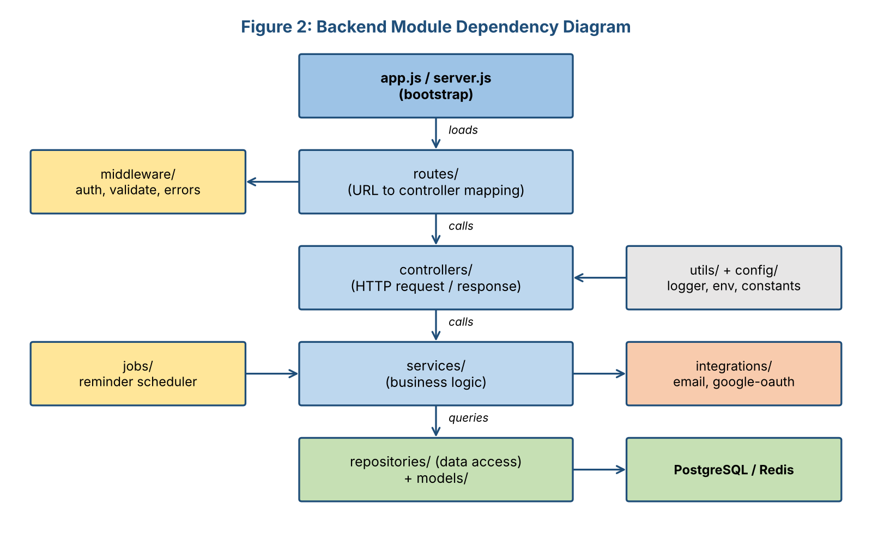
Figure 2: Backend module dependency diagram
Layer | Responsibility | Must NOT
routes | Map URLs and HTTP methods to controllers; attach middleware | Contain any logic
controllers | Read request data, call a service, return the response and status code | Access the database or hold business rules
services | Business rules, validation, coordination between repositories and integrations | Know about HTTP (req/res objects)
repositories | All SQL/ORM queries for one entity | Contain business rules
integrations | Wrap third-party APIs behind simple interfaces | Be called directly from controllers

4.3 Key Classes and Functions
Figure 3 shows the main domain classes and the services that operate on them. Services receive their repositories through the constructor (dependency injection), which makes them easy to test with mock objects.
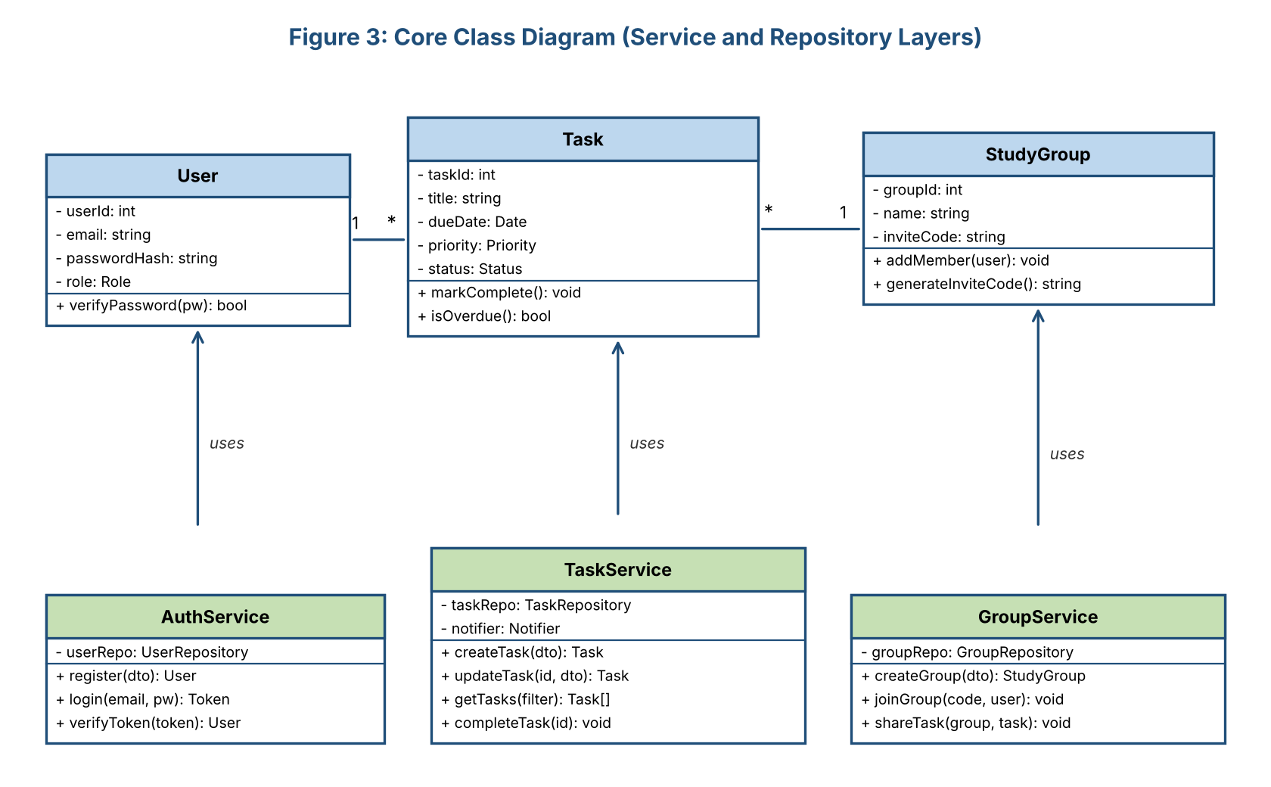
Figure 3: Core class diagram
Module | Main Classes / Functions | Responsibility
Auth | AuthService.register(), login(), verifyToken(); authMiddleware(); UserRepository | Create accounts, hash passwords with bcrypt, issue and verify JWTs
Task | TaskService.createTask(), updateTask(), getTasks(filter), completeTask(); TaskRepository; Task.isOverdue() | Task CRUD, filtering, completion, overdue detection
Notification | ReminderJob.run(), NotificationService.scheduleReminder(), EmailAdapter.send() | Find due reminders every minute, send emails, mark as sent, retry on failure
Group | GroupService.createGroup(), joinGroup(code, user), shareTask(); StudyGroup.generateInviteCode() | Groups, memberships, shared tasks and notes
Analytics | AnalyticsService.getWeeklyProgress(), getCompletionRate() | Aggregate task data for dashboard charts, cached in Redis
Admin | AdminService.listUsers(), suspendUser(), reviewReports(); roleGuard('admin') | User management and moderation
Shared | errorHandler(), validate(schema), logger, config loader | Consistent errors, input validation, logging and configuration

4.4 Example: How a Module Is Written
The following sketch shows the intended style for the Task module. It demonstrates thin controllers, service-level business rules and dependency injection.
// services/TaskService.js
class TaskService {
constructor(taskRepo, notifier) {
this.taskRepo = taskRepo; // injected dependencies
this.notifier = notifier;
}
async createTask(userId, dto) {
if (new Date(dto.dueDate) < new Date())
throw new ValidationError('Due date cannot be in the past');
const task = await this.taskRepo.create({ ...dto, userId });
await this.notifier.scheduleReminder(task);
return task;
}
}

// controllers/taskController.js
const create = async (req, res, next) => {
try {
const task = await taskService.createTask(req.user.id, req.body);
res.status(201).json(task);
} catch (err) { next(err); } // handled by central error middleware
};

4.5 Frontend Structure
- Pages (Login, Dashboard, Tasks, Groups, Admin) compose small reusable components such as TaskCard, TaskForm, CalendarView and ProgressChart.
- An API client module wraps all HTTP calls so components never build URLs themselves.
- Custom hooks (useAuth, useTasks) hold data-loading and state logic, keeping components focused on display.
- Protected routes redirect unauthenticated users to the login page.

5. Technical Guidelines

5.1 Coding Practices
Practice | How It Will Be Applied
Consistent style | ESLint and Prettier run automatically before every commit (Husky pre-commit hook).
Meaningful naming | Descriptive names for files, functions and variables (e.g., getOverdueTasks, not getData).
Small, single-purpose functions | Functions should do one thing and stay short enough to read on one screen.
DRY and separation of concerns | Shared logic lives in utils or services; no duplicated validation or queries.
Error handling | Custom error classes and one central error-handling middleware; no silent failures.
Configuration | Secrets and environment settings live in .env files, never in source code.
Code reviews | Every change goes through a pull request approved by at least one other developer.
Testing | Unit tests with Jest, API tests with Supertest, UI tests with React Testing Library; target 70% coverage on core modules.
Git workflow | main (stable), develop (integration), feature/<name> branches; Conventional Commit messages.
Security basics | Parameterized queries, input validation, hashed passwords, least-privilege access.

5.2 Definition of Done
A task is complete only when: the code is merged through a reviewed pull request; unit tests pass; the linter reports no errors; the API documentation is updated; and the feature has been demonstrated against its acceptance criteria.

6. Design Patterns and Technology Justification

6.1 Design Patterns
Pattern | Where Used | Justification
MVC / Layered | Routes, controllers, services, repositories | Separates concerns so each layer can be changed and tested independently.
Repository | All database access | Keeps SQL out of business logic and allows the database or ORM to be swapped or mocked in tests.
Dependency Injection | Services receive repositories and adapters through constructors | Makes services testable with mock objects and reduces coupling.
Adapter | EmailAdapter, GoogleAuthAdapter | A third-party provider can be replaced without changing business code.
Observer / Event | Task created or updated triggers reminder scheduling | Task code does not need to know how notifications work.
Middleware (Chain of Responsibility) | Authentication, validation, rate limiting, error handling | Cross-cutting concerns are applied cleanly and in order to every request.
Singleton | Database connection pool, logger, configuration | One shared instance avoids wasted connections and inconsistent settings.
Factory | Creating notification messages by type (reminder, welcome, reset) | Adding a new message type does not change existing code.

6.2 Technology Choices and Justification
Area | Choice | Why
Frontend | React + Tailwind CSS | Component reuse, large community, fast development of responsive screens.
Backend | Node.js + Express | One language (JavaScript) across the stack; lightweight and well suited to REST APIs.
Database | PostgreSQL | Relational data with integrity constraints; strong reporting queries for analytics.
ORM | Prisma (or Sequelize) | Type-safe queries and migrations; reduces SQL injection risk.
Cache | Redis | Fast access to sessions and dashboard statistics.
Auth | JWT + bcrypt + Passport (Google) | Stateless authentication that scales; industry-standard password hashing.
Testing | Jest, Supertest, React Testing Library | Standard tools for JavaScript with easy CI integration.
API docs | OpenAPI / Swagger | Single source of truth shared by frontend and backend developers.
CI/CD | GitHub Actions | Free, integrated with the repository; runs lint and tests on every push.
Hosting | Vercel (frontend), Render (API and DB) | Low cost, simple deployment from GitHub, free tiers suit the pilot.

7. Potential Roadblocks and Mitigation
# | Roadblock | Where It May Occur | Mitigation
1 | Scope creep as new feature ideas appear | All sprints | Freeze sprint scope; log new ideas in a backlog; apply MoSCoW before accepting changes.
2 | Integration problems between frontend and backend | Sprint 5 | Agree on the OpenAPI contract in Sprint 2; frontend uses mock API until backend is ready; integration tests.
3 | Reminder scheduling is unreliable (missed or duplicate emails) | Notification module | Use a database flag (sent) with idempotent job logic, retries with back-off, and tests with a mocked clock.
4 | Time zone and date-handling bugs | Tasks, reminders | Store all times in UTC; convert only in the UI; use one date library throughout.
5 | Third-party limits or outages (email, Google OAuth) | Integrations | Adapter pattern, retry and fallback to in-app alerts, monitor usage against free-tier limits.
6 | Slow dashboard queries as data grows | Analytics | Add indexes, cache results in Redis, pre-aggregate weekly data.
7 | Security vulnerabilities | Auth, input handling | Follow OWASP Top 10 checklist, dependency scanning (npm audit), security tests before release.
8 | Team member unavailable or skill gaps | All sprints | Pair programming, shared documentation, short learning spikes, cross-training.
9 | Merge conflicts and inconsistent code | Parallel development | Small pull requests, frequent merges, branch protection, automated linting.
10 | Underestimated tasks cause delay | All sprints | Buffer in each sprint, daily stand-ups, burn-down chart, drop 'Could have' features first.

8. Maintainability and Extensibility

8.1 Maintainability
- Layered structure means a change in one concern (for example, the database) affects only one layer.
- Automated tests and CI catch regressions early, so refactoring is safe.
- Consistent style, naming and folder conventions let any team member find and understand code quickly.
- Centralized logging and error handling make production problems easier to diagnose.
- Dependencies are reviewed and updated regularly (Dependabot) to avoid security debt.

8.2 Extensibility
Possible Future Feature | How the Design Supports It
Native mobile apps | The REST API is client-independent; a mobile app can reuse all existing endpoints.
Additional notification channels (SMS, push) | Add a new adapter behind the existing Notification interface; no changes to the Task module.
AI-based study recommendations | Add a new service that reads from the Analytics module and exposes its own route.
Payment and premium plans | New Billing module following the same routes/controllers/services/repositories layout.
Splitting into microservices | Modules communicate only through service interfaces, so Notification or Analytics can be moved to separate services.
Multiple languages | UI text kept in translation files from the start (i18n), so adding a language needs no code change.

9. Documentation Plan
Documentation is produced alongside the code rather than after it, so it always reflects the real system.
Document | Content | Owner / Timing
README.md | Project summary, setup steps, scripts, folder overview | Created in Sprint 1; updated every sprint
API documentation | OpenAPI specification with request/response examples | Written in Sprint 2; kept in sync with code
Code comments | Purpose of each module, non-obvious logic, JSDoc for public functions | Developers, during coding
Architecture and design docs | Week 2 architecture document and decision records | Updated when design changes
Test reports | Coverage results and test cases | QA, Sprint 5
User guide | Step-by-step instructions with screenshots | Sprint 6
Deployment guide | Environment variables, deployment and rollback steps | DevOps, Sprint 6

10. How the Parts Fit Together
Every part of this plan serves the final product. The roadmap sets the order of work; the folder structure and layering rules decide where each piece of code lives; the design patterns keep modules loosely coupled so they can be built and tested independently; the guidelines keep quality consistent across developers; and the risk plan protects the schedule. Concretely, when a student saves a task in the finished product, the request passes through the routes and middleware built in the Foundation and Auth sprints, is handled by the TaskController and TaskService from Sprint 3, is stored by the TaskRepository, schedules a reminder through the Notification module from Sprint 4, and is displayed by the React components developed in parallel. Each sprint therefore adds a working vertical slice of the same architecture instead of isolated pieces.

11. Conclusion
This plan breaks StudySync into six phases and six sprints, defines a clear build order based on module dependencies, and describes a layered code structure with named modules, classes and functions. It recommends proven practices, design patterns and technologies and gives a reason for each choice. It also identifies ten likely roadblocks with mitigations and explains how the design supports future maintenance and extension. With this roadmap in place, the team can start coding with a shared understanding of what to build, in what order, and to what standard.

12. References
- Martin, R. C., Clean Code: A Handbook of Agile Software Craftsmanship, Prentice Hall.
- Gamma, E., Helm, R., Johnson, R. & Vlissides, J., Design Patterns: Elements of Reusable Object-Oriented Software.
- Fowler, M., Patterns of Enterprise Application Architecture.
- Schwaber, K. & Sutherland, J., The Scrum Guide.
- OWASP Foundation, OWASP Top 10 and Application Security Verification Standard.
- Conventional Commits specification; OpenAPI Specification.

