System Architecture Design Document
StudySync: A Smart Study Planner & Collaboration Platform
Week 2 Task - Junior Software Developer Intern
Prepared by: Vemula Vigneshwari
Date: 04 October 2026 | Version 1.0

Table of Contents
1. System Overview
2. Architecture Diagrams
3. Module Descriptions
4. Scalability, Security and Maintainability
5. Data Flow and Integration
6. Deployment View
7. Design Decisions and Trade-offs
8. Conclusion
9. References

1. System Overview

1.1 Purpose of this Document
This document describes the high-level architecture of StudySync, the web application planned in the Week 1 Project Planning and Requirements Analysis document. It translates the functional and non-functional requirements (FR-01 to FR-10 and NFR-01 to NFR-08) into a concrete technical design covering modules, data flow, data storage, external integrations and deployment.

1.2 System Context
StudySync helps students plan tasks, receive deadline reminders, track progress and collaborate in study groups. Students and mentors use the system through a web browser. The system also communicates with two external services: an email provider for reminders and Google for optional single sign-on.

1.3 Main Components
Component | Short Description
Web Client (React SPA) | Browser-based user interface for tasks, calendar, groups and dashboard.
API Gateway (Express) | Single entry point that routes requests, validates input and verifies JWT tokens.
Auth Module | Registration, login, password hashing, token issue and Google sign-in.
Task Module | Create, update, filter and complete tasks; schedules reminders.
Group Module | Study groups, invite codes, membership, shared tasks and notes.
Analytics Module | Calculates completion rate and weekly progress for dashboard charts.
Notification Module | Sends scheduled email and in-app reminders.
Admin Module | User management and content moderation for administrators.
Data Layer | PostgreSQL (main data), Redis (cache and sessions), file storage for attachments.

1.4 Architectural Style
StudySync uses a layered, modular monolith. The code is divided into independent modules with clear boundaries, deployed as one application. This keeps development and hosting simple for a small team while still allowing individual modules (for example Notifications) to be separated into microservices later if load requires it.

2. Architecture Diagrams

2.1 Layered Architecture
Figure 1 shows the four horizontal layers. Each layer communicates only with the layer directly below it, which keeps responsibilities separated and makes each layer easy to test and replace.
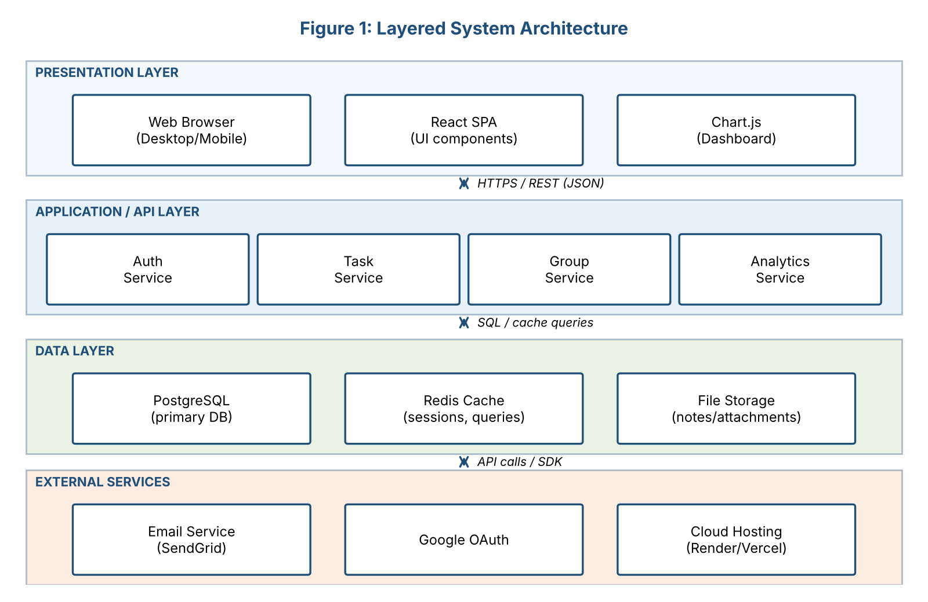
Figure 1: Layered system architecture

2.2 Component Diagram
Figure 2 shows the internal components. All client requests pass through the API Gateway, which dispatches them to the appropriate module. Modules never access the database directly; they use a shared Data Access Layer, which centralizes queries, transactions and caching.
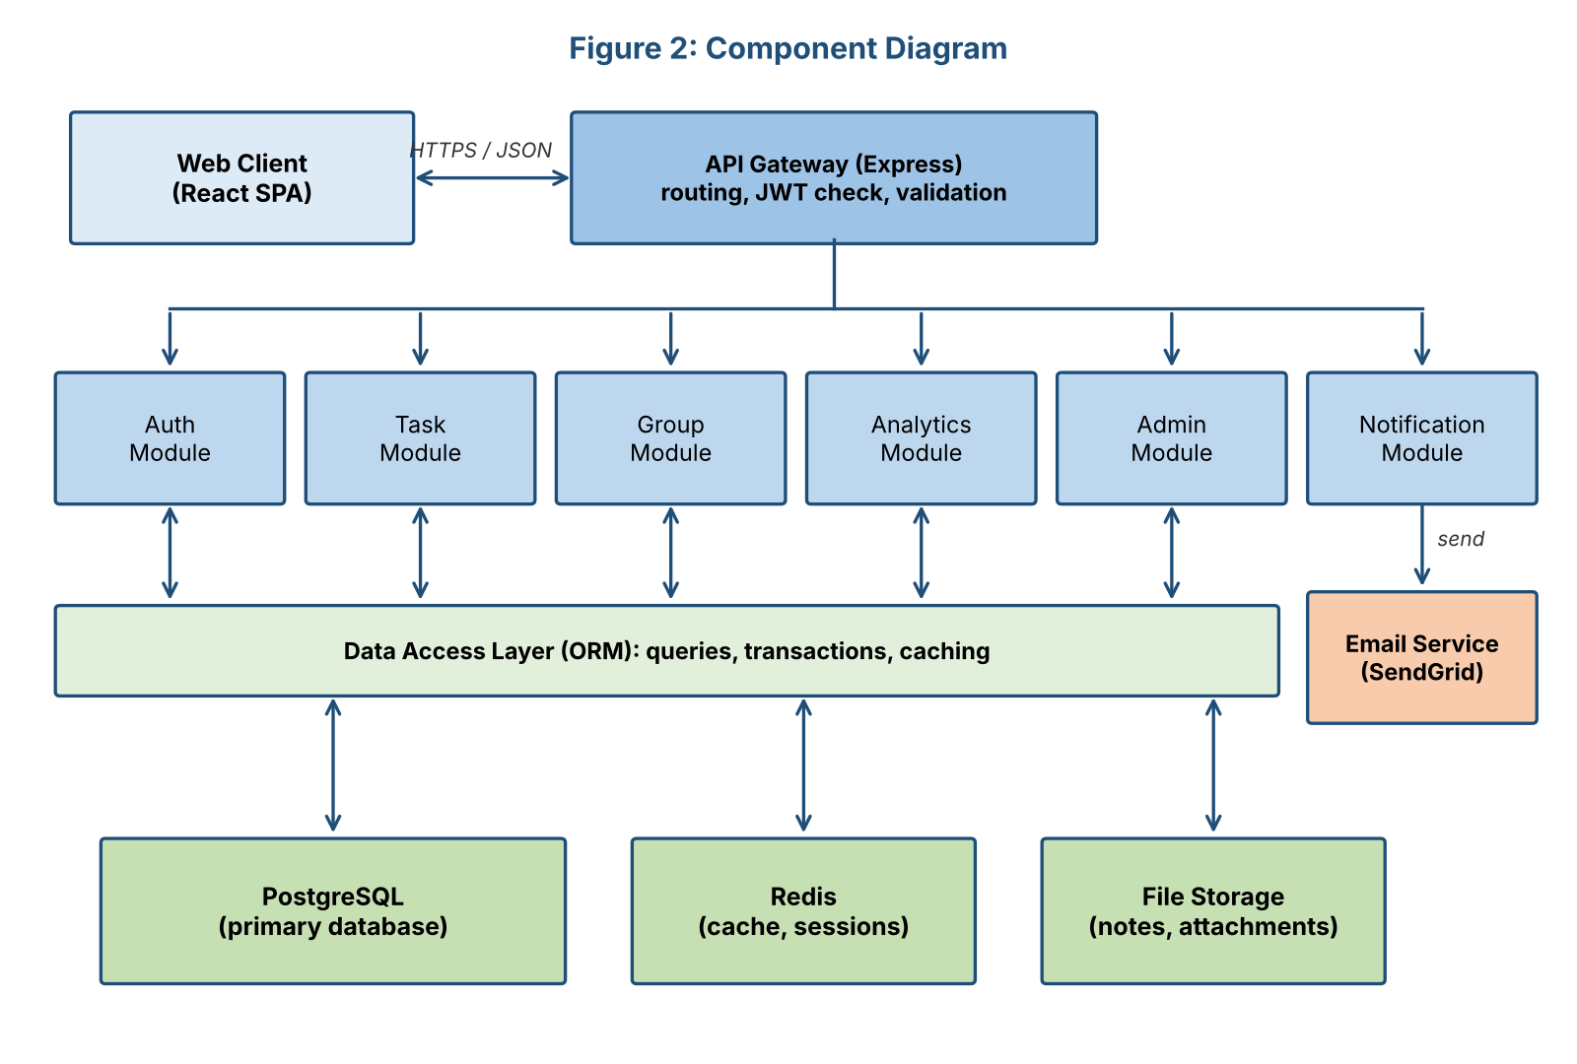
Figure 2: Component diagram

2.3 Data Flow Diagram (Sequence)
Figure 3 follows the most important user scenario, creating a task and receiving a reminder (use case UC-01 from Week 1). It shows the order of messages between the user, UI, backend components and the email service.
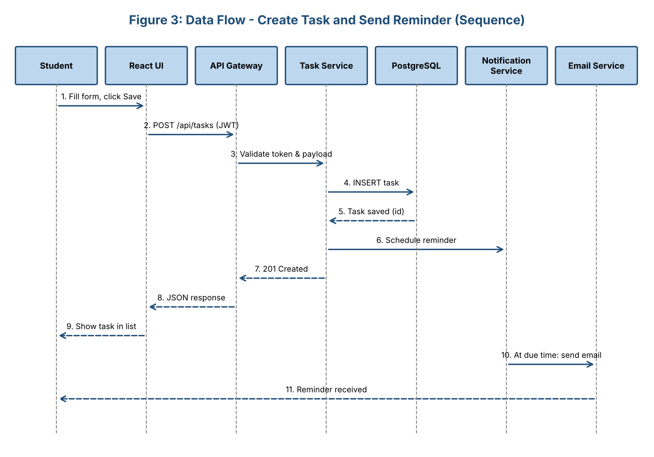
Figure 3: Sequence diagram - create task and send reminder

2.4 Database Design (ER Diagram)
Figure 4 shows the core entities and their relationships. A user can belong to many groups through GROUP_MEMBERS, own many tasks and write many notes. Each task can have one or more reminders. Foreign keys are marked FK and primary keys PK.
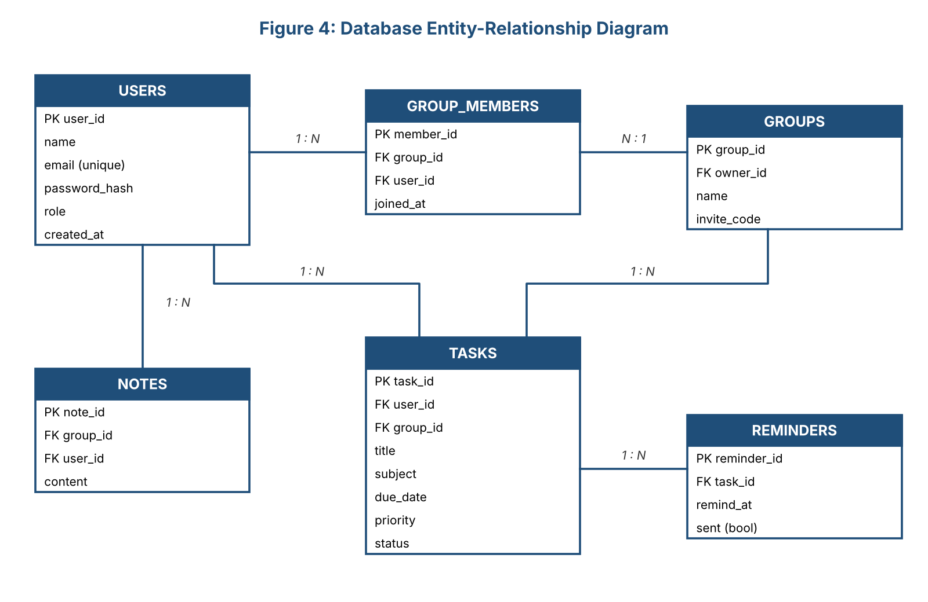
Figure 4: Entity-relationship diagram

3. Module Descriptions
Each module has a single, well-defined responsibility, exposes a REST interface and uses the technologies listed below.
Module | Responsibilities | Key Interfaces | Technology
Web Client | Render UI, form validation, calendar/list views, charts, call REST APIs, store JWT in memory/secure cookie | REST over HTTPS | React, Tailwind CSS, Chart.js
API Gateway | Routing, JWT verification, input validation, rate limiting, error handling, CORS | All /api/* routes | Node.js, Express, Joi, Helmet
Auth Module | Register, login, logout, password hashing, token refresh, Google OAuth sign-in | POST /api/auth/* | bcrypt, jsonwebtoken, Passport.js
Task Module | CRUD for tasks, search and filter, mark complete, create reminder records | /api/tasks | Express, ORM (Prisma/Sequelize)
Group Module | Create/join groups via invite code, membership, shared tasks and notes | /api/groups | Express, ORM
Analytics Module | Aggregate completion rate, weekly study hours, subject-wise progress | GET /api/analytics | SQL aggregation, Redis cache
Notification Module | Scan due reminders on a schedule, send email, mark as sent, in-app alerts | Internal service calls | node-cron, Nodemailer/SendGrid
Admin Module | List/suspend users, review reported content, system statistics | /api/admin (role-protected) | Express, RBAC middleware
Data Access Layer | Single place for queries and transactions; connection pooling; cache lookups | Internal functions | Prisma/Sequelize, pg, ioredis

4. Scalability, Security and Maintainability

4.1 Scalability
- Stateless API servers: authentication uses JWT, so any server instance can handle any request. More instances can be added behind a load balancer.
- Caching: Redis stores frequently read data such as dashboard statistics and session data, reducing database load.
- Database optimization: indexes on user_id, due_date and group_id; connection pooling; read replicas for heavy reporting queries.
- Asynchronous work: email sending runs in the background so users never wait for it.
- Future growth: modules are loosely coupled so Notification or Analytics can become separate services.

4.2 Security
- Authentication and authorization: passwords hashed with bcrypt; short-lived JWT access tokens; role-based access control for admin routes; users can only access their own data and groups they belong to.
- Transport and data protection: HTTPS/TLS everywhere; sensitive configuration in environment variables; encrypted database backups.
- Input protection: server-side validation, parameterized queries (prevents SQL injection), output escaping (prevents XSS), CSRF protection and rate limiting against brute-force attempts.
- Privacy: minimal personal data is stored; users can delete their account and all linked data.

4.3 Maintainability
- Modular folder structure (routes, controllers, services, models) with one responsibility per file.
- Consistent coding standards enforced by ESLint and Prettier.
- Automated unit and integration tests (Jest, Supertest) run on every push through GitHub Actions.
- API documentation using OpenAPI/Swagger, and version control with Git branches and pull requests.
- Centralized logging and error handling to make debugging faster.

5. Data Flow and Integration

5.1 Communication Between Modules
The Web Client communicates with the backend only through the API Gateway using JSON over HTTPS. Inside the backend, modules call each other through well-defined service functions rather than touching each other's data. The table below lists the main dependencies.
From | To | Purpose
Web Client | API Gateway | All user actions (REST requests, JWT in header)
API Gateway | Auth / Task / Group / Analytics / Admin | Route request after token and payload validation
Task Module | Notification Module | Schedule a reminder when a task is created or its due date changes
Group Module | Task Module | Fetch and assign shared tasks for a group
Analytics Module | Task Module data | Read task statuses to compute progress metrics
All modules | Data Access Layer | Read/write PostgreSQL and Redis
Notification Module | Email Service | Send reminder emails

5.2 Step-by-Step Data Flow: Create Task
- The student fills in the task form and clicks Save in the React UI.
- The UI sends POST /api/tasks with the JWT in the Authorization header.
- The API Gateway verifies the token and validates the request body.
- The Task Module stores the task in PostgreSQL through the Data Access Layer.
- The Task Module asks the Notification Module to schedule a reminder.
- A 201 Created response with the new task returns to the UI, which updates the list.
- At the reminder time, the Notification Module sends an email through the Email Service and marks the reminder as sent.

5.3 External Integrations
Service | Used For | How the Integration Works
Email Service (SendGrid) | Deadline reminders, welcome and password-reset emails | The Notification Module calls the provider's HTTPS API with an API key stored in an environment variable. Failures are retried up to 3 times with delay; permanent failures are logged and shown as in-app alerts instead.
Google OAuth 2.0 | Optional sign-in with Google | The browser is redirected to Google; Google returns an authorization code; the Auth Module exchanges it for the user's profile, creates or finds the account and issues the StudySync JWT.
Cloud hosting (Vercel/Render) | Hosting frontend and API | Code is deployed automatically from GitHub through the CI/CD pipeline.

All integrations are wrapped in small adapter classes, so a provider (for example SendGrid) can be replaced without changing the rest of the code.

6. Deployment View
Figure 5 shows the planned production deployment. Static frontend files are served from a CDN for speed. API traffic goes through a load balancer that terminates TLS and distributes requests across one or more Node.js instances. The instances connect to a managed PostgreSQL database with a read replica, and to Redis for caching and sessions. Automated backups run daily.
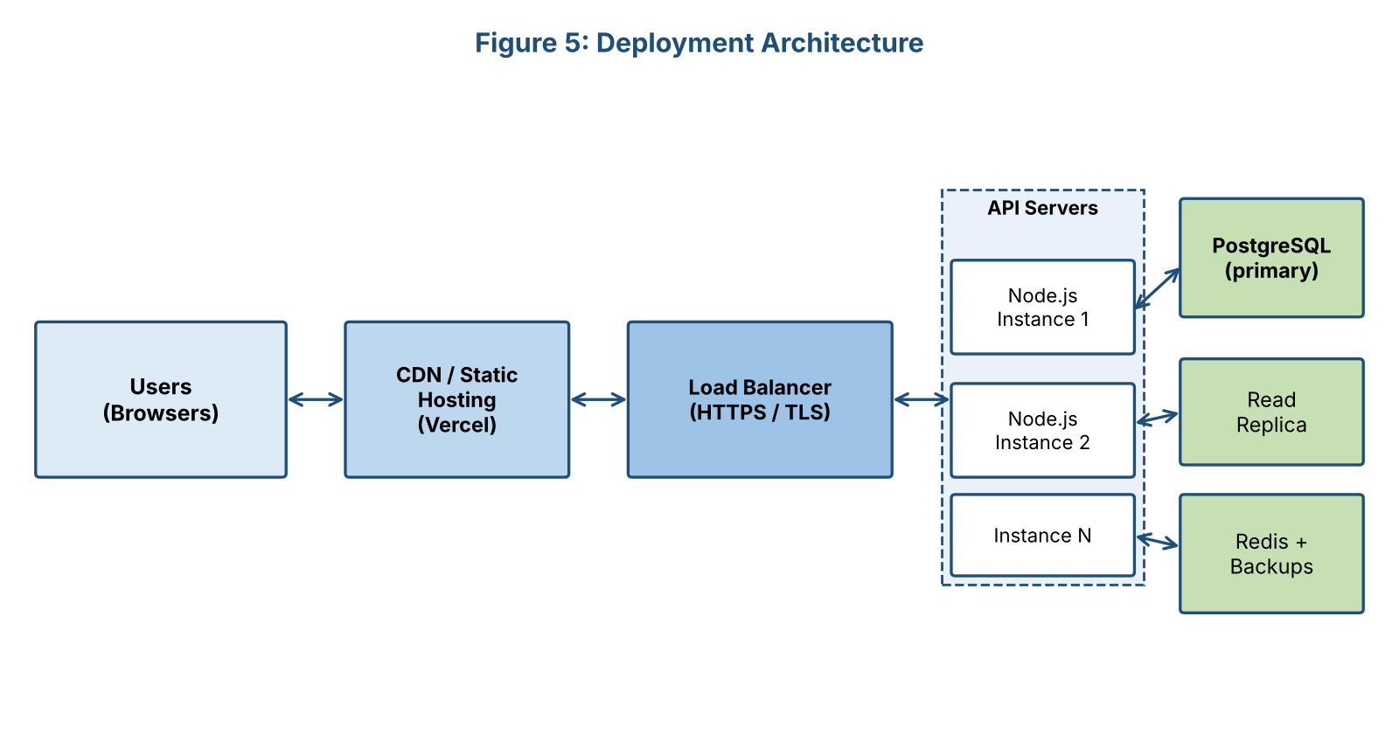
Figure 5: Deployment architecture

7. Design Decisions and Trade-offs
Decision | Reasoning | Trade-off / Alternative
Modular monolith | Simple to build, test and host for a small team with a 12-week schedule | Less independent scaling than microservices; can be split later
REST API | Familiar, easy to test and well supported by React | GraphQL would reduce over-fetching but adds complexity
PostgreSQL | Structured, relational data (users, groups, tasks) with strong consistency | NoSQL is more flexible but weaker for relationships and reports
JWT authentication | Stateless and scales across multiple servers | Tokens are hard to revoke; handled with short expiry and refresh tokens
Redis cache | Fast reads for dashboard and sessions | Adds one more service to operate
React SPA | Rich, responsive interface and reusable components | Needs extra work for SEO (not a priority for a logged-in app)

8. Conclusion
The proposed architecture for StudySync is a layered, modular design built on widely used technologies (React, Node.js/Express, PostgreSQL and Redis). It meets the requirements defined in Week 1 by separating responsibilities into clear modules, keeping the API stateless for scalability, protecting data through layered security controls, and using adapters for external services. The choices favour simplicity and speed of delivery for the MVP while leaving a clear path to scale or split services as the user base grows. This design will guide the interface mockups, database implementation and API development in the next phases.

9. References
- Bass, L., Clements, P. & Kazman, R., Software Architecture in Practice, Addison-Wesley.
- ISO/IEC/IEEE 42010:2022, Architecture description.
- OWASP Foundation, OWASP Top 10 Web Application Security Risks.
- Fowler, M., Patterns of Enterprise Application Architecture.
- OpenAPI Initiative, OpenAPI Specification.

