Final Integration Plan & Code Review Strategy
StudySync: A Smart Study Planner & Collaboration Platform
Week 6 Task - Junior Software Developer Intern
Prepared by: Vemula Vigneshwari
Date: 05 October 2026 | Version 1.0

Table of Contents
1. Introduction and Summary of Previous Work
2. Final Integration Plan
3. Merge Strategy
4. Code Review Strategy and Protocols
5. Roles and Responsibilities
6. Code Quality Checklists
7. Feedback Management
8. Quality Assurance after Integration (CI and Automated Testing)
9. Release Readiness and Rollback
10. Documentation Plan
11. Continuous Improvement
12. Worked Example: A Pull Request from Start to Merge
13. Conclusion
14. References

1. Introduction and Summary of Previous Work

1.1 Purpose
This document completes the StudySync planning series. It unifies the work of Weeks 1 to 5 into a single plan for finishing the project: how the modules will be integrated into one working system, how code will be reviewed before it is merged, and how automated quality controls protect the codebase after integration. The goal is a production-ready release in which all components work together and every line of merged code has met the same quality standard.

1.2 How Earlier Deliverables Feed This Plan
Week | Deliverable | What This Document Takes From It
1 | Project Planning & Requirements | Requirements FR-01 to FR-10 and NFR-01 to NFR-08 become the integration acceptance criteria; scope and risks define what must be in the release.
2 | System Architecture Design | Module list, layered structure, data flows and external integrations define what is integrated and through which interfaces.
3 | Implementation Roadmap & Code Structure | Build order, sprint plan, folder structure, layering rules and branching approach define the order and location of integration work.
4 | Coding Style Guidelines | The style guide, linting rules and JSDoc standard form the review criteria and automated gates.
5 | Testing Strategy & QA Plan | Test levels, quality gates, defect process and release criteria define how integration is verified.

1.3 Objectives
- Integrate all backend modules, the React frontend and external services into one deployable system with no unresolved interface mismatches.
- Merge features safely, with small reviewed changes and no broken main branch.
- Apply one systematic, documented code review process with clear roles, checklists and response times.
- Use CI and automated tests to keep the integrated codebase healthy after every change.
- Document every step so that future developers can continue improving the system.

1.4 Assumptions
- A team of three to five people: backend developer, frontend developer, QA/DevOps engineer, a tech lead, and a product owner (roles can be combined in a small team, but the responsibilities remain separate).
- Source code is hosted on GitHub; GitHub Actions is used for CI/CD; the application is deployed to Vercel (frontend) and Render (API and database).
- Roles are partly hypothetical; where one person holds several roles, the author of a change must never be the only reviewer of that change.

2. Final Integration Plan

2.1 Modules to Be Integrated
Module | Main Responsibility | Depends On | Integrates With
Foundation | Config, logging, error handling, DB connection, CI | None | All modules
Auth | Registration, login, JWT, Google sign-in | Foundation, Users table | All protected routes, frontend login
Task | Task CRUD, filtering, completion | Auth, Foundation | Notification, Group, Analytics
Notification | Reminder scheduling and email sending | Task, Email adapter | Task, Redis, SendGrid
Group | Study groups, invites, shared tasks and notes | Auth, Task | Frontend group screens
Analytics | Progress and streak calculations | Task data, Redis | Dashboard UI
Admin | User management and moderation | Auth (role check) | Admin UI
React Frontend | All user screens | All APIs (OpenAPI contract) | Backend through API client
External services | Email (SendGrid), Google OAuth, hosting | Adapters | Notification, Auth, deployment

2.2 Integration Strategy: Incremental, Contract-First
Instead of joining all modules at the end (big-bang integration), StudySync is integrated incrementally in five waves. Each wave adds a small group of modules to an already working system and is verified before the next begins. Figure 1 shows the waves.
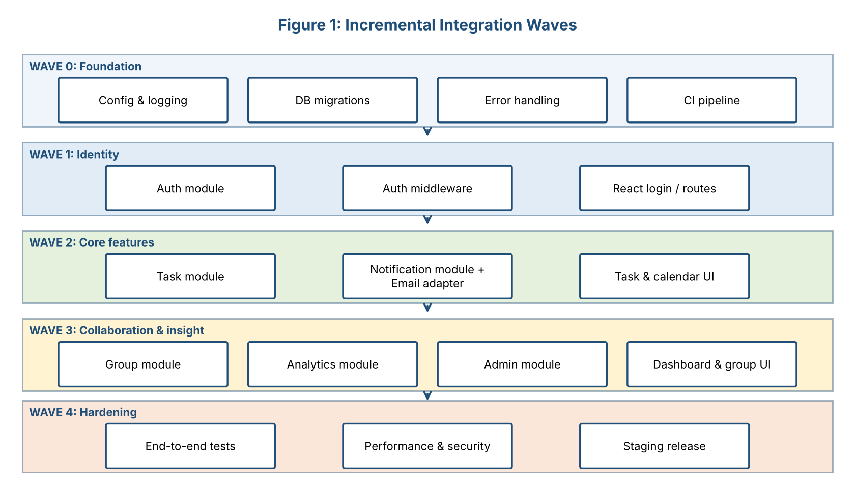
Figure 1: Incremental integration waves
Approach | Advantages | Why Chosen / Not Chosen
Big-bang (everything at the end) | Simple to plan | Not chosen: defects appear late, are hard to locate, and can delay the release.
Incremental waves (chosen) | Early detection of interface problems; each step is testable; always a working system | Chosen: fits the sprint plan and small team; matches dependency order.
Top-down (UI first with stubs) | Early user feedback | Used partly: the frontend develops against mocked API responses until the real API is ready.
Bottom-up (data and services first) | Solid foundations | Used partly: Foundation, Auth and Task modules are built first.

2.3 Integration Waves in Detail
Wave | Weeks | Integration Activities | Verification (exit check)
0. Foundation | 5 | Connect config, logger, error handler and database migrations; set up CI pipeline and Docker test environment | CI is green on an empty app; migrations run on a clean database
1. Identity | 5-6 | Connect Auth module to database, add auth middleware to router, connect React login to /api/auth, enable Google OAuth | Login to protected-route flow works end to end (TC-01, TC-02)
2. Core features | 6-8 | Connect Task module to auth; connect Notification module through the reminder job and email adapter; connect task and calendar UI | Create task to reminder email works (TC-03, TC-06); contract tests pass
3. Collaboration and insight | 7-9 | Connect Group module to tasks and users; connect Analytics to task data and Redis; connect Admin module and role guard; dashboard and group UI | Group scenarios (TC-05) and dashboard pass; analytics queries meet performance target
4. Hardening | 9-10 | Run full end-to-end, cross-browser, security and performance suites on staging; fix defects; freeze features | System test exit criteria from Week 5 are met

2.4 Integration Steps (Per Module)
Every module follows the same repeatable procedure when it joins the system:
- Step 1 - Verify readiness: the module's unit tests pass, lint is clean, its API is documented in the OpenAPI file, and its pull request has been approved.
- Step 2 - Check the interfaces: confirm that inputs and outputs match the contracts of the modules it connects to (request/response shapes, error codes, database fields).
- Step 3 - Integrate behind a flag if needed: incomplete features are merged but hidden behind a feature flag (for example ENABLE_GROUPS=false) so the main branch is always releasable.
- Step 4 - Run migrations: apply new database migrations on a copy of the test database; verify rollback scripts.
- Step 5 - Replace mocks with real connections: remove temporary stubs (mock API, fake email) and run the integration tests against real components.
- Step 6 - Run the integration test suite: API tests, contract tests and the relevant end-to-end flows.
- Step 7 - Deploy to staging: automatic deployment from the develop branch; run smoke tests.
- Step 8 - Sign off: QA confirms the wave's exit check; the tech lead updates the integration log; the next wave begins.

2.5 Interface and Integration Points
Interface | Between | Integration Check
REST API contract (OpenAPI) | React frontend and Express API | Contract tests compare real responses with the specification; frontend uses the same spec to generate its API client types.
Auth middleware | Auth module and all protected routes | Every protected endpoint returns 401 without a token and 403 for wrong role.
Service-to-service calls | Task to Notification, Group to Task | Unit tests with mocks plus integration tests with real services.
Data Access Layer | All modules and PostgreSQL/Redis | Migration tests; constraint tests; cache invalidation tests.
Email adapter | Notification module and SendGrid | Sandbox mode test; failure and retry test; no duplicate emails.
Google OAuth adapter | Auth module and Google | Callback flow tested in staging with a test Google account.
Scheduled job | Reminder job and database clock | Runs with mocked time in tests; verified once on staging with real time.

2.6 Configuration and Data Integration
- Environment variables are listed in .env.example with descriptions; real values live only in the hosting platform's secret store.
- Database migrations are versioned, run automatically by the pipeline, and each has a tested rollback (down) script.
- Configuration differences between local, staging and production are limited to values (URLs, keys), never to code paths.
- Seed data scripts create realistic test data for staging; production data is never copied to test environments.

2.7 Definition of Integration Complete
[ ] | All planned modules are merged into main and deployed to staging.
[ ] | No placeholder, mock or stub code remains in production paths.
[ ] | All API endpoints in the OpenAPI specification are implemented and contract tests pass.
[ ] | All Must-have requirements (FR-01 to FR-05, FR-07 and NFR-01 to NFR-05) are traced to passing tests.
[ ] | End-to-end tests for the main user journeys pass on all supported browsers.
[ ] | Database migrations run cleanly from an empty database and from the previous release.
[ ] | No critical or high-severity defects are open.

3. Merge Strategy

3.1 Branching Model
StudySync uses a simplified Git Flow, shown in Figure 2. Work is done on short-lived feature branches and enters develop only through reviewed pull requests; a release branch is cut when the feature set is complete.
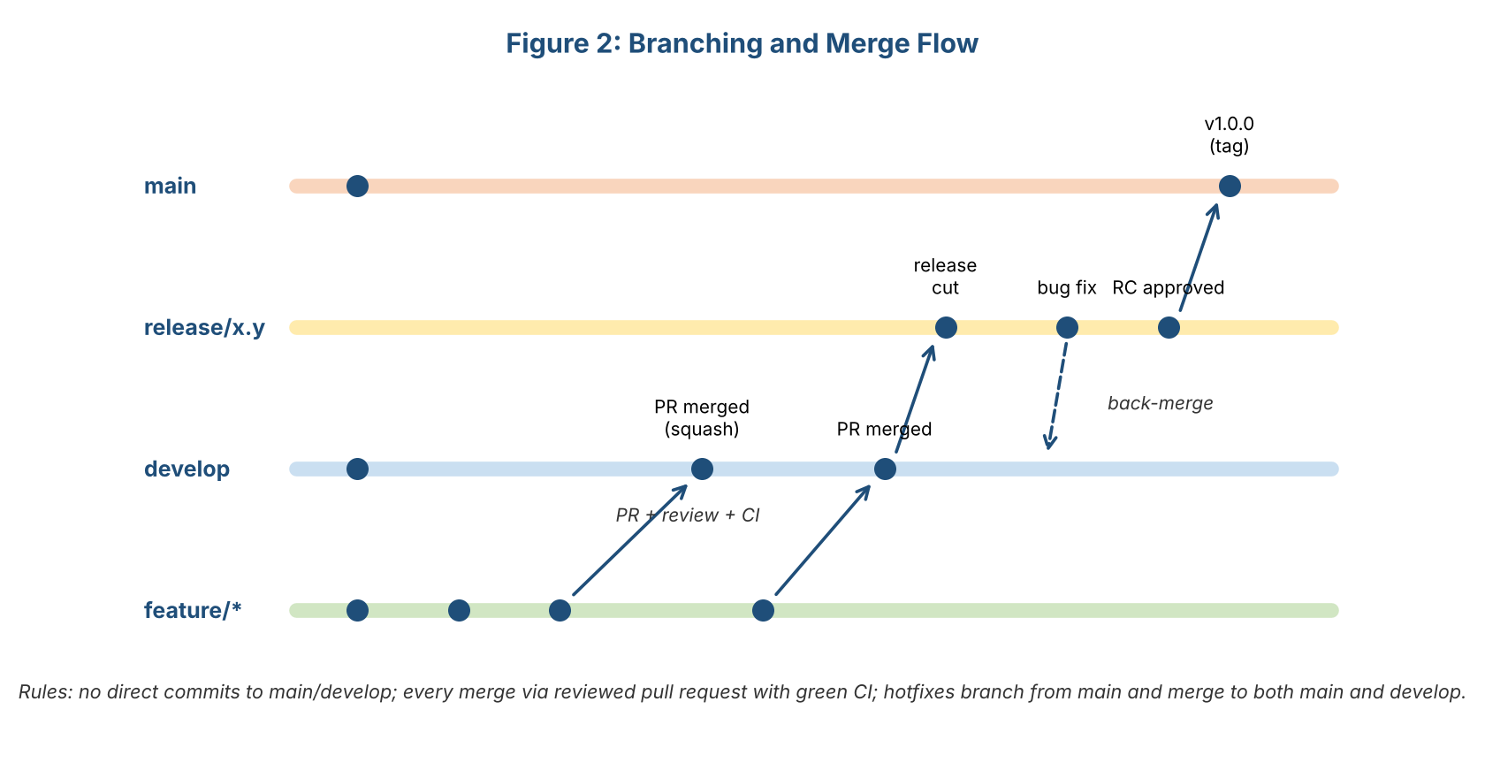
Figure 2: Branching and merge flow
Branch | Purpose | Rules
main | Production-ready code; every commit is a release candidate or release | Protected: no direct pushes; only merged from release or hotfix branches; tagged with version numbers (v1.0.0).
develop | Integration branch where finished features come together | Protected: pull request, one or two approvals, all CI checks green.
feature/<name> | One feature or fix, for example feature/group-invite | Created from develop; lives no longer than a few days; deleted after merge.
release/x.y | Stabilization before a release: only bug fixes | Created from develop; merged to main and back to develop.
hotfix/<name> | Urgent production fixes | Created from main; merged to main and develop; fast-track review by two reviewers.

3.2 Strategies for Merging Features Seamlessly
- Small pull requests: aim for fewer than 400 changed lines and one purpose per PR. Small changes are reviewed faster, contain fewer bugs, and conflict less.
- Frequent integration: developers update their branch from develop at least once a day (git fetch and rebase), so differences never grow large.
- Feature flags: unfinished work can be merged early but stays switched off, avoiding long-lived branches and big merges.
- Squash and merge: each pull request becomes one clean commit on develop with a Conventional Commit message, giving a readable history and easy reverts.
- Contract-first development: API changes are agreed in the OpenAPI file before code is written, so frontend and backend branches fit together.
- Clear ownership: a CODEOWNERS file assigns reviewers for each folder, which reduces overlapping work.
- Merge windows: features are merged to develop continuously, but no merges are made to the release branch except approved bug fixes after the feature freeze.

3.3 Conflict Resolution
- Resolve conflicts on the feature branch (rebase on develop), never on develop itself.
- If a conflict touches code owned by someone else, ask the owner to review the resolution.
- After resolving, re-run the full test suite locally and wait for CI before requesting review again.
- If the same files conflict repeatedly, the tech lead reviews the work split and may reorder tasks.

3.4 Merge Requirements (Enforced by GitHub Branch Protection)
Requirement | Detail
Required CI checks | Lint, format check, unit tests, integration tests, coverage threshold, security audit must be green.
Required approvals | At least 1 approval for develop (2 for main, release and hotfix); code owner approval for sensitive folders.
Up-to-date branch | Branch must be up to date with the target before merging.
Conversation resolution | All review comments must be resolved.
No force pushes / deletions | Disabled on main, develop and release branches.
Signed / conventional commits | Commit messages follow the Conventional Commits format (checked by commitlint).

4. Code Review Strategy and Protocols

4.1 Goals of Code Review
- Find defects, security issues and design problems before they reach users.
- Ensure the code follows the Week 4 coding style and the Week 3 architecture and layering rules.
- Share knowledge so that no part of the system is understood by only one person.
- Keep the codebase consistent, readable and maintainable.
- Improve skills through constructive feedback, for authors and reviewers alike.

4.2 Review Process
Figure 3 shows the review workflow that every change follows.
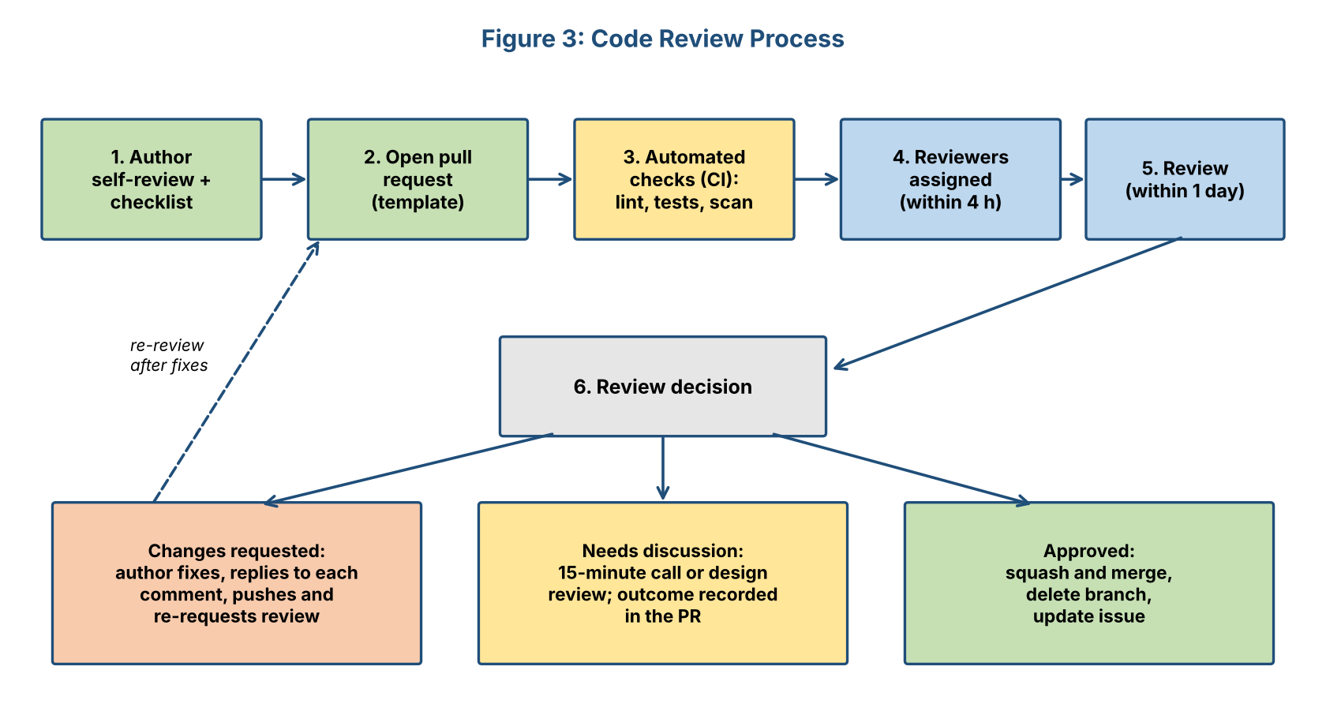
Figure 3: Code review process
Step | Activity | Details
1 | Author self-review | The author reads their own diff, runs the code locally, completes the author checklist and adds comments to explain tricky parts.
2 | Open pull request | Uses the PR template: summary, linked issue/requirement, how it was tested, screenshots (UI), risks, documentation updates.
3 | Automated checks | CI runs lint, format check, tests, coverage and security scan. Review starts only when checks are green, so humans never review style or failing code.
4 | Reviewer assignment | Reviewers are assigned automatically through CODEOWNERS, plus one cross-module reviewer for knowledge sharing.
5 | Review | Reviewers read the description first, then the tests, then the code, using the review checklist (Section 6). Comments use the labels in Section 7.
6 | Decision | Approve, request changes, or call a short discussion for complex issues; outcome is written in the PR.
7 | Merge | After approval and green CI, the author (or merger) squashes and merges, deletes the branch and closes the issue.

4.3 Types of Review
Type | When Used | Details
Pull request review (asynchronous) | Every change to develop | Default method; documented in GitHub; the main quality gate.
Pair programming / live review | Complex or risky changes (auth, payments, data migrations) | Two developers work or review together in real time; the PR still receives formal approval.
Design review | Before large features (e.g., Group module changes) and for architectural changes | Short meeting with a one-page proposal before coding starts, to avoid costly rework.
Security review | Changes to authentication, authorization, input handling, dependencies | Reviewer uses the security checklist; OWASP ZAP and dependency scan results are examined.
Release review | Before each release candidate | Tech lead and QA review the full diff between releases, the changelog and migration scripts.
Post-merge / spot check | Weekly | Tech lead picks two merged PRs at random to check that standards are being followed.

4.4 Scheduling and Service Levels
Rule | Standard
First response to a review request | Within 4 working hours (assign reviewer, or acknowledge).
Complete first review | Within 1 working day for normal PRs; within 2 hours for hotfixes.
Author response to comments | Within 1 working day.
Review sessions | Each developer reserves two 30-minute review slots per day (for example 11:00 and 16:00) so reviews do not wait.
Review size | Preferably under 400 changed lines; reviewers must not review more than 400 lines in one sitting, because attention drops.
Weekly review meeting | 30 minutes every Friday: discuss difficult reviews, recurring problems and improvements to the checklist.
Stale PR policy | PRs with no activity for 3 days are flagged in stand-up; after 7 days they are closed or split.
Escalation | If a review is blocked for more than 2 days, the tech lead decides.

4.5 Review Criteria
A change is approved only when it satisfies all of the following:
Criterion | Question the Reviewer Asks
Correctness | Does the code do what the requirement and acceptance criteria describe? Are edge cases and error paths handled?
Design and architecture | Does it respect the layering rules (routes, controllers, services, repositories)? Is the responsibility in the right place? Is there needless complexity or duplication?
Readability and style | Are names clear? Does it follow the style guide? Is the code easy to follow without explanation?
Tests | Are there meaningful unit and integration tests for new behaviour and bug fixes? Do they test failure cases?
Security and privacy | Is all input validated? Are queries parameterized? Are permissions checked? Are secrets and personal data protected?
Performance | Any queries in loops, missing indexes, unnecessary re-renders or large payloads?
Documentation | Are JSDoc comments, README, OpenAPI file and changelog updated where needed? Do comments explain why?
Maintainability | Can another developer change this safely in six months? Is it easy to extend?
Compatibility and migration | Does it break existing API clients? Is the database migration reversible?

4.6 Pull Request Template and CODEOWNERS
.github/pull_request_template.md
## Summary
What does this change do and why? (Link issue / requirement: Closes #__ / FR-__)

## Type of change
- [ ] Feature - [ ] Bug fix - [ ] Refactor - [ ] Docs - [ ] Config / CI

## How was it tested?
- [ ] Unit tests - [ ] Integration tests - [ ] Manual (steps / screenshots)

## Checklist (author)
- [ ] I reviewed my own diff - [ ] Lint, format and tests pass locally
- [ ] Docs / OpenAPI / changelog updated - [ ] No secrets, no debug code
- [ ] Database migration included and reversible (if applicable)

## Risks and notes for reviewers
Anything risky, unfinished or deliberately left out?
.github/CODEOWNERS
# Each path requires review from its owner(s)
/backend/src/services/auth* @tech-lead @security-champion
/backend/src/services/ @backend-dev @tech-lead
/backend/src/repositories/ @backend-dev
/frontend/src/ @frontend-dev
/backend/migrations/ @tech-lead @devops-qa
/.github/workflows/ @devops-qa
/docs/ @tech-lead

5. Roles and Responsibilities
Several roles take part in integration and review. In a small team one person may hold more than one role, but the rule 'authors cannot approve their own changes' always applies.
Role | Responsibilities | Authority
Author (developer) | Keeps changes small; self-reviews; writes tests and documentation; completes the PR template; responds to feedback promptly and respectfully; fixes issues and re-requests review. | Owns the change until merged; may disagree with feedback with reasons.
Reviewer (peer developer) | Reviews within the agreed time; checks correctness, design, tests, security and documentation using the checklist; gives clear, specific, kind feedback; approves or requests changes. | Can approve or block a merge.
Code owner | Developer responsible for a folder or module (listed in CODEOWNERS); reviews all changes to it; protects its design and quality. | Required approval for their module.
Tech lead / architect | Defines and updates review standards; resolves disagreements; reviews architectural and risky changes; runs design reviews; owns the integration log; makes final decisions on blocked reviews. | Final decision on technical disputes.
Security champion | Reviews changes to auth, input handling and dependencies; maintains the security checklist; reviews scan results. | Can block merges for security reasons.
QA engineer | Checks test coverage and test quality in reviews; owns the end-to-end suite; verifies integration waves; manages defects and release test reports. | Can reject a release candidate.
DevOps engineer | Maintains CI/CD, branch protection, environments, monitoring and deployment/rollback procedures. | Owns pipeline and infrastructure changes.
Product owner | Confirms that merged features meet acceptance criteria; prioritizes review feedback that changes scope; signs off the release. | Accepts or rejects features and the release.
Release manager (can be tech lead) | Coordinates release branch, freeze, changelog, tagging, deployment and rollback plan. | Decides go/no-go with the product owner and QA.

5.1 Responsibility Matrix (RACI)
R = Responsible, A = Accountable, C = Consulted, I = Informed.
Activity | Author | Reviewer | Tech Lead | QA | DevOps | Product Owner
Write code, tests and docs | R/A | I | C | C | I | I
Review pull request | C | R | A | C | I | I
Security-sensitive review | C | R | A | C | I | I
Resolve review disagreement | C | C | R/A | I | I | I
Maintain CI and branch protection | I | I | A | C | R | I
Verify integration wave | C | I | A | R | C | I
Release approval | I | I | R | R | C | A
Update review checklist | C | C | R/A | C | C | I

6. Code Quality Checklists

6.1 Author Checklist (before requesting review)
[ ] | I have read my entire diff and removed debugging code, console.log statements and commented-out code.
[ ] | The change does one thing and is under about 400 lines (or I explained why not).
[ ] | Lint, format check and all tests pass locally.
[ ] | New behaviour and bug fixes have unit and integration tests, including failure cases.
[ ] | Names, formatting and file layout follow the Week 4 style guide.
[ ] | Exported functions, classes and components have JSDoc; comments explain why, not what.
[ ] | No secrets, keys or personal data are in the code or logs.
[ ] | README, OpenAPI file and changelog are updated if behaviour or configuration changed.
[ ] | Database migrations are included, tested and reversible.
[ ] | The PR description explains what, why, how it was tested and any risks.

6.2 Reviewer Checklist

Correctness and design
[ ] | The code meets the linked requirement and acceptance criteria.
[ ] | Edge cases (null, empty, boundary values, time zones) and error paths are handled.
[ ] | Layering rules are respected: controllers contain no business logic; services contain no HTTP code; repositories contain no business rules.
[ ] | No duplicated logic; shared code lives in utils or services.
[ ] | Functions are small and single-purpose; nesting is shallow.

Security and reliability
[ ] | All external input is validated; queries are parameterized; output is escaped.
[ ] | Authentication and role checks are present on every new endpoint.
[ ] | Errors are handled with context; there are no empty catch blocks; no sensitive data in error messages or logs.
[ ] | Third-party calls have timeouts, retries or fallbacks; new dependencies are justified and scanned.

Tests, performance and documentation
[ ] | Tests are meaningful (not only coverage), independent and readable; mocks are used appropriately.
[ ] | Queries are indexed and avoid N+1 patterns; caching is used correctly; large lists are paginated.
[ ] | Frontend: components are reusable, accessible (labels, keyboard use), responsive, and avoid unnecessary re-renders.
[ ] | Documentation and comments are accurate and sufficient for a new team member.

6.3 Integration-Specific Checklist
[ ] | API changes match the OpenAPI specification; breaking changes are versioned or agreed with the frontend.
[ ] | Feature flags are used for incomplete features and have a removal plan.
[ ] | Migrations run on a clean database and on the previous release; rollback scripts are tested.
[ ] | Environment variables are added to .env.example and documented.
[ ] | Integration and contract tests cover the new interface.
[ ] | No mock or stub code remains in production paths.

7. Feedback Management

7.1 How to Give Effective Feedback
- Be specific: point to the line and explain the problem and the reason, ideally with a suggested fix or example.
- Be kind and respectful: critique the code, not the person; use 'we' and questions ('What do you think about extracting this into a helper?').
- Separate must-fix from preferences using labels, so the author knows what blocks the merge.
- Praise good solutions; positive comments reinforce good practice.
- Do not discuss anything a tool can enforce; leave formatting and style to Prettier and ESLint.

7.2 Comment Labels
Label | Meaning | Example
blocking: | Must be fixed before merge (bug, security issue, standard violation) | blocking: this query concatenates userId into SQL; please use a parameter.
suggestion: | Improvement worth considering; author decides | suggestion: extract the date logic into a helper so TaskService stays short.
question: | Reviewer needs to understand; may become a comment or a change | question: why is the retry limit 3 rather than 5?
nit: | Minor, optional detail | nit: 'tasksList' could simply be 'tasks'.
praise: | Something done well | praise: nice use of a fake clock in this test.

7.3 How Feedback Is Handled and Implemented
# | Step | Detail
1 | Read all comments first | The author reads every comment before replying, to understand the overall picture.
2 | Respond to each comment | Reply 'Done' with the commit, or explain respectfully why no change is needed. Comments are resolved by the author after the fix, or by the reviewer if it was a discussion.
3 | Fix in small follow-up commits | Review fixes are pushed as new commits so reviewers can see exactly what changed; commits are squashed on merge.
4 | Re-request review | The author clicks 'Re-request review' once all blocking comments are addressed.
5 | Track larger suggestions | If a suggestion is valuable but out of scope, create a follow-up issue and link it in the comment, instead of enlarging the PR.
6 | Resolve disagreements | If author and reviewer cannot agree after two exchanges, they hold a 15-minute call; if still unresolved, the tech lead decides. The reasoning is recorded in the PR (and in an architecture decision record if it affects design).
7 | Capture lessons | Recurring comments become new checklist items, lint rules or style guide updates, so that the same feedback is never needed twice.

8. Quality Assurance after Integration (CI and Automated Testing)

8.1 Continuous Integration Pipeline
After integration, the CI pipeline protects the integrity of the codebase. Every pull request and every merge runs the stages below, following the Week 5 test plan.
Stage | Trigger | Checks | Target Time
1. Static checks | Every push | ESLint, Prettier check, commit message check, secret scan | Under 1 min
2. Unit tests | Every push | Jest unit tests with coverage threshold (70%) | Under 3 min
3. Integration tests | Pull request | Supertest API tests against Docker PostgreSQL and Redis; contract tests against OpenAPI | Under 6 min
4. Security | Pull request | npm audit, dependency scan, OWASP ZAP baseline (nightly) | Under 3 min
5. Build | Pull request | Build frontend and backend; generate JSDoc and Swagger pages | Under 3 min
6. End-to-end | Merge to develop; nightly | Cypress on Chrome and Firefox; accessibility checks; smoke tests | Under 25 min
7. Deploy to staging | Merge to develop | Automatic deployment; run migrations; smoke test | Under 5 min
8. Release pipeline | Tag on main | Full regression, load test, deploy to production after manual approval, post-deploy smoke test | Under 60 min

.github/workflows/ci.yml (pull request pipeline)
name: CI
on:
pull_request:
branches: [develop, main, 'release/**']
jobs:
quality:
runs-on: ubuntu-latest
services:
postgres:
image: postgres:16
env: { POSTGRES_PASSWORD: test, POSTGRES_DB: studysync_test }
ports: ['5432:5432']
redis:
image: redis:7
ports: ['6379:6379']
steps:
- uses: actions/checkout@v4
- uses: actions/setup-node@v4
with: { node-version: 20, cache: npm }
- run: npm ci
- run: npm run lint && npm run format:check
- run: npm run test:unit -- --coverage
- run: npm run migrate:test && npm run test:integration
- run: npm audit --audit-level=high
- run: npm run build && npm run docs

8.2 Safeguards that Protect the Integrated Codebase
- Branch protection: no merge without green CI, required reviews and resolved comments (Section 3.4).
- Regression suite: every defect fixed gets a test, so the suite grows stronger with the product.
- Coverage ratchet: coverage may not fall below the current level; thresholds only increase.
- Dependency automation: Dependabot opens weekly update pull requests, which go through the same review and CI.
- Quality dashboards: coverage trend, build duration, flaky-test rate and open defects are visible to the team.
- Monitoring after release: uptime checks, error logging (for example Sentry), performance metrics and alerts for failed reminder jobs.
- Nightly builds: full regression and security scans on develop catch problems that appear only after combinations of changes.
- Flaky test policy: an unstable test is quarantined and fixed within one sprint so that the pipeline stays trustworthy.

9. Release Readiness and Rollback

9.1 Release Steps
# | Step | Detail
1 | Feature freeze | All planned features merged into develop; only bug fixes allowed from this point.
2 | Cut release branch | Create release/1.0 from develop; version number and changelog prepared.
3 | Release candidate testing | Full system test suite, performance and security tests, UAT sign-off (Week 5 criteria).
4 | Release review | Tech lead and QA review the complete diff, migrations, configuration changes and open risks.
5 | Go / no-go meeting | Product owner, tech lead, QA and DevOps confirm the release criteria below.
6 | Merge and tag | Merge release branch to main (two approvals), tag v1.0.0, back-merge to develop.
7 | Deploy | Run migrations, deploy frontend and API, run production smoke tests.
8 | Monitor | Watch error rates and performance for 24 hours; team on standby.
9 | Retrospective | Review what worked, record lessons learned and update this plan.

9.2 Release Criteria
[ ] | All integration waves complete; Definition of Integration Complete (Section 2.7) satisfied.
[ ] | CI is green on the release branch; coverage at least 70% on core modules.
[ ] | No open critical or high-severity defects; medium defects have an agreed plan.
[ ] | UAT signed off by the product owner; usability score at least 70.
[ ] | Security scan clean; no high-risk dependency vulnerabilities.
[ ] | Backups verified; rollback plan tested on staging.
[ ] | Documentation complete: user guide, API documentation, deployment guide, changelog.

9.3 Rollback Plan
- Frontend: redeploy the previous build from the hosting platform (one-click rollback).
- API: redeploy the previous tagged version; feature flags can disable a problematic feature immediately without redeployment.
- Database: every migration has a tested down script; a full backup is taken immediately before release, so data can be restored if a rollback is not possible.
- Decision rule: roll back if a critical defect affects more than 5% of users or any data-loss or security issue is found, and cannot be fixed within one hour.

10. Documentation Plan
Every step of integration and review is documented so that future contributors can understand what was done and why, and can continue to improve the product.
Document | Content | Owner / Update Trigger
Integration log | Date, wave, modules integrated, issues found and how they were solved, sign-off | Tech lead; updated after every wave
Pull request history | Description, review discussion and decisions for every change | Authors and reviewers; automatic in GitHub
Architecture decision records (ADRs) | Short records of important design decisions, options considered and reasons | Tech lead; whenever a major decision is made
CHANGELOG.md | User-visible changes by release (Added, Changed, Fixed, Security) | Release manager; every release
API documentation | OpenAPI / Swagger generated from code comments | Developers; with every API change
Code documentation | JSDoc site generated by the pipeline | Developers; with every merge
README and CONTRIBUTING | Setup, scripts, branching, PR and review rules, links to this plan and the style guide | Tech lead; when processes change
Runbook | How to deploy, roll back, restore backups, rotate secrets, handle incidents | DevOps; after each release or incident
Test reports | Coverage, pass rates, defect statistics for each release | QA; each release
Lessons learned / retrospective notes | What worked, what did not, improvement actions | Whole team; each retrospective

Example integration log entry
Wave 2 - Core features Date: 2026-11-12 Owner: Tech lead
Integrated: Task module, Notification module, EmailAdapter, task + calendar UI
Verified: TC-03, TC-06 pass; contract tests pass; staging smoke test OK
Issues: #61 reminder sent twice when task edited -> fixed in PR #64 (idempotent job)
#63 calendar shows UTC times -> fixed in PR #66 (convert in UI)
Decisions: ADR-004: reminders are idempotent via 'sent' flag, not via job locking
Sign-off: QA (R. Kumar), Tech lead - approved to start Wave 3

11. Continuous Improvement

11.1 Review and Integration Metrics
Metric | Target | Why It Matters
Time to first review | Under 4 working hours | Prevents work from waiting
Review turnaround (open to merge) | Under 2 working days | Keeps flow of work smooth
Pull request size (median) | Under 300 changed lines | Small changes are safer and easier to review
Defects found in review vs. in testing | More found in review over time | Shows effectiveness of reviews
Escaped defects (found after release) | Zero critical; fewer each release | Overall quality indicator
CI pass rate on first attempt | Above 85% | Shows quality before review
Rework rate (PRs needing 3+ review rounds) | Below 10% | Shows clarity of standards and descriptions
Flaky test rate | Under 2% | Trust in automation

11.2 Improvement Practices
- Weekly review meeting: examine difficult reviews and recurring comments; convert them into checklist items or lint rules.
- Sprint retrospective: look at metrics above and agree two concrete improvement actions per sprint.
- Root cause analysis for every critical defect and every escaped defect: fix the bug, the missing test and the process gap.
- Rotate reviewers so that knowledge spreads and fresh eyes catch different problems.
- Short learning sessions (30 minutes) on topics that appear often in reviews, such as security or testing techniques.
- Review this document and the style guide every two sprints and after every release; version changes through pull requests.
- Maintain a technical-debt list with owners and a fixed share of each sprint (about 15%) reserved for paying it down.

12. Worked Example: A Pull Request from Start to Merge
The following example shows how the strategy works in practice for the feature 'join study group with invite code' (TC-05).
Stage | What Happens
Branch | Author creates feature/group-join from develop and works for two days.
Self-review | Author reads the diff, finds a leftover console.log, adds a test for the 'group full' case, updates the OpenAPI file.
Pull request | Opens PR #72 'feat(group): join study group with invite code' (320 lines) using the template, linking FR-05 and TC-05.
CI | Lint and tests pass; coverage on group module 78%. Security scan clean.
Review | Code owner (tech lead) and a cross-module reviewer (frontend developer) are assigned automatically. First comment arrives after 3 hours.
Feedback | See comments below.
Fixes | Author pushes two small commits, replies 'Done' to each comment and re-requests review.
Approval and merge | Both approve; CI green; squash and merge with message 'feat(group): join study group with invite code (#72)'; branch deleted; issue closed.
Integration | Merged into develop; staging deployment runs automatically; QA runs TC-05 on staging and records it in the integration log.

Sample review comments on PR #72
blocking: groupService.joinGroup() checks the member limit and then inserts in two separate
queries. Two users joining at the same time could exceed 30 members. Please wrap
both steps in one transaction (or use a conditional insert).

suggestion: The invite code comparison is case-sensitive. Normalising to upper case would
avoid 'invalid code' errors when students type it in lower case.

question: Should an expired invite code return 404 or 410? The OpenAPI file says 404.

nit: 'grpList' -> 'groups' to match the naming guide.

praise: Great test names - 'rejects join when group is full' reads like documentation.
Outcome: the blocking comment prevented a real race-condition bug. The author fixed it with a transaction and added a concurrency test; the suggestion was applied; the question was answered in the PR and the API documentation was clarified. The review cost about 40 minutes in total and avoided a defect that would have been expensive to find in production.

13. Conclusion
This final document brings the whole StudySync plan together. It uses the requirements, architecture, roadmap, coding standards and test strategy from Weeks 1 to 5 to define how the project will be completed: an incremental, contract-first integration in five waves; a clear branching and merge strategy built on small, frequent, reviewed changes; a structured code review process with defined scheduling, criteria, roles, checklists and feedback rules; and a CI pipeline and set of safeguards that keep the integrated codebase healthy. Release criteria, a rollback plan, a documentation plan and continuous improvement practices ensure that the product can be released with confidence and improved afterwards. By following this strategy, the team can deliver a production-ready system whose components work together and whose code meets the same high standard from the first commit to the final release.

14. References
- Humble, J. & Farley, D., Continuous Delivery, Addison-Wesley.
- Fowler, M., Patterns for Managing Source Code Branches and Continuous Integration (martinfowler.com).
- Google Engineering Practices Documentation: How to do a code review; The CL author's guide.
- Driessen, V., A successful Git branching model (Git Flow); GitHub Docs: Protected branches, CODEOWNERS, Actions.
- SmartBear, Best Practices for Code Review (Cisco code review study).
- Conventional Commits specification; Keep a Changelog; Nygard, M., Documenting Architecture Decisions.
- OWASP Foundation, Code Review Guide and Top 10.
- Earlier project documents: StudySync Weeks 1-5 (Requirements, Architecture, Roadmap, Coding Style, Testing Plan).

