Testing Strategy & Quality Assurance Plan
StudySync: A Smart Study Planner & Collaboration Platform
Week 5 Task - Junior Software Developer Intern
Prepared by: Vemula Vigneshwari
Date: 05 October 2026 | Version 1.0

Table of Contents
1. Overview
2. Testing Lifecycle
3. Testing Phases
4. Testing Types
5. Methodologies and Tools
6. Test Environment, Data and Roles
7. Test Case Examples
8. Requirements Traceability
9. Quality Assurance Process
10. Metrics and Release Criteria
11. Test Schedule
12. Risks to Testing
13. Conclusion
14. References

1. Overview

1.1 Purpose
This document defines how StudySync will be tested and how quality will be assured from the first line of code until release. It builds on the requirements (Week 1), architecture (Week 2), implementation roadmap (Week 3) and coding guidelines (Week 4). The aim is to find defects as early as possible, prove that every requirement is met, and give the team and stakeholders objective evidence that the software is ready for users.

1.2 Why Testing Matters
- Quality and trust: students depend on reminders and deadlines; a missed reminder or lost task directly harms the user and the product's reputation.
- Lower cost: a defect found during coding costs a fraction of one found in production. Early testing reduces rework.
- Security and privacy: StudySync stores personal data and credentials, so security flaws must be found before attackers find them.
- Safe change: a strong automated test suite lets developers refactor and add features without fear of breaking existing behaviour.
- Evidence for acceptance: test results show stakeholders that requirements FR-01 to FR-10 and NFR-01 to NFR-08 are satisfied.

1.3 Scope
In Scope | Out of Scope
Backend modules: Auth, Task, Group, Analytics, Notification, Admin | Native mobile apps (not part of the MVP)
React web client on latest Chrome, Firefox, Edge and Safari, desktop and mobile browsers | Testing of third-party services' own internals (SendGrid, Google OAuth); only our integration with them is tested
REST API, database, caching, scheduled reminder job | Load beyond 1,000 concurrent users (NFR-03 target)
Functional, security, performance, usability and accessibility testing | Penetration testing by an external specialist firm

1.4 Testing Principles
- Test early and continuously (shift-left): tests are written alongside code, not after it.
- Automate repeatable tests; reserve manual effort for exploratory, usability and acceptance testing.
- Risk-based priority: features that are most important or most likely to fail (login, reminders, data privacy) get the deepest testing.
- Testing shows the presence of defects, not their absence, so the plan targets coverage of risks and requirements rather than claiming perfection.
- Every defect found gets a test that prevents it from returning (regression test).

2. Testing Lifecycle
Testing follows a defined lifecycle that runs in parallel with development. Figure 1 shows how each development activity is matched by a test level (the V-model): each test level checks the work product of the activity on the same row.
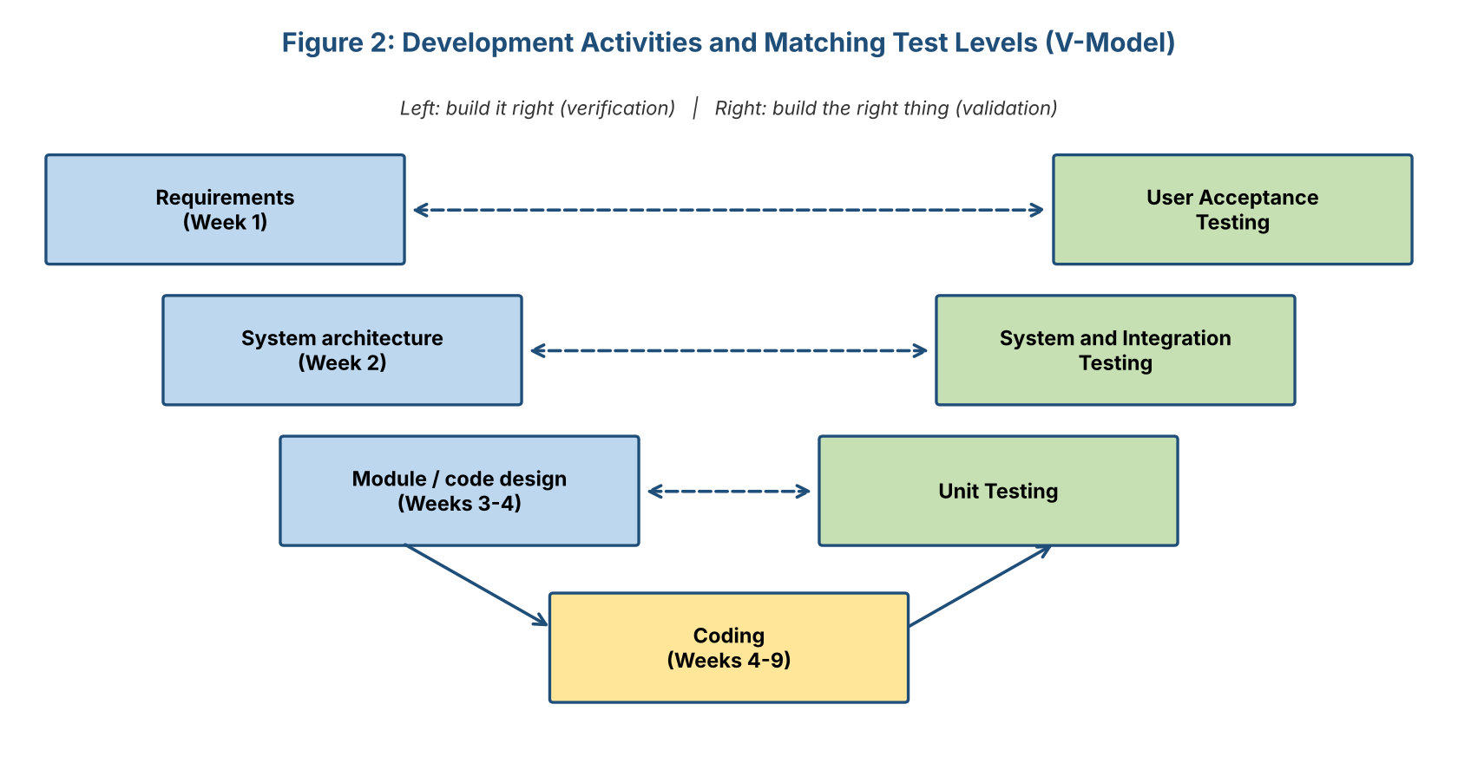
Figure 1: Development activities and matching test levels
# | Lifecycle Stage | Activities and Outputs
1 | Test planning | Define scope, approach, environments, roles, schedule and risks (this document). Output: test plan.
2 | Test design | Derive test cases and scenarios from requirements and user stories; prepare test data. Output: test cases, traceability matrix.
3 | Environment setup | Prepare development, test (staging) and production-like environments with seeded data and CI pipeline.
4 | Test execution | Run automated and manual tests; log results and defects. Output: test run reports, defect log.
5 | Defect management | Triage, fix, retest and regression test every defect (Section 9).
6 | Test reporting | Summarize coverage, pass rate, open defects and risks at the end of every sprint.
7 | Test closure | Evaluate against exit criteria, archive test assets, hold a retrospective and record lessons learned.

3. Testing Phases
StudySync uses four test levels. Figure 2 shows the proportion of effort: many fast, cheap tests at the bottom and a small number of slower, broader tests at the top.
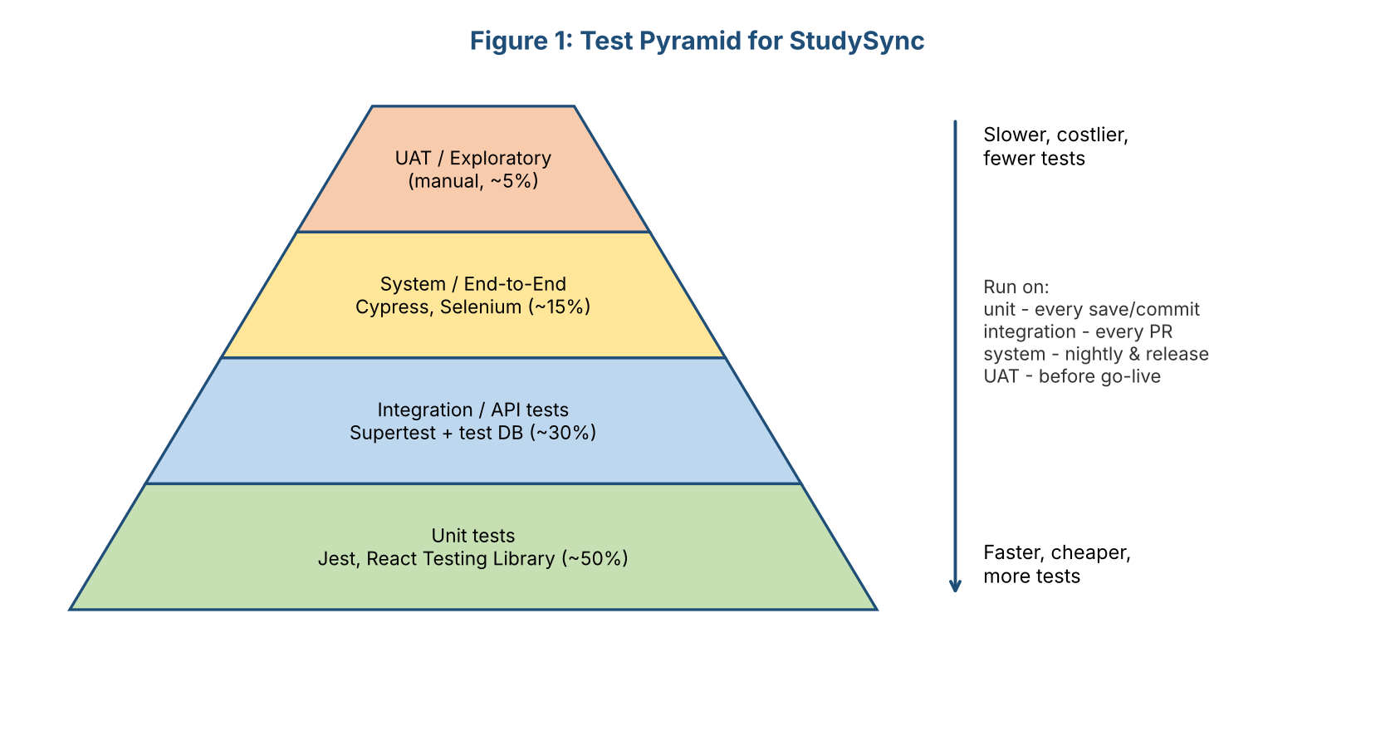
Figure 2: Test pyramid for StudySync

3.1 Unit Testing
Aspect | Plan
Objective | Verify that each function, class or React component works correctly in isolation.
Scope | Service classes (TaskService, AuthService, GroupService), utility functions, validators, model methods (e.g., Task.isOverdue()), React components and hooks.
Approach | White-box testing. Dependencies (repositories, email adapter, clock) are replaced with mocks and stubs. Each test follows Arrange-Act-Assert.
Techniques | Equivalence partitioning, boundary value analysis (e.g., title length 0, 1, 120, 121), error-path testing, branch coverage.
Tools | Jest (backend and frontend), React Testing Library, jest.mock / sinon for mocks.
Responsible | The developer who writes the code; reviewed in the pull request.
Entry criteria | Code compiles and passes lint checks.
Exit criteria | All unit tests pass; at least 70% line coverage on core modules (Auth, Task, Group, Notification); no failing test merged.
When run | Locally on every save (watch mode), on every commit (pre-commit hook for changed files), and on every pull request (CI).

3.2 Integration Testing
Aspect | Plan
Objective | Verify that modules work together correctly: controller to service to repository to database, and our code to external services.
Scope | REST API endpoints with a real test PostgreSQL database and Redis; Auth middleware with protected routes; Task-to-Notification reminder scheduling; Google OAuth and email adapters against sandbox or mocked provider endpoints; frontend to API calls.
Approach | Gray-box testing through the public API. Database is reset and seeded before each test run; each test creates its own data.
Techniques | Top-down and bottom-up integration, contract testing against the OpenAPI specification, database transaction and constraint testing.
Tools | Jest + Supertest, Docker Compose (test database), Postman/Newman collections, Mock Service Worker (frontend), Pact (optional contract tests).
Responsible | Developers (backend and frontend) with QA review.
Entry criteria | Unit tests pass; module APIs documented in OpenAPI.
Exit criteria | All API endpoints covered by at least one success and one failure test; all integration tests pass; no critical or high defects open.
When run | On every pull request and nightly on the develop branch.

3.3 System Testing
Aspect | Plan
Objective | Verify the complete, integrated application against the functional and non-functional requirements in a production-like environment.
Scope | End-to-end user journeys (register, add tasks, receive reminder, join group, view dashboard, admin moderation); cross-browser and responsive layout; performance, security, accessibility and compatibility tests.
Approach | Black-box testing from the user's perspective on the staging environment, using realistic data volumes.
Techniques | Scenario-based testing, regression testing, exploratory testing sessions, risk-based testing, negative testing.
Tools | Cypress and Selenium WebDriver (end-to-end and cross-browser), k6 or Apache JMeter (performance), OWASP ZAP (security scan), Lighthouse and axe (accessibility, performance), BrowserStack (device matrix, optional).
Responsible | QA engineer, supported by developers for diagnosis.
Entry criteria | Integration testing exit criteria met; build deployed to staging; test data loaded.
Exit criteria | 100% of Must-have requirements tested; at least 95% of system test cases pass; no open critical or high-severity defects; performance and security targets met.
When run | Nightly smoke and regression suite; full run before each release candidate.

3.4 User Acceptance Testing (UAT)
Aspect | Plan
Objective | Confirm that the system meets real user needs and business goals and is ready to go live.
Scope | Acceptance criteria of the user stories US-01 to US-06; usability of main flows; clarity of reminder emails and messages.
Participants | 10-15 pilot users: students from different courses, two study-group leaders, one teacher/mentor and the product owner.
Approach | Alpha testing by the internal team, then beta testing by pilot users on staging for one week. Users follow scripted scenarios plus free exploration; feedback is collected through a short form and a usability questionnaire (e.g., System Usability Scale).
Tools | Test scenario sheets, feedback form, screen recording (with consent), issue board.
Entry criteria | System testing exit criteria met; user guide drafted.
Exit criteria | All acceptance scenarios pass or are accepted by the product owner with documented workarounds; usability score of at least 70 (SUS); 90% of testers complete the create-task-and-reminder flow within 2 minutes (matches Week 1 objective); formal sign-off.
When run | Sprint 5, before release candidate approval.

4. Testing Types
Besides the four levels above, several types of testing are applied across the levels. The table shows each type, its role in quality, and where it is applied.
Type | Role in Ensuring Quality | How | Level
Functional testing | Checks that features behave as specified (FR-01 to FR-10) | Test cases from requirements and user stories | All levels
Regression testing | Ensures new changes do not break existing features | Automated suite run on every PR and nightly | Unit to system
Smoke testing | Quick check that a new build is stable enough to test further | 10-15 critical tests after every deployment | System
Security testing | Protects data and accounts (NFR-02, NFR-08) | OWASP Top 10 checklist, OWASP ZAP scan, npm audit, auth and role tests | Integration, system
Performance testing | Verifies speed and capacity (NFR-01, NFR-03) | k6 load test up to 1,000 virtual users; API p95 under 500 ms; page load under 3 s | System
Usability testing | Confirms the product is easy to learn and use (NFR-04) | Observed sessions, SUS questionnaire | UAT
Accessibility testing | Ensures use by people with disabilities (WCAG 2.1 AA) | axe, Lighthouse, keyboard and screen-reader checks | System
Compatibility testing | Works on required browsers and devices (NFR-06) | Cypress/Selenium on Chrome, Firefox, Edge, Safari; mobile browsers | System
Reliability / recovery testing | Confirms uptime and backups work (NFR-05) | Restart services, restore database from backup, retry failed emails | System
Exploratory testing | Finds unexpected issues scripted tests miss | Time-boxed 60-minute sessions with charters | System, UAT
Static analysis / code review | Finds defects without running code | ESLint, pull-request review checklist | Before all levels

5. Methodologies and Tools

5.1 Recommended Methodologies
Methodology | How It Is Used in StudySync | Why
TDD (Test-Driven Development) | For business-rule code in services (e.g., due-date validation, invite-code logic, streak calculation): write a failing test, write the minimum code to pass, then refactor (Red-Green-Refactor). | Produces testable design, high coverage and fewer defects in the most important logic.
BDD (Behaviour-Driven Development) | User stories are turned into Given-When-Then scenarios in Gherkin and automated with Cucumber.js and Cypress. | Shared language between developers, testers and the product owner; scenarios double as acceptance tests.
Risk-based testing | Test effort is allocated by risk (probability x impact). Login, reminders and data privacy are tested most deeply. | Makes best use of limited time in a 12-week project.
Shift-left testing | Testers review requirements and designs; developers run tests locally and in CI. | Defects are cheaper to fix the earlier they are found.
Continuous Integration / Delivery | Every pull request triggers lint, unit, integration and a subset of end-to-end tests in GitHub Actions; merges to main deploy to staging. | Fast feedback and always-releasable code.
Exploratory testing | Time-boxed sessions guided by charters (e.g., 'explore group invitations with expired codes'). | Finds issues that scripted tests do not anticipate.

5.2 Recommended Tools
Purpose | Tool | Notes
Unit testing (JavaScript) | Jest, React Testing Library | Fast, built-in mocking and coverage; JUnit is the equivalent for Java projects.
API / integration testing | Supertest, Postman + Newman | Newman runs Postman collections in CI.
End-to-end / UI automation | Cypress (primary), Selenium WebDriver (cross-browser) | Cypress for speed and developer experience; Selenium for the wider browser matrix.
BDD | Cucumber.js (Gherkin) | Feature files stored in the repository.
Performance | k6 or Apache JMeter | Load, stress and spike tests with pass/fail thresholds.
Security | OWASP ZAP, npm audit, Snyk | Automated scans in CI plus manual checklist.
Accessibility | axe-core, Lighthouse | Run automatically in Cypress and CI.
Code coverage | Istanbul / nyc (built into Jest) | Coverage report fails the build below thresholds.
Test management and defects | GitHub Issues + Projects (or Jira); test cases in a shared sheet or TestRail | Links defects to requirements and pull requests.
CI/CD | GitHub Actions | Runs the whole pipeline on every PR.
Test environment | Docker Compose | Spins up PostgreSQL and Redis identically on every machine and in CI.

5.3 Test Automation Pipeline
Trigger | Tests That Run | Target Duration
On save / pre-commit | Unit tests for changed files, lint | Under 30 seconds
Pull request | All unit tests, integration tests, lint, coverage check, accessibility checks, smoke E2E | Under 10 minutes
Merge to develop (nightly) | Full regression E2E on Chrome and Firefox, security scan, performance smoke | Under 45 minutes
Release candidate | Full cross-browser suite, full load test, security scan, manual exploratory and UAT | 1-2 days

6. Test Environment, Data and Roles

6.1 Environments
Environment | Purpose | Details
Local | Developer unit and integration tests | Docker Compose with PostgreSQL and Redis; email provider mocked.
CI | Automated tests on every PR | Fresh containers per run; database seeded by scripts.
Staging | System testing, UAT, performance tests | Mirrors production configuration; sandbox email provider; anonymised sample data.
Production | Live system | Only smoke tests and monitoring; no destructive testing.

6.2 Test Data
- Synthetic data generated by seed scripts (users, groups, tasks with past, present and future due dates).
- Boundary data: empty and maximum-length titles, due dates today/yesterday/tomorrow, groups with 29, 30 and 31 members.
- Special cases: non-English characters, very long notes, users in different time zones.
- No real personal data in test environments; passwords and keys in test environments are never reused in production.

6.3 Roles and Responsibilities
Role | Responsibility
Developers | Write unit and integration tests, fix defects, keep the CI pipeline green.
QA / DevOps engineer | Own the test plan, automated E2E and performance suites, environments, defect triage and reports.
Product owner | Approve acceptance criteria, take part in UAT, sign off the release.
Pilot users (testers) | Execute UAT scenarios and give feedback.
Scrum master / team lead | Remove blockers, run triage meetings, ensure the Definition of Done includes testing.

7. Test Case Examples
The following sample test cases and scenarios illustrate the format and the level of detail. They cover the most important functions of StudySync and are not an exhaustive list.

7.1 Functional Test Cases
TC-01: User login with valid credentials (FR-01)
Priority / Type | High / Functional, positive
Precondition | User student1@example.com is registered with password 'Study@123'.
Test steps | 1. Open the login page. 2. Enter the email and password. 3. Click Login.
Test data | Email: student1@example.com; Password: Study@123
Expected result | User is redirected to the dashboard; a valid JWT is issued; user name is displayed in the header.
Level / Tool | System / Cypress

TC-02: User login with wrong password (FR-01, NFR-02)
Priority / Type | High / Functional + security, negative
Precondition | User student1@example.com exists.
Test steps | 1. Open the login page. 2. Enter the email and an incorrect password. 3. Click Login. 4. Repeat 5 times quickly.
Expected result | Error 'Invalid email or password' is shown (does not reveal which one is wrong); no token issued; after repeated attempts the rate limiter returns HTTP 429.
Level / Tool | Integration / Supertest

TC-03: Create task with all valid fields (FR-02, FR-03)
Priority / Type | High / Functional, positive
Precondition | User is logged in.
Test steps | 1. Click Add Task. 2. Enter title 'Read chapter 3', subject 'Physics', due date tomorrow, priority High, reminder 1 hour before. 3. Click Save.
Expected result | API returns 201 with the new task; task appears in list and calendar; a reminder record is created with the correct time in UTC.
Level / Tool | System / Cypress; API part with Supertest

TC-04: Task validation - boundary and invalid values (FR-02)
Priority / Type | Medium / Functional, negative, boundary
Test data | Title lengths: 0 (empty), 1, 120, 121 characters; due date in the past; invalid priority 'Urgent!!'
Test steps | Submit the create-task request for each data item.
Expected result | Lengths 1 and 120 are accepted (201). Empty title, 121 characters, past date and invalid priority are rejected with HTTP 400 and a clear message naming the field. No record is created.
Level / Tool | Unit (TaskService) and Integration (Supertest)

TC-05: Join study group with invite code (FR-05)
Priority / Type | High / Functional, positive and negative
Precondition | Group 'Physics Squad' exists with invite code 'PHY-7K2Q' and 29 members.
Test steps | 1. User A enters 'PHY-7K2Q' and joins. 2. User B enters the same code. 3. User C enters 'WRONG-CODE'.
Expected result | User A joins (group now has 30 members). User B is refused because the maximum of 30 members is reached (HTTP 409). User C receives 'Invalid invite code' (HTTP 404). Group tasks are visible only to members.
Level / Tool | Integration / Supertest

TC-06: Reminder email is sent once at the right time (FR-03)
Priority / Type | High / Functional, time-based
Precondition | Task due at 10:00 UTC with reminder 60 minutes before; mocked clock and mocked email provider.
Test steps | 1. Set clock to 08:59 and run ReminderJob. 2. Set clock to 09:00 and run the job. 3. Run the job again at 09:01.
Expected result | No email at 08:59. Exactly one email at 09:00 containing task title and due time; reminder marked as sent. No duplicate at 09:01. If the provider fails, the job retries up to 3 times, then creates an in-app alert.
Level / Tool | Unit + Integration / Jest with fake timers

7.2 Non-Functional Test Scenarios
ID | Scenario | Expected Result | Requirement
NF-01 | Load test: ramp from 0 to 1,000 virtual users over 5 minutes performing login, list tasks, create task | p95 API response under 500 ms; error rate under 1%; no crashes | NFR-01, NFR-03
NF-02 | SQL injection attempt in the search field (' OR 1=1 --) and script injection in the task title | Input treated as plain text; no data leaked; script is escaped and not executed | NFR-02
NF-03 | Access another user's task by changing the task ID in the URL | HTTP 403/404; no data returned | NFR-02, NFR-08
NF-04 | Open the app on a 360 px wide phone screen and on a desktop in all four browsers | Layout is usable without horizontal scrolling; all main actions work | NFR-04, NFR-06
NF-05 | Navigate login and task creation using only the keyboard; run axe scan | All controls reachable; no critical accessibility violations | NFR-04 (WCAG 2.1 AA)
NF-06 | Stop the API server for 2 minutes during use, then restart; restore database from last backup in staging | Client shows friendly error and recovers; backup restored with no data corruption | NFR-05

7.3 Automated Test Code Samples
Unit test (Jest) - written test-first for the due-date rule
describe('TaskService.createTask', () => {
let taskRepo, notifier, service;
beforeEach(() => {
taskRepo = { create: jest.fn(async (t) => ({ id: 1, ...t })) }; // mock
notifier = { scheduleReminder: jest.fn() }; // mock
service = new TaskService(taskRepo, notifier);
});

test('rejects a due date in the past', async () => {
const dto = { title: 'Read ch. 3', dueDate: new Date('2020-01-01') };
await expect(service.createTask(7, dto)).rejects.toThrow(ValidationError);
expect(taskRepo.create).not.toHaveBeenCalled();
});

test('saves the task and schedules a reminder', async () => {
const dto = { title: 'Read ch. 3', dueDate: new Date(Date.now() + 86400000) };
const task = await service.createTask(7, dto);
expect(task.userId).toBe(7);
expect(notifier.scheduleReminder).toHaveBeenCalledWith(task);
});
});
Integration test (Supertest) - API with real test database
test('POST /api/tasks returns 400 for an empty title', async () => {
const token = await loginAs('student1@example.com');
const res = await request(app)
.post('/api/tasks')
.set('Authorization', `Bearer ${token}`)
.send({ title: '', dueDate: tomorrow() });
expect(res.status).toBe(400);
expect(res.body.error).toMatch(/title/i);
});
BDD scenario (Gherkin) - acceptance criterion for US-01
Feature: Task reminders
Scenario: Student receives a reminder before a deadline
Given I am logged in as a student
And I have a task "Physics report" due tomorrow at 10:00
And I set a reminder 1 hour before the due time
When the reminder time is reached
Then I should receive one reminder email for "Physics report"
And the task should show a "reminder sent" indicator
End-to-end test (Cypress)
it('lets a student create a task and see it in the list', () => {
cy.login('student1@example.com', 'Study@123');
cy.contains('Add Task').click();
cy.get('[data-test=title]').type('Read chapter 3');
cy.get('[data-test=due-date]').type(tomorrowIso());
cy.contains('Save').click();
cy.contains('[data-test=task-card]', 'Read chapter 3').should('be.visible');
});

8. Requirements Traceability
A traceability matrix links each requirement to the tests that verify it. It guarantees that no requirement is left untested and shows impact when a requirement changes. The matrix below is a sample covering the Must-have requirements; the full version is maintained in the test management sheet.
Req. ID | Requirement (short) | Test Cases / Scenarios | Test Level
FR-01 | Register and log in | TC-01, TC-02, NF-03 | Unit, Integration, System
FR-02 | Create, edit, delete, complete tasks | TC-03, TC-04 | Unit, Integration, System
FR-03 | Reminders before deadlines | TC-03, TC-06 | Unit, Integration
FR-04 | List and calendar views | Cypress view tests, NF-04 | System
FR-05 | Create or join study groups | TC-05 | Integration, System
FR-07 | Progress dashboard | Analytics unit tests, dashboard E2E, NF-01 | Unit, System
NFR-01/03 | Performance and scalability | NF-01 | System
NFR-02 | Security | TC-02, NF-02, NF-03 | Integration, System
NFR-04 | Usability and accessibility | NF-04, NF-05, UAT survey | System, UAT
NFR-05 | Availability and backups | NF-06 | System

9. Quality Assurance Process
Quality assurance covers the entire process, not only test execution. It defines how defects are tracked, how feedback flows to the team, and how the process itself improves.

9.1 Defect (Bug) Tracking
All defects are logged in GitHub Issues (or Jira) using a standard template and follow the life cycle in Figure 3.
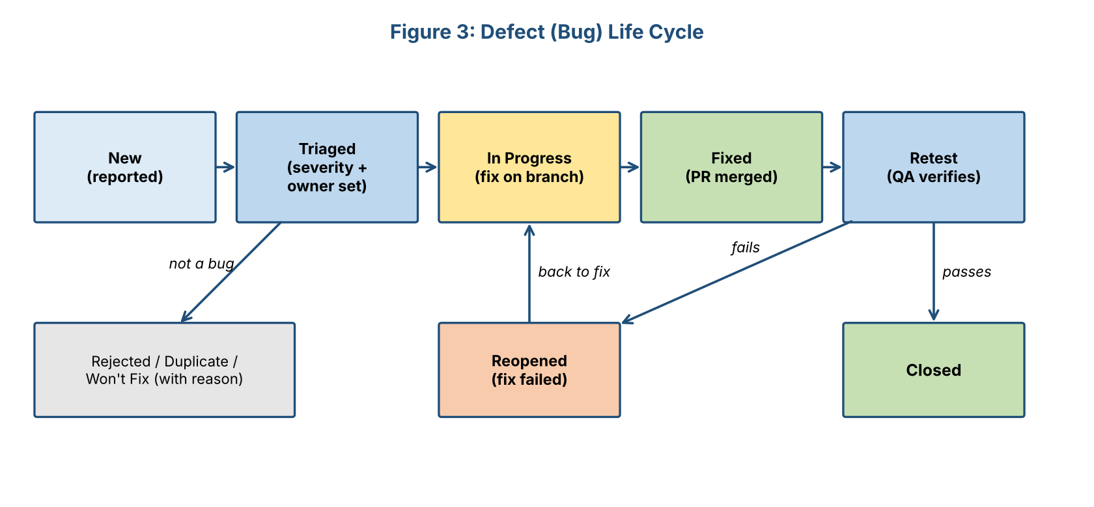
Figure 3: Defect life cycle
Each defect report must contain:
Title: Short, specific summary (e.g., 'Reminder email sent twice for same task')
Environment: Staging / Chrome 126 / build #214
Steps: 1... 2... 3... (reproducible)
Expected: Exactly one email is sent
Actual: Two emails received 1 minute apart
Evidence: Screenshot, log excerpt, request ID
Severity: Critical / High / Medium / Low Priority: P1-P4
Linked: Requirement FR-03, test case TC-06, pull request #58

9.2 Severity and Priority
Severity | Definition | Example | Target Fix Time
Critical | System unusable, data loss or security breach; no workaround | Login fails for all users; user can read another user's tasks | Same day
High | Major feature broken; workaround difficult | Reminders not sent; groups cannot be joined | Within 2 days
Medium | Feature partly affected; workaround exists | Calendar view shows wrong colour for priority | Within the sprint
Low | Cosmetic or minor inconvenience | Typo, small alignment issue | Backlog / next sprint

9.3 Triage and Feedback Loops
Feedback Loop | How It Works
Developer feedback (minutes) | Local tests and pre-commit checks tell the developer immediately if a change breaks something.
CI feedback (under 10 minutes) | Pull request shows failing tests and coverage; merging is blocked until fixed.
Daily triage (15 minutes) | QA and the lead review new defects, set severity and assign owners.
Sprint review and demo | Product owner reviews working software and test results; acceptance criteria are confirmed or changes requested.
Beta / UAT feedback | Pilot users' comments are classified (defect, usability issue, new idea) and added to the backlog.
Production monitoring | Error logs, uptime alerts and user-reported issues feed back into new tests.

9.4 Continuous Improvement
- Sprint retrospective: the team reviews escaped defects (bugs found by users), flaky tests and slow pipelines, and agrees on improvement actions.
- Root cause analysis for every critical or high defect: ask 'why' repeatedly, then fix the process (missing test, unclear requirement, review gap) as well as the bug.
- Every fixed defect gets a regression test so it cannot return.
- Flaky tests are quarantined and fixed within one sprint; the suite must be trusted.
- Metrics (Section 10) are reviewed each sprint; thresholds are tightened as the team matures.
- Test cases are reviewed and updated whenever requirements change; obsolete tests are removed.
- Lessons learned are recorded in the project wiki for future projects.

9.5 Quality Gates
Gate | Condition to Pass | Enforced By
Commit | Lint passes, Prettier format applied, unit tests for changed files pass | Husky pre-commit
Pull request | All CI checks green, coverage not reduced, at least one reviewer approval, checklist complete | GitHub branch protection
Release candidate | System test exit criteria met, no open critical/high defects, security scan clean | QA sign-off
Go-live | UAT sign-off by product owner, backups and rollback plan verified | Release meeting

10. Metrics and Release Criteria
Metric | Target | Purpose
Code coverage (core modules) | At least 70% line, 60% branch | Shows how much code is exercised by tests
Test pass rate (release candidate) | At least 95% overall; 100% of critical-path tests | Overall stability
Requirements coverage | 100% of Must-have requirements have at least one test | Completeness
Open defects at release | 0 critical, 0 high; medium with documented plan | Release readiness
Defect detection percentage | Over 90% of defects found before release | Effectiveness of testing
Defect density | Fewer than 1 defect per 1,000 lines of new code in system testing | Code quality trend
Mean time to fix | Critical: 1 day; High: 2 days | Responsiveness
Flaky test rate | Under 2% of runs | Trust in automation
Performance | p95 API under 500 ms; page load under 3 s | NFR-01
UAT usability score | SUS of 70 or higher | User satisfaction

10.1 Entry, Exit and Suspension Criteria
- Suspend testing if the build is unstable (smoke test fails), the environment is unavailable, or a blocking defect prevents more than 30% of planned tests from running. Testing resumes after the fix is deployed and the smoke test passes.
- Release approval requires all exit criteria of the four phases to be met or formally accepted as risks by the product owner.

11. Test Schedule
The schedule aligns with the 12-week roadmap from Week 3. Testing is continuous; formal system testing and UAT take place after integration.
Sprint | Weeks | Testing Activities | Output
1 | 1-2 | Test strategy, review of requirements for testability, tool selection | Test plan
2 | 3-4 | Design test cases from user stories; set up CI test jobs and Docker test environment; prepare test data | Test cases, CI skeleton
3 | 5-6 | Unit tests with every feature (TDD for services); first API integration tests for Auth and Task | Coverage report
4 | 7-8 | Integration tests for Groups, Analytics, Notification; Cypress tests for main flows; security checks started | Regression suite
5 | 9-10 | System testing, performance and security tests, accessibility and cross-browser tests; UAT (alpha then beta); defect fixing and retest | Test summary report, UAT sign-off
6 | 11-12 | Production smoke tests, post-deployment monitoring, test closure and lessons learned | Closure report

12. Risks to Testing
# | Risk | Impact | Mitigation
1 | Insufficient time for system testing because of development delays | High | Automate early; protect Sprint 5 for testing; prioritize by risk; cut 'Could-have' features before cutting tests.
2 | Flaky end-to-end tests reduce trust | Medium | Stable selectors (data-test attributes), mocked time and email, retries only for known network issues, weekly flaky-test review.
3 | Test environment differs from production | High | Docker Compose and infrastructure-as-code; same versions and configuration; staging mirrors production.
4 | Third-party services unavailable during tests | Medium | Mock or sandbox providers; contract tests; fallbacks tested explicitly.
5 | Not enough pilot users for UAT | Medium | Recruit early through class groups; offer simple scenario sheets; minimum of 10 testers.
6 | Unclear or changing requirements make test cases obsolete | Medium | Traceability matrix, review tests when requirements change, acceptance criteria written with each user story.
7 | Team members lack testing experience | Medium | Pair programming, short training on Jest and Cypress, shared examples in repository.

13. Conclusion
This plan sets out a practical, layered approach to verifying and validating StudySync. Unit tests protect the logic, integration tests protect the connections between modules and services, system tests protect the complete user journeys and non-functional goals, and user acceptance tests confirm that real users can achieve their goals. TDD and BDD, an automated CI pipeline and a risk-based focus make the effort efficient, while a clear defect life cycle, feedback loops, quality gates and measurable release criteria turn testing into a continuous improvement process. Following this plan gives the team objective evidence that the software meets its requirements and is ready for release.

14. References
- ISTQB, Certified Tester Foundation Level Syllabus and Glossary.
- ISO/IEC/IEEE 29119, Software and systems engineering - Software testing.
- IEEE Std 829-2008, Standard for Software and System Test Documentation.
- Beck, K., Test-Driven Development: By Example, Addison-Wesley.
- Wynne, M. & Hellesoy, A., The Cucumber Book (BDD).
- Cohn, M., Succeeding with Agile (test pyramid).
- OWASP Foundation, OWASP Top 10 and Web Security Testing Guide.
- Documentation for Jest, Supertest, Cypress, Selenium, k6 and axe-core.

