SESSION 1 — ACTIVITY (20 MIN) • STUDENT HANDOUT (Set 39 of 40 — every set uses different data) Decode the Chart

Name: Vemula Jaswanth Roll No: 192424231
For each chart below, answer: What is it trying to tell you? Do you trust it? Why or why not?
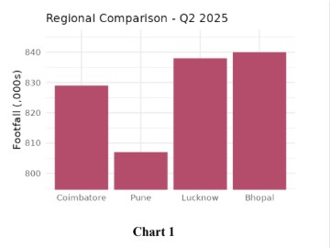
Chart 1 – Regional Comparison, Q2 2025 (bar chart)
WHAT IS IT TRYING TO TELL ME?
Footfall (in thousands) in four cities. Bhopal (~840) and Lucknow (~838) are highest, Coimbatore is ~829, and Pune is lowest at ~807. At first glance Pune looks like it has only a fraction of Bhopal's footfall.
DO I TRUST IT? WHY / WHY NOT?
Only partly. The numbers themselves may be fine, but the picture is misleading. The y-axis is truncated: it starts at about 800 instead of 0, so a gap of ~33 thousand (about 4%) looks like Pune is 1/6th the size of Bhopal. The real differences between the cities are small.
HOW TO IMPROVE
Fix: start the axis at 0 (or label the break clearly) and show the actual values on the bars.
Verdict: PARTLY – data may be OK, but the visual exaggerates the differences.
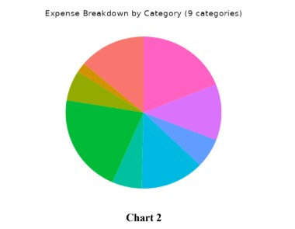
Chart 2 – Expense Breakdown by Category (pie chart)
WHAT IS IT TRYING TO TELL ME?
How total expenses are split across 9 categories. The green slice is the
biggest (~20%), pink is next (~19%), and purple, cyan and salmon are
about 12–13% each. The remaining slices are small.
DO I TRUST IT? WHY / WHY NOT?
No. There are no labels, no legend and no percentages, so I cannot tell
which colour is which expense. Nine slices is too many for a pie, several
colours look alike, and similar-sized slices are hard to rank by eye. The
chart cannot actually be used to make a decision.
HOW TO IMPROVE
Fix: use a sorted horizontal bar chart (largest to smallest) with category
names and % values, or group the small ones into 'Other'.
Verdict: NO – unreadable and incomplete, so it cannot be trusted or
acted on.
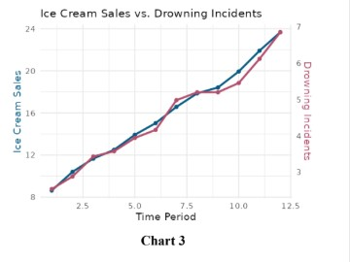
The correlation is real, but the causation is not. Ice cream does not cause drowning. A hidden third variable (a confounder), hot weather or summer season, pushes both up: people buy more ice cream AND swim more when it is hot. The two separate y-axes are also scaled so the lines sit right on top of each other, which makes the link look stronger than it would otherwise.
Chart 3 – Ice Cream Sales vs. Drowning Incidents (dual-axis
line chart)
WHAT IS IT TRYING TO TELL ME?
Over time periods 1 to 12, both ice cream sales (about 8 to 24) and
drowning incidents (about 3 to 7) rise together, almost perfectly in step. It
looks like more ice cream means more drownings.
DO I TRUST IT? WHY / WHY NOT?
HOW TO IMPROVE
Remember: correlation does not imply causation. A better chart would include temperature or season, and the two metrics would not be forced onto matching scales.
Verdict: NO (for the causal claim) – the pattern is real but the conclusion is false.
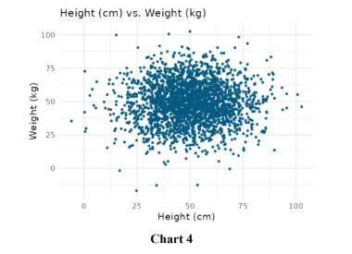
Chart 4 – Height (cm) vs. Weight (kg) (scatter plot)
WHAT IS IT TRYING TO TELL ME?
Each dot is one person. The cloud is a round blob centred at roughly 50 cm height and 50 kg weight, with no upward slope. In other words, height and weight appear to be unrelated.
DO I TRUST IT? WHY / WHY NOT?
No. In real life taller people tend to weigh more, so a clear upward trend is expected, but none is visible. The data also has impossible values: heights near 0 cm and below 0, and negative weights. Typical adult heights are around 150–190 cm, not 50 cm. This points to bad, simulated or wrongly-scaled data (or a unit mix-up). Thousands of overlapping points also hide the density.
HOW TO IMPROVE
Fix: check and clean the data source and units, remove impossible values, and use transparency to reduce overplotting.
Verdict: NO – the data looks unrealistic or corrupted, so no conclusion should be drawn.

Your notes:
- Always check the axis – a truncated y-axis (Chart 1) can make small gaps look huge.
- A chart needs labels, a legend and units to be readable (Chart 2); too many slices make a pie useless.
- Correlation is not causation (Chart 3) – look for a hidden third factor such as temperature.
- If the data looks impossible (Chart 4: negative weights, 0 cm heights), question the data before the chart.

