PL/SQL

- Write a program that prompts for EMPNO, ENAME, SAL. If EMPNO does not exist in EMP table, INSERT the EMPNO, ENAME, SAL into the EMP table; otherwise UPDATE ENAME and SAL for that EMPNO.

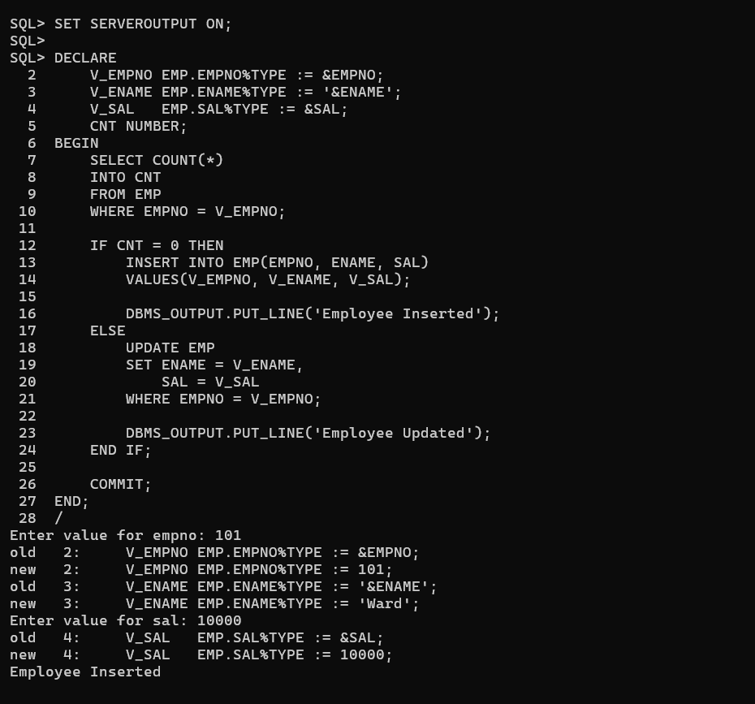

- Write a program that prompts for a number and displays whether the number is ODD or EVEN.

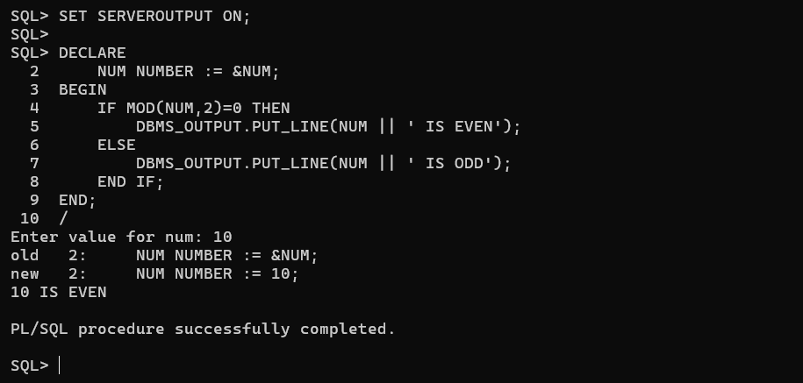

- Write program that prompts for EMPNO and update his salary based on the below specification:
If the employee belongs to DEPTNO 10 then update his salary by 10%.
If the employee belongs to DEPTNO 20 then update his salary by 15%.
If the employee belongs to other DEPTNO then update his salary with SALARY+COMM.
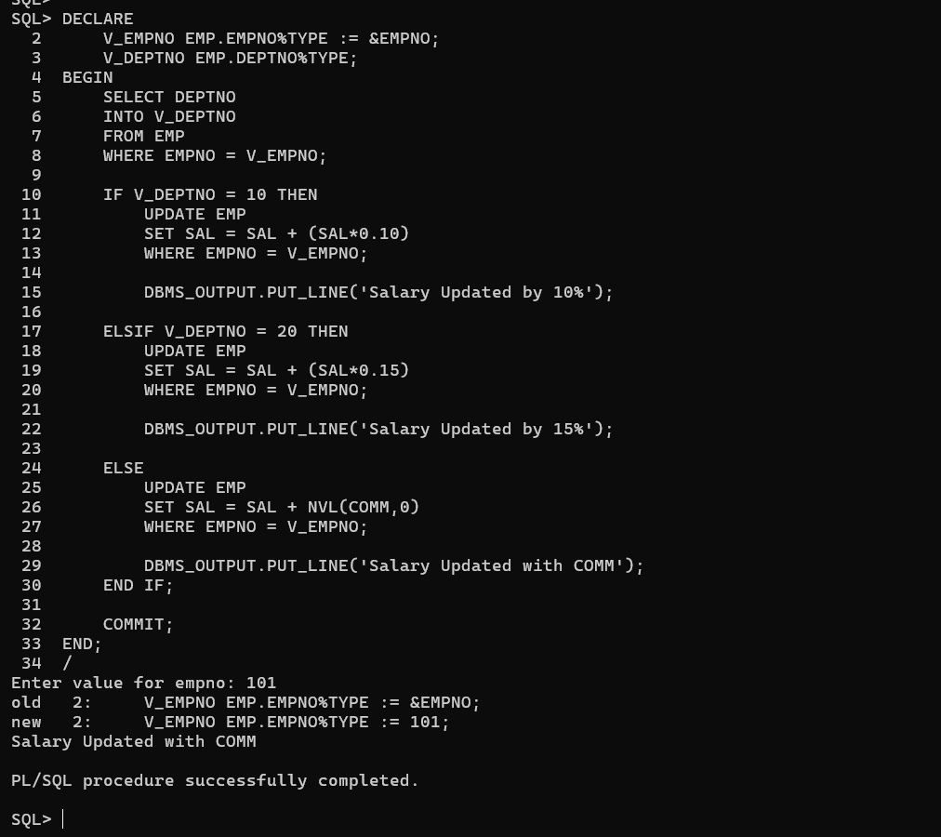

- In SQL Prompt create a table MYTABLE1 with RESULT as a NUMBER datatype. Write a program that inserts values from 1 to 10 into MYTABLE1. Do not insert 6 and 8.

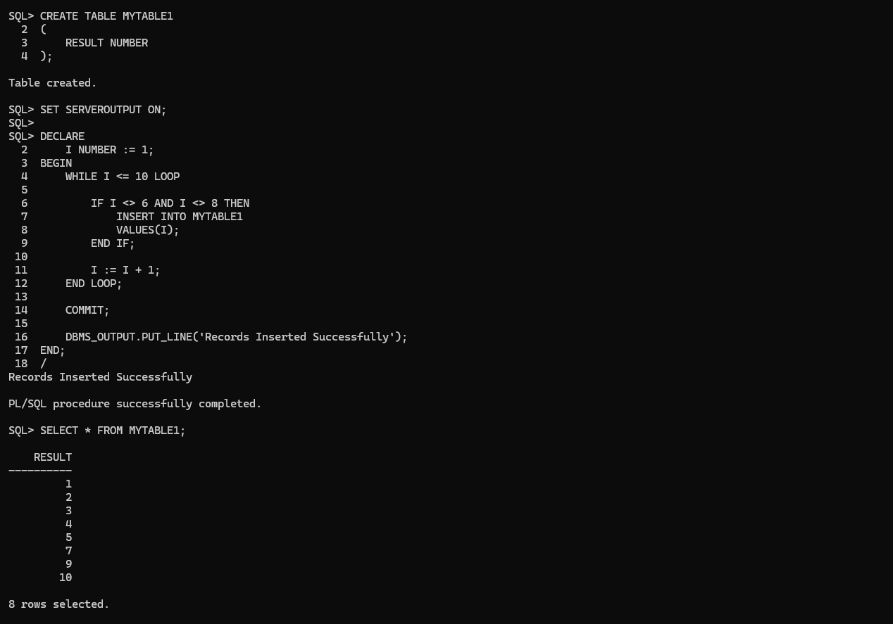

- Write a PL/SQL program that displays the Net Salary (SAL + COMM) of an employee entered at run time from the EMP table. (Use the NVL function.)

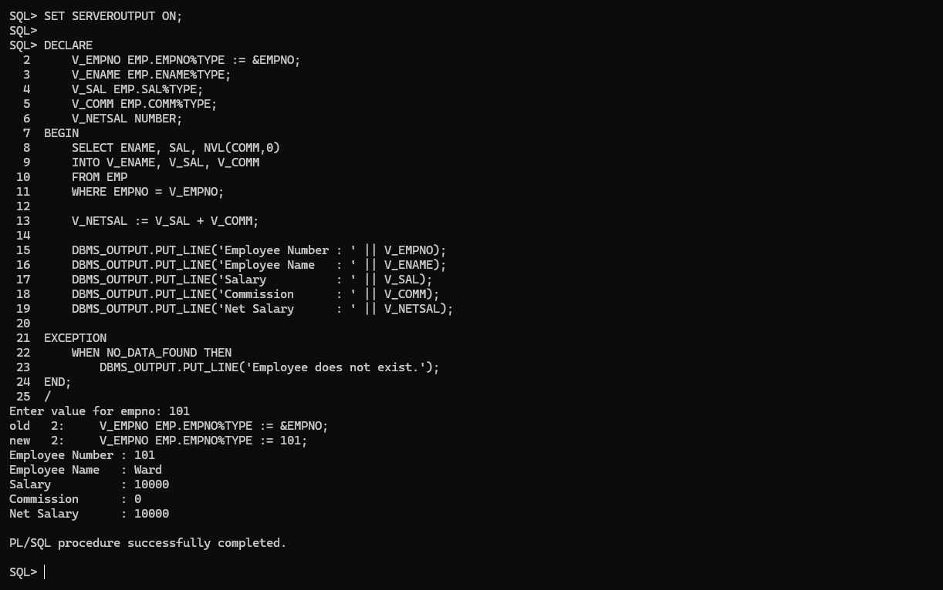

- Write a PL/SQL program that displays the entire row of an employee by passing the EMPNO at runtime. (Use %ROWTYPE)
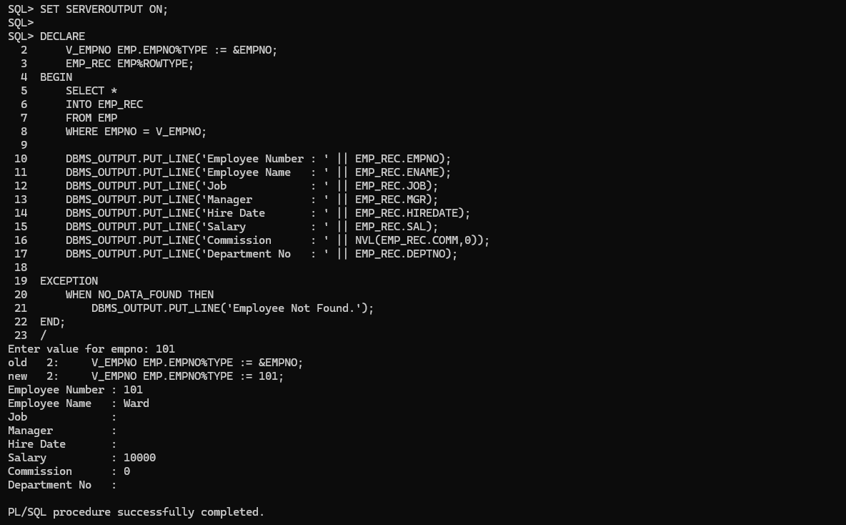

- Write an implicit cursor program that prompts for a JOB and deletes the employees working in that job. Store the number of records deleted in a session variable.
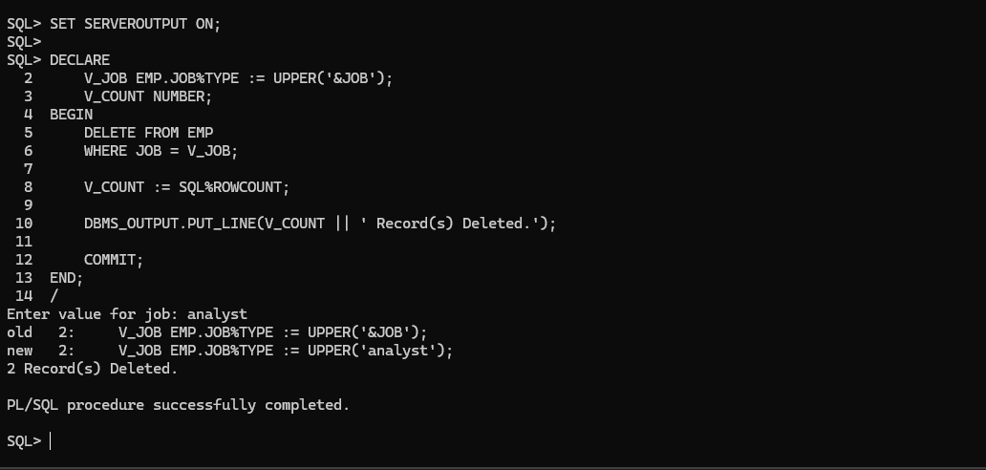

- Rollback the previous DELETE statement.
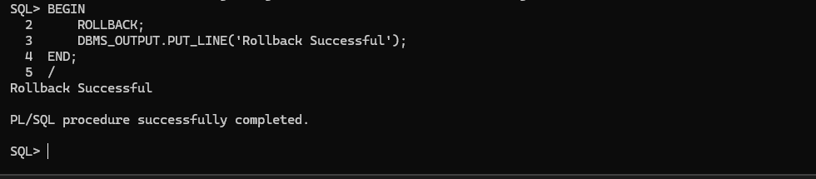

- Write a program that displays the Top N salaries using a Simple Explicit Cursor.

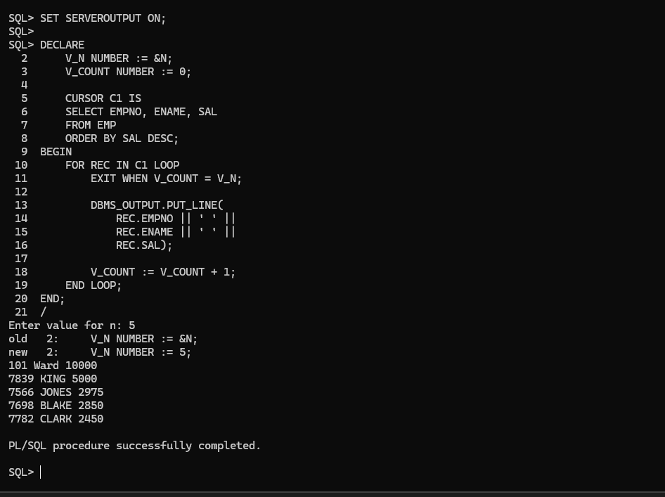

- Create a Simple Explicit Cursor that displays all the employees who are earning more than the average salary of the EMP table.

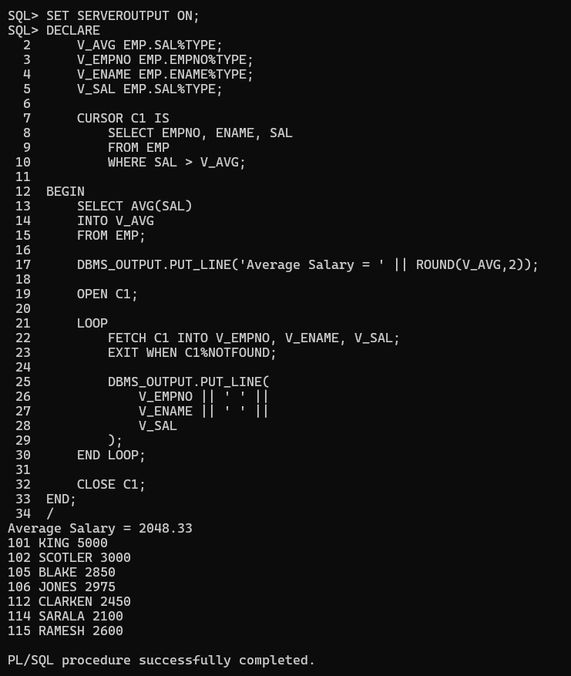

11.Create a Simple Explicit cursor that displays the employees who earn more than 2000 and have joined the company after 15-Jun-1981. Print the output : <> earns <> and joined the organization on <>.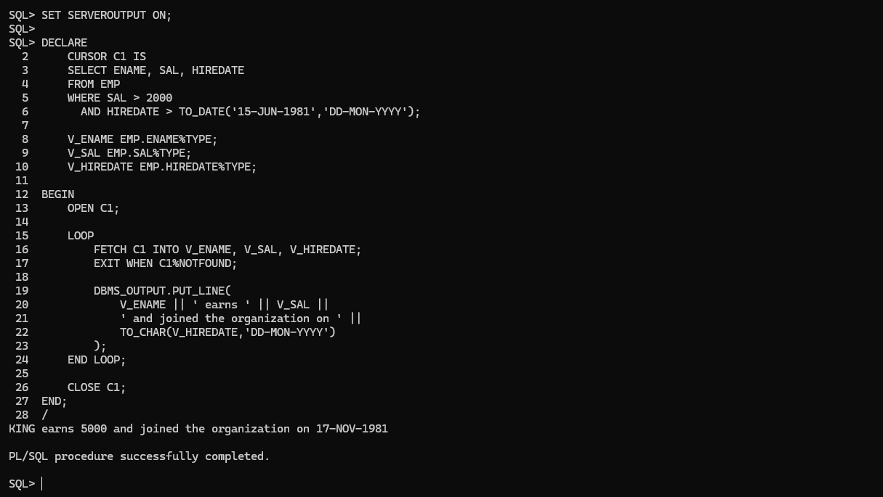

- Create a Simple Explicit Cursor that displays the Hire Date in the format DD-MM-RRRR and Day. Sort the records on Day, starting from Saturday.
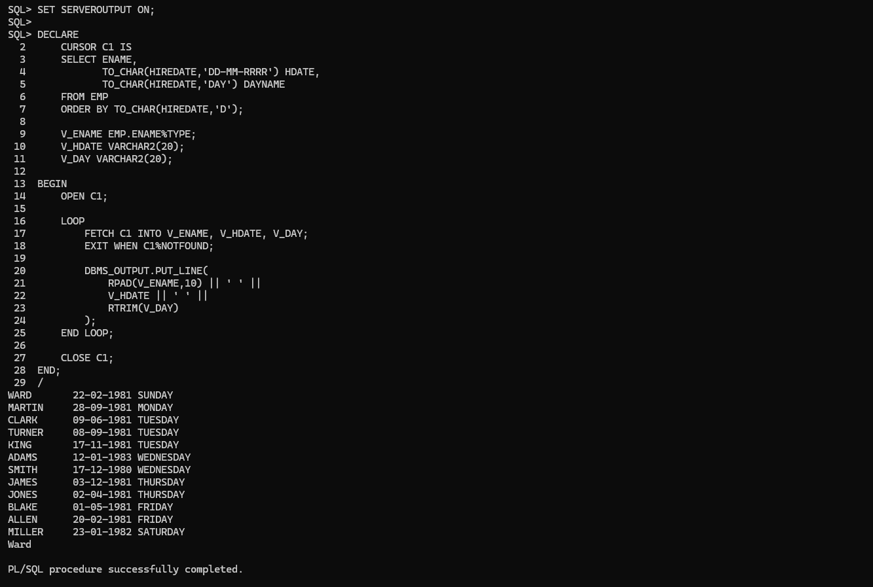

- Create a Simple Explicit Cursor that displays the employee names and commission amounts. If an employee does not earn commission, display "No Commission". Label the commission column as COMM.
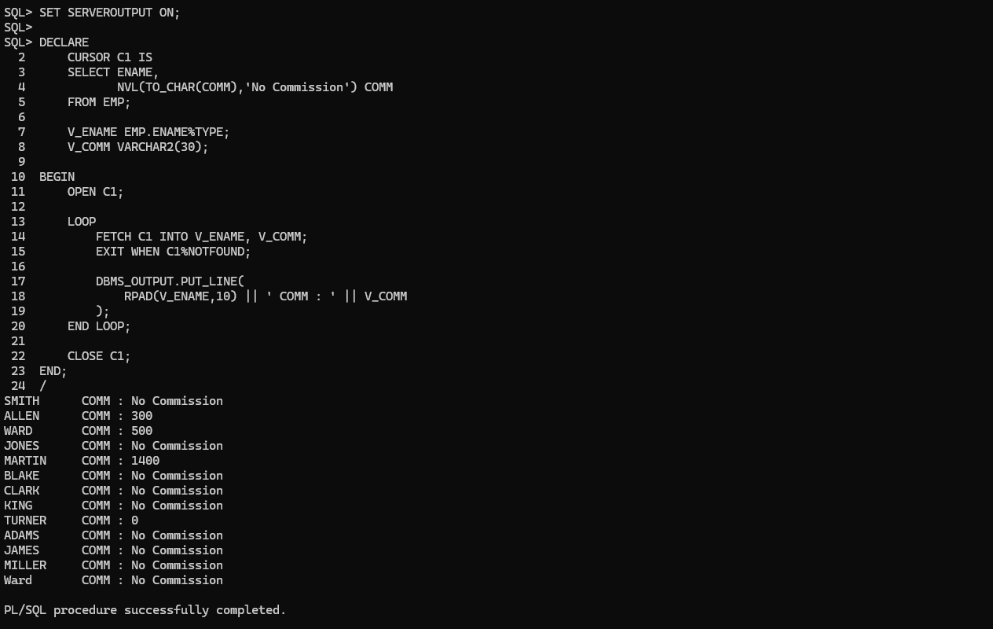

- Create a parameter cursor that takes DEPTNO as a parameter and update the star column with ‘’. Every ‘’ represent a 1000. For example : If the employees salary is 5000 then update star column with ‘***’. Use Parameter Cursor ,CURSOR WITH FOR LOOP and WHERE CURRENT OF OPTION.
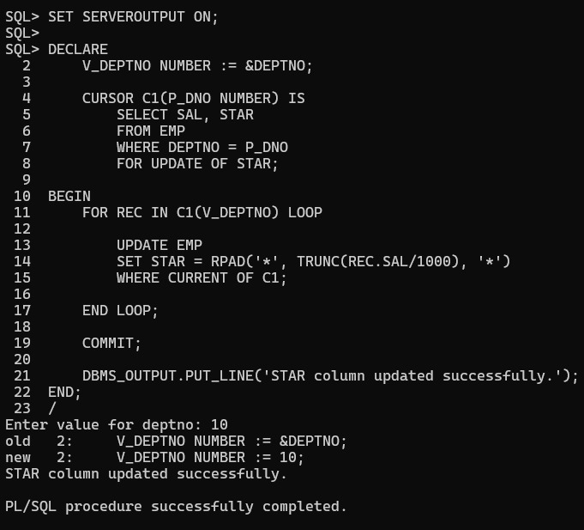

- Write a Parameter Cursor program that promotes CLERK who earn more than 1000 to SR CLERK and increase the salary by 10%. Pass CLERK as a parameter to the Cursor. Use Parameter Cursor, CURSOR WITH FOR LOOP and CURSOR WITH UPDATE CLAUSE.

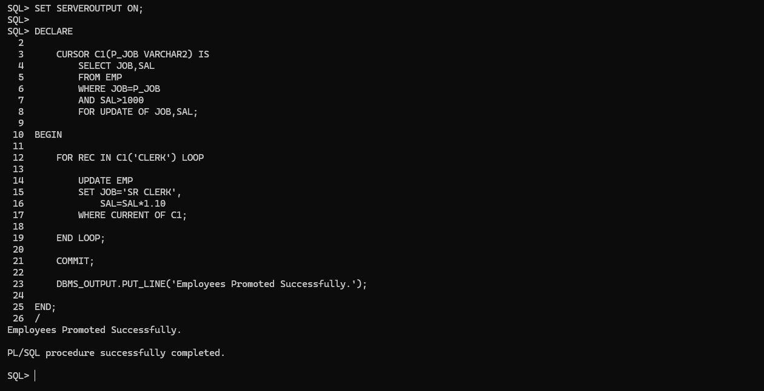

- Display entire record from the Dept table by passing a DEPTNO. Increase the Salary of employees working in deptno 10 by 15%, Deptno 20 by 15% and others by 5% Also display the corresponding employees working in that Dept. Use a parameter Cursor , For Loop Cursor and Cursor with Update clause.
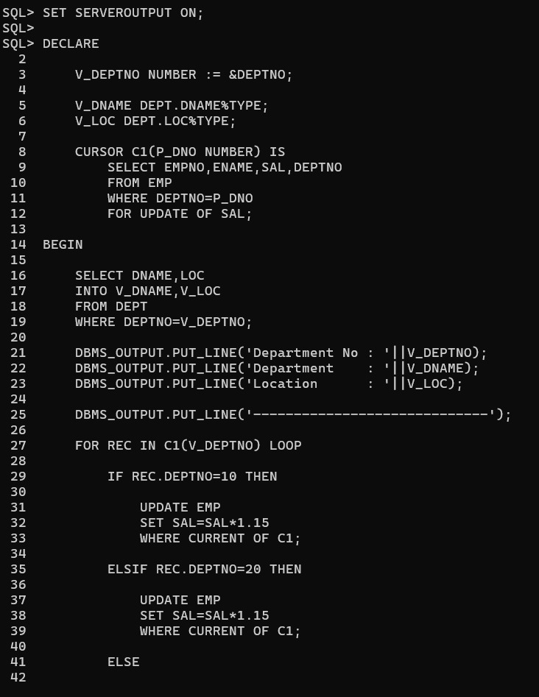

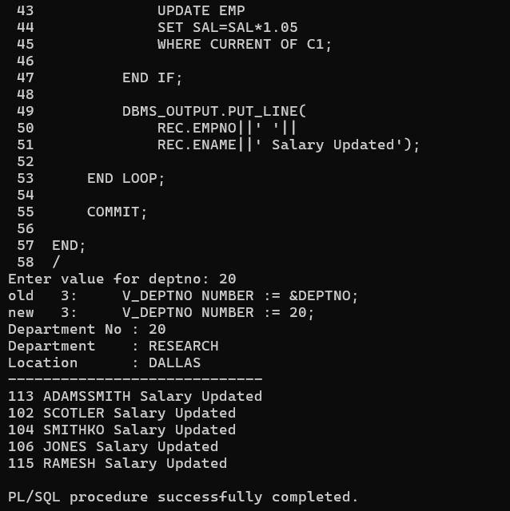

16.Write a program that will prompt the user for a CHOICE. IF CHOICE is 1 then display all the employees who earn more than 2000 from EMP table else display all the Employees who earn less than 2000. Use REF CURSORS.
