Sub Queries

1.Create a report that displays EMPNO, ENAME, DEPTNO of employees who work with that employee. (Nested Sub Query)
Query:
SELECT employee_id, first_name, department_id
FROM employees
WHERE job_id=(SELECT job_id FROM employees WHERE first_name='Steven');
Output:
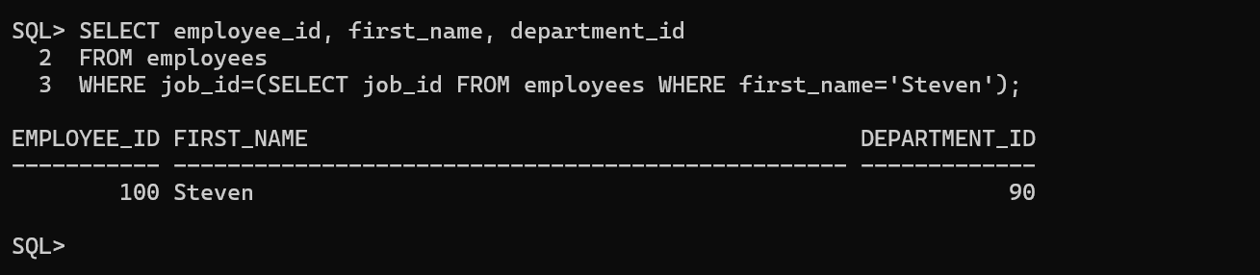

2.Display the employees who earn more than the average salary of EMP table. (Nested Sub Query)
Query:
SELECT employee_id,first_name,salary
FROM employees
WHERE salary>ALL(SELECT AVG(salary) FROM employees GROUP BY department_id);
Output:
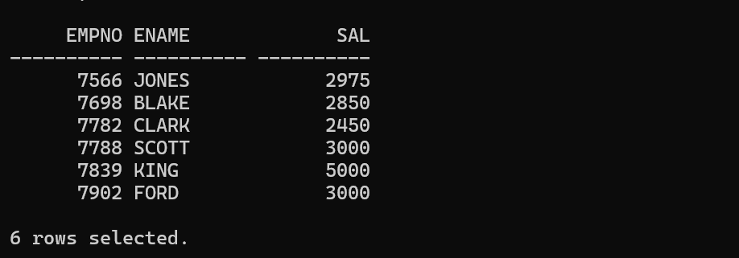

3.Display the ENAME, JOB who are Managers. (EXISTS Operator)
Query:
SELECT employee_id,first_name,job_id
FROM employees
WHERE employee_id IN (SELECT manager_id FROM departments);
Output:
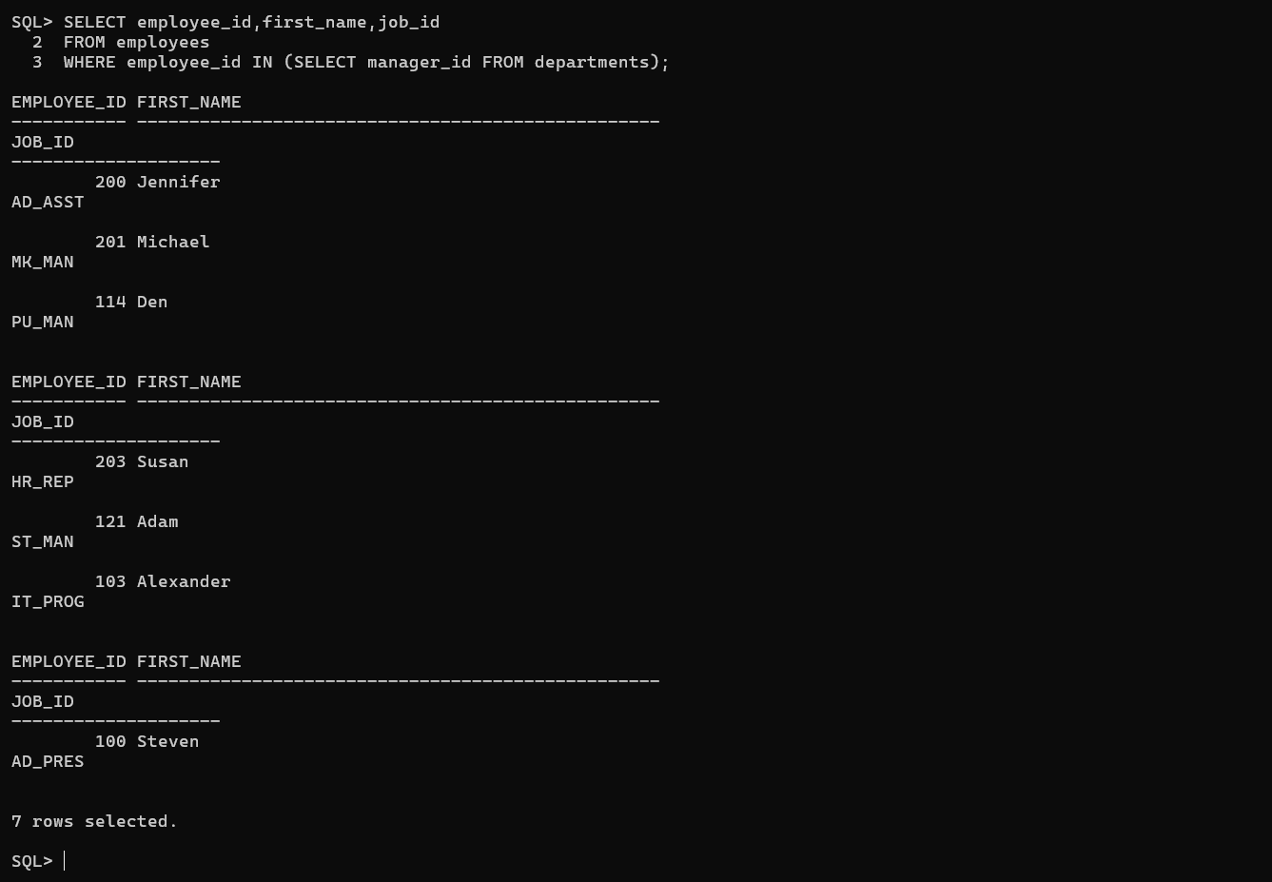

4.Display the employees who earn less than the least salary of DEPTNO 10. (ALL Operator)
Query:
SELECT first_name,last_name,salary,department_id
FROM employees
WHERE salary=(SELECT MIN(salary) FROM employees WHERE department_id=10);

Output:
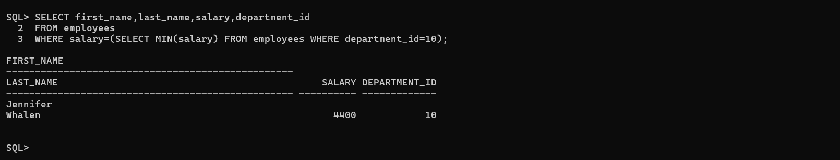

5. Display the employees who have the same DEPTNO and MGR of a given employee, excluding that employee. (Nested Sub Query)
Query:
SELECT empno, ename, deptno, mgr
FROM emp
WHERE (deptno, mgr) =(SELECT deptno, mgr
FROM emp
WHERE ename=’Ward'
)AND ename<>'Ward';
Output:
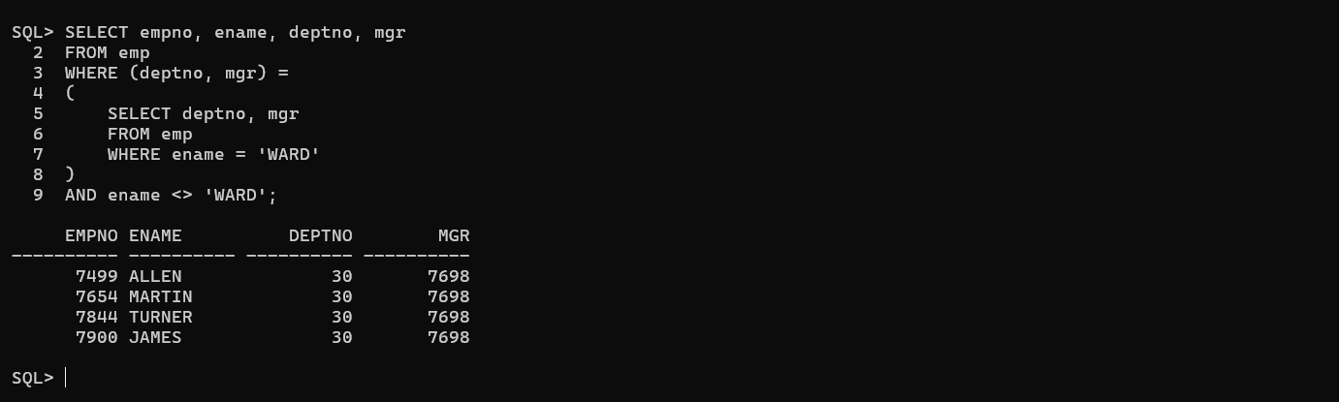

6.Display the employee number and name of all employees who work in a department with any employee whose name contains 'R'. (Nested Sub Query)
Query:
SELECT employee_id,first_name||' '||last_name AS name
FROM employees
WHERE department_id IN (SELECT department_id FROM employees WHERE LOWER(first_name||last_name) LIKE '%r%');
Output:
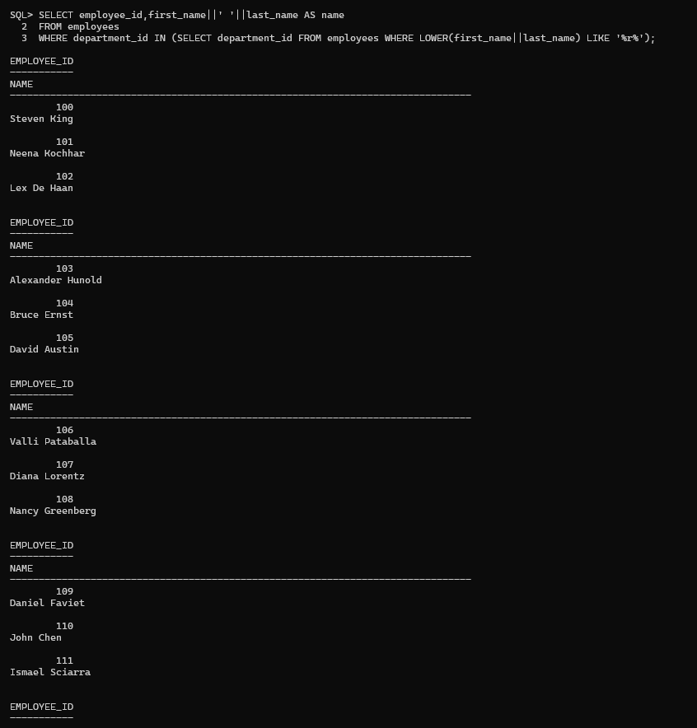
7. Display the ENAME, DEPTNO, JOB of all employees who work in NEW YORK. (Nested Sub Query)
Query:
SELECT employee_id,first_name,department_id
FROM employees
WHERE department_id IN (SELECT department_id FROM departments WHERE location_id=(SELECT location_id FROM locations WHERE city='South San Francisco'));

Output:
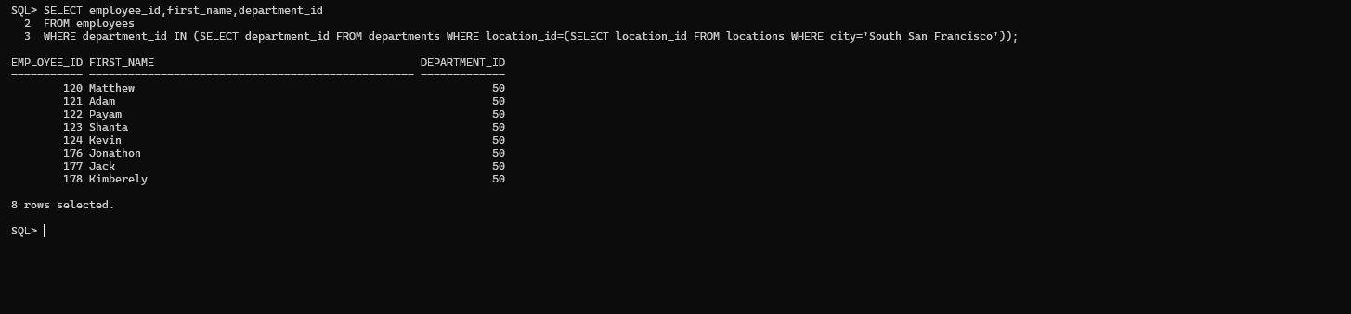

8. Modify the query so that the user is prompted for a LOC.
Query:
SELECT ENAME, DEPTNO, JOB FROM EMP WHERE DEPTNO=( SELECT DEPTNO FROM DEPT WHERE LOC='&LOC' );
Output:
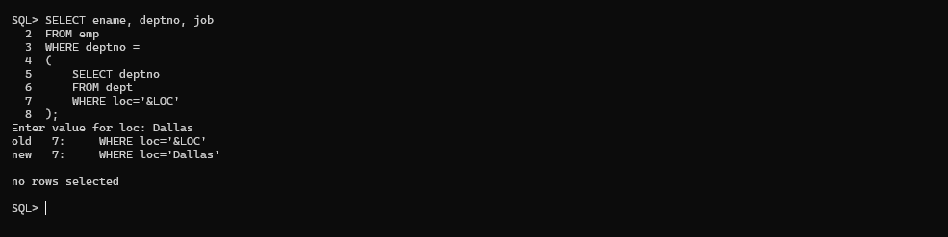
9. Display the name and salary of every employee who reports to KING.
Query:
SELECT first_name,salary
FROM employees
WHERE manager_id=(SELECT employee_id FROM employees WHERE last_name='King');
Output:
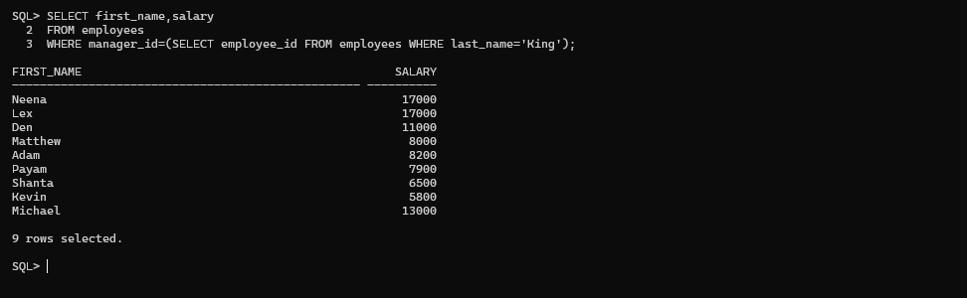
10. Display all the employees working with JAMES.
Query:
SELECT * FROM employees
WHERE department_id=(SELECT department_id FROM employees WHERE first_name='James');
Output:
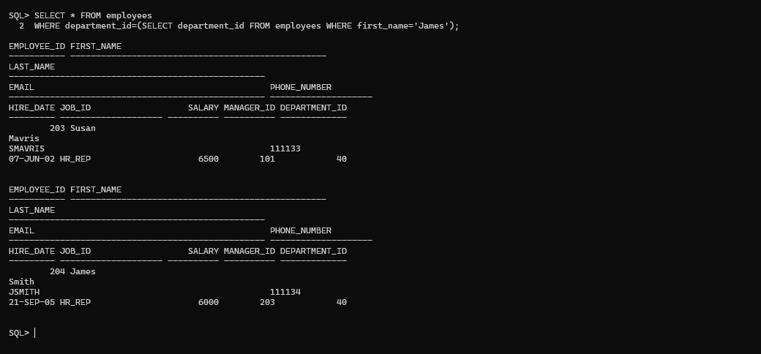

11. Display all the employees who earn less than the average salary of their respective departments. (Correlated Sub Query)
Query:
SELECT first_name,salary,department_id
FROM employees e
WHERE salary<(SELECT AVG(salary) FROM employees WHERE department_id=e.department_id);
Output:
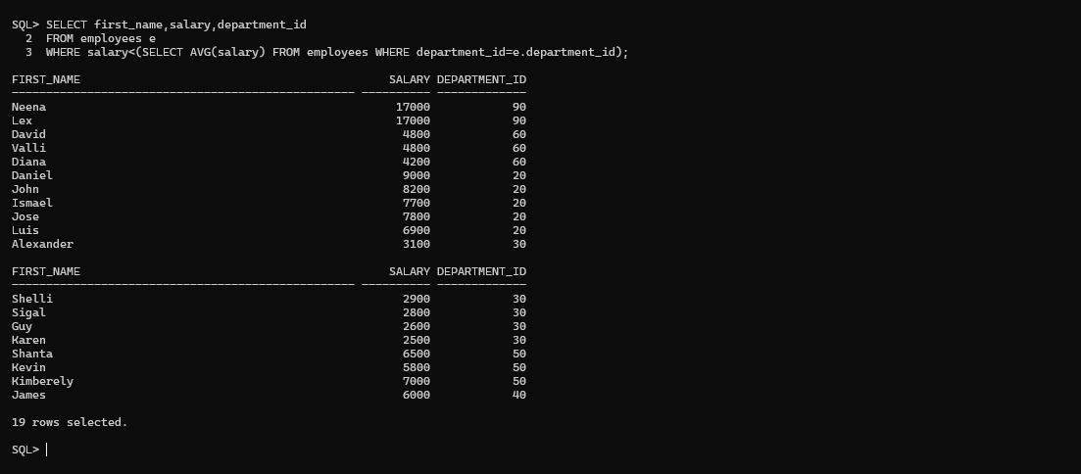

12. Display the LOC and average salary of each location. (Scalar Sub Query)
Query:
SELECT d.loc,(
SELECT AVG(e.sal)
FROM emp e
WHERE e.deptno=d.deptno) AS avg_salary FROM dept d;
Output:
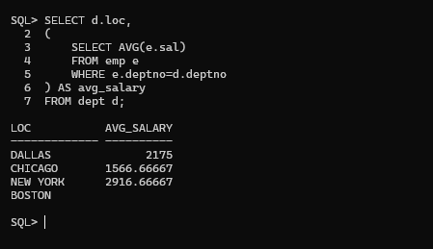

13. Display the least N salaries. (Inline View)
Query:
SELECT * FROM (SELECT employee_id,first_name,salary FROM employees ORDER BY salary) WHERE ROWNUM<=5;
Output:
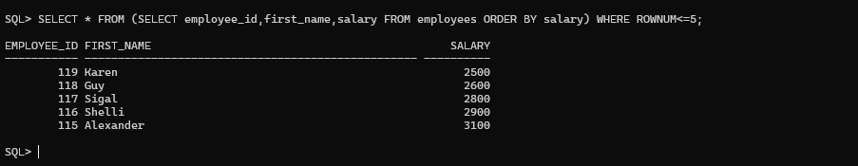

14. Display the last N rows from the EMP table. (Correlated Sub Query)
Query:
SELECT * FROM (SELECT * FROM employees ORDER BY employee_id DESC) WHERE ROWNUM<=5;
Output:


15. Display the employees and sort only employees working in DALLAS. (Scalar Sub Query)
Query:
SELECT * FROM employees WHERE department_id IN (SELECT department_id FROM departments WHERE location_id=(SELECT location_id FROM locations WHERE city='Dallas')) ORDER BY salary;

Output:


- Display the employees who earn a salary less than the average salary of their respective department. Also display the average salary. (Inline View)
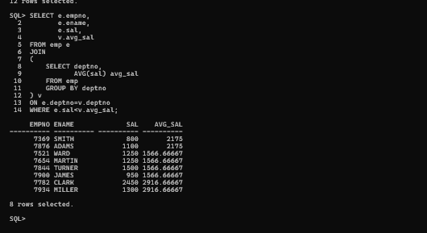
17. Display the LOC of those departments whose total salary is less than the average salary of all employees. (WITH Clause)
Query:
WITH dept_sal AS (
SELECT d.location_id,SUM(e.salary) total_sal FROM departments d JOIN employees e ON d.department_id=e.department_id GROUP BY d.location_id)
SELECT * FROM dept_sal;
Output:
