This is what I understood what to do for this project.

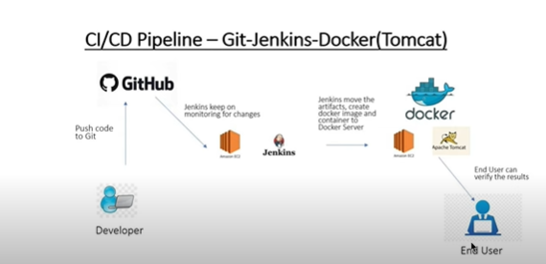

Task1: Push the local source code (given) to githb

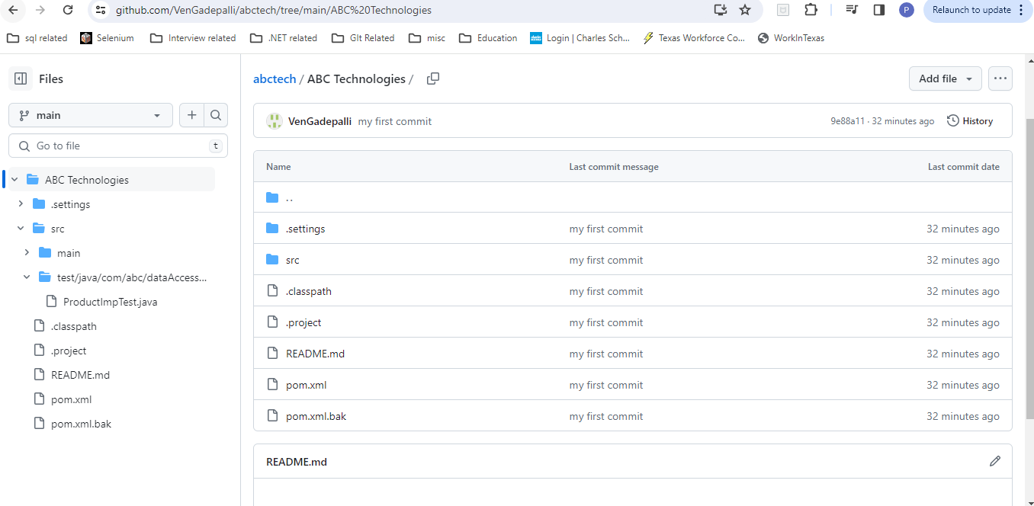

Task2: Install Git, Java, Jenkins on the server

Git

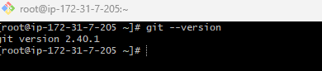

Java

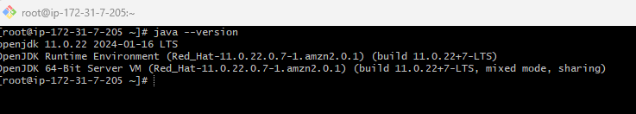

Jenkins: 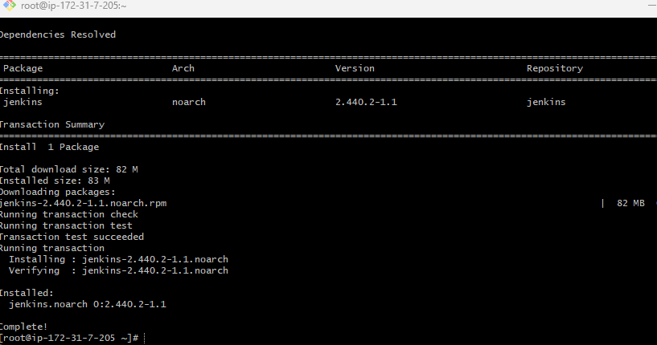

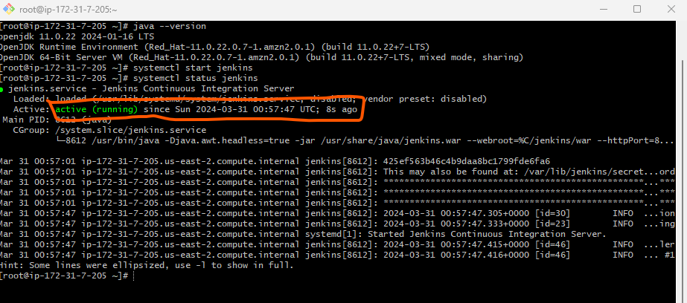

Jenkins dashboard

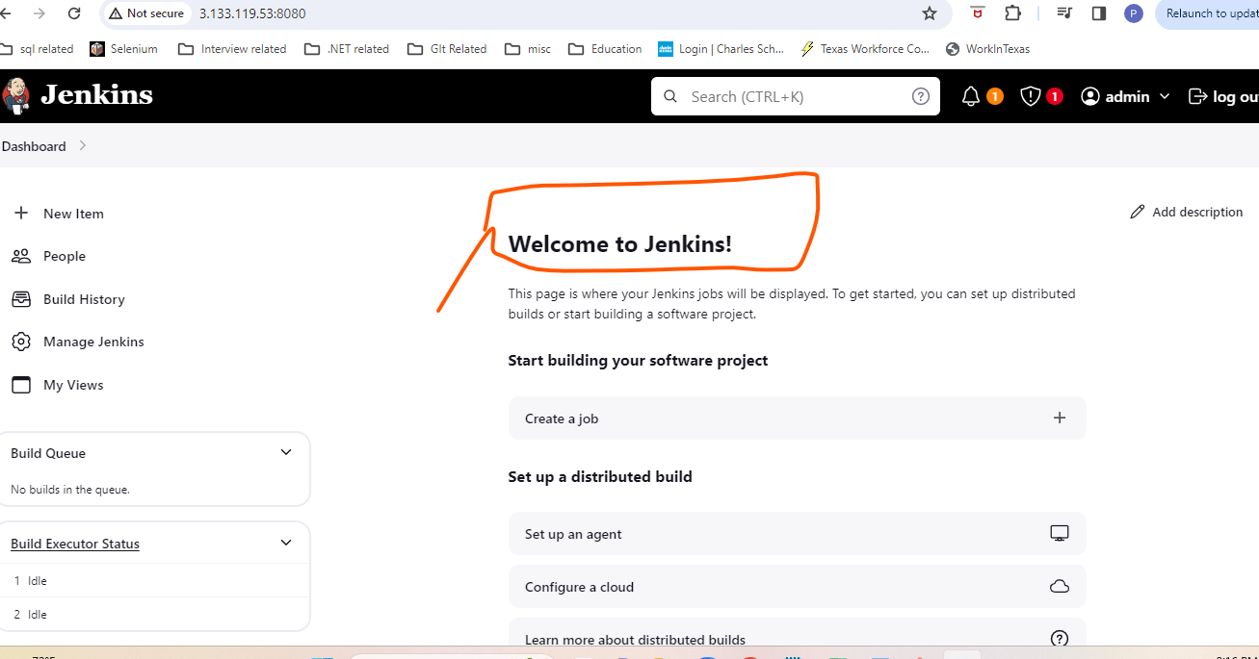

CICD Pipeline

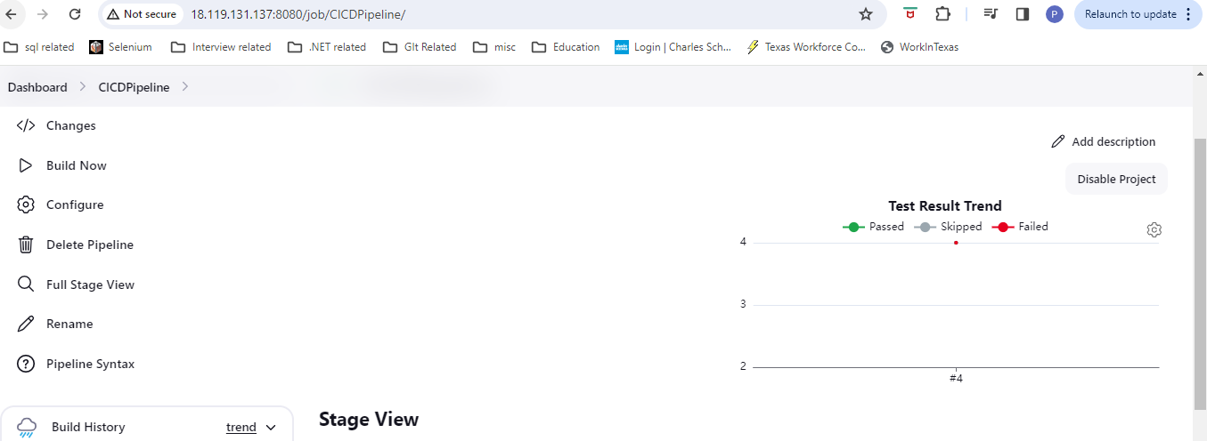

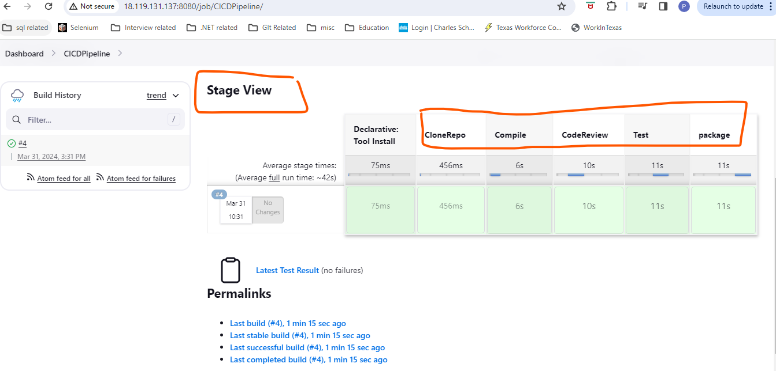

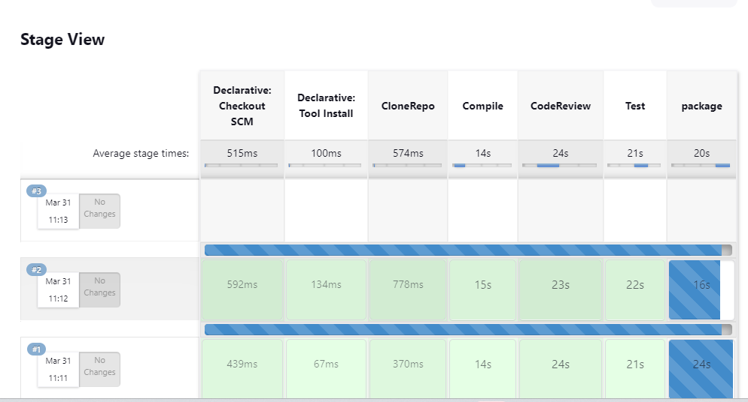

**Master/Slave to distribute work**

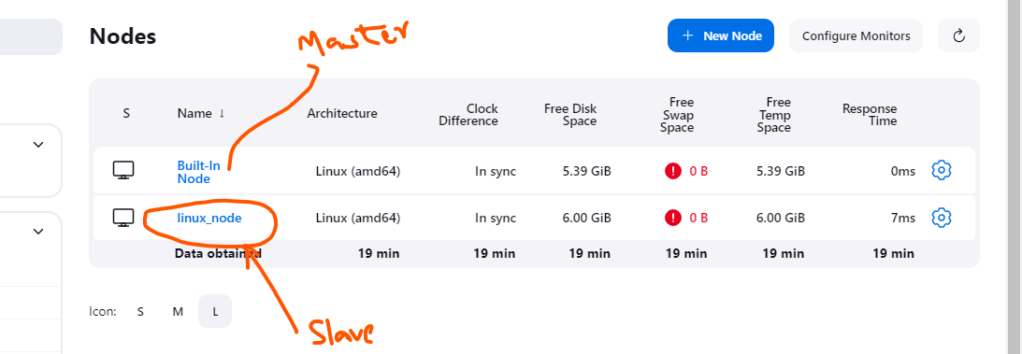

**Tomcat Installation & deploying the application to tomcat**

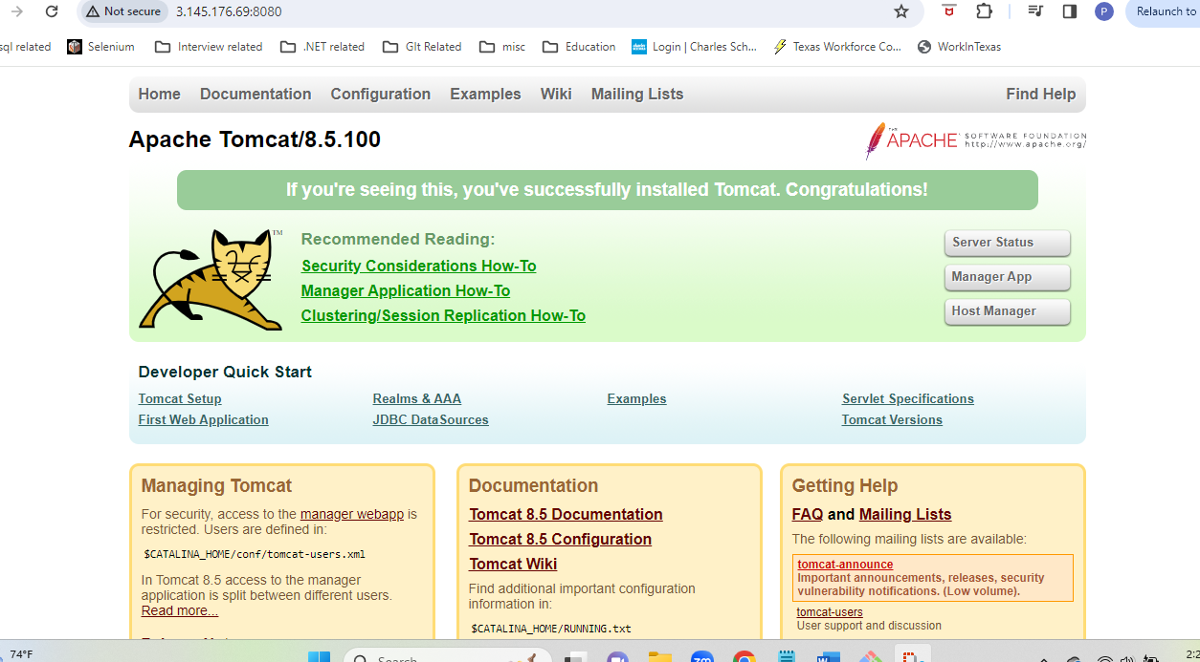

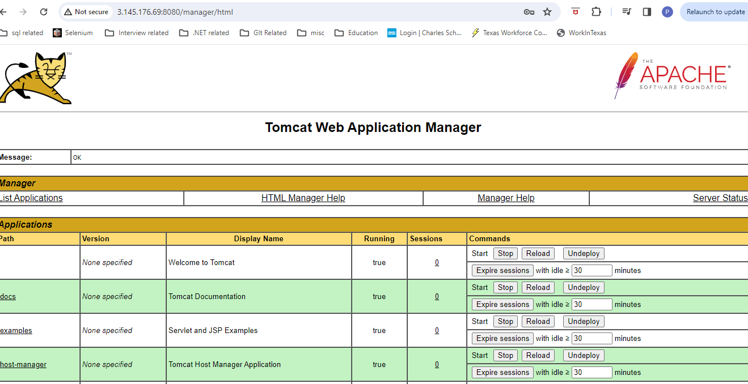

Deployed abctechnologies application to tomcat

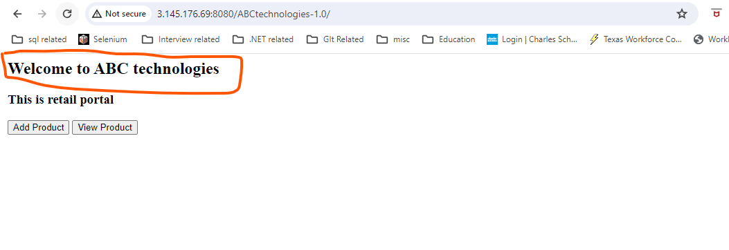

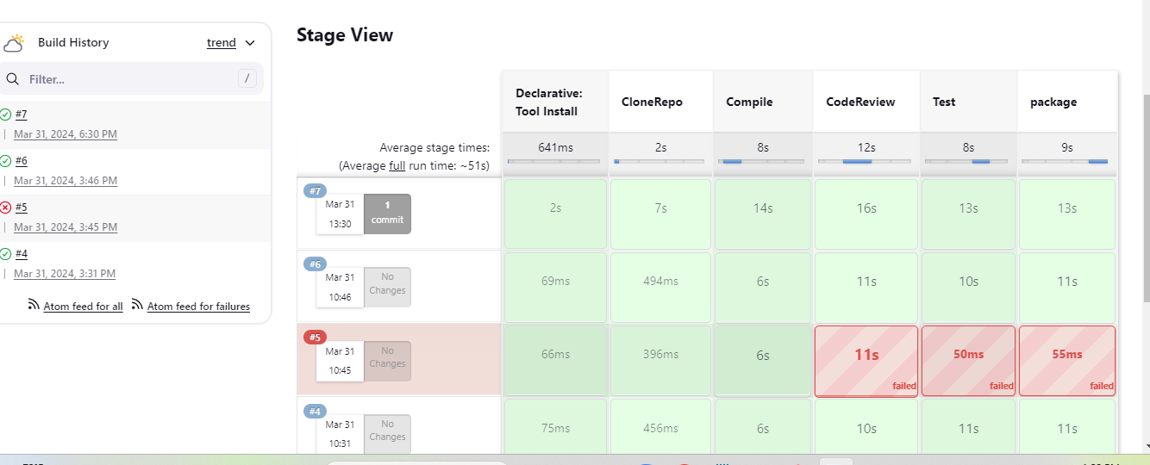

Task3: Write a Docket file Create an Image and container on docker host. Integrate docker host with

Jenkins. Create CI/CD job on Jenkins to build and deploy on a container

1. Enhance the packagejob created in step 1 of task 2 to create a docker image
2. In the docker image add code to move the war file to tomcat server and build the image

Docker image is bulit

Used dockerfile to create the image from docker file

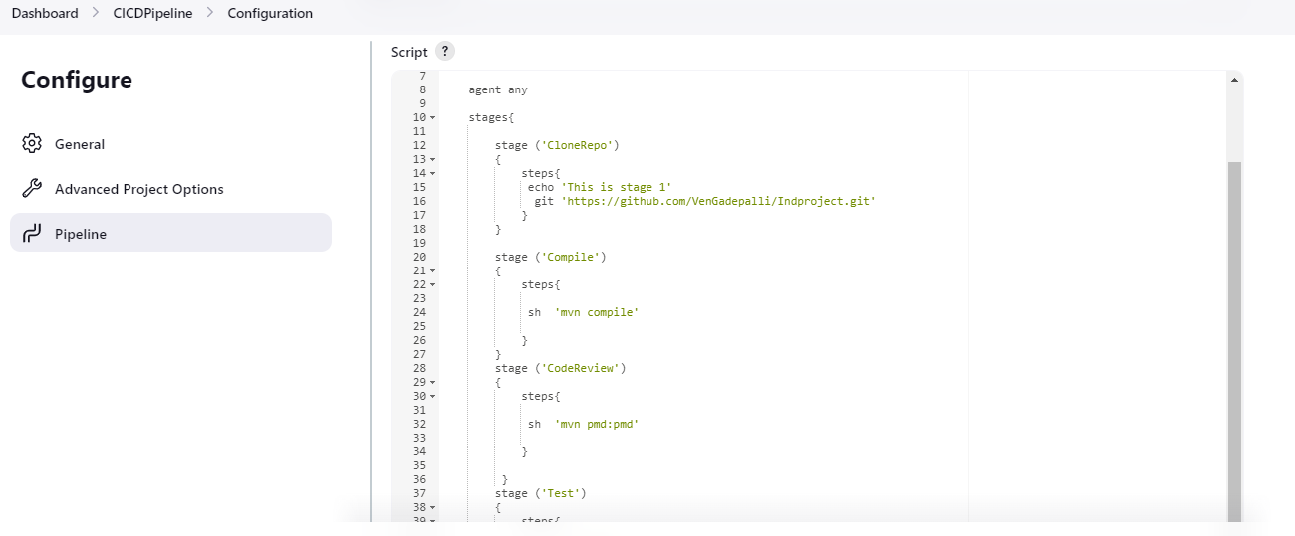

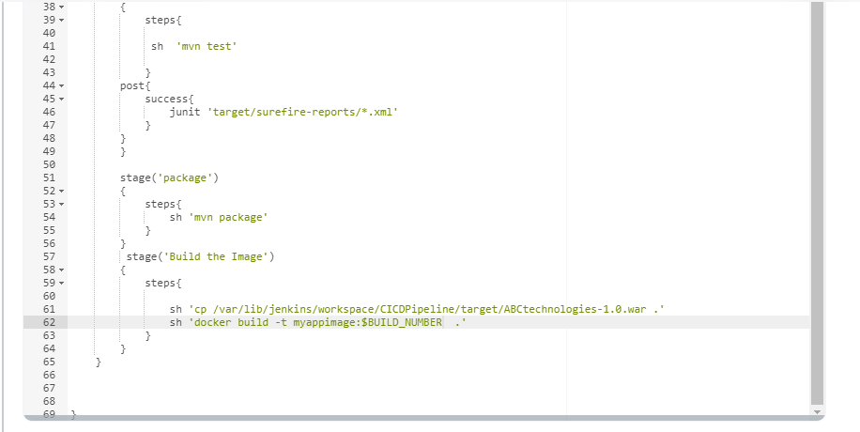

Doker Image

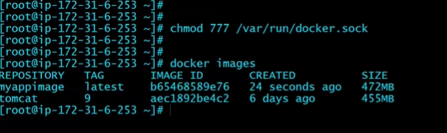

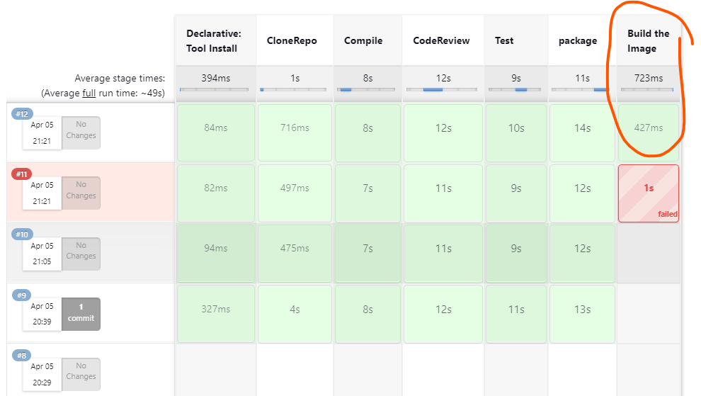

Ansible playbook

