ព្រះរាជាណាចក្រកម្ពុជា

ជាតិ​ សាសនា ព្រះមហាក្សត្រ

Institute of technology of Cambodia



Assignment English: Reflection Writing

My topig: ANGKOR WAT TEMPLE

Professor: PEAN KOSOMAK

Student name: VEN THON

ID: e20191250

Group: I3-A2-I

Year: 2021-2022

Angkor wat temple

Everyone know that Angkor wat temple is famous all around the world. Angkor is one of the most important archaeological sites in South-East Asia. Stretching over some 400 km2, including forested area, Angkor Archaeological Park contains the magnificent remains of the different capitals of the Khmer Empire, from the 9th to the 15th century. They include the famous Temple of Angkor Wat and, at Angkor Thom, the Bayon Temple with its countless sculptural decorations. UNESCO has set up a wide-ranging programme to safeguard this symbolic site and its surroundings.

Angkor, in Cambodia’s northern province of Siem Reap, is one of the most important archaeological sites of Southeast Asia. It extends over approximately 400 square kilometres and consists of scores of temples, hydraulic structures (basins, dykes, reservoirs, canals) as well as communication routes. For several centuries Angkor, was the centre of the Khmer Kingdom. With impressive monuments, several different ancient urban plans and large water reservoirs, the site is a unique concentration of features testifying to an exceptional civilization. Temples such as Angkor Wat, the Bayon, Preah Khan and Ta Prohm, exemplars of Khmer architecture, are closely linked to their geographical context as well as being imbued with symbolic significance. The architecture and layout of the successive capitals bear witness to a high level of social order and ranking within the Khmer Empire. Angkor is therefore a major site exemplifying cultural, religious and symbolic values, as well as containing high architectural, archaeological and artistic significance.

King Suryavarman II built Angkor Wat in the early 12th century, at the height of the Khmer Empire’s power. Scholars disagree on whether it was meant as a state temple or a funerary one. The name translates as "City Temple" and it reportedly took some 50,000 artisans, workers and slaves to complete. It is still the world's largest religious building, covering 162.6 hectares. It was first dedicated to the Hindu god Vishnu, but became a Buddhist temple in the 14th century.

King Suryavarman II built Angkor Wat in the early 12th century, at the height of the Khmer Empire’s power. Scholars disagree on whether it was meant as a state temple or a funerary one. The name translates as "City Temple" and it reportedly took some 50,000 artisans, workers and slaves to complete. It is still the world's largest religious building, covering 162.6 hectares. It was first dedicated to the Hindu god Vishnu, but became a Buddhist temple in the 14th century.

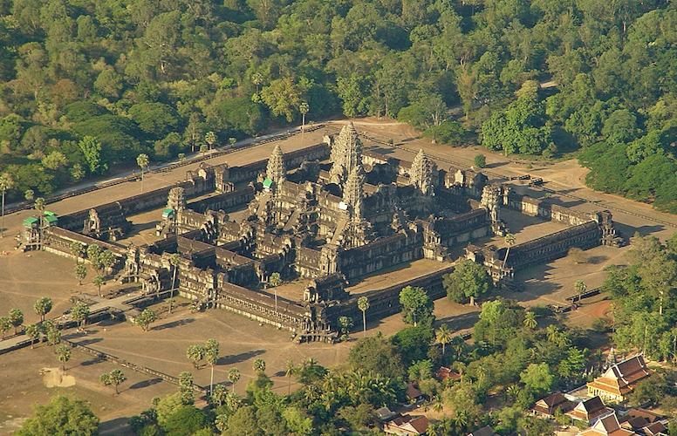**Apsaras** are the ethereal, elegant and youthful beings dancing in celestial palaces while **Devatas** are beautiful standing young goddesses in elegant outfits. Images of Devatas and Apsaras are delicately carved in the  sandstone of many  Angkorian temples. If some of them did not stand the test of time and others were defaced (some of them can be seen in Preah Khan) many are still today beautifully preserved in **Angkor Wat** where about 1800 have been counted.

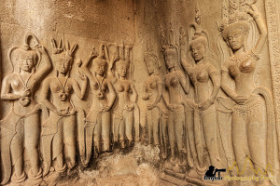

In the 20th century various restoration programs were undertaken, but they were suspended amid the political unrest that engulfed Cambodia in the 1970s. When work resumed in the mid-1980s, the required repairs were extensive. Notably, sections had to be dismantled and rebuilt. In 1992 the Angkor complex, which included Angkor Wat, was designated a [World Heritage site](https://www.britannica.com/topic/World-Heritage-site) by [UNESCO](https://www.britannica.com/topic/UNESCO) and was immediately added to the list of World Heritage in Danger. In the ensuing years, restoration efforts increased, and Angkor was removed from the danger list in 2004. Today Angkor Wat is one of the most important pilgrimage shrines in [Southeast Asia](https://www.britannica.com/place/Southeast-Asia) and a popular tourist attraction. The temple complex appears on the [Cambodian flag](https://www.britannica.com/topic/flag-of-Cambodia).

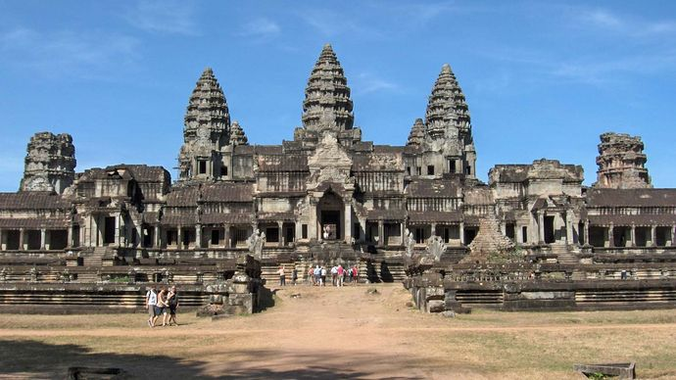

Finally for me chose the text Angkor wat temple because Angkor wat is be long of Cambodia and world heritage by UNESCO. So that, as Cambodian children we must to preserve the temple of Angkor wat so that future generation will know and to be attract national and international tourists.

Thank you.