ព្រះរាជាណាចក្រកម្ពុជា

ជាតិ​ សាសនា ព្រះមហាក្សត្រ

Institute of technology of Cambodia

Department of Information and communication Engineering



The lesson taking about basic of array.

TP8-Use array

TP: Algorithm and Programming

Lecturer: BOU CHANNA

Student: VEN THON

ID: e20191250

Group: I3-GIC-C

Year: 2021-2022

Contents

Problem1: 3

Problem2: 4

Problem3: 5

Problem4: 6

Problem5: 7

# 

# Problem1:

Write a program which displays the letters in a string (sequence of character / array of character / char array)

in reverse order. The program ask a user for a string.

E.g: Input: covid19 vaccine

=>   Output: eniccav 91divoc

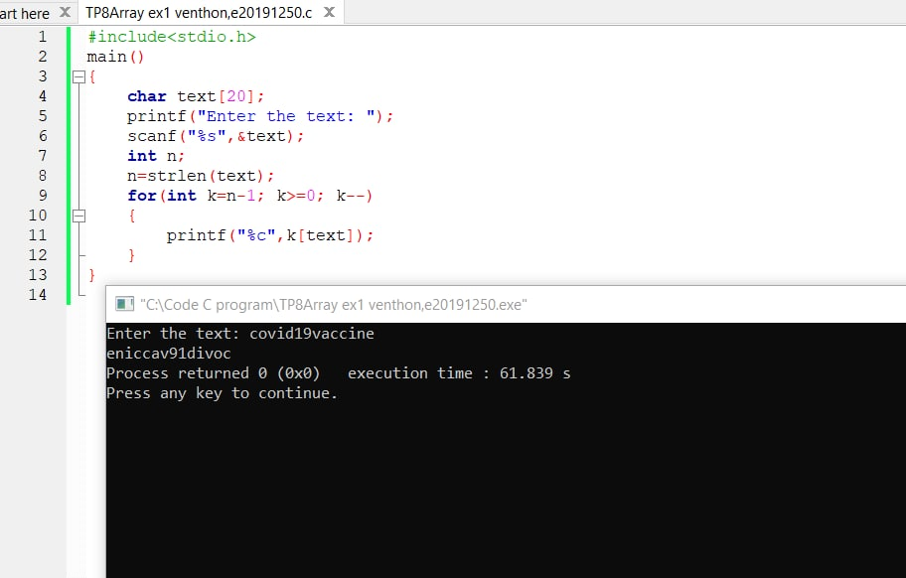

# 

# Problem2:

 Write a program to fill data in the 2D (two-dimentional) array as the following.

1   2   3   4   5

6   7   8   9   10

11  12  13  14  15

16  17  18  19  20

21  22  23  24  25

int m[5][5];

Then make your program to be able to:

a) Display all data above.

b) Display the data in reverse order for each row.

c) Sum all data in the 2D array and display the sum.

E.g output of b)

5   4   3   2   1

10  9   8   7   6

15  14  13  12  11

20  19  18  17  16

25  24  23  22  21

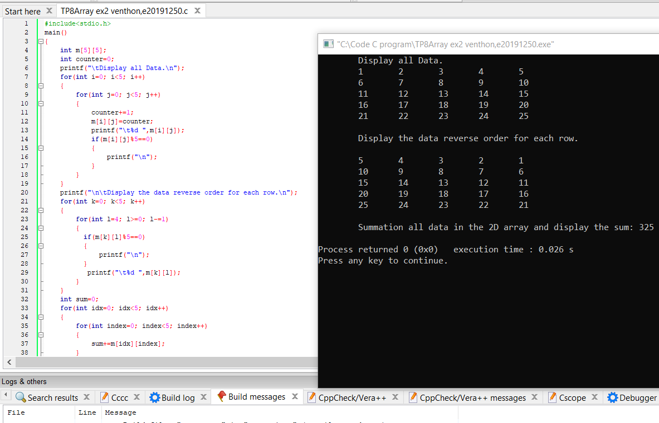

# Problem3:

Write a C program to ask a user to input 7 numbers and store in an array. Find largest and second largest element in an array.

-----

E.g 20 10 9 80 -9 3 80

largest: 80

second largest: 20

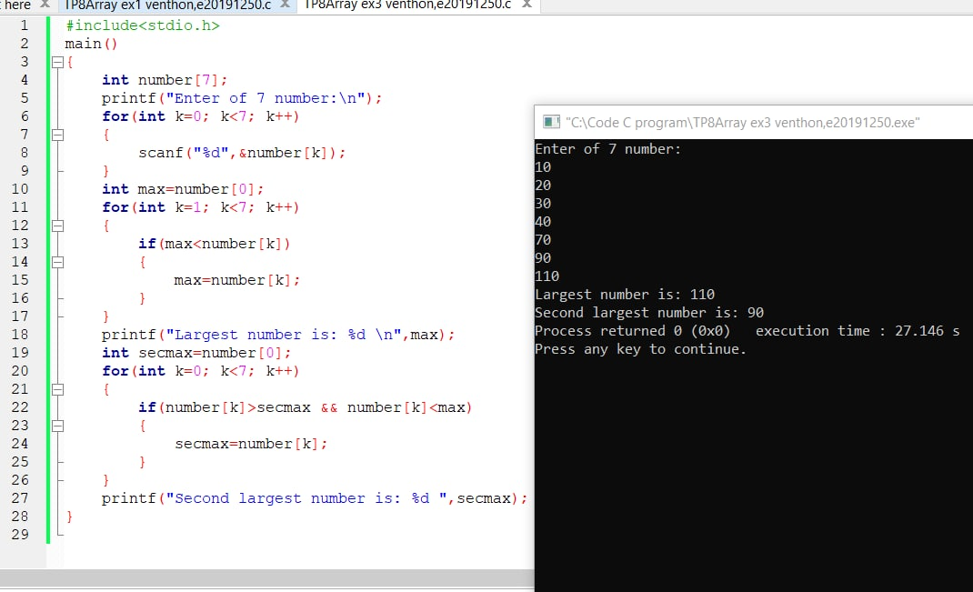

# 

# Problem4:

 Write a C program to search an element in an array, say myArray. The program ask the user to input 8 numbers (each number is in between 1 to 9) and store in an array.

Then ask the user to input another number, say n. The program searches for the position of n in myArray and display how many n are appearing in myArray and its positions.

-----

E.g 7 8 9 4 7 6 1 1

   n: 1

=> There are 2 times in array.

They are located in positions 6 and 7.

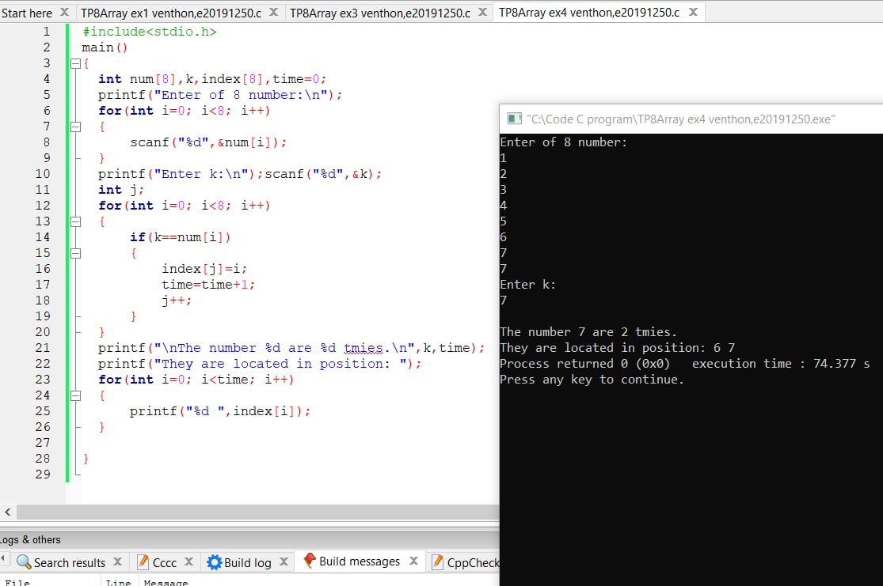

# Problem5:

 Randomize 9 numbers and store in the two 3x3 matrices, say m1 and m2. Each matrix is a 2D array of 3 rows and 3 columns.

int m1[3][3], m2[3][3];

a) Find the matrix m3 which is the summation of these two matrices. (m3 = m1+m2)

b) Find and display the max and min numbers in m3.

c) Find and display the average in m3 (find sum of all numbers, then divide by 9)

