**COVER LETTER**

Name : VEN THON

Address : Sangkat Phnom Penh Thmey Khan Sen Sok

PhnomPenh

Tell : 096 82 21 810

Apply for : Medical Representative

Dear: Sir or Madam

First of all, I am apply for Medical Representative after I have heard your announcement. I am very interest for applying to be your employment moreover, I really ability to do this job because I have special skill in communication. So I want to develop my knowledge and experience for my job. Furthermore, I am believe that I would be a good employee addition, it is opportunity to show my ability and knowledge.

Finally, I am very thanking for your consideration. I have enclosed for my resume for your perusal. I am available for interviewing upon request.

Thank you for time and consideration.

Sincerely your

For your company. Hence, when I have known your information I am quickly to apply to do your member.

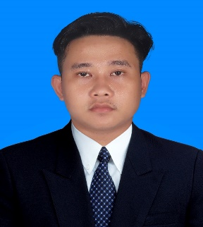CURRICULUM VITAE

Name : VEN THON

Address : Sangkat Phnom Penh Thmey Khan Sen Sok

Phnom Penh

Tel : 096 82 21 810

Apply for : Medical Representative

PERSONAL DATA:

Nationality : Cambodian

Sex : Male

Height : 1.75m

Marital : Single

Health : Good

Date of birth: 18-09-2000

Place of birth: Treng Village, Sdech Kong North Commune, Banteay Meas District

Kampot province

EDUCATION:

2009 – 2015 : Studied at Pong Tuek Primary School

2015 – 2017 : Studied at Chrung Sralao Secondary School

2017 – 2019 : Studied at Touk Meas Hight school

2019 – 2021 : Studying Information technology at ITC

WORK EXPERIENCE:

No experience

LANGUAGES:

Khmer : Mother langue

English : Reading Writing Listening and Speaking(Average)

France : A little bit

INTERESTED:

Research, study, listen music, learn something new about technologies and to do exercise.

REFERENCE:

Ms. Ton Nimol

Work at Brawn Laboratories Ltd

Tel: 092 29 86 87