**Name: VEN THON**

**ID: e20191250**

**Group: I5-GIC-C**

Assignment_Discussion06

Lesson 6: Huffman Coding

1. What is Huffman coding?

* Huffman coding is a compression technique used to reduce the number of bits needed to send or store a message.

1. Explain Huffman coding algorithm?

algorithm of Huffman coding:

* Scan text to be compressed and tally occurrence of all characters.
* Sort or prioritize characters based on number of occurrences in text.
* Build Huffman code tree based on prioritized list.
* Perform a traversal of tree to determine all codewords.
* Scan text again and create new file using the Huffman codes.

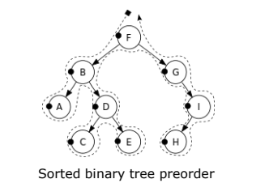Example:

1. Why do we use Huffman tree?

We use Huffman trees to define the Huffman code and find codelength of the word.

1. Assume that we have 6 symbols, draw Huffman tree and find codeword of each symbol? You can choose your own values.

Assume that we have 6 symbols: s1, s2, s3, s4, s5, s6 which:

P(s1) = 0.3

P(s2) = 0.125

P(s3) = 0.2

P(s4) = 0.125

P(s5) = 0.1

P(s6) = 0.15

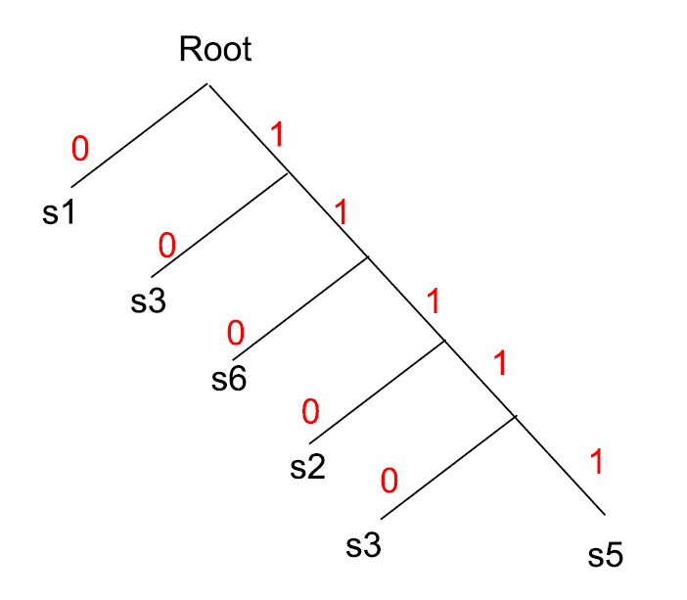

s1->0

s3->10

s6->110

s2->1110

s3->1 1110

s5->1 1111

1. Find entropy and average codeword length from the word "lessonseemscool"?

P(l)= 2/15 = 0.133

P(e)= 3/15 = 0.2

P(s)= 4/15 = 0.266

P(o)= 3/15 = 0.2

P(n)= 1/15 = 0.066

P(m)= 1/15 =0.066

P(c)= 1/15 =0.066

H=0.133log2(1/0.133) + 0.2log2(1/0.2) + 0.266log2(1/0.266) + 0.2log2(1/0.2) + 0.066log2(1/0.066) + 0.066log2(1/0.066) + 0.066log2(1/0.066)

H=2.6 bit

E=0.266x1+0.2x2+0.2x3+0.133x4+0.066x5+0.066x6+0.066x6

E = 2.92 bit