**Name: VEN THON**

**ID: e20191250**

**Group: I5-GIC-C**

Assignment_Lesson06

Lesson 6: Huffman Coding

1) Draw a Huffman tree and calculate average codeword length? If we have:

Input string: “ gotoyooggy ” (double quotation marks doesn’t count!)

P(o)= 4/10 = 0.4

P(g)= 3/10 = 0.3

P(y)= 2/10 = 0.2

P(t)= 1/10 = 0.1

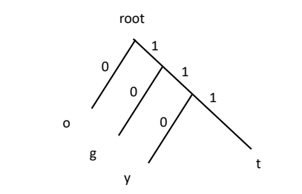

o→0

g→10

y→110

t→111

The average Codeword Length = (0.4 x 1) + (0.3 x 2) + (0.2 x 3) + (0.1 x 3) = 1.7

2) Draw a Huffman tree and calculate average codeword length? If we have:

Input string: “ alibaba bali la” (double quotation marks doesn’t count!)

P(a)= 5/15 = 0.33

P(l)= 3/15 = 0.2

P(b)= 3/15 = 0.2

P(i)= 2/15 = 0.13

P([space])= 2/15 = 0.13

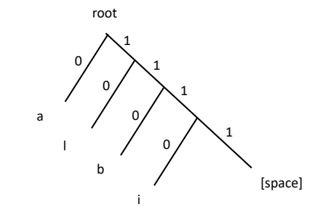

a→0

l→10

b→110

i→1110

[space]→1111

The Average Codeword Length = (0.33 x 1) + (0.2 x 2) + (0.2 x 3) + (0.13 x 4) + (0.13 x 4) = 2.37