Name: VEN THON

ID: e20191250

Group: I5-GIC-C

Assignment Lesson 10

Research on Nyquist sampling theorem and summarize by your own knowledge? (maximum 1 page including 1 or 2 figures).

The Nyquist–Shannon sampling theorem is an essential principle for digital signal processing linking the frequency range of a signal and the sample rate required to avoid a type of distortion called aliasing. The theorem states that the sample rate must be at least twice the bandwidth of the signal to avoid aliasing distortion. In practice, it is used to select band-limiting filters to keep aliasing distortion below an acceptable amount when an analog signal is sampled or when sample rates are changed within a digital signal processing function.

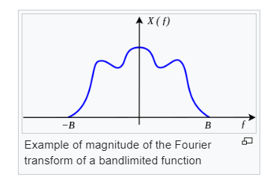The Nyquist–Shannon sampling theorem is a

theorem in the field of signal processing which

serves as a fundamental bridge between

continuous-time signals and discrete-time signals.

It establishes a sufficient condition for a sample rate

that permits a discrete sequence of samples

to capture all the information from

a continuous-time signal of finite bandwidth.

In conclusion, the Nyquist sampling theorem is a fundamental principle in signal processing that provides guidelines for accurately representing continuous analog signals in a discrete digital form. It states that the sampling rate must be at least twice the highest frequency component of the signal to avoid aliasing and enable perfect reconstruction of the original signal.