Name: VEN THON

ID: e20191250

Group: I5-GIC-C

Assignment Discussion 01

1. How does the computer display image from the real-world image?

* The computer displays from the real world image we need a sensor.
* Example real world with sensor:

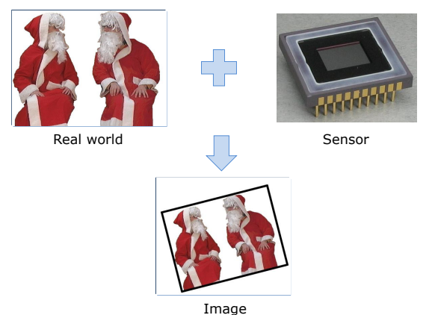

* There are many types of sensors:
* Visual sensors:
* Photochimic: is used in biological systems and photographic films.
* Photoelectric: is used in CMOS and CCD.
* Other sensors:
* Medical imaging: is used for scanning body (X-ray) and detectin g diseases (cancer).
* Seismic imaging: is used for finding crude oil and natural gas.

1. What is the difference between analog and digital signal processing?

* Analog signal processing is any type of signal processing conducted on continuous analog signals by some analog means. Analog indicates something that is mat hematically represented as a set of continuous values.
* Digital signal processing is the numerical manipulation of signals, usually with the intention to measure, filter, produce or compress continuous analog signals.

1. What is the difference between 4 and 8 neighborhood pixels?

* 4 neighborhood pixels take 4 pixels near current pixel C(x,y) by:
* N(x-1, y)
* N(x+1, y)
* N(x, y-1)
* N(x, y+1)
* 8 neighborhood pixels take 8 pixels near current pixel C(x,y) by:
* N(x-1, y)
* N(x+1, y)
* N(x, y-1)
* N(x, y+1)
* N(x-2, y)
* N(x+2, y)
* N(x, y-2)
* N(x, y+2)

1. In your opinion, among Euclidean, Block, and Chess distance algorithm which one is the best? Why?

* Euclidean distance is the best method because:
* It can measure correct distance
* It takes short way

1. What is the difference between binary, grayscale, and color image?

* Black and white images or binary images
* A pixel value is black or white (binary).
* It has only 2 values: 0 and 1 (or 255).
* Grey images or grey levels images
* A pixel value is represented by a scalar (only size, no direction) value.
* It has 256 values from 0 to 255.
* Color image
* A pixel value is represented by 3 scalar values (RGB).
* Each pixel has an intensity which consists of red value, green value, and bl ue value (eg.: intensity=50 → R=20, G=18, B=12).
* It has 256 values from 0 to 255.
* Example:

