**Name: VEN THON**

**ID: e20191250**

Assignment Lesson 2: Data Structure and Color of Images

1. Why do we need to know data structure of images?

We want a structure that enable us:

* to access to pixel values regarding the coordinates (x, y)
* to browse an image from the first to the last pixel
* to access to pixel (x, y) neighbours

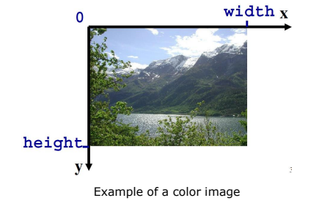

1. How to access all pixels in a 2D image?

We can store a 2D(dimension) image as:

* A 2D image seen as a 1D array:
* It allows to have only one loop for the entire image browsing

for (int i = 0 ; i < im.getWidth()*im.getHeight(); i++)

{ ... }

* However, it is not so easy to access to neighbours
* Neighborhood pixels are stored as 2D array
* It is difficult to access the index of pixel values

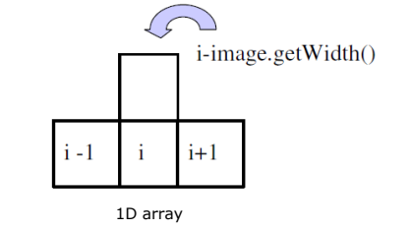

* A 2D image seen as a 2D array:
* It allows to have two loops for the entire image browsing
* for( int x = 0 ; x < image.getWidth() ; x++) {

for ( int y = 0 ; y < image.getHeight(); y++) {

...

}

}

* It is easy to access to neighbours
* data[x-1][y], data[x+1][y], data[x][y-1], data[x][y+1], …

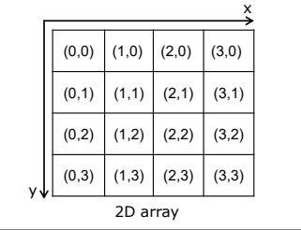

1. Why do we need to convert from RGB to other color channels?

We need to convert from RGB to other color channels because:

* RGB values can be negative and after conversion, all the values become positive.
* To get more color.
* Easy to determine a specific color.

1. If we change the value of luminance, does the color change? Why?

Because luminance is the light source if the light source changes, thus it affects the whole image reflected by light.

1. What is the difference between 2D and 3D image?

* 2D image:
  + - 1D array: use only one loop, but difficult to access to neighbors
    - 2D array: use two loops and easy to access to neighbors
* 3D image:

can represent color by 3D space (x, y ,z) which is:

* based on our perception
* related to physical entities