Name: VEN THON

ID: e20191250

Group: I5-GIC-C

Assignment screenshots openstack configuration in:

For error me I vai the command line below

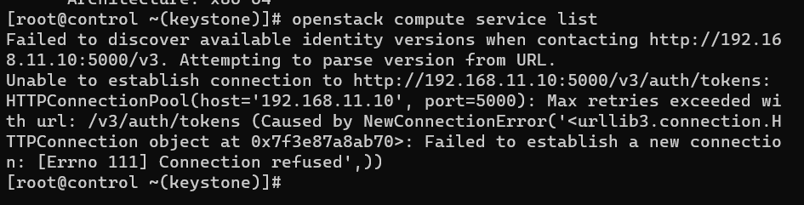

But I check the NginX is active normal:

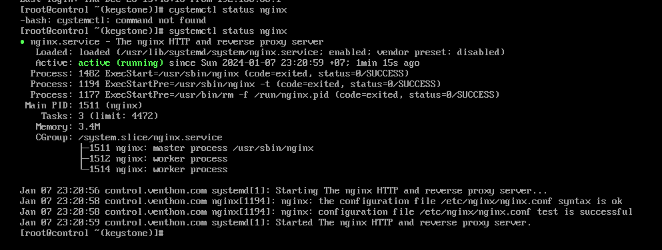

When I check the status of httpd is error, I have config follow step by step on file word control server Centos, I asked my classmate help me to solve the problem but is error.

(I used CentOS8)

