Name: VEN THON

ID: e20191250

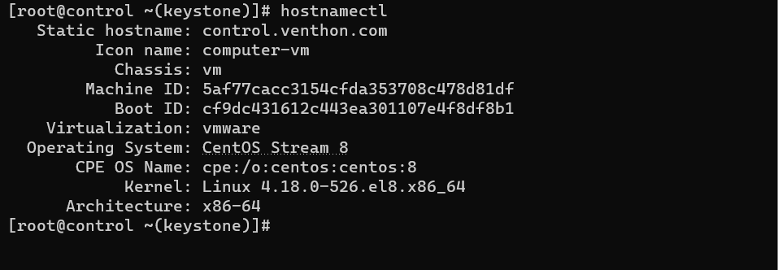

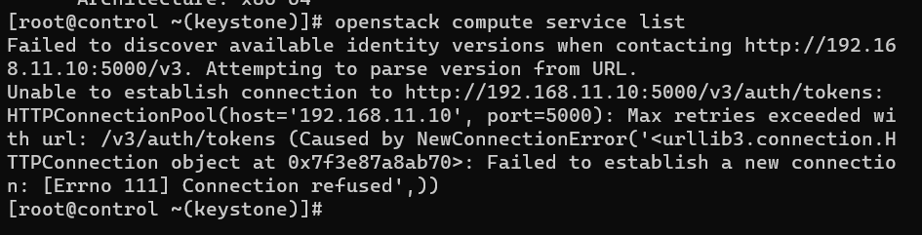

For command openstack compute service list, I have problem error with the httpd .