Team 6: Appointment Booking Service

Name: VEN THON

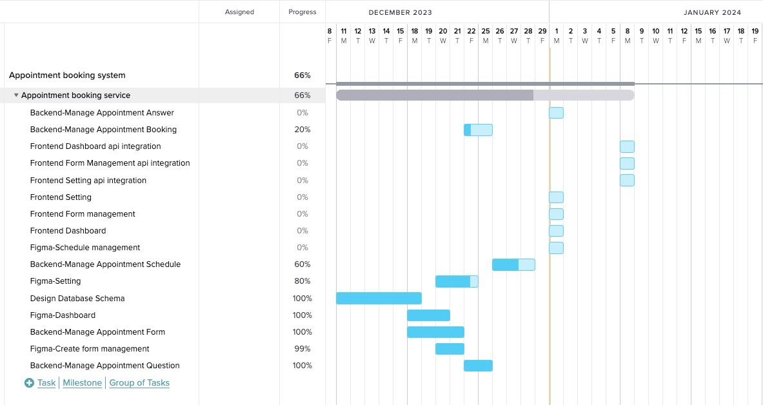ID: e201911250

