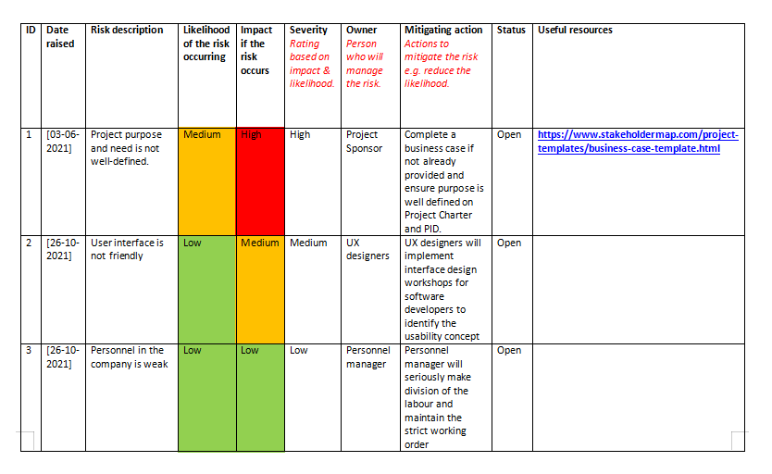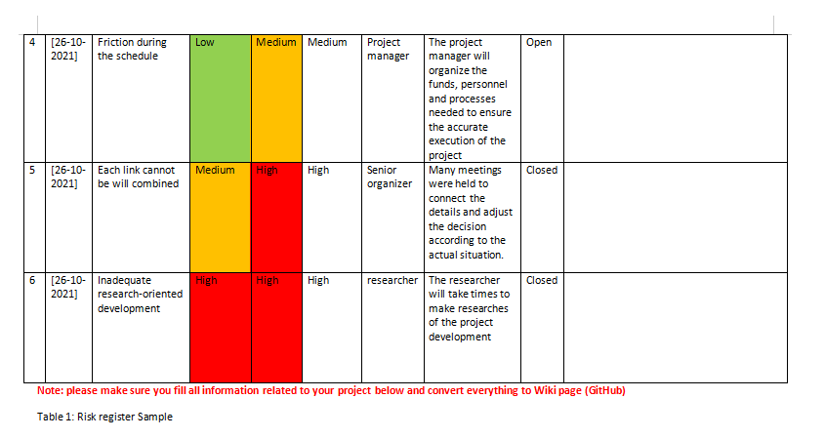In Iteration1, our team learned how to use Stakeholders, which can help us turn code into a real picture. And at the beginning, we didn't know how to use it. Thanks to Vera, a team member, we were able to finish the assignment quickly and start to understand this function. In the back, Nora in understanding how to use this function to upload screenshots, we finally finished the homework, but before finding the right way, we have been failing, later Nora found that it was always forgotten to download the address of the picture. This makes us more careful in the future. In Iteration2, we pretend to be a business, designing a lot of things to do and worlds to need. And this for our own course analysis also brought convenience. When analyzing ourselves, Delia actively provides us with new ideas and makes us feel confident in our analysis. However, in the process of writing this, we also encountered difficulties. Our dates were always inconsistent. Thanks to Crystal, we were able to fill in the dates correctly. In Iteration3 we started to get in touch with GitHub, everyone has their own GitHub and started uploading more easily, but we couldn't log in until Vera managed to log in using VPN. In the follow-up study of GitHub, we gradually got familiar with GitHub. Now we can skillfully use GitHub to hand in various assignments.

