Database System Engineering and Distributed Backend Development(25CS1302E)
DDL,DML,DCL,TCL

Name: Venati Rukesh
Roll No: 2520030519
Sec: 7
1.DDL COMMANDS: CREATE, ALTER, DROP, TRUNCATE, RENAME:
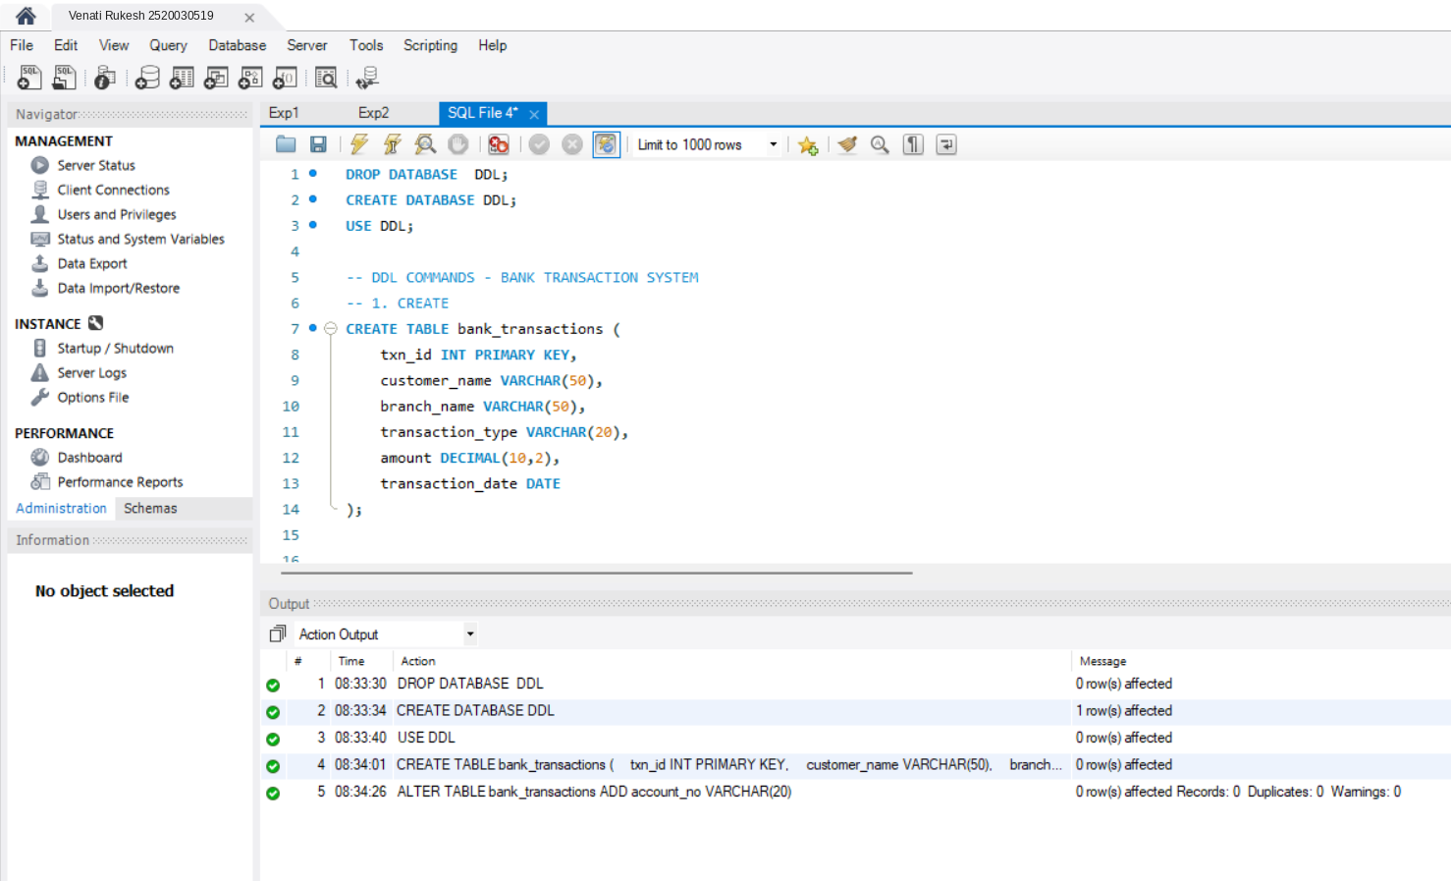

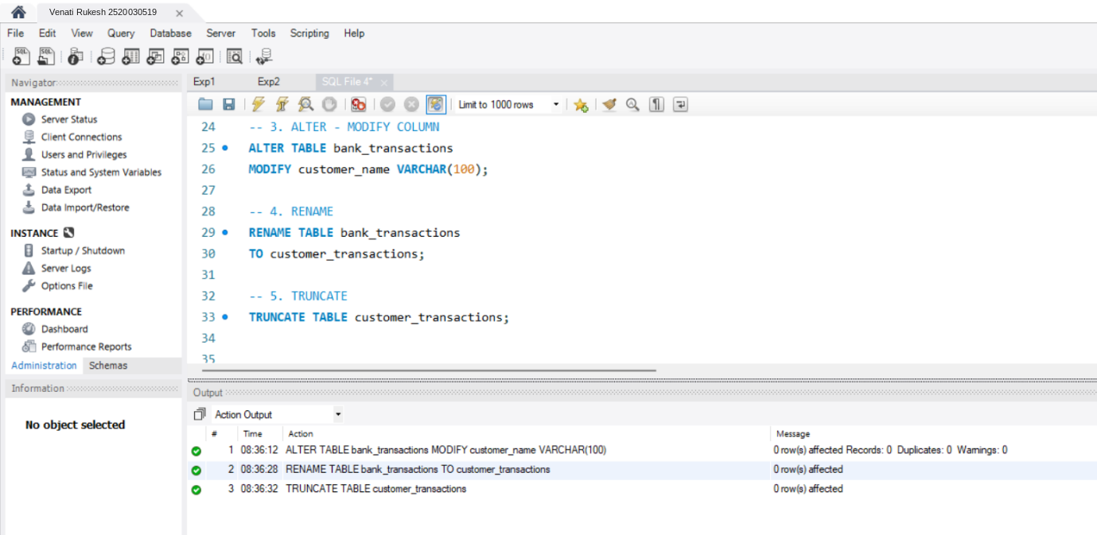

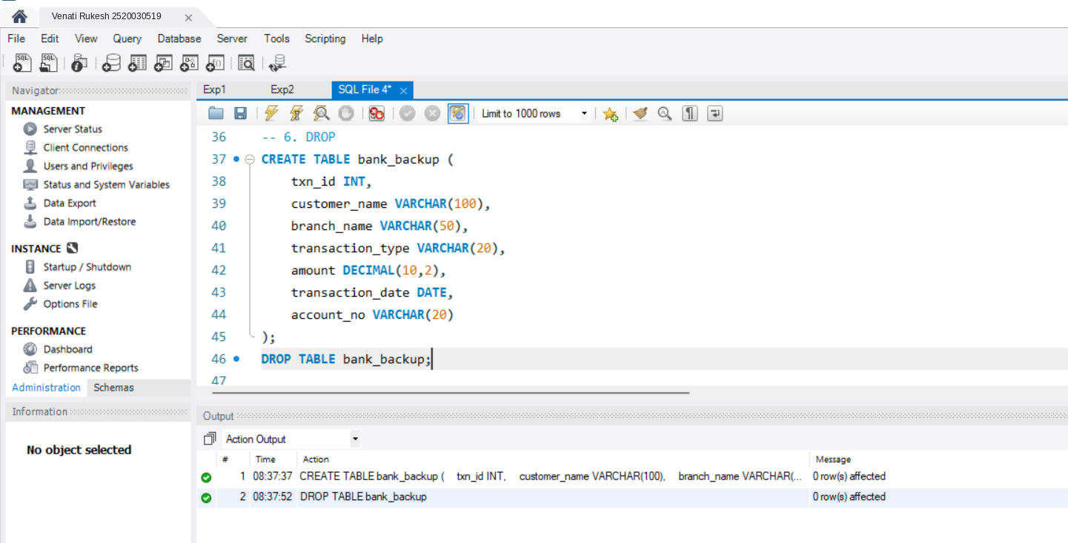

2. DML COMMANDS: INSERT, UPDATE, DELETE, SELECT:
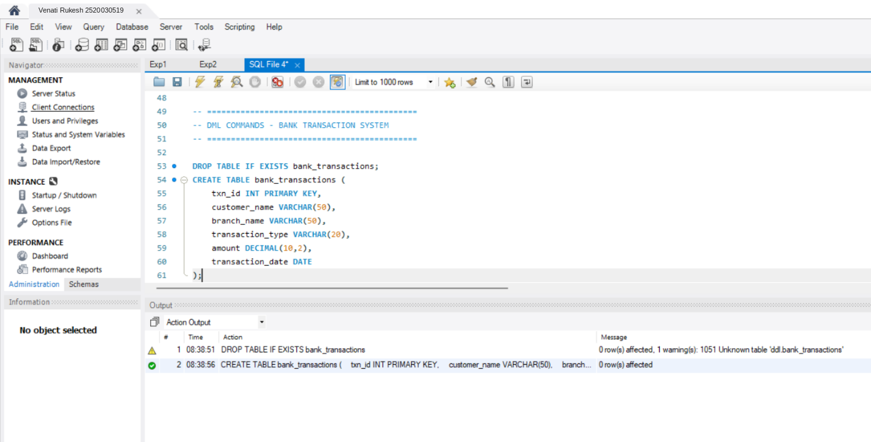

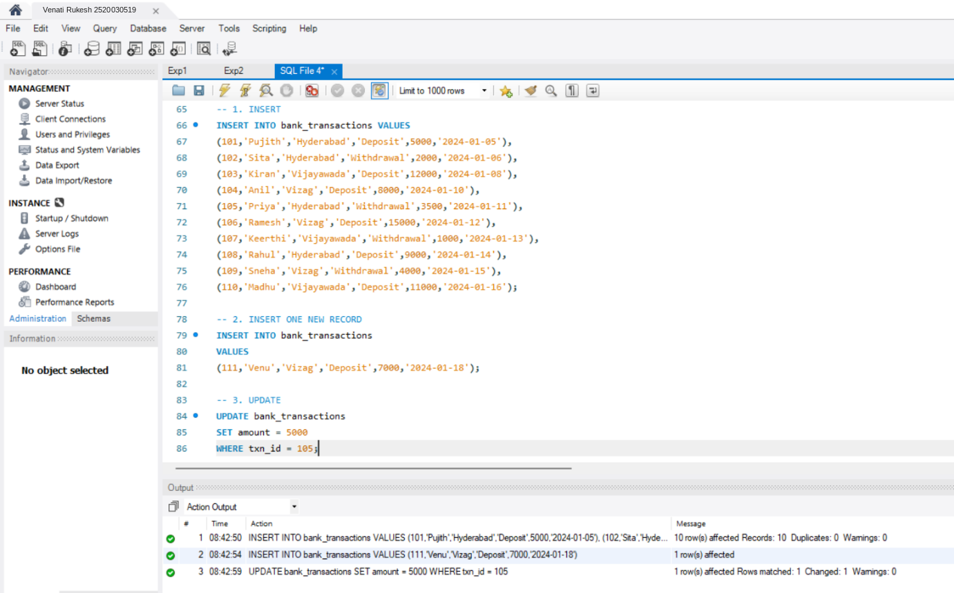
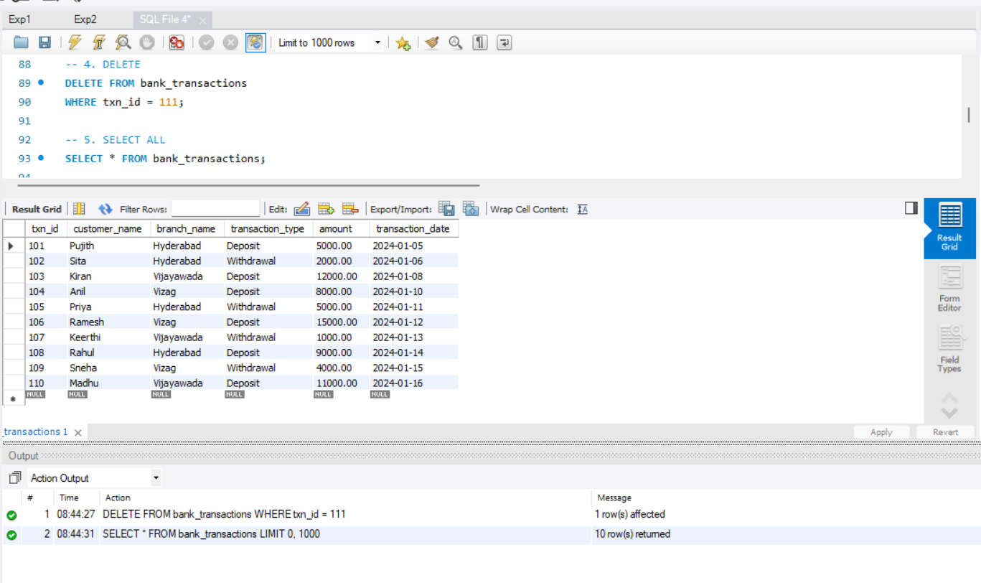

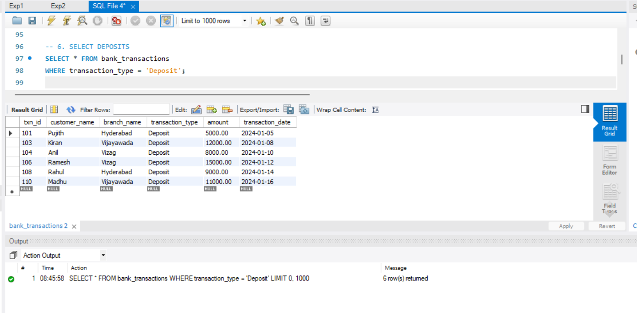

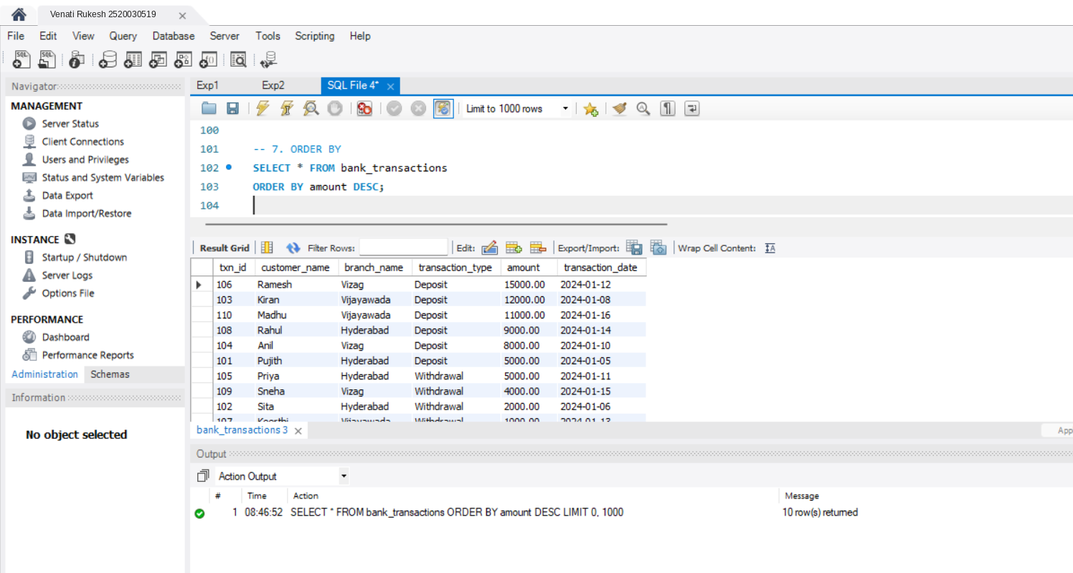
3. DCL COMMANDS: GRANT, REVOKE:
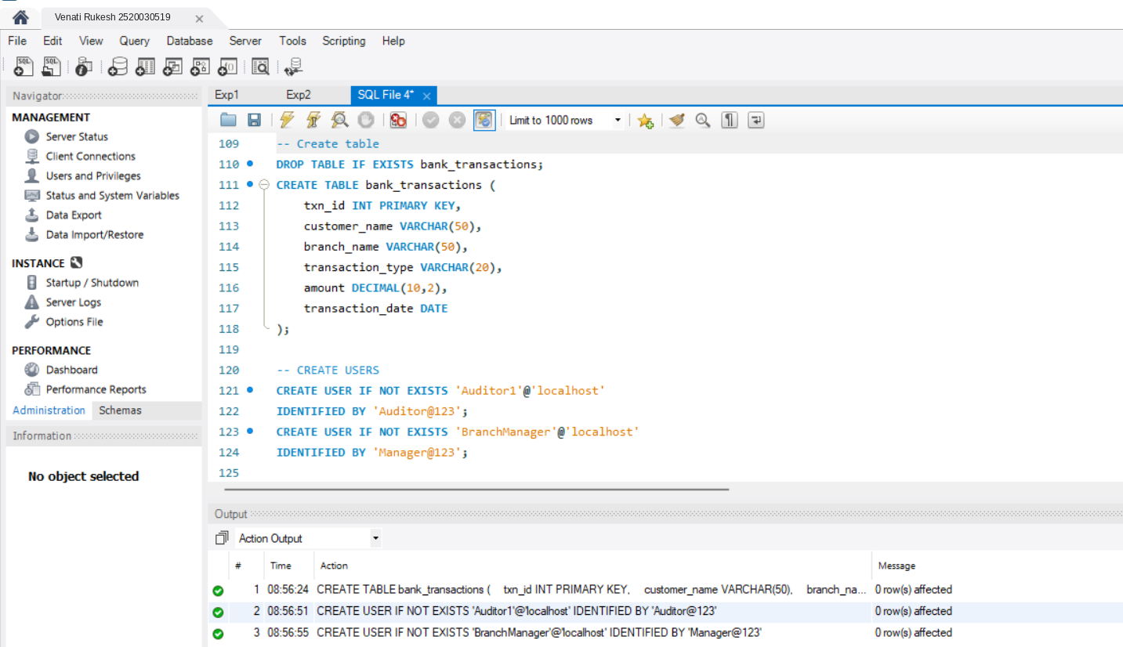
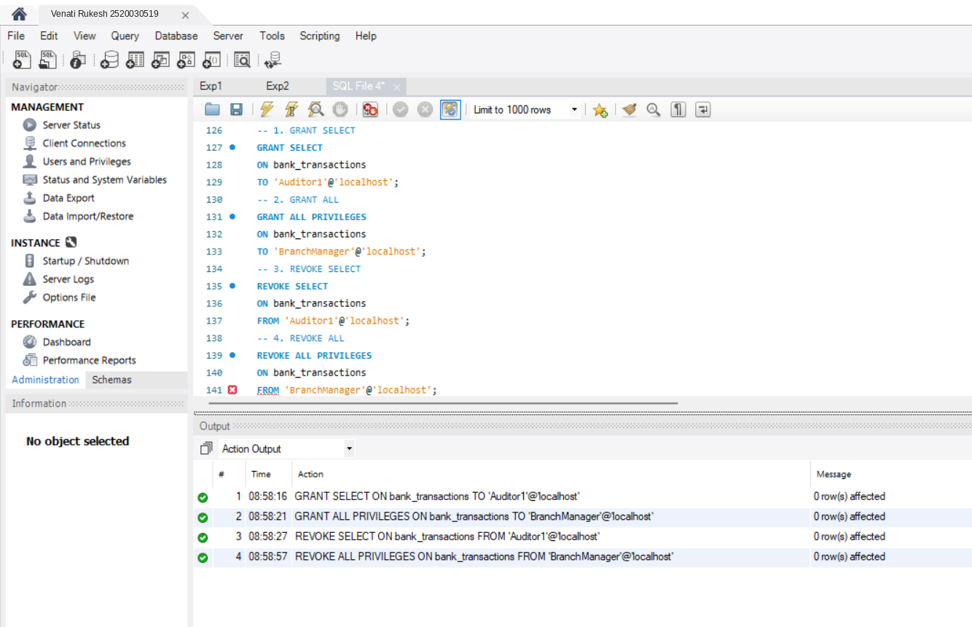

4. TCL COMMANDS : COMMIT, SAVEPOINT, ROLLBACK :
