**PROPERTIES OF DERIVATIVES**

Today we will discuss some of useful derivative properties that are actually used in math and Machine Learning. Next paper will be about optimization

**MULTIPLICATION BY SCALAR**

(if our function f = const c * function g

Derivative of f is gonna be derivative of g times c)

We can easily plot it to proof

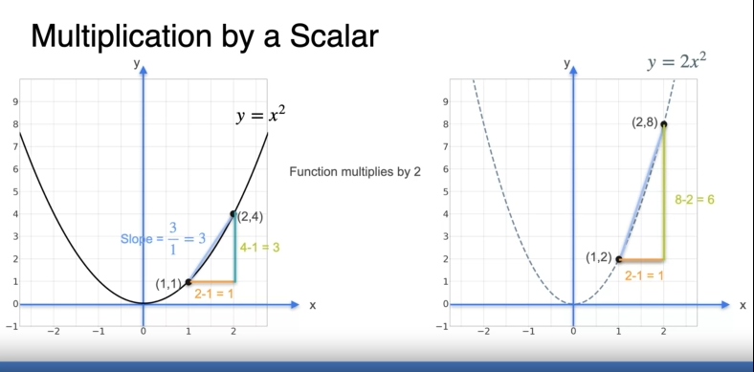

**SUM RULE**

(where f, c, and g - functions)

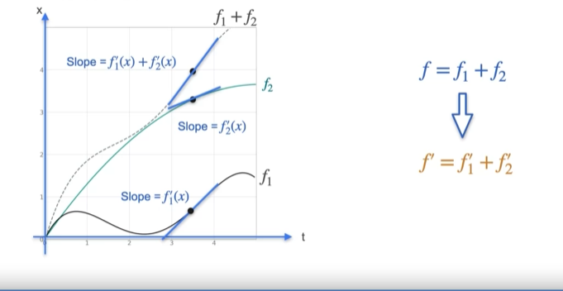

**PRODUCT RULE**

(where f, h, and g - functions)

**CHAIN RULE**

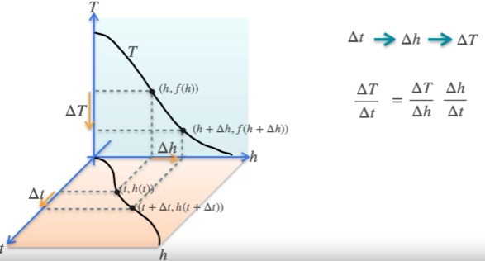

Sorry for such a short and brief paper.

I’m really tired now, as I’ve been working all day.

This is probably the best I could write here.

(it’s hard to deal with formulas in docs).

Also I quit MIT course for a while

(cuz it’s too deep for now, and it doesn’t give particular essence of calculus in Machine Learning)

Anyways:



I’ll read 1984 and go to sleep…

________________________________________

This material is free to use, share, and criticize.

Written by Venchislav for the GitHub community❤.

21.03.2024

_____________

GoodBye!