**1.**[**Microsoft Visual Studio 2012 Pro**](http://www.microsoft.com/visualstudio/eng/products/visual-studio-professional-2012)

If you are looking for the definitive IDE for Windows application development, look no further than to Microsoft's own developer toolset. Visual Studio products cover languages like C++, C# and VB.NET. In addition, you are also able to develop for the Windows x86, Windows RT, and Windows Phone. The latest version of Visual Studio is also designed to be optimized for touch, just in case you happen to be writing code on a Microsoft Surface. Visual Studio Professional will cost you $499.

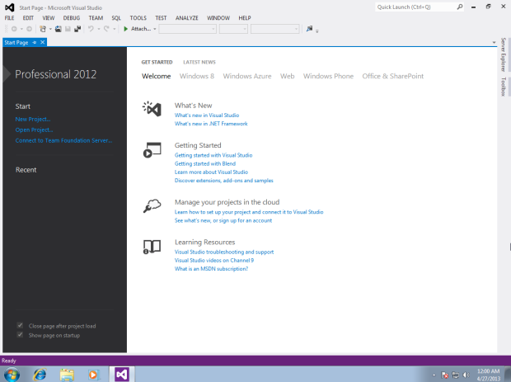

**2.**[**Oracle Netbeans 7**](https://netbeans.org/)

If you are more of a Java developer, Oracle's got your back with their Netbeans IDE. Of course, despite the fact that excellent Java support is its claim to fame going as far back as the Sun Microsystems days, other languages like C/C++, Ruby, HTML5, PHP and more are supported as well. Netbeans is extremely extensible via its plugin-centric design, allowing you to add additional language syntax support and libraries, among other things. Netbeans is free under the[Common Development and Distribution License](https://netbeans.org/cddl-gplv2.html) (CDDL) v1.0 and GNU General Public License (GPL) v2.

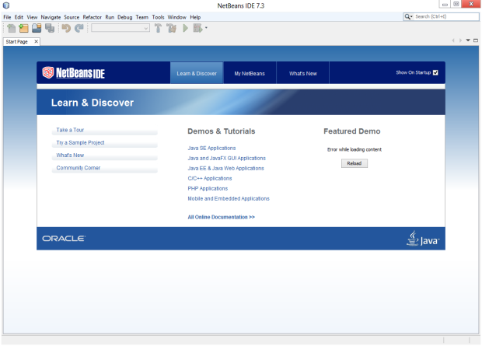

**3.**[**Eclipse**](http://eclipse.org/)

This IDE is quite comprehensive and even similar to Netbeans in a variety of ways, including its use of Java and plugin architecture. However, Eclipse as an IDE comes in a wild variety of flavors, catering to various needs and objectives in software development workflows. The Eclipse Foundation even provides a [comparison page](http://www.eclipse.org/downloads/compare.php) to view the differences between the variants of Eclipse. Eclipse is free under the terms and conditions of the Eclipse Foundation Software User Agreement unless otherwise specified.

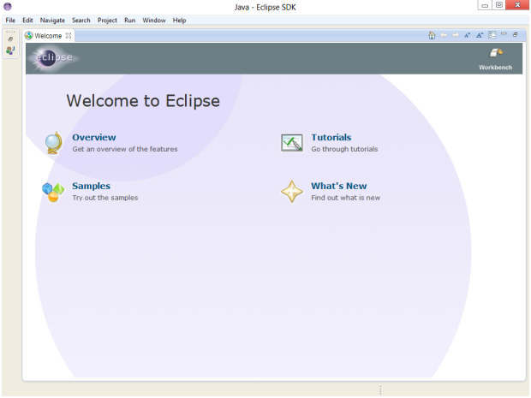

**4.**[**Code::Blocks**](http://codeblocks.org/)

Unlike the other products seen thus far, Code::Blocks, which is built on the wxWidgets framework, is exceptionally lightweight in size, yet still quite functional and feature-rich IDE. You can load up a number of under-the-hood compiler engines, ranging from GCC and LLVM, to Digital Mars and Open Watcom. Code::Blocks also takes advantage of multi-core compiling, allowing you to get the job done faster. Code::Blocks is distributed under the GPL v3.0 license which means it can be used freely by anyone.

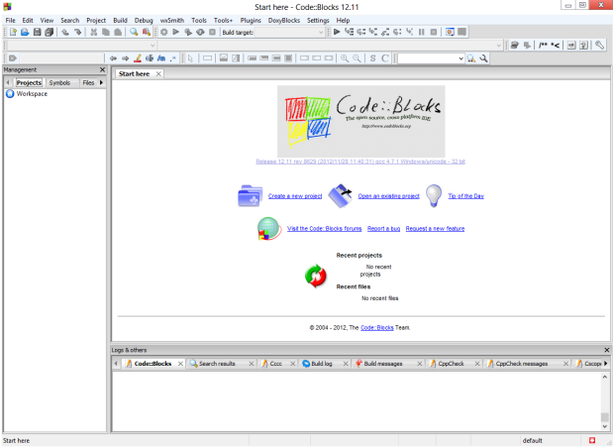

**5.**[**Aptana Studio 3**](http://aptana.com/)

If web and scripting languages are more of your style, Aptana is well suited for the task. PHP, Ruby on Rails, and Python are supported as well as the likes of Adobe AIR. Even the studio itself is available as a plugin for Eclipse if you prefer the way Aptana handles your work and want to combine it with a more comprehensive IDE. Aptana Studio 3 is free and available solely under the [GNU General Public License](http://www.gnu.org/copyleft/gpl.html).

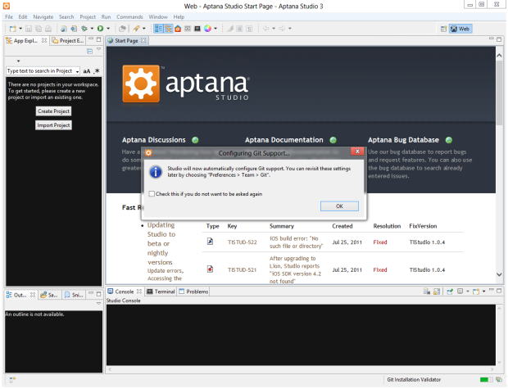

**6. Xcode**

Xcode is an integrated development environment (IDE) containing a suite of software development tools developed by Apple for developing software for OS X and iOS. First released in 2003, the latest stable release is version 5.0 and is available via the Mac App Store free of charge for Mac OS X Lion and OS X Mountain Lion users.Registered developers can download preview releases and previous versions of the suite through the Apple Developer website.

