Wheels Documentation

Hello! Thanks for downloading the asset, I hope you find it useful.

If you liked the asset, you can rate it on the asset store page. This helps a lot in promoting assets.

## You can also take a look at my other assets:

An asset with excellent car physics:

[Universal Car Controller](https://assetstore.unity.com/packages/templates/systems/universal-car-controller-176314?aid=1011l7xfR)

ACC series, well optimized for mobile projects:

[Arcade Car Controller (Lite version)](https://assetstore.unity.com/packages/templates/systems/arcade-car-controller-lite-version-145489?aid=1011l7xfR)

[Arcade Car Controller (Standard version)](https://assetstore.unity.com/packages/templates/systems/arcade-car-controller-142660?aid=1011l7xfR)

[Arcade Car Controller (Multiplayer version)](https://assetstore.unity.com/packages/templates/systems/arcade-car-controller-multiplayer-155209?aid=1011l7xfR)

## Third-party assets that I myself use and recommend to everyone:

[EasyRoads3D Pro v3](https://assetstore.unity.com/packages/tools/terrain/easyroads3d-pro-v3-469?aid=1011l7xfR) - An asset with which it is easy to create roads for games of any genre.

[Gaia 2 - Terrain & Scene Generator](https://assetstore.unity.com/packages/tools/terrain/gaia-2-terrain-scene-generator-42618?aid=1011l7xfR) - An asset with which it is easy to create and generate terrains of any complexity.

Sizes: the outer radius of all sizes (Tire radius) is equal to one unit, for the possibility of replacement at the time of application execution and ease of synchronization with the radius of the wheel colliders (The wheel needs to be set to a scale equal to the radius of the wheel collider).

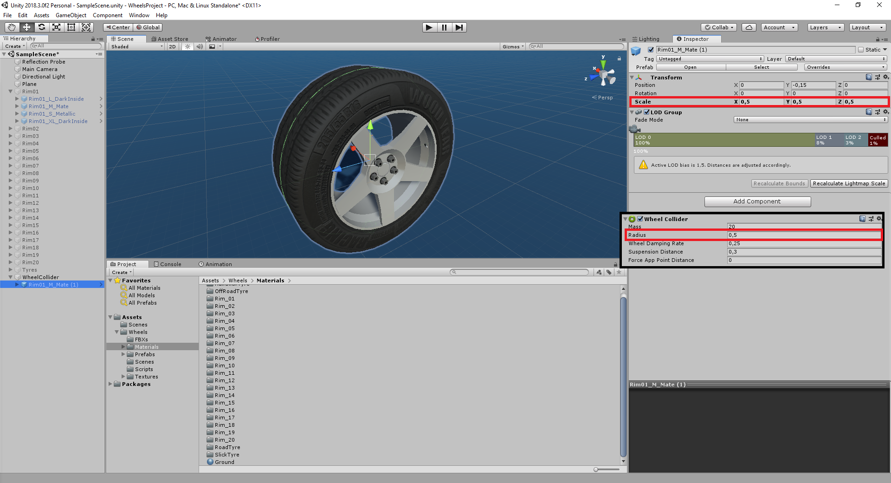

All tire and rim models have 4 different sizes:

S - Small.

M - Normal.

L - Big.

XL - Very Large.

All rims of the same size are interchangeable.

Each rim and tire has a system of lods, for optimization, so all prefabs are configured accordingly.

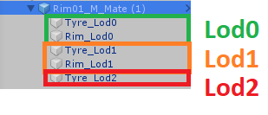

There is also a model with internal parts to display a rim without a tire or a tire without a rim, the model contains a string in the name "_InsideDetailed".

All rims have several options for the material, the material can be adjusted Smoothness (with this you can adjust the color metallic or matte) and color.

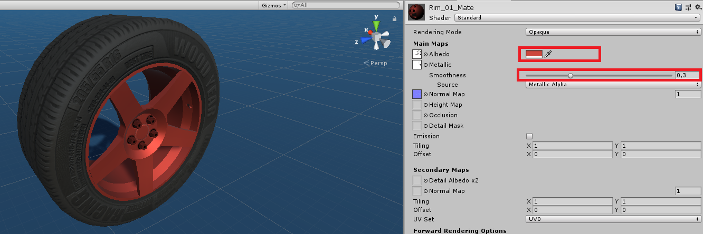

Tires have materials with 4 different treads, each tread has 6 material options.

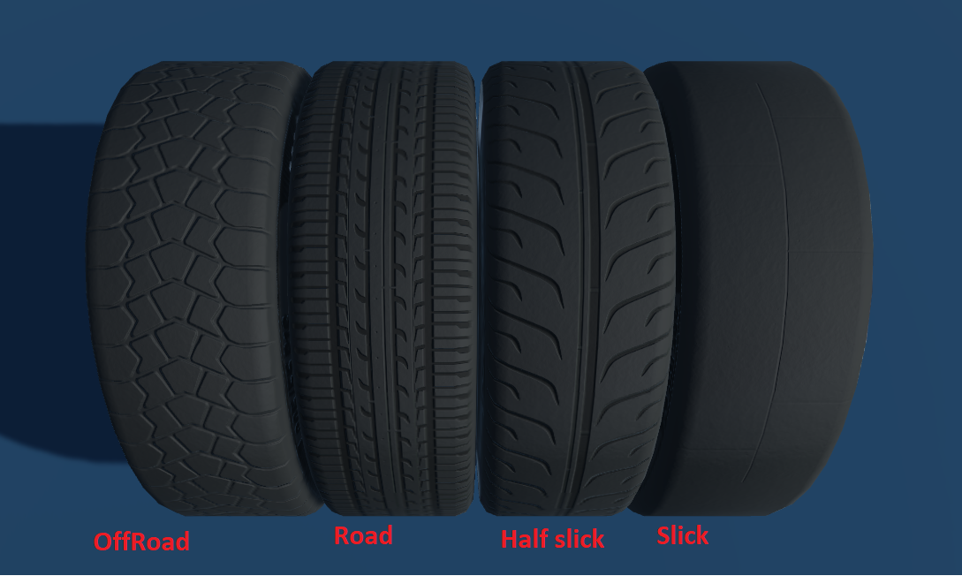

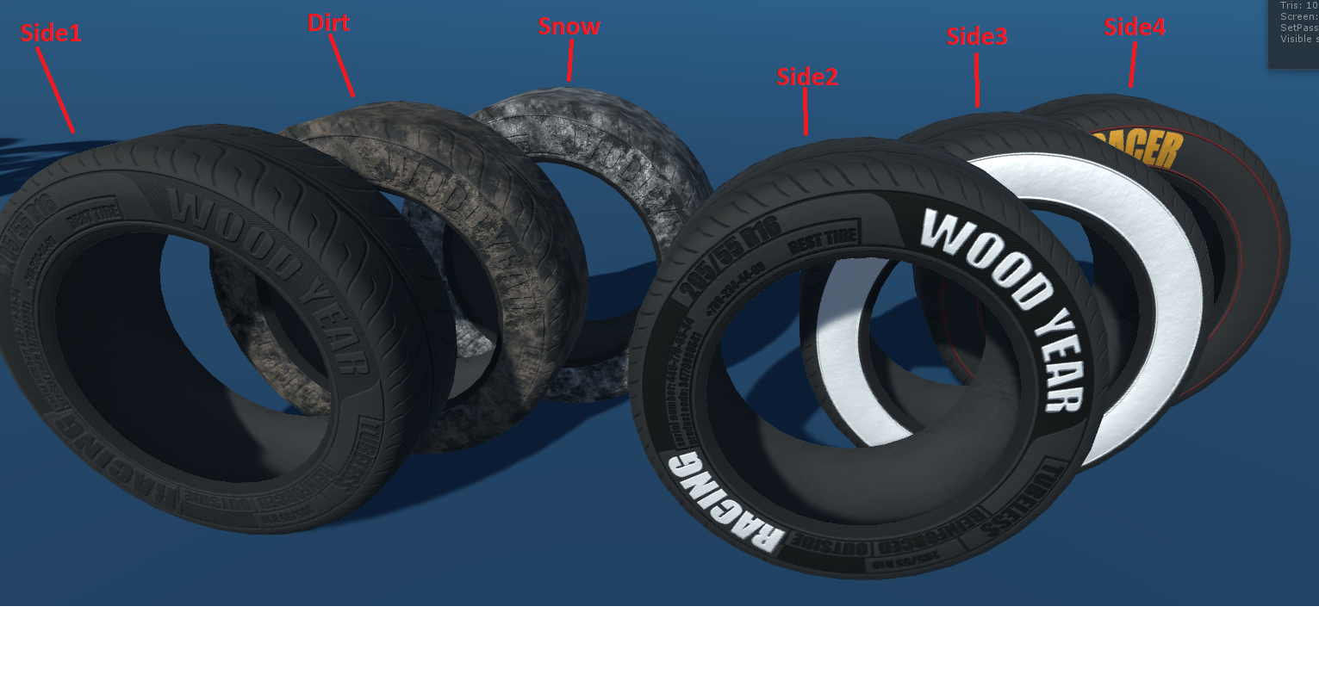

All tire materials and rims materials are suitable for all sizes.

In order to assign a different material, you need to assign it to each lod.

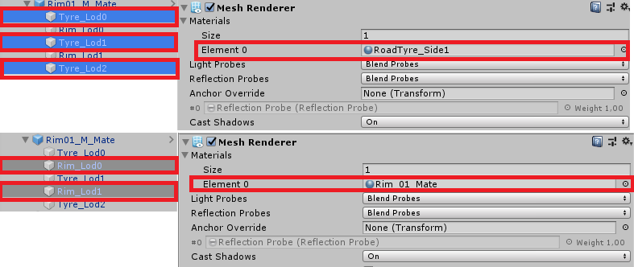

Some rims have 2 materials (Main and Extra), this allows you to configure multiple colors for one rim, you need to assign materials similarly to rims with one material.

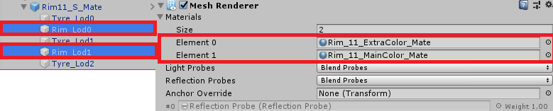

Name: All models have special names. First comes the name of the model "Rim _11", then the size of the model "_M", then the level of the Lod "_Lod0". Full name is Rim_11_M_Lod0.

Prefabs also have the title of the material in the header, for example Rim_11_M_Mate.

I tried to name all the textures, materials, models and prefabs as clearly as possible, I hope that everything is clear to you. If you have questions, you can ask them by e-mail:

[Bugrov1990@gmail.com](mailto:Bugrov1990@gmail.com)

[war.90@mail.ru](mailto:war.90@mail.ru)