Brainstorm & Idea Prioritization Template

Date | 16 February 2026
Team ID | LTVIP2026TMID53603
Project Name | HouseHunt: Finding Your Perfect  Rental Home
Maximum Marks | 4 Marks

Step-1: Team Gathering, Collaboration and Select the Problem Statement

Our team collaborated to understand common pain points in the rental housing sector. After identifying issues such as lack of trust in listings and poor renter-owner communication, we finalized our problem statement to create a trustworthy and rolebased rental property platform.

Step-2: Brainstorm, Idea Listing and Grouping

• Ideas generated include:
- Filtered property browsing
- Owner-side property management
- Admin approval for listing validation
- Messaging system between renter and owner
- Booking and notification system
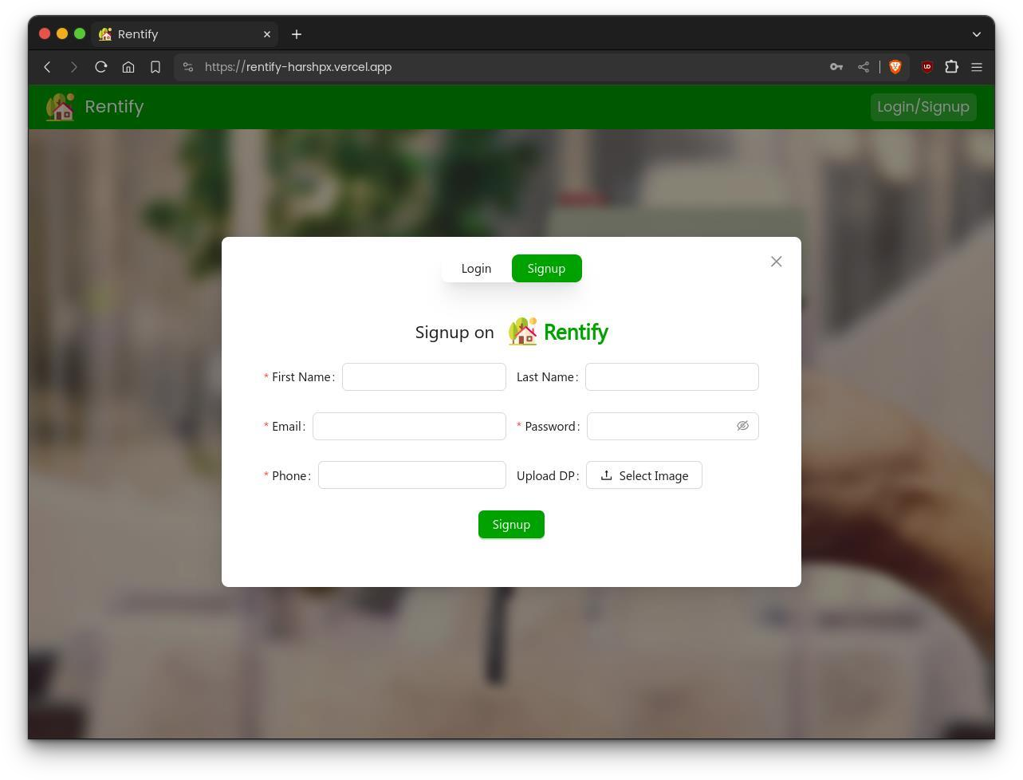

Step-3: Idea Prioritization

Idea | Impact | Feasibility | Priority
Verified Property  Listings | High | High | Must Do
Role-based User  Dashboards | High | Medium | Must Do
Admin Verification  Workflow | Medium | Medium | Should Do
Messaging System | High | Low | Could Do
Lease PDF  Generator | Medium | Low | Not for MVP
