**Отборен проект  
 “Find my recipe”**

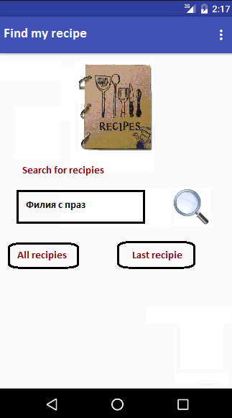***Main:***

***Found recipie: (from search)***

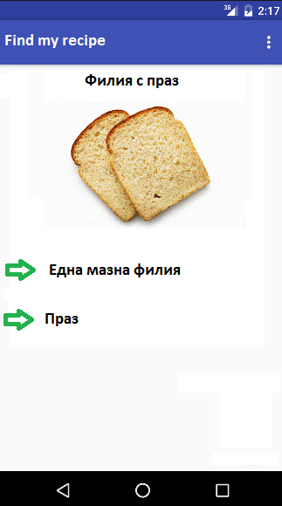

***All recipies:***

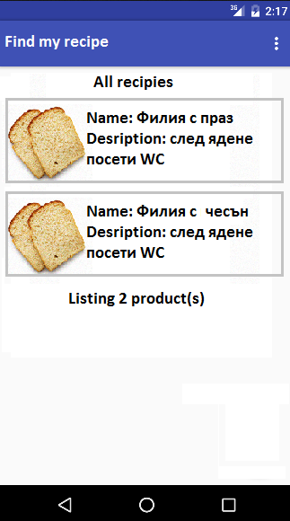

**Tasks:**

* **Use custom views (7)**
* **Use animations (6)**
* **Device API’s: up to (10)**

**\*** **Accelerometer**

**\*** **Camera**

**\*** **Compass**

**\*** **Geolocation**

**\*** **Capture**

* **Application Storage (SQLite) (5)**
* **Remote data (5)**
* **Background tasks (6)**
* **Notifications (9)**
* **High-quality code and reusability (6)**
* **Validation and Error handling (4)**