Cavendish University Uganda

Final Project Report

Student Information
Name | Namugga Vanessa Susan 235-422
Faculty | Faculty of Computing and Information Technology
Department | Department of Data Science and Software Engineering
Project title | Elite_Ecommerce: A web-based E-Commerce Platform
Program | Diploma of Data Science and Analytics
Mode of Study | Day
Exam Date | May 11, 2026

Problem Statement
Small and medium-sized businesses in Uganda lack affordable, easy-to-use e-commerce platforms to sell their products online. Existing solutions are either too expensive, complex to manage, or require technical expertise. Many local entrepreneurs resort to manual order management through social media, leading to disorganized inventory, lost sales, and poor customer experience.

Objectives
- To develop a user-friendly e-commerce website with product browsing capabilities
- To implement a shopping cart system for seamless order management
- To create user authentication for secure customer accounts
- To provide an admin dashboard for easy product and inventory management
- To design a responsive interface accessible on both desktop and mobile devices

UI/UX Design
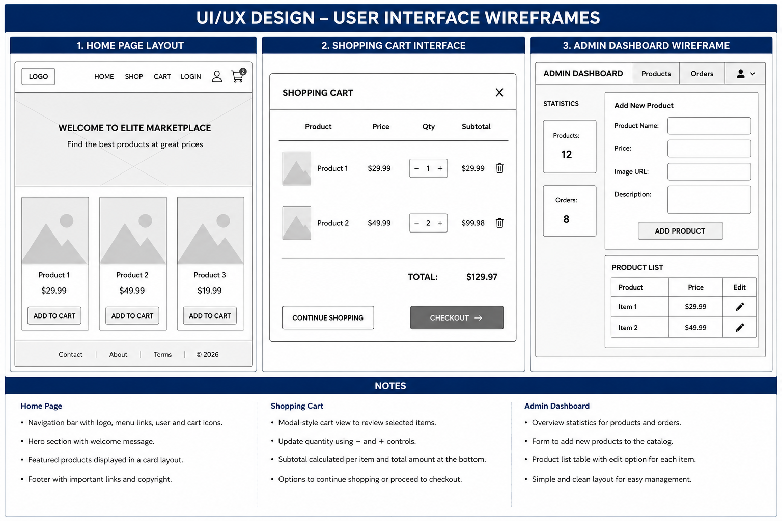

Github_link: https://github.com/VenessaCUU7/ELITE-ECOMMERCE

Images of the actual system.
Admin dashboard.

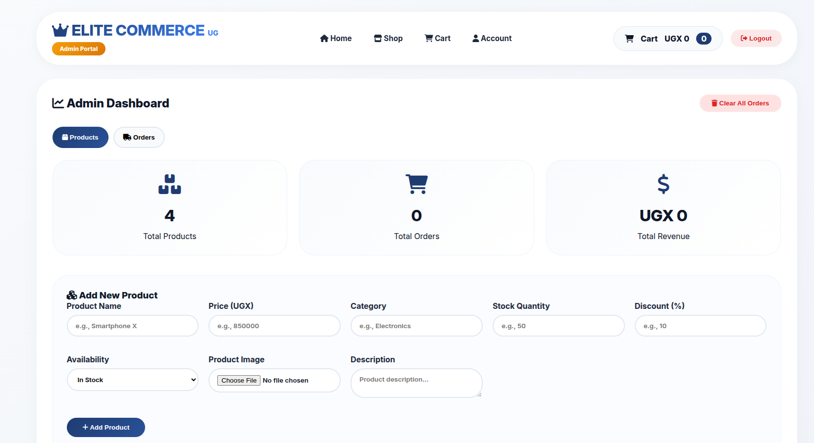
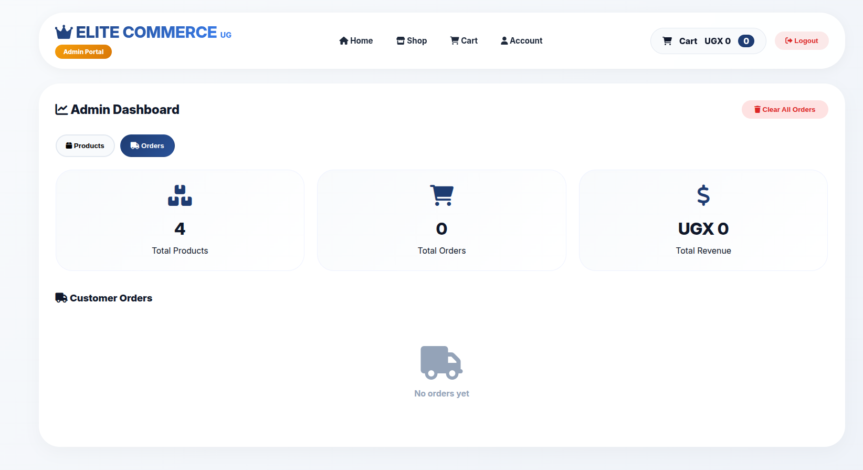
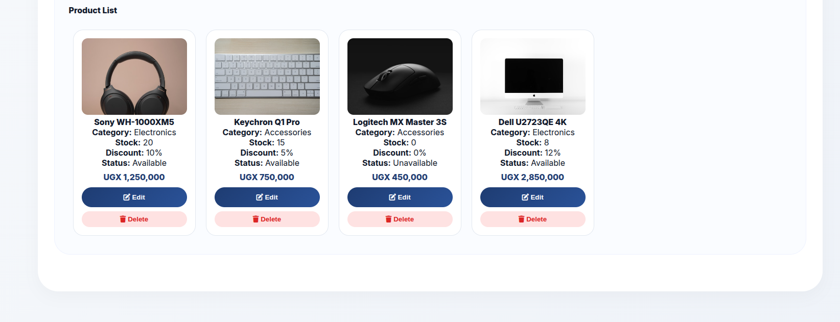

User dashboard
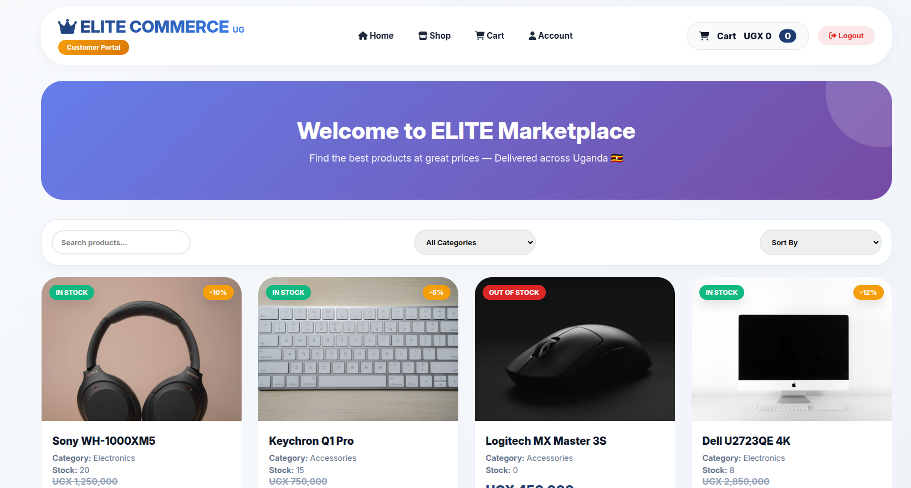


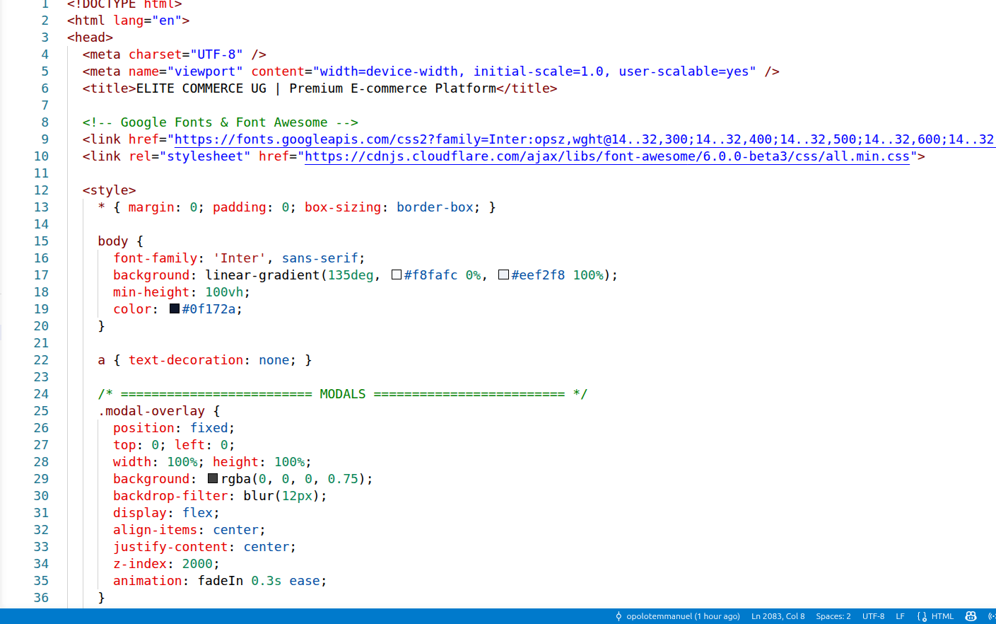
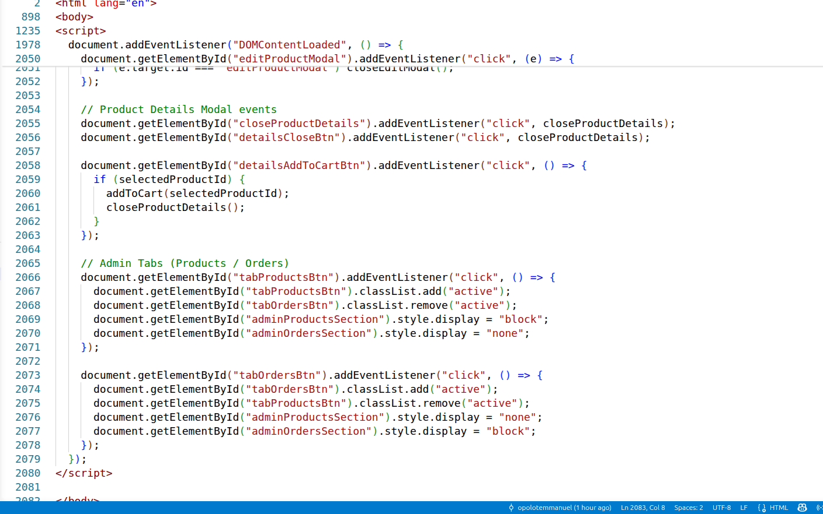
Screen shots of code

Conclusion

The ELITE-ECOMMERCE platform successfully delivers core e-commerce functionality including product browsing, shopping cart management, user authentication, and an admin dashboard. The system uses client-side local storage for data persistence, making it lightweight and easy to deploy. The responsive design ensures accessibility across desktop, tablet, and mobile devices.
Student Signature: _________________
Date: May 11, 2026
Institution: Cavendish Universities Uganda

