Puerto Rico Population Forecasting and Policy Response Analysis
Andres Ruiz
Rutgers, The State University of New Jersey, Camden, NJ 08102 US

ABSTRACT. This project develops a machine learning framework to forecast municipal population change in Puerto Rico and evaluate disaster and policy scenarios. The analysis integrates municipal population, economic, demographic, social vulnerability, and disaster exposure data into a panel structure. A chronological train-validation-test design is used to preserve temporal ordering, and a tuned Lasso model is selected as the final predictive backbone, achieving strong out-of-sample performance (test R² ≈ 0.9092; RMSE ≈ 0.4531). Interpretability analysis shows that population change is highly path-dependent: lagged population dynamics dominate model predictions, while disaster variables are better understood as indirect and delayed amplifiers. Scenario simulations show that hurricanes and earthquakes can accelerate existing decline trajectories. Policy simulations show that standard policy bundles can slow decline, while a recovery-rebound sensitivity case indicates that stabilization or growth requires stronger coordinated recovery dynamics, including return migration and sustained improvements in structural conditions.
1. Introduction
1.1 Background and Objective:
Puerto Rico has experienced sustained population decline over the past decade. This decline is not simply a demographic statistic; it affects labor markets, municipal tax bases, school enrollment, infrastructure needs, public services, and long-term economic planning. Natural disasters such as Hurricane Maria and major earthquakes added additional shocks to an already fragile demographic environment, but the analysis developed in this project shows that the deeper population process is persistent and structural.
The objective of this project is to build an end-to-end predictive and scenario-based framework for understanding municipal population change in Puerto Rico. The project moves beyond a single predictive model by combining feature engineering, model interpretation, disaster scenario simulation, and policy stress testing. The final goal is to identify which factors most strongly shape population outcomes and to estimate how alternative disaster and policy conditions may shift future trajectories.
1.2 Dataset Description:
The analysis uses a municipal-year panel for Puerto Rico. The final modeling dataset covers 78 municipalities across target-eligible years and integrates demographic, economic, vulnerability, public safety, and disaster exposure information. The core outcome is municipal population change, modeled as a 3-year forward target to capture longer-term demographic dynamics and reduce short-term volatility.
· Population variables: total population, annual population change, lagged population change, rolling population dynamics, and 3-year forward population-change targets.
· Economic variables: income growth, employment indicators, business establishment growth, and related lagged or rolling measures.
· Demographic context: islandwide birth, death, and natural-change rates, carried forward as annual background conditions.
· Disaster exposure variables: hurricane wind exposure, earthquake exposure, rolling disaster measures, and interactions with vulnerability features.
· Vulnerability and geography: social vulnerability indicators, regional labels, and municipal identifiers.
1.3 Research Questions
1. What are the strongest predictors of municipal population change in Puerto Rico?
2. Does a chronological modeling framework produce reliable out-of-sample forecasts?
3. How do disaster scenarios change regional and island-level population trajectories?
4. Which policy-relevant feature changes appear most effective within the fitted model structure?
5. What level of recovery or return-migration momentum would be required to stabilize or increase population?
2. Descriptive Statistics & Exploratory Data Analysis
2.1 Methodology:
The exploratory phase focused on understanding how population change relates to temporal, economic, disaster, vulnerability, and regional features before fitting predictive models. The analysis emphasized lagged relationships because population change is unlikely to reset from year to year. Instead, migration and demographic trends tend to persist over time, especially in municipalities already experiencing decline.
2.2 Results:
The most important EDA finding is that lagged population-change variables provide the strongest pre-model signal. Disaster exposure variables, by contrast, show weak and noisy direct relationships with the target. Regional patterns are also persistent, indicating that municipal population decline is spatially structured rather than randomly distributed across the island.
· Lagged population dynamics are the strongest pre-model predictors of future population change.
· Disaster variables do not show a clean direct relationship with the target, suggesting delayed or indirect effects.
· Economic and vulnerability features provide important context but do not outweigh temporal population structure.
· Regional disparities persist over time, supporting the inclusion of geographic structure in later models.
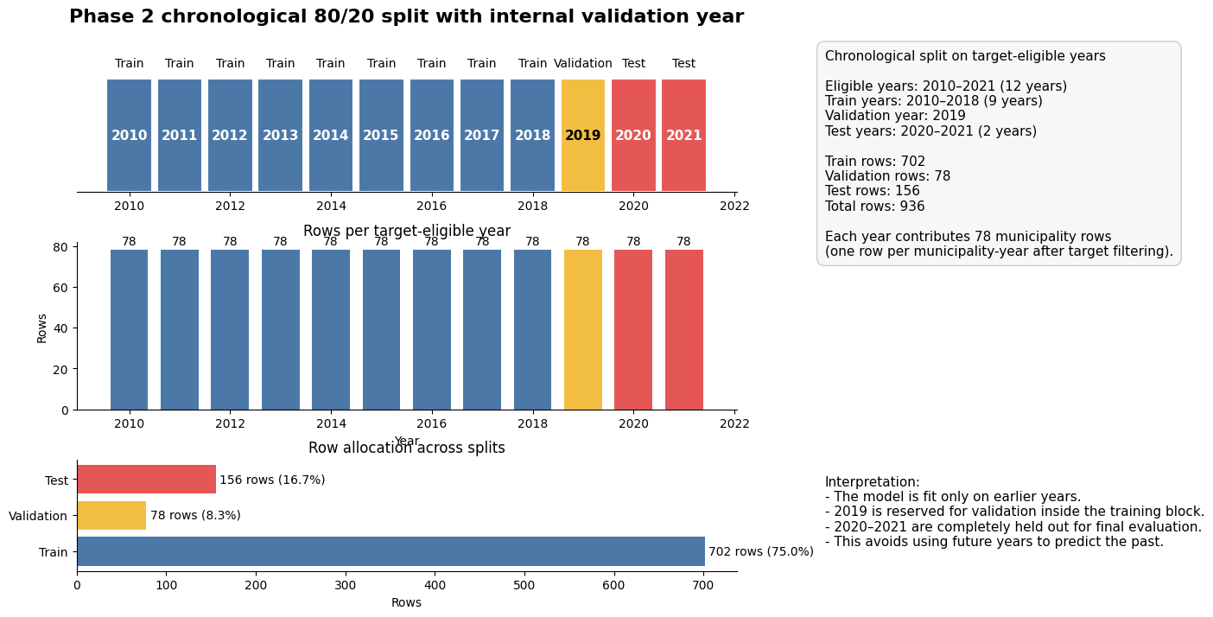
Figure 1: Chronological train-validation-test split. The model is trained on earlier years, tuned on 2019, and tested on future years to avoid leakage.
2.3 Interpretation:
The EDA results guided the modeling plan. Because population change was strongly path-dependent, the final model needed to leverage lagged and rolling features. The weak direct disaster relationships also suggested that disasters should not be treated as simple one-period predictors. Instead, their effects are likely transmitted through migration responses, economic disruptions, and persistent demographic momentum.
3. Predictive Modeling and Temporal Validation
3.1 Methodology:
The modeling phase used a chronological split rather than a random split. This is essential because the goal is forecasting: the model should learn from earlier years and be evaluated on later, unseen years. Target-eligible years were divided into training years, a validation year, and final test years. In the final setup, the training set includes years up to 2018, 2019 is used for validation, and years 2020 and later are held out for testing.
Several linear and nonlinear methods were evaluated, including OLS, Ridge, Random Forest, Extra Trees, HistGradientBoosting, and Lasso. Lasso was selected because it delivered the strongest out-of-sample performance while remaining interpretable. This was especially important because the feature space includes many lagged and correlated predictors.
3.2 Results:
· Final selected model: tuned Lasso regression.
· Validation R²: approximately 0.9526.
· Test R²: approximately 0.9092.
· Test RMSE: approximately 0.4531.
· Tree-based models performed worse under the chronological split, while unregularized OLS showed weaker generalization.
3.3 Interpretation:
The Lasso results reinforce the Phase 1 finding that Puerto Rico population change is highly path-dependent. The strongest predictors are lagged population and rolling temporal variables. Coefficients and SHAP analysis confirm that disaster-related features do not emerge as dominant standalone predictors in the final fitted model. This does not mean disasters are unimportant; rather, their effects appear to be indirect, delayed, and embedded in subsequent population dynamics.
The model is therefore best understood as a forecasting backbone: it captures the persistence of municipal population trends and provides a stable structure for later scenario and policy analysis.
4. Scenario Forecasting and Model Validation
4.1 Methodology:
Phase 3 carries forward the validated Phase 2 Lasso model into a multi-scale scenario forecasting framework. The notebook applies stylized hurricane and earthquake shocks through the engineered feature space and produces municipal, regional, and island-level forecasts through 2030. The same backbone model is used to preserve consistency across phases.
The scenario engine includes baseline forecasts, hurricane intensity scenarios, earthquake magnitude scenarios, and a Maria-like backtest. Uncertainty is represented using simulated prediction intervals and summary percentiles.
4.2 Results:
Scenario results show that severe hurricane scenarios generate the largest long-run population losses relative to baseline. Earthquake scenarios also reduce projected population, though high-magnitude earthquake scenarios become similar at the aggregate level, suggesting a practical ceiling in the stylized overlay design. The Maria backtest captures the direction of post-disaster decline, but it tends to overestimate long-run population loss, so scenario outputs should be interpreted as structured stress tests rather than precise causal forecasts.
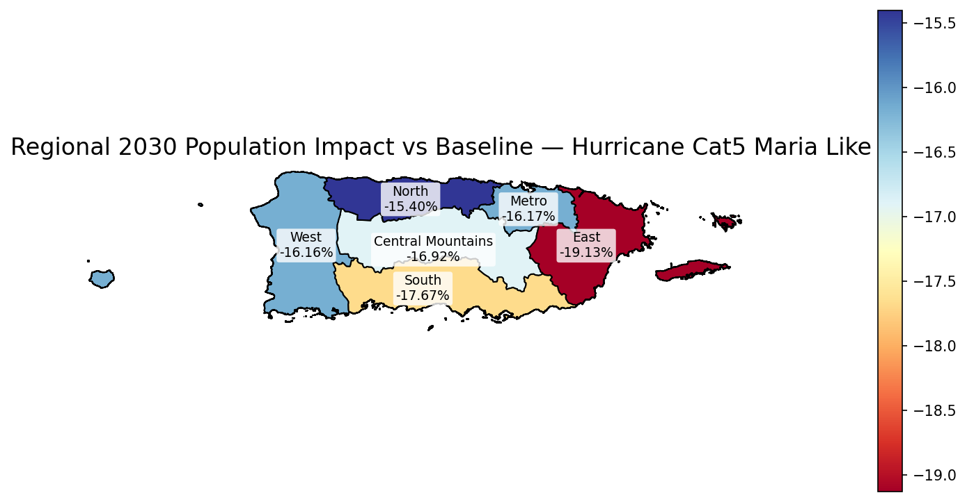
Figure 2: Regional 2030 population impact map for a Maria-like hurricane scenario. Scenario results show spatially uneven impacts across Puerto Rico.
4.3 Interpretation:
The scenario results strengthen the central interpretation of the project: disasters amplify existing population trends rather than creating demographic decline from scratch. Population trajectories remain shaped by the model’s strong temporal structure. This is why the scenario layer is presented as a stress-testing framework, not a causal disaster-impact model.
5. Policy Response and Recovery Rebound Analysis
5.1 Methodology:
Phase 4 extends the forecasting framework into model-based policy simulation. Policy packages modify policy-relevant input features such as income growth, establishment growth, crime rates, vulnerability, demographic support, and lagged population momentum. These adjusted features are then passed through the validated forecasting backbone to estimate how predicted outcomes shift under alternative policy conditions.
The policy simulations are counterfactual stress tests, not causal treatment-effect estimates. They show how the fitted model responds when observed municipal conditions are improved under stylized policy packages.
5.2 Results:
Standard policy packages improve outcomes and slow projected decline, but they do not fully reverse Puerto Rico’s underlying demographic momentum. The retention bundle performs better than isolated policies because it combines economic, safety, vulnerability, and demographic improvements. However, even coordinated policy improvements remain bounded by strong lagged population dynamics.
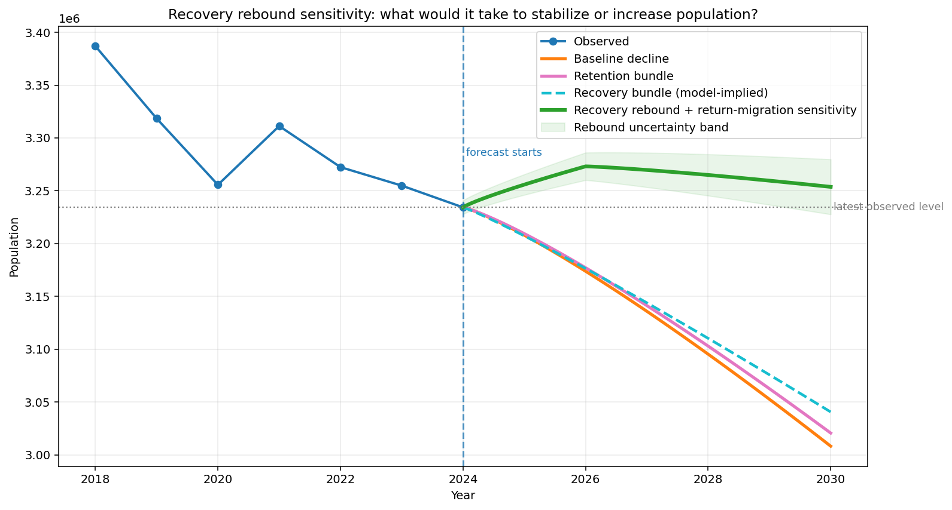
Figure 3: Island-level recovery rebound sensitivity. Standard policy packages slow decline, while stabilization or temporary increase requires an additional return-migration or recovery-momentum layer.
5.3 Recovery Bundle vs. Recovery Rebound Sensitivity:
The Recovery bundle is model-implied. It applies stronger feature improvements and lets the fitted Lasso model translate those changes into a projected population path. This improves the forecast but still generally follows a declining trajectory because the learned demographic momentum remains negative.
The Recovery rebound plus return-migration sensitivity is different. It adds an explicit optimistic recovery layer on top of the model-implied response. This line asks a “what-would-it-take” question: what additional recovery momentum would be needed for population to stabilize or temporarily increase? This sensitivity case is not a causal estimate and should not replace the baseline policy results. Instead, it clarifies the scale of intervention needed to overcome persistent decline.
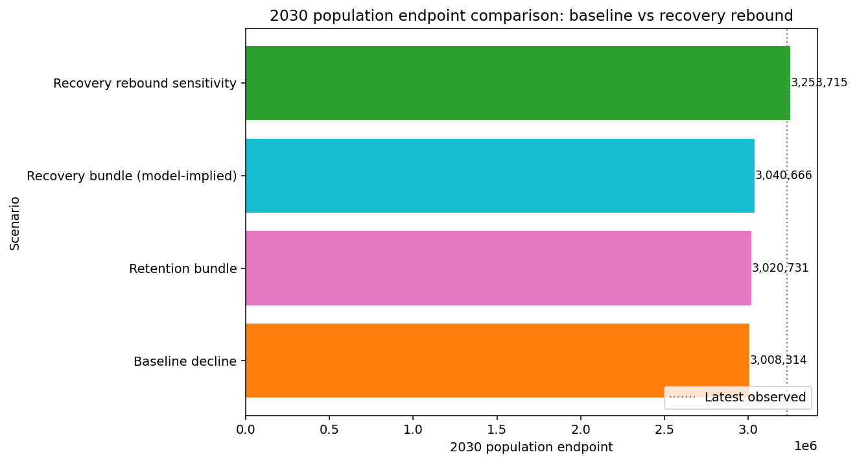
Figure 4: Recovery scenario gains relative to baseline. The rebound sensitivity produces the largest gain because it adds return-migration and recovery momentum beyond model-implied policy changes.
5.4 Interpretation:
The policy analysis provides the most actionable output of the project. It shows that policy interventions can alter projected trajectories, but true population recovery requires coordinated structural improvement and migration dynamics strong enough to offset persistent decline. For decision-makers, the implication is that isolated programs are unlikely to reverse population loss. A more effective approach would combine job creation, safety improvements, vulnerability reduction, family support, housing/infrastructure recovery, and return-migration incentives.
6. Final Conclusion
This project successfully developed a full population forecasting and policy analysis framework for Puerto Rico. The analysis identified a clear hierarchy of drivers:
1. Temporal population dynamics: lagged and rolling population variables are the dominant drivers of forecasts.
2. Structural context: economic, demographic, vulnerability, and regional variables provide important modifiers.
3. Disaster effects: hurricanes and earthquakes act as amplifiers of existing decline rather than dominant direct predictors.
4. Policy response: coordinated policy bundles can slow decline, but reversal requires a stronger recovery dynamic involving return migration and sustained improvements.
The final implication is that Puerto Rico’s population decline is persistent, structured, and predictable, but not entirely fixed. Model-based policy analysis suggests that interventions can improve outcomes. However, stabilizing or increasing population likely requires coordinated recovery strategies strong enough to change the underlying demographic trajectory.
References
[1] United States Census Bureau. Population and demographic data used for Puerto Rico municipal analysis.
[2] Federal Emergency Management Agency (FEMA) and related public hazard data sources. Hurricane and disaster exposure data.
[3] Centers for Disease Control and Prevention / Social Vulnerability Index documentation. Social vulnerability concepts and indicators.
[4] Pedregosa, F. et al. (2011). Scikit-learn: Machine Learning in Python. Journal of Machine Learning Research.
[5] Lundberg, S. M., & Lee, S.-I. (2017). A Unified Approach to Interpreting Model Predictions. Advances in Neural Information Processing Systems.
[6] Course materials and capstone project guidance. Rutgers, The State University of New Jersey, Camden.
APPENDIX 1. PYTHON CODE EXCERPTS
# Chronological split used in Phase 2
train_years = [year for year in eligible_years if year <= 2018]
val_year = 2019
test_years = [year for year in eligible_years if year >= 2020]

# Final model backbone
final_pipeline = Pipeline([
("preprocessing", preprocessor),
("model", Lasso(alpha=best_alpha, max_iter=10000))
])
final_pipeline.fit(X_train, y_train)

# Phase 3 / Phase 4 artifact loading
phase3_backbone_path = Path("Phase3/models/phase3_v7_backbone_pipeline.joblib")
backbone_pipeline = joblib.load(phase3_backbone_path)

# Policy counterfactual mechanism
policy_frame = latest_feature_frame.copy()
policy_frame = apply_policy_package(policy_frame, package_definition)
policy_prediction = backbone_pipeline.predict(policy_frame)
APPENDIX 2. SELECTED OUTPUT SUMMARY
Phase 2 model performance:
· Best model: tuned Lasso regression.
· Validation R²: approximately 0.9526.
· Test R²: approximately 0.9092.
· Test RMSE: approximately 0.4531.
Phase 3 scenario interpretation:
· Baseline decline remains substantial through 2030.
· Hurricane scenarios generally produce larger losses than earthquake scenarios in the stylized framework.
· Maria-like backtest captures directional decline but may overestimate long-run population loss.
Phase 4 policy interpretation:
· Policy packages improve outcomes but standard packages do not fully reverse decline.
· Recovery rebound sensitivity shows the extra return-migration or recovery momentum needed for stabilization or growth.
· Results should be interpreted as predictive counterfactual stress tests, not causal estimates.

I need to add a Readme file on the GitRepo
I need to add explanation on what each model line means and the exact changes done that produce those results.

