Statistical Drivers of Medical Insurance Costs
Jose A. Riveraruiz
Rutgers, The State University of New Jersey, Camden, NJ 08102 US

ABSTRACT. This project analyzes the “Medical Cost Personal Dataset” (N = 1338) to identify the primary factors driving healthcare expenses. Utilizing R, we performed a comprehensive statistical evaluation including Pearson Correlation, Non–Parametric Hypothesis Testing (Wilcoxon Rank Sum), Two-Way Analysis of Variance (ANOVA), and Chi-Square Goodness of Fit testing. The analysis reveals that lifestyle choices, specifically smoking, are the overwhelmingly dominant predictor of costs (p < 0.001), overshadowing geographic location. While regional differences exist (p < 0.001), they are not driven by smoking prevalence, as verified by independence testing.

Introduction

  - Background and Objective: In the insurance industry, accurate risk assessment is critical for setting premiums that cover expected losses while remaining competitive. Medical charges are rarely normally distributed; they are often characterized by a large number of low-cost claims and a “long tail” of extremely high-cost outliers. Medical charges follow a heavily right-skewed distribution, with many low-cost claims and a long tail of high-utilization outliers. This project aims to apply statistical methods to disentangle the effects of physiological factors (Body Mass Index), lifestyle choices (Smoking), and demographic factors (Region) on medical charges.

  - Dataset Description: The analysis utilizes the “Medical Cost Personal Dataset”, consisting of 1,338 observations. The key variables examined in this study include:

    - Charges (Dependent Variable): Individual medical costs billed by health insurance (Continuous).
    - Body Mass Index (BMI) (Independent Variable): Body mass index, providing an understanding of body weights that are relatively high or low relative to height (Continuous).
    - Smoker (Independent Variable): Smoking status of the beneficiary (Categorical: Yes/No).
    - Region (Independent Variable): The beneficiary’s residential area in the US: Northeast, Northwest, Southeast, Southwest (Categorical).

  - Research Questions

- How do BMI and smoking status individually and jointly relate to medical charges?
- Given the non-normal distribution of charges, is there a statistically significant difference in median costs between smokers and non-smokers?
- Do regional cost differences persist after controlling for smoking?
- Is smoking prevalence independent of geographic region?

Descriptive Statistics & Correlation Analysis

  - Methodology: We began by analyzing the relationship between BMI and Charges using the Pearson Correlation Coefficient (r). This falls under the domain of descriptive statistics (describing relationships between continuous variables).

  - Results: The Pearson correlation test yielded a statistically significant result:

    - Correlation (r): 0.198
    - P-value: 2.459e⁻¹³

While a coefficient of 0.198 suggests a weak positive correlation overall, visually inspecting the data reveals a more complex story. As shown in Figure 1, the data is split into two distinct clusters.

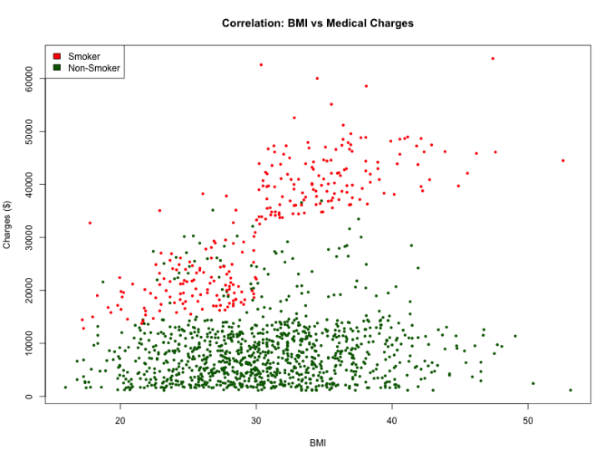
Figure 1: Scatterplot of BMI vs. Medical Charges. Smokers (red) show a strong positive correlation, while non-smokers (green) do not.
  - Interpretation: The scatterplot clearly demonstrates an interaction effect.

    - Non-Smokers (Green points): Exhibit a relatively flat relationship; increasing BMI does not drastically increase costs.
    - Smokers (Red points): Exhibit a steep, positive linear relationship. For smokers, a higher BMI correlates strongly with skyrocketing medical costs. This suggests that BMI is a significant financial risk factor primarily when combined with smoking.

Non-Parametric Hypothesis Testing

  - Assumption Checking: Standard parametric tests (like the T-Test) assume that the data follows a normal (bell curve) distribution. As illustrated in Figure 2, the medical charges in this dataset are heavily right-skewed with a long tail of outliers. Due to this violation of normality, we selected the Wilcoxon Rank Sum Test (Mann–Whitney U), which is robust against non-normal data and compares medians rather than means.

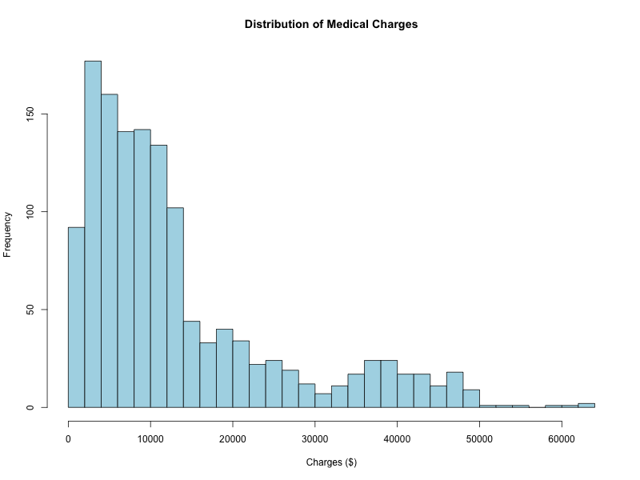

Figure 2: Distribution of Medical Charges. The histogram displays a heavily right-skewed distribution with a long tail of high-cost outliers. This violation of normality justifies the use of the non-parametric Wilcoxon Rank Sum test instead of a T-test.

  - Test: Smoker vs. Non-Smoker

    - Null Hypothesis (H₀): The distribution of charges is the same for smokers and non-smokers.
    - Alternative Hypothesis (H₁): The distributions differ.

  - Results

    - Test Statistic (W): 7403
    - P-value: < 2.2e⁻¹⁶

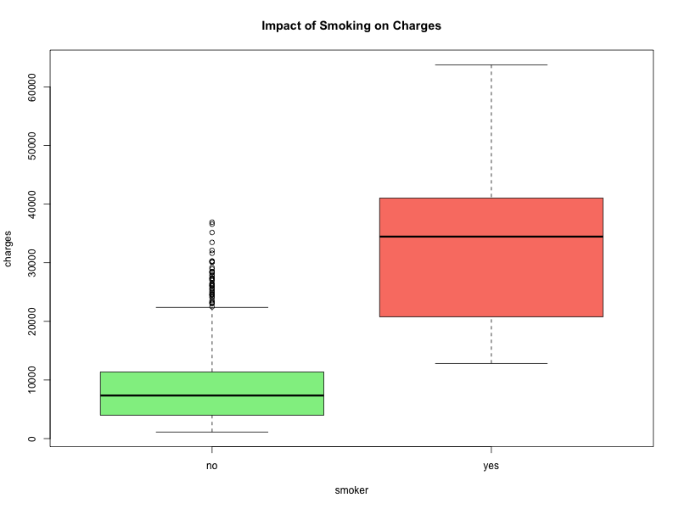

Figure 3: Distribution of Charges by Smoking Status. The median cost for smokers is significantly higher than for non-smokers.
  - Conclusion: With a p-value far below the significance level (α = 0.05), we reject the null hypothesis. The boxplot (Figure 3) highlights the magnitude of this difference: the median cost for smokers is roughly triple that of non-smokers. Beyond statistical significance, the magnitude of difference is substantial: the median charge for smokers exceeds that of non-smokers by approximately a factor of three. This confirms that smoking is the single most significant predictor of high medical costs in this dataset.

Multi-Factor Analysis of Variance (Two-Way ANOVA)

  - Methodology: To investigate geographic differences, a simple One-Way ANOVA would be insufficient because smoking distorts the data. Instead, we utilized a Two-Way ANOVA (Factorial Design) including an interaction term. This allows us to model Charges as a function of Region, Smoker, and the interaction between them (Region * Smoker).

  - Results (Two-Way ANOVA with Interaction)

    - Region: F(3, 1330) = 7.90, p < .001 (Significant)
    - Smoker: F(1, 1330) = 2191.34, p < .001 (Significant)
    - Interaction (Region × Smoker): F(3, 1330) = 8.60, p < .001(Significant)

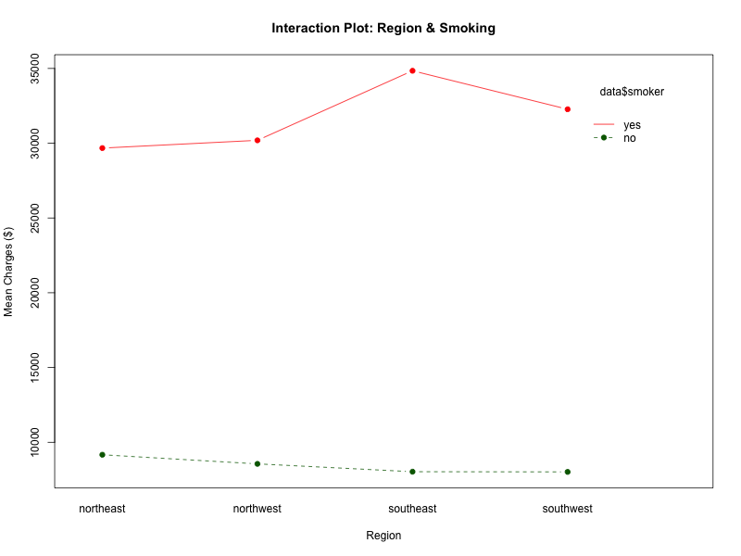

Figure 4: Interaction Plot of Region and Smoking. Parallel lines indicate the smoking effect is consistent across all four regions.

  - Interpretation: The ANOVA results reveal a statistically significant interaction between Region and Smoking (p < 0.001). However, comparing the F-values puts this in perspective. The Main Effect of Smoking (F ≈ 2191) is vastly larger than both the Region effect (F ≈ 7.9) and the Interaction effect (F ≈ 8.6).

While the interaction is statistically significant, this is likely driven by the high statistical power of our large sample size rather than a major practical difference. The visual evidence in the Interaction Plot (Figure 4) displays nearly parallel lines, indicating that the "smoker penalty" is largely consistent across all regions. Therefore, smoking status remains the primary driver of costs regardless of geography.
  - Post-Hoc Analysis (Tukey HSD): Since the ANOVA indicated a significant difference for Region, we performed Tukey’s Honestly Significant Difference (HSD) test to pinpoint exactly which regions differed.

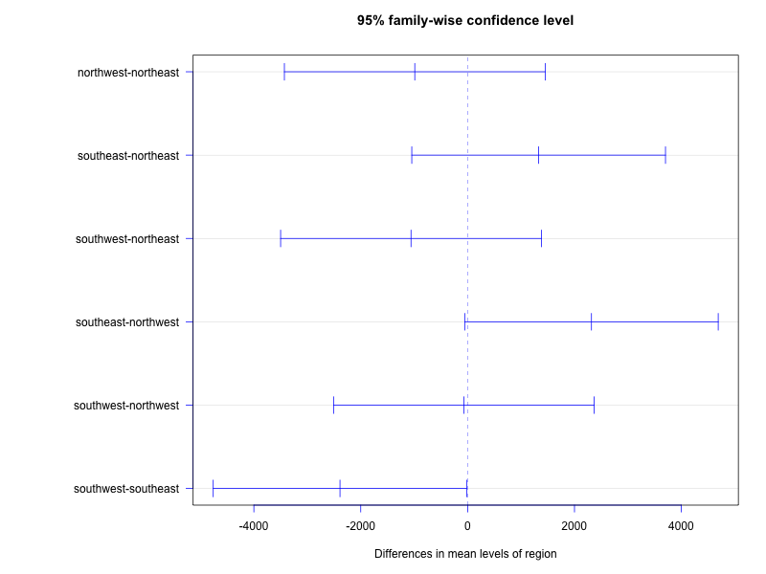

Figure 5: Tukey HSD 95% Confidence Intervals. The Southeast-Southwest comparison is the only significant difference (does not cross zero).
Key Finding: The only statistically significant pairwise difference was between the Southeast and Southwest (p ≈ 0.047), with the Southeast showing higher average costs. All other regional comparisons (e.g., Northwest vs. Northeast) were not statistically significant.

Chi-Square Test of Independence

Methodology: Given that the “Southeast” region had higher costs, we hypothesized that perhaps more smokers live in the Southeast. To test this, we performed a Chi-Square Test of Independence (X²).

    - Null Hypothesis (H₀): Smoking status is independent of Region.
    - Alternative Hypothesis (H₁): Smoking status is dependent on Region.

Results

    - X-squared: 7.3435
    - Degrees of Freedom: 3
    - P-value: 0.06172

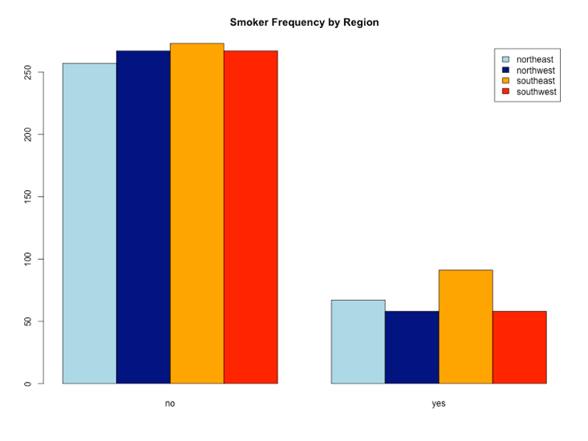

Figure 6: Frequency of Smokers by Region. The consistent proportion of smokers across regions supports the finding of statistical independence.

Conclusion: The p-value of 0.06172 exceeds the standard alpha of 0.05. Therefore, we fail to reject the null hypothesis.

This is a crucial finding for our report. Although the Chi-Square statistic (X² = 7.34, p = 0.062) is close to the α = 0.05 threshold, it does not reach statistical significance. This supports the conclusion that regional cost disparities are not driven by variation in smoking prevalence. It implies that smoking habits are statistically consistent across all four regions. The higher costs observed in the Southeast (from our ANOVA analysis) are not caused by a higher prevalence of smokers in that area. Instead, other unobserved variables (likely the higher BMI average in the Southeast, which is a known demographic trend) are likely driving the regional cost difference.

Final Conclusion

This statistical analysis successfully identified the hierarchy of risk factors for medical insurance costs:

Lifestyle (Smoking): This is the overwhelming driver of cost. Smokers have a distinct, higher cost distribution (p < 0.001) and a steeper correlation with BMI.

Physiology (BMI): BMI is positively correlated with costs (r = 0.198), but its risk is severely compounded by smoking.

Demographics (Region): While statistically significant (p < 0.001), the regional effect is small. The Southeast is slightly more expensive than the Southwest, but this is not due to smoking rates, as confirmed by the Chi-Square test of independence.

Implication: Based on these findings, insurance risk models should weigh smoking status and BMI heavily. Geographic region, while relevant, serves as a secondary factor.

References

- Dataset Source: Lantz, B. (2019). Machine Learning with R: Expert techniques for predictive modeling (3rd ed.). Packt Publishing. Data retrieved from: https://github.com/stedy/Machine-Learning-with-R-datasets

- Statistical Software: R Core Team. (2025). R: A language and environment for statistical computing. R Foundation for Statistical Computing, Vienna, Austria. https://www.R-project.org/

- Course Materials: Kushary, D. (2025). STAT-Methods-DS: Course Lecture Notes and Exam Materials. [Rutgers, The State University of New Jersey, Camden].

APPENDIX 1. R CODE

# =====================================================================
# PROJECT: Statistical Analysis of Medical Insurance Costs
# TOPICS: Non-Parametrics, Two-Way ANOVA, Correlation, Chi-Square
# =====================================================================

# --- STEP 1: SETUP ------------------------------------------------------------
file_name <- "insurance.csv"
url <- "https://raw.githubusercontent.com/stedy/Machine-Learning-with-R-datasets/master/insurance.csv"

if (!file.exists(file_name)) { download.file(url, destfile = file_name) }
data <- read.csv(file_name)
message("Data Loaded. N = ", nrow(data))

# =====================================================================
# ANALYSIS 1: DESCRIPTIVE & CORRELATION (BMI vs Charges)
# Relevance: Modules 1 & 2 (Descriptive Stats)
# =====================================================================
message("\n--- ANALYSIS 1: Correlation (BMI vs Charges) ---")

# Calculate Pearson Correlation
cor_test <- cor.test(data$bmi, data$charges)
print(cor_test)

# SAVE PLOT 1: Scatterplot
png("01_Scatterplot_BMI_Charges.png", width = 800, height = 600)
# Color points by smoker status (Red=Smoker, Green=Non-Smoker)
colors <- ifelse(data$smoker == "yes", "red", "darkgreen")
plot(data$bmi, data$charges,
main = "Correlation: BMI vs Medical Charges",
xlab = "BMI", ylab = "Charges ($)",
col = colors, pch = 16, cex = 0.7)
legend("topleft", legend=c("Smoker", "Non-Smoker"), fill=c("red", "darkgreen"))
dev.off()
message("Saved: 01_Scatterplot_BMI_Charges.png")

# =====================================================================
# ANALYSIS 1B: NORMALITY CHECK (Histogram)
# Relevance: Justifies using Non-Parametric Tests
# =====================================================================
message("\n--- ANALYSIS 1B: Normality Check ---")

# SAVE PLOT: Histogram
png("01B_Histogram_Charges.png", width = 800, height = 600)
hist(data$charges,
main = "Distribution of Medical Charges",
xlab = "Charges ($)",
col = "lightblue",
breaks = 30)
dev.off()
message("Saved: 01B_Histogram_Charges.png")

# =====================================================================
# ANALYSIS 2: NON-PARAMETRIC TEST (Smoker Effect)
# Relevance: Module 8 (Non-Parametrics)
# =====================================================================
message("\n--- ANALYSIS 2: Non-Parametric Test (Smoker) ---")

# SAVE PLOT 2: Boxplot
png("02_Boxplot_Smoker.png", width = 800, height = 600)
boxplot(charges ~ smoker, data = data,
main = "Impact of Smoking on Charges",
col = c("lightgreen", "salmon"))
dev.off()
message("Saved: 02_Boxplot_Smoker.png")

# Wilcoxon Test
print(wilcox.test(charges ~ smoker, data = data))

# =====================================================================
# ANALYSIS 3A: INTERACTION CHECK (New Step)
# This tests if we are ALLOWED to use the additive model (+)
# =====================================================================
message("\n--- ANALYSIS 3A: Checking for Interaction (Region * Smoker) ---")
interaction_model <- aov(charges ~ region * smoker, data = data)
print(summary(interaction_model))
message("Note: If 'region:smoker' p-value is > 0.05, the interaction is NOT significant.")

# =====================================================================
# ANALYSIS 3B: TWO-WAY ANOVA (Region + Smoker)
# Relevance: Module 9 (ANOVA) & Sample Test 2 Q2 (Two-Factor Model)
# =====================================================================
message("\n--- ANALYSIS 3B: Main Additive Model (Region + Smoker) ---")

# We fit a model with BOTH factors to see independent effects
# Model: Charges = Region + Smoker
two_way_model <- aov(charges ~ region + smoker, data = data)
print(summary(two_way_model))

# SAVE PLOT 3: Interaction Plot
# This visualizes if the effect of region changes based on smoking status
png("03_Interaction_Plot.png", width = 800, height = 600)
interaction.plot(x.factor = data$region,
trace.factor = data$smoker,
response = data$charges,
fun = mean,
type = "b", legend = TRUE,
col = c("darkgreen", "red"), pch = 19,
main = "Interaction Plot: Region & Smoking",
xlab = "Region", ylab = "Mean Charges ($)")
dev.off()
message("Saved: 03_Interaction_Plot.png")

# =====================================================================
# ANALYSIS 4: REGIONAL DIFFERENCES (One-Way ANOVA Post-Hoc)
# Relevance: Sample Test 2 Q4
# =====================================================================
# We still run the standard one-way to get the specific regional Tukey values
one_way_model <- aov(charges ~ region, data = data)
tukey_res <- TukeyHSD(one_way_model)

# SAVE PLOT 4: Tukey Plot
png("04_Tukey_Region.png", width = 800, height = 600)

# FIX: Increased left margin to 14 to fit long labels
par(mar=c(5, 14, 4, 2))

plot(tukey_res, las=1, col="blue")
dev.off()
message("Saved: 04_Tukey_Region.png")

# =====================================================================
# ANALYSIS 5: CHI-SQUARE (Independence)
# Relevance: Module 10
# =====================================================================
message("\n--- ANALYSIS 5: Chi-Square ---")

tbl <- table(data$region, data$smoker)
print(chisq.test(tbl))

# SAVE PLOT 5: Barplot
png("05_Barplot_Region_Smoker.png", width = 800, height = 600)
barplot(tbl, beside=TRUE, legend=TRUE, col=c("lightblue", "navy", "orange", "red"),
main="Smoker Frequency by Region")
dev.off()
message("Saved: 05_Barplot_Region_Smoker.png")

message("Done.")
APPENDIX 2. R CODE OUTPUT

> setwd("~/Library/CloudStorage/OneDrive-Personal/DataSci/Classes/StatMethods_DS/Project")
> # =====================================================================
> # PROJECT: Statistical Analysis of Medical Insurance Costs
> # TOPICS: Non-Parametrics, Two-Way ANOVA, Correlation, Chi-Square
> # =====================================================================
>
> # --- STEP 1: SETUP ------------------------------------------------------------
> file_name <- "insurance.csv"
> url <- "https://raw.githubusercontent.com/stedy/Machine-Learning-with-R-datasets/master/insurance.csv"
>
> if (!file.exists(file_name)) { download.file(url, destfile = file_name) }
> data <- read.csv(file_name)
> message("Data Loaded. N = ", nrow(data))
Data Loaded. N = 1338
>
> # =====================================================================
> # ANALYSIS 1: DESCRIPTIVE & CORRELATION (BMI vs Charges)
> # Relevance: Modules 1 & 2 (Descriptive Stats)
> # =====================================================================
> message("\n--- ANALYSIS 1: Correlation (BMI vs Charges) ---")

--- ANALYSIS 1: Correlation (BMI vs Charges) ---
>
> # Calculate Pearson Correlation
> cor_test <- cor.test(data$bmi, data$charges)
> print(cor_test)

Pearson's product-moment correlation

data: data$bmi and data$charges
t = 7.3966, df = 1336, p-value = 2.459e-13
alternative hypothesis: true correlation is not equal to 0
95 percent confidence interval:
0.1463052 0.2492822
sample estimates:
cor
0.198341

>
> # SAVE PLOT 1: Scatterplot
> png("01_Scatterplot_BMI_Charges.png", width = 800, height = 600)
> # Color points by smoker status (Red=Smoker, Green=Non-Smoker)
> colors <- ifelse(data$smoker == "yes", "red", "darkgreen")
> plot(data$bmi, data$charges,
+ main = "Correlation: BMI vs Medical Charges",
+ xlab = "BMI", ylab = "Charges ($)",
+ col = colors, pch = 16, cex = 0.7)
> legend("topleft", legend=c("Smoker", "Non-Smoker"), fill=c("red", "darkgreen"))
> dev.off()
null device
1
> message("Saved: 01_Scatterplot_BMI_Charges.png")
Saved: 01_Scatterplot_BMI_Charges.png
>
>
> # =====================================================================
> # ANALYSIS 2: NON-PARAMETRIC TEST (Smoker Effect)
> # Relevance: Module 8 (Non-Parametrics)
> # =====================================================================
> message("\n--- ANALYSIS 2: Non-Parametric Test (Smoker) ---")

--- ANALYSIS 2: Non-Parametric Test (Smoker) ---
>
> # SAVE PLOT 2: Boxplot
> png("02_Boxplot_Smoker.png", width = 800, height = 600)
> boxplot(charges ~ smoker, data = data,
+ main = "Impact of Smoking on Charges",
+ col = c("lightgreen", "salmon"))
> dev.off()
null device
1
> message("Saved: 02_Boxplot_Smoker.png")
Saved: 02_Boxplot_Smoker.png
>
> # Wilcoxon Test
> print(wilcox.test(charges ~ smoker, data = data))

Wilcoxon rank sum test with continuity correction

data: charges by smoker
W = 7403, p-value < 2.2e-16
alternative hypothesis: true location shift is not equal to 0

>
>
> # =====================================================================
> # ANALYSIS 3A: INTERACTION CHECK (New Step)
> # This tests if we are ALLOWED to use the additive model (+)
> # =====================================================================
> message("\n--- ANALYSIS 3A: Checking for Interaction (Region * Smoker) ---")

--- ANALYSIS 3A: Checking for Interaction (Region * Smoker) ---
> interaction_model <- aov(charges ~ region * smoker, data = data)
> print(summary(interaction_model))
Df Sum Sq Mean Sq F value Pr(>F)
region 3 1.301e+09 4.336e+08 7.896 3.19e-05 ***
smoker 1 1.203e+11 1.203e+11 2191.337 < 2e-16 ***
region:smoker 3 1.416e+09 4.721e+08 8.598 1.18e-05 ***
Residuals 1330 7.303e+10 5.491e+07
---
Signif. codes: 0 ‘***’ 0.001 ‘**’ 0.01 ‘*’ 0.05 ‘.’ 0.1 ‘ ’ 1
> message("Note: If 'region:smoker' p-value is > 0.05, the interaction is NOT significant.")
Note: If 'region:smoker' p-value is > 0.05, the interaction is NOT significant.
>
>
> # =====================================================================
> # ANALYSIS 3B: TWO-WAY ANOVA (Region + Smoker)
> # Relevance: Module 9 (ANOVA) & Sample Test 2 Q2 (Two-Factor Model)
> # =====================================================================
> message("\n--- ANALYSIS 3B: Main Additive Model (Region + Smoker) ---")

--- ANALYSIS 3B: Main Additive Model (Region + Smoker) ---
>
> # We fit a model with BOTH factors to see independent effects
> # Model: Charges = Region + Smoker
> two_way_model <- aov(charges ~ region + smoker, data = data)
> print(summary(two_way_model))
Df Sum Sq Mean Sq F value Pr(>F)
region 3 1.301e+09 4.336e+08 7.764 3.85e-05 ***
smoker 1 1.203e+11 1.203e+11 2154.498 < 2e-16 ***
Residuals 1333 7.445e+10 5.585e+07
---
Signif. codes: 0 ‘***’ 0.001 ‘**’ 0.01 ‘*’ 0.05 ‘.’ 0.1 ‘ ’ 1
>
> # SAVE PLOT 3: Interaction Plot
> # This visualizes if the effect of region changes based on smoking status
> png("03_Interaction_Plot.png", width = 800, height = 600)
> interaction.plot(x.factor = data$region,
+ trace.factor = data$smoker,
+ response = data$charges,
+ fun = mean,
+ type = "b", legend = TRUE,
+ col = c("darkgreen", "red"), pch = 19,
+ main = "Interaction Plot: Region & Smoking",
+ xlab = "Region", ylab = "Mean Charges ($)")
> dev.off()
null device
1
> message("Saved: 03_Interaction_Plot.png")
Saved: 03_Interaction_Plot.png
>
>
> # =====================================================================
> # ANALYSIS 4: REGIONAL DIFFERENCES (One-Way ANOVA Post-Hoc)
> # Relevance: Sample Test 2 Q4
> # =====================================================================
> # We still run the standard one-way to get the specific regional Tukey values
> one_way_model <- aov(charges ~ region, data = data)
> tukey_res <- TukeyHSD(one_way_model)
>
> # SAVE PLOT 4: Tukey Plot
> png("04_Tukey_Region.png", width = 800, height = 600)
>
> # FIX: Increased left margin to 14 to fit long labels
> par(mar=c(5, 14, 4, 2))
>
> plot(tukey_res, las=1, col="blue")
> dev.off()
null device
1
> message("Saved: 04_Tukey_Region.png")
Saved: 04_Tukey_Region.png
>
>
> # =====================================================================
> # ANALYSIS 5: CHI-SQUARE (Independence)
> # Relevance: Module 10
> # =====================================================================
> message("\n--- ANALYSIS 5: Chi-Square ---")

--- ANALYSIS 5: Chi-Square ---
>
> tbl <- table(data$region, data$smoker)
> print(chisq.test(tbl))

Pearson's Chi-squared test

data: tbl
X-squared = 7.3435, df = 3, p-value = 0.06172

>
> # SAVE PLOT 5: Barplot
> png("05_Barplot_Region_Smoker.png", width = 800, height = 600)
> barplot(tbl, beside=TRUE, legend=TRUE, col=c("lightblue", "navy", "orange", "red"),
+ main="Smoker Frequency by Region")
> dev.off()
null device
1
> message("Saved: 05_Barplot_Region_Smoker.png")
Saved: 05_Barplot_Region_Smoker.png
>
> message("Done.")
Done.
>

