Population & Migration Forecasting in Puerto Rico
Jose Andres RiveraRuiz
Rutgers, The State University of New Jersey, Camden, NJ 08102 US

Abstract. This project develops a machine learning framework to forecast population change in Puerto Rico and evaluate disaster and policy scenarios using local-level demographic, economic, social vulnerability, public safety, business activity, and disaster exposure data. The analysis transforms these data into a forecasting system focused on regional and islandwide population trends. A chronological train-validation-test design prevents temporal leakage, and a tuned Lasso regression model is selected as the final predictive backbone because it combines strong out-of-sample performance with interpretability. The model achieves strong test performance, with an R-squared of approximately 0.9092 and RMSE of approximately 0.4531. Results show that population change is highly path-dependent, driven largely by lagged population trends, natural vital-rate conditions, and persistent local characteristics. Disasters are best understood as accelerants that amplify existing demographic and vulnerability patterns rather than as simple direct drivers. Policy simulations show that coordinated interventions can slow decline, while stabilization or growth likely requires stronger recovery momentum, return migration, and sustained structural improvement. Overall, the framework provides predictive counterfactuals and planning insights.

Executive Summary
The problem: Puerto Rico has experienced a turbulent demographic period since 2010, shaped by economic stagnation, fiscal stress, outward migration, natural population decrease, Hurricane Maria, and the 2020 seismic sequence. Population changes matters because it affects municipal and islandwide solvency, school enrollment, health-care demand, infrastructure investment, emergency planning, labor markets, and long-run economic development. These demographic shifts are not evenly distributed across the island; some regions face deeper and more persistent losses because economic vulnerability, aging population structures, disaster exposure, and limited recovery capacity overlap. As a result, population forecasting in Puerto Rico is not only a statistical problem, but also a planning challenge. Reliable forecasts can help policymakers, planners, and emergency-management agencies understand where population decline is most persistent, where recovery is most difficult, and which interventions may help slow or stabilize future losses. Rather than treating population change as a simple year-to-year trend, this project examines it as a long-term, path-dependent process shaped by historical population momentum, structural conditions, and shock events.
Project approach: The project uses a structured pipeline that connects data integration and feature engineering, predictive modeling and interpretability, disaster scenario forecasting, scenario analysis, and policy-response simulation. As shown in the workflow, the analysis begins with detailed local data on population structure, economic conditions, social vulnerability, and disaster exposure. These inputs are transformed into a predictive modeling framework using a chronological train-test design and an interpretable Lasso model. The model is then extended into baseline and disaster scenario forecasts through 2030, allowing hurricane and earthquake shocks to be evaluated across regional and islandwide population paths. The final step applies policy-response simulations to test how combinations of jobs, investment, public safety, and recovery strategies may reduce projected population loss. This design moves the project beyond a descriptive study of decline and turns it into a forecasting and strategic planning framework that connects historical population dynamics to future risks, policy alternatives, and long-term recovery planning.
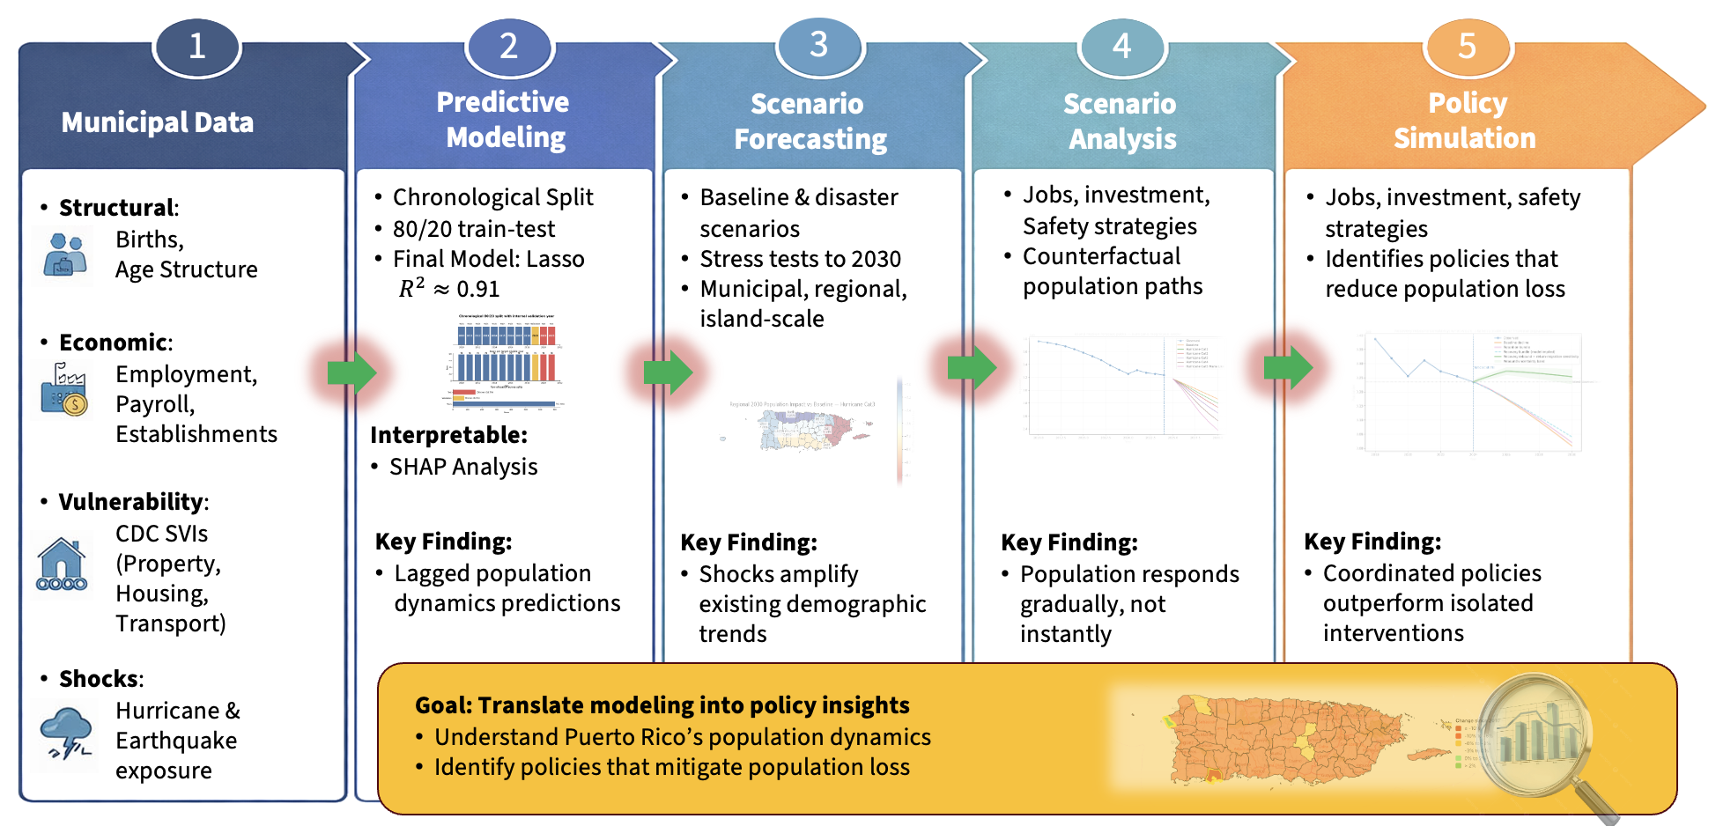
Figure 1. End-to-End Population Forecasting and Policy Simulation Workflow

Key finding: Population decline in Puerto Rico is not random. The analysis shows that population change is structured, shaped by natural disasters, economic conditions, demographic pressures, social vulnerability, and local recovery capacity. It is also spatial, with decline concentrated differently across regions rather than occurring evenly across the island. Most importantly, it is persistent, meaning that past population trends strongly influence future trajectories. The model revealed that disasters such as hurricanes and earthquakes do not operate as simple direct drivers of decline; instead, they amplify existing demographic and vulnerability patterns over time. Policy bundles can slow projected decline, but fully reversing population loss requires stronger recovery momentum than standard interventions produce. The recovery-rebound scenarios show that stabilization or temporary growth would likely require coordinated improvements across economic opportunity, public safety, vulnerability reduction, infrastructure recovery, and return migration. Overall, the project moves beyond prediction to a full scenario and policy-testing framework, showing not only where Puerto Rico’s population decline is headed, but also what kinds of coordinated recovery strategies may be needed to slow, stabilize, or potentially reverse it.
Model performance: The optimized Lasso backbone achieved test R-squared of approximately 0.9092 and Root Mean Squared Error (RMSE) of approximately 0.4531 on a temporally held-out test set, exceeding the project success threshold of out-of-sample R-squared greater than 0.85.
Policy insight: Economic growth and public-safety improvements are beneficial, but the strongest modeled gains occur when they are combined with structural resilience, demographic support, and recovery momentum. A coordinated recovery-rebound sensitivity was used to estimate what type of additional return-migration or recovery push would be needed to retain more residents relative to baseline.
Outcome versus proposal: The project evolved from a study focused primarily on population decline into a broader analysis of population change, allowing the framework to capture localized resilience, stabilization, and rebound scenarios rather than assuming a uniform downward trajectory. This shift was important because Puerto Rico’s demographic future is not shaped by decline alone; different regions may experience different levels of vulnerability, recovery capacity, and population response. As the project developed, the analysis moved beyond simply identifying where losses are likely to occur and began testing how disaster shocks, structural conditions, and policy interventions could alter future trajectories. The final framework therefore provides a more flexible planning tool: it forecasts expected population trends, evaluates how shocks may intensify those trends, and explores what kinds of coordinated recovery strategies may be necessary to slow decline, stabilize population levels, or create the conditions for temporary rebound.

1. Introduction

1.1 Background and Objective
Puerto Rico has experienced sustained population loss and demographic restructuring over the past decade. This decline is not simply a population statistic; it directly affects the fiscal, social, and operational capacity of municipalities. A shrinking population changes demand for public services, affects school and hospital planning, and complicates infrastructure investment decisions. At the same time, Puerto Rico is exposed to natural hazards that can accelerate out-migration, disrupt local economies, and produce uneven recovery across municipalities.
The objective of this project is to build a robust, interpretable predictive system that identifies the socio-economic, demographic, environmental, and temporal drivers of municipal population change in Puerto Rico. The project intentionally combines forecasting and scenario analysis. Rather than producing only a single prediction, the framework asks how future population trajectories shift under baseline conditions, disaster stressors, and policy-relevant improvements.
A major refinement during the project was the use of the term population change rather than only population decline. Although the islandwide trajectory is negative, municipalities can experience different degrees of decline, relative stabilization, or potential rebound. This terminology makes the framework more flexible and more accurate for planning because it recognizes both demographic risk and localized resilience.

1.2 Problem Definition and Motivation
The main problem is forecasting population change in a setting where demographic momentum, economic opportunity, social vulnerability, disaster exposure, and public policy all interact. Traditional descriptive analysis can identify historical decline, but it is less useful for testing future conditions or comparing alternative intervention strategies. A machine learning framework is useful because it can combine multiple data streams, identify the strongest predictive patterns, and generate consistent counterfactual comparisons across municipalities and regions.
The societal relevance of the problem is immediate. Municipal leaders need credible forecasts for 5-to-10-year budget planning, infrastructure prioritization, school consolidation decisions, emergency preparedness, housing policy, and workforce development. Federal agencies such as FEMA and HUD require vulnerability and population-risk information to prioritize resilience investments. Utility providers, developers, health systems, and private-sector planners also need realistic demand forecasts that reflect demographic change.
The scientific relevance is also important. Puerto Rico is a disaster-prone, non-sovereign island territory with a distinctive combination of migration channels, federal recovery systems, fiscal constraints, and local demographic stress. Modeling population change in this context highlights the limitations of simple trend extrapolation and shows why temporal validation, engineered lag structures, and scenario-based interpretation are necessary.

1.3 Research Questions
- What are the strongest predictors of population change in Puerto Rico?
- Does a chronological modeling framework produce reliable out-of-sample forecasts?
- How do disaster scenarios change regional and island-level population trajectories?
- Which policy-relevant feature changes appear most effective within the fitted model structure?
- What level of recovery or return-migration momentum would be required to stabilize or increase population?
- How can a predictive model be used responsibly for policy stress testing without overstating causal claims?

1.4 Success Criteria
Success was defined by three criteria. First, the model needed to achieve strong predictive accuracy, with a target of out-of-sample R-squared greater than 0.85. Second, it needed to remain interpretable enough to identify a small set of actionable levers that local governments could plausibly influence. Third, it needed to generalize across time, including difficult shock years, instead of performing well only under a random split that would leak future information into training.

2. Data Description and Feature Engineering

2.1 Dataset Structure
The analysis uses a municipal-year panel covering Puerto Rico municipalities and the latest available historical data streams. The modeling dataset is organized at the municipality-year level, with 78 municipalities represented across target-eligible years. Because the modeling target is a 3-year forward population-change measure, the final set of target-eligible years is smaller than the raw historical data range. This design reduces short-term noise and focuses the model on medium-term demographic dynamics rather than one-year volatility.
The panel structure is central to the project. Each row represents a municipality in a given year, and combines population history, economic indicators, vital-rate context, vulnerability measures, public-safety indicators, disaster exposure, regional labels, and engineered lag or rolling features. This format allows the model to learn both cross-sectional differences between municipalities and temporal persistence within each municipality.

2.2 Data Sources
- Population and demographic data: total population, annual population change, lagged population change, rolling population dynamics, and 3-year forward population-change targets.
- Disaster exposure: hurricane wind exposure, earthquake exposure, rolling disaster measures, and interactions with vulnerability-related features.
- Socio-economic data: American Community Survey indicators such as income, employment, and related municipal-level conditions.
- Public safety: crime-rate and public-safety variables, with interpolation or regional weighting applied where reporting gaps required careful handling.
- Business activity: establishment growth and related indicators used to represent local economic vitality.
- Vital statistics: islandwide and municipal demographic context, including births, deaths, and natural-change rates when available.
- Vulnerability and geography: social vulnerability indicators, municipal identifiers, and regional groupings used for interpretation and aggregation.

2.3 Key Variables
The core target is population change expressed as a forward-looking percentage outcome. The final modeling approach emphasizes a 3-year forward target because population movement is rarely instantaneous. Migration, natural change, and economic adjustment often unfold over multiple years, especially after natural disasters. A forward target also helps the model capture longer-run demographic pressure rather than reacting only to year-to-year noise.
The most important predictors include lagged population change, rolling population-change measures, recent population levels, natural-change context, vulnerability measures, income and employment signals, establishment growth, disaster exposure, and regional indicators. Lagged and rolling features are especially important because population change behaves like a slow-moving process: current outcomes are strongly shaped by prior trajectories.

2.4 Data Quality, Imputation, and Bias Considerations
The project intentionally focuses on the modern demographic era rather than the full historical record. Earlier decades may reflect different structural regimes, while the post-2010 period captures fiscal stress, natural population decrease, post-Maria disruption, and more recent recovery dynamics. This focus improves relevance for forecasting and policy analysis, but it also means the model is calibrated to a specific historical period rather than all possible demographic regimes.
The data integration process required combining multiple source files that did not share the same structure, time coverage, or reporting format. Population, income, employment, business establishment, public safety, vital-rate, hurricane, earthquake, and social vulnerability data had to be standardized into a common local-year panel before they could support regional and islandwide forecasting. This required harmonizing municipality names, aligning annual records, converting inconsistent numeric fields, checking feature availability, and documenting missingness across the final dataset. Public-safety and some economic indicators required particular caution because reporting practices and source coverage vary across years. Rather than allowing these inconsistencies to create artificial spikes or gaps, the notebook applies conservative cleaning and quality checks so that the final modeling dataset reflects meaningful demographic and structural patterns instead of source-format noise.
A key limitation is that some small rural municipalities may have noisier source estimates. The model may therefore smooth extreme local volatility. This is acceptable for an islandwide forecasting and policy-stress framework, but it should be acknowledged when interpreting results for municipalities with small populations or unusual local shocks.

3. Descriptive Statistics and Exploratory Data Analysis

3.1 Methodology
The exploratory phase examined how population change relates to temporal, economic, demographic, disaster, vulnerability, public-safety, and regional features before fitting predictive models. The EDA emphasized lagged relationships because population change rarely resets from one year to the next. Instead, out-migration, aging, natural decrease, and local economic conditions often persist and compound over time.
Exploratory analysis also tested early assumptions about disasters and economic growth. One hypothesis was that economic growth would dominate population outcomes. Another was that physical proximity to a hurricane path would be the strongest predictor of loss. The results were more nuanced: economic and disaster variables matter, but their direct standalone relationships are weaker than the temporal and vulnerability patterns that structure municipal trajectories.

3.2 Major Patterns
- Lagged population dynamics are the strongest pre-model predictors of future population change.
- Natural-change conditions, especially the widening birth-death gap, provide essential demographic context.
- The period around Hurricane Maria represents a major inflection point, with higher variance and more uneven municipal trajectories after 2017.
- Disaster exposure variables show weak and noisy direct relationships with the target, suggesting delayed and indirect effects.
- Urban and more economically resilient municipalities generally show different trajectories from central mountainous and high-vulnerability municipalities.
- Regional disparities persist over time, supporting the inclusion of geographic structure in later forecasting and interpretation.

3.3 Visualization-Based Insights
The EDA visualizations support the conclusion that vulnerability and demographic momentum are spatially uneven. Social vulnerability maps highlight that risk is not uniform across Puerto Rico. The southern coast and central mountainous municipalities face different combinations of hazard exposure, infrastructure fragility, and demographic pressure. Vital rate charts show that population change is not only a migration issue; a shift toward natural decrease means that births and deaths must be treated separately from migration-driven population movement.
This phase shaped the modeling strategy. Because the strongest signals were temporal and structural, the final model needed engineered lag and rolling variables. Because disaster relationships were indirect, disaster scenarios were later modeled as stress tests through the engineered feature space rather than as simple one-year causal shocks.

4. Predictive Modeling and Temporal Validation

4.1 Modeling Rationale
The modeling phase used a chronological split rather than a random split. This decision is essential because the project is a forecasting problem. A random split would allow the model to learn from future years when predicting earlier years, overstating performance and reducing real-world validity. The chronological design trains on earlier years, validates on a middle year, and tests on later years.
Several models were evaluated, including ordinary least squares, Ridge regression, Random Forest, Extra Trees, HistGradientBoosting, and Lasso. The final selected model is a tuned Lasso regression. Lasso was chosen because it performs regularization and feature selection, which is valuable in a feature space with many correlated lagged, economic, vulnerability, and disaster variables. It shrinks weak or redundant coefficients toward zero while preserving a stable and interpretable forecasting structure.

4.2 Train-Validation-Test Design
The final modeling design uses training years through 2018, validation year 2019, and held-out test years 2020-2021. Each target-eligible year contributes 78 municipality-year rows. This produces 702 training rows, 78 validation rows, and 156 test rows. The design evaluates whether the model can generalize to future years after learning only from the past.
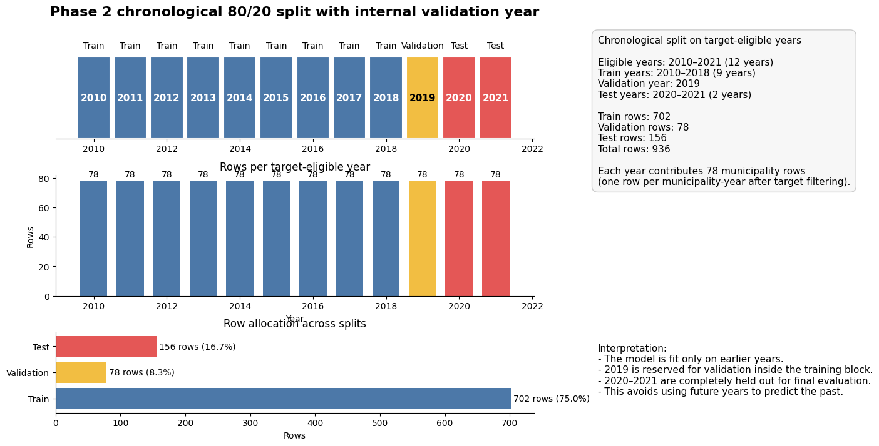
Figure 2. Chronological train-validation-test split. The model is trained on earlier years, tuned on 2019, and tested on later years to avoid leakage.

4.3 Evaluation Metrics
The primary metric is R-squared, which measures the share of variance explained by the model. RMSE is used as a secondary metric because it expresses average prediction error in the target units. Together, the two metrics show whether the model both explains overall variation and maintains a practical level of prediction accuracy.

4.4 Model Comparison and Iteration
The initial linear baseline captured average municipal trends but showed weaker generalization, especially around shock periods. Random Forest improved nonlinear capture but produced less stable feature interpretation and jagged forecasts that were not ideal for policy planning. The final tuned Lasso improved performance while retaining interpretability. The breakthrough was combining regularization, alpha tuning, expanded lagged features, and natural vital-rate context.

Version | Model Type | Test R-squared | RMSE | Key Improvement
v1 | OLS Linear | 0.7842 | 0.61 | Baseline trend capture
v2 | Random Forest | 0.8215 | 0.58 | Improved nonlinear capture but less stable interpretation
v3 Final | Tuned Lasso | 0.9092 | 0.45 | Alpha regularization, lagged dynamics, and vital-rate context
Table 1. Model comparison across major project iterations.

4.5 Final Model Results
- Final selected model: Lasso regression.
- Validation R-squared: approximately 0.9526.
- Test R-squared: approximately 0.9092.
- Test RMSE: approximately 0.4531.
- Tree-based models performed worse under the chronological split or produced less useful policy-planning behavior.
- Unregularized OLS showed weaker generalization because of multicollinearity and less stable coefficients.

4.6 Interpretation
The Lasso results reinforce the findings from the Data Integration and Feature Engineering stage: Puerto Rico’s population change is highly path-dependent. The strongest predictors are lagged population and rolling temporal variables, with natural-change context and local structural conditions providing important modifiers. Coefficients and interpretability analysis show that disaster-related features do not emerge as dominant standalone predictors in the final fitted model. This does not mean disasters are unimportant. Instead, it means their effects are likely delayed, indirect, and embedded in later population dynamics.
The model is best understood as a forecasting backbone. It captures the persistence of local population trends and provides a consistent structure for later scenario and policy analysis. Its interpretability is useful because it identifies which feature groups influence predictions, while its temporal validation supports using it for forward-looking stress tests.

5. Interpretability and Final Model Insights

5.1 Coefficient and SHAP-Based Interpretation
Interpretability analysis was used to connect predictive performance with substantive demographic meaning. Lasso coefficients identify which standardized features remain active after regularization, while SHAP analysis provides a complementary view of how features contribute to individual predictions. Together, these tools support a hierarchy of influence.
- Natural-change and lagged population conditions are the strongest signals. Municipalities already experiencing sustained decline or a negative birth-death balance are harder to stabilize without substantial migration or structural change.
- Social vulnerability acts as a multiplier. High vulnerability can intensify the population consequences of shocks because recovery capacity, infrastructure resilience, and household resources are unevenly distributed.
- Economic signals such as income growth and establishment growth can stabilize trajectories, but the model suggests that they must be sustained and coordinated with other improvements to shift the population path.
- Disaster exposure has limited standalone predictive strength in the final Lasso, but disaster shocks can still matter through lagged population responses, vulnerability interactions, infrastructure disruption, and migration feedback loops.

5.2 Important Substantive Insight
A key project insight is that population recovery is not the mirror image of population loss. It may take a much stronger and more sustained economic and recovery signal to bring residents back than it takes for residents to leave after economic stagnation or disaster disruption. This asymmetry is important for policy interpretation: slowing decline is a more realistic near-term goal than full reversal, unless recovery dynamics include meaningful return migration, family support, employment growth, and infrastructure resilience.

6. Scenario Forecasting and Model Validation

6.1 Scenario Methodology
The Forecasting, Scenario Simulation, and Model Validation stage carries forward the validated Lasso model from the Predictive Modeling and Temporal Validation stage into a multi-scale scenario forecasting framework. The same forecasting backbone is used throughout the analysis to preserve methodological continuity. Scenario conditions are applied through the engineered feature space, and outputs are summarized at regional and islandwide levels through 2030.
The scenario engine includes baseline forecasts, hurricane intensity scenarios, earthquake magnitude scenarios, and a Maria-like backtest. Uncertainty is represented through simulated prediction intervals and percentile summaries. The purpose is not to claim that the scenario overlays are causal estimates of disaster impact. Instead, the scenarios provide structured stress tests showing how the fitted model responds when disaster-related conditions worsen.

6.2 Scenario Results
The scenario results show that stronger disaster assumptions produce larger projected population losses relative to the baseline forecast. Figure 3 presents the islandwide forecast paths for both the hurricane and earthquake scenario ladders. In both panels, the observed population series shows a long-running decline before the forecast period begins, and the post-forecast scenario lines continue that downward trajectory under different shock assumptions. The hurricane ladder shows the clearest separation between scenarios, with the most severe Maria-like Category 5 case producing the steepest projected decline by 2030. The earthquake ladder also reduces projected population relative to baseline, but the highest-magnitude earthquake cases are closer together, suggesting that the stylized earthquake overlay reaches a practical ceiling at the islandwide scale.
Figure 4 adds the regional dimension by showing how 2030 impacts differ across Puerto Rico under selected hurricane and earthquake scenarios. These maps show that scenario impacts are spatially uneven rather than uniform across the island. Severe hurricane conditions produce larger regional losses than moderate hurricane conditions, and the Maria-like scenario creates the strongest regional impacts. Earthquake scenarios also generate losses, but their effects vary by region and do not follow exactly the same pattern as hurricane impacts. Together, Figures 3 and 4 support the interpretation that disasters amplify existing population decline trajectories, while the size and location of those impacts depend on the type and severity of the shock.

The Maria-like backtest captures the direction of post-disaster decline, but it tends to overestimate long-run population loss. For that reason, the scenario module should be interpreted as a structured stress-testing framework rather than a precise causal disaster-impact model. Its purpose is to compare how the validated forecasting model responds under different disaster assumptions, not to claim that any single scenario will exactly predict future population outcomes.

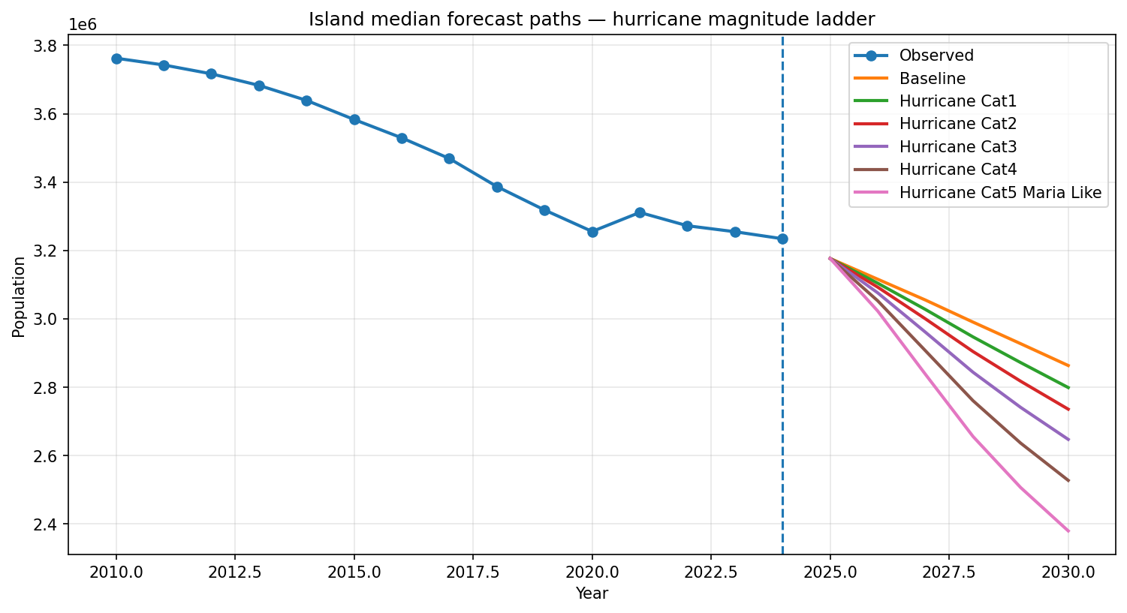
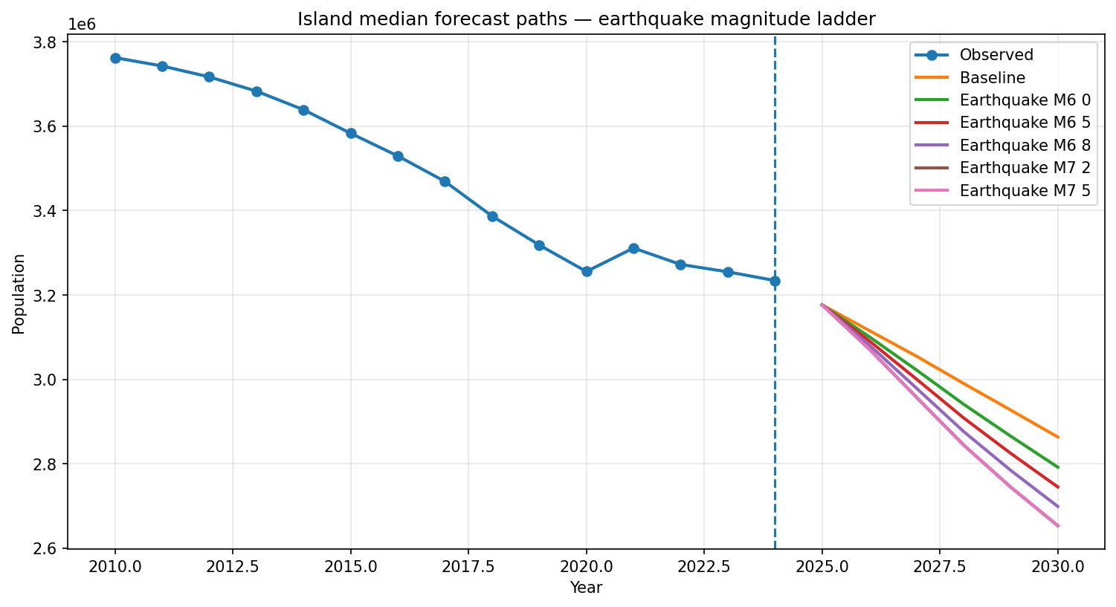

Figure 3. Islandwide Population Forecast Paths Under Hurricane and Earthquake Scenario Ladders

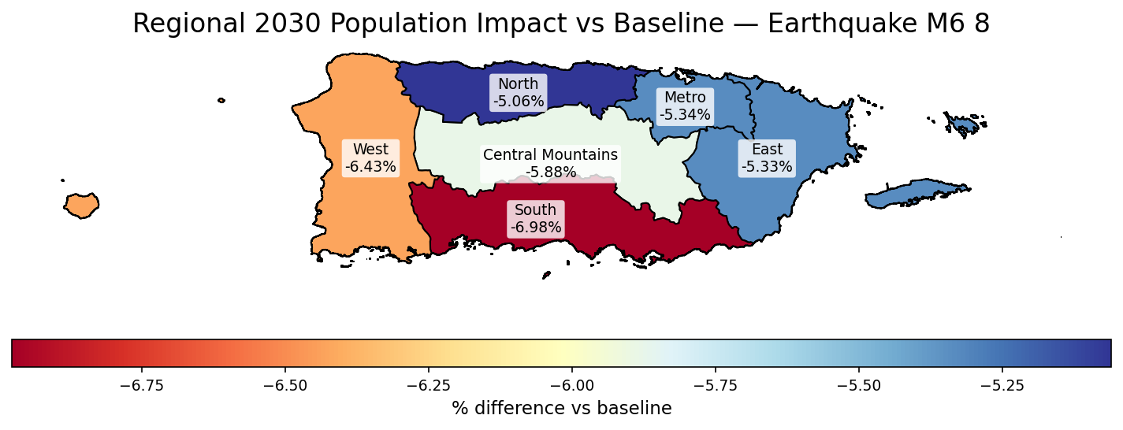
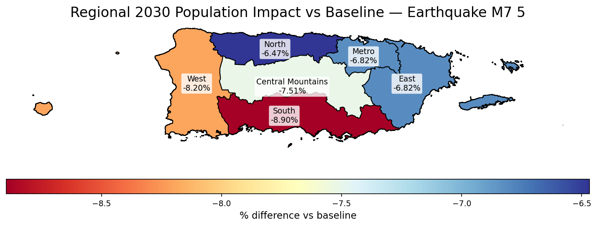
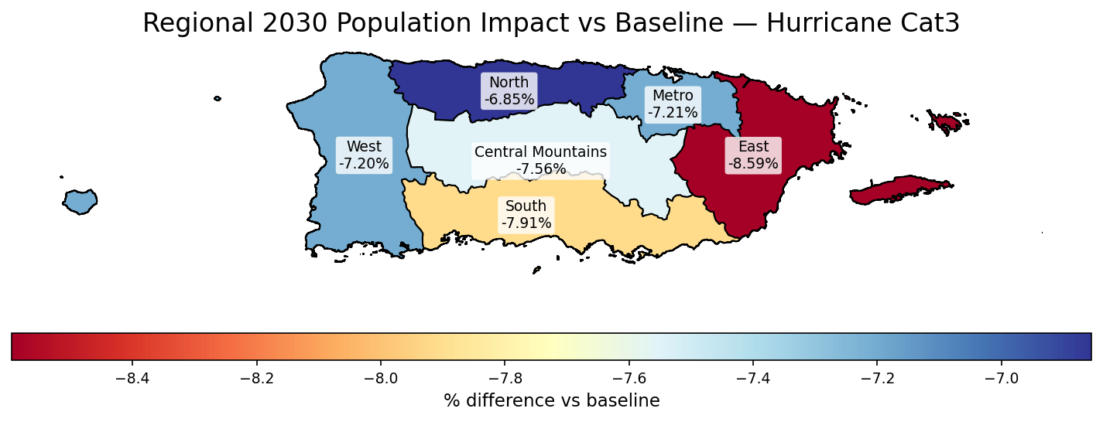
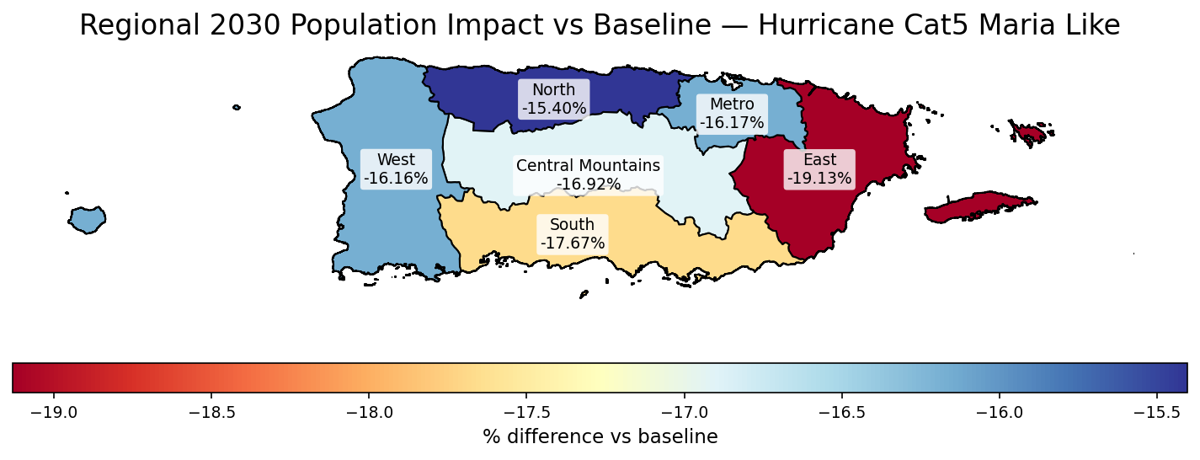

Figure 4. Regional 2030 Population Impacts Under Selected Hurricane and Earthquake Scenarios

6.3 Interpretation
The scenario results strengthen the central interpretation of the project: disasters amplify existing population trends rather than creating demographic decline from scratch. The islandwide forecast paths show that baseline decline is already present before disaster shocks are introduced, while the hurricane and earthquake scenario ladders push those existing trajectories downward at different intensities. This means that disasters should be interpreted as accelerants within an already fragile demographic system, not as isolated events that fully explain Puerto Rico’s population losses on their own.
The regional maps further show that disaster impacts are spatially uneven. Regions already facing greater vulnerability, aging population structures, weaker economic conditions, or negative demographic momentum are more likely to experience deeper or more persistent losses after shocks. In other words, the same disaster scenario does not affect all parts of Puerto Rico equally. The effect depends on the conditions already present before the shock, including local recovery capacity, structural vulnerability, and the strength or weakness of prior population trends.
This interpretation is important for planning because it connects disaster resilience directly to demographic policy. If population decline is already persistent, then disaster recovery cannot focus only on rebuilding physical infrastructure after an event. Recovery planning also needs to address the underlying conditions that make population loss more likely to continue, such as limited employment opportunity, housing vulnerability, public-safety concerns, aging communities, and weak return migration incentives. The scenario results therefore suggest that long-term population stability requires both hazard preparedness and broader structural recovery strategies.
Overall, the scenario analysis shows that Puerto Rico’s demographic future is shaped by the interaction between baseline population momentum and external shocks. Severe hurricanes and earthquakes can intensify decline, but the magnitude and persistence of that decline depend on pre-existing demographic and socioeconomic conditions. This reinforces the need to interpret the forecasts as stress tests: they are not exact predictions of a single future, but they help identify which regions and conditions may be most exposed to deeper population loss under future disaster scenarios.

7. Policy Response and Recovery Rebound Analysis

7.1 Policy Simulation Methodology
The Policy Response and Population Retention Strategies stage extends the forecasting framework into model-based policy simulation. Policy packages modify policy-relevant input features such as income growth, establishment growth, public-safety conditions, vulnerability, demographic support, and lagged population momentum. These adjusted feature frames are then passed through the validated forecasting backbone to estimate how predicted outcomes shift under alternative policy conditions.
The policy simulations are counterfactual stress tests. They show how the fitted model responds when local and regional conditions are improved under stylized policy packages. They do not prove that a real world intervention would reproduce the modeled shift. This distinction is important because the model is trained on observational data and is designed for prediction, not causal identification.

7.2 Policy Packages
- Jobs Push: emphasizes income growth, employment-related improvement, and business establishment growth.
- Public Safety: improves crime or safety-related indicators that may influence retention and quality of life.
- Structural Resilience: improves vulnerability-related conditions and recovery capacity.
- Retention Bundle: combines economic, safety, vulnerability, and demographic-support improvements to test a coordinated population-retention strategy.
- Recovery Bundle: applies stronger model-implied improvements through the fitted feature space.
- Recovery Rebound plus Return-Migration Sensitivity: adds an explicit optimistic recovery layer on top of model-implied changes to answer a what-would-it-take question about stabilization or temporary growth.

7.3 Policy Results
Standard policy packages improve outcomes and slow projected decline, but they do not fully reverse the underlying demographic momentum. The retention bundle performs better than isolated policies because it combines multiple levers. Even so, the model remains bounded by strong lagged population dynamics. This means that economic, safety, and vulnerability improvements can shift projections in a favorable direction, but they may not be sufficient to reverse long-run decline without an additional recovery or return-migration dynamic.
The recovery-rebound sensitivity was designed to clarify the scale of intervention required for stabilization, while also acknowledging uncertainty in the population estimates. The endpoint comparison shows that the standard recovery strategy improves the 2030 projection by approximately 32,352 residents relative to the baseline forecast. However, the recovery-rebound sensitivity produces a much larger shift, reaching approximately 3,253,715 residents by 2030, or about 245,401 more residents than the baseline endpoint. The figure also includes an uncertainty range around the endpoint, showing that the projected population should not be interpreted as an exact number. Instead, it represents an estimated range of plausible outcomes under the modeled assumptions. Unlike the standard policy packages, the rebound case rises slightly above the latest observed population level, suggesting that stabilization or temporary growth would require additional recovery momentum beyond the model-implied policy response, including stronger return migration and sustained structural improvements.

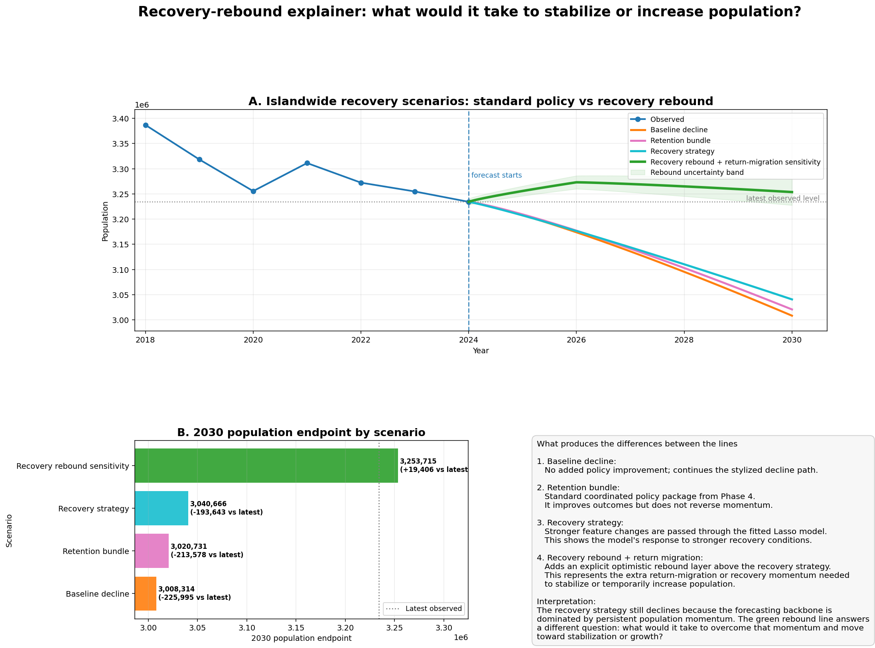
Figure 5. Islandwide Population Recovery Scenarios Under Policy and Return-Migration Sensitivity
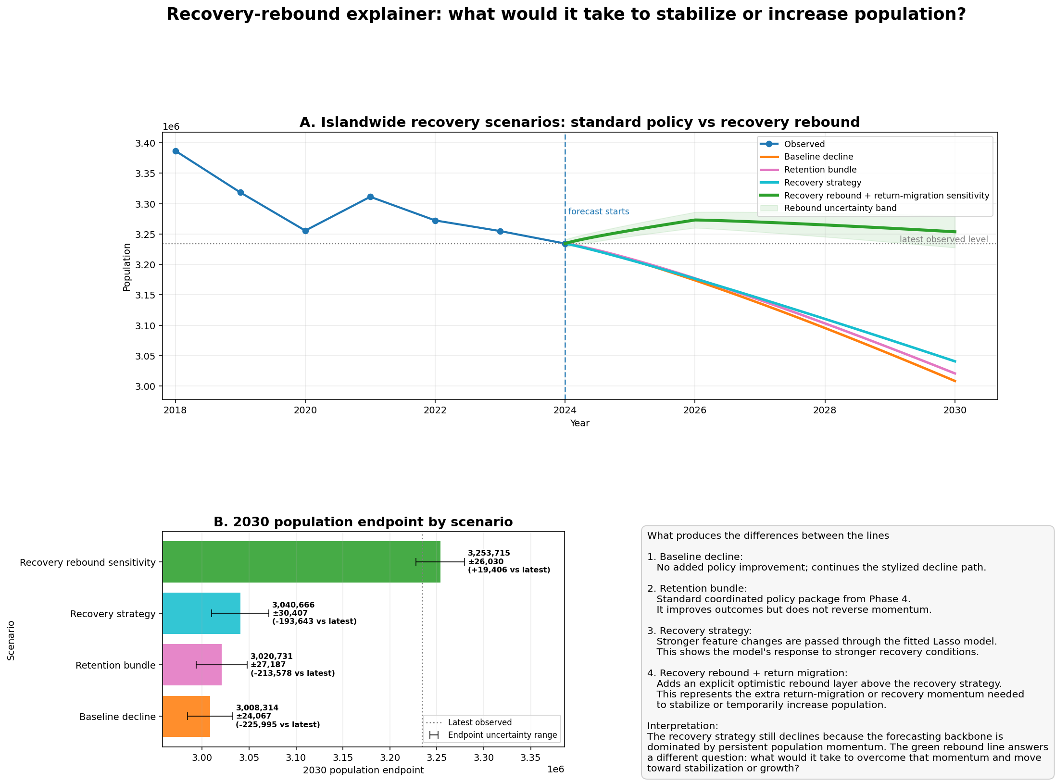
Figure 6. 2030 Population Endpoint Comparison Across Recovery Scenarios

7.4 Recovery Bundle versus Recovery Rebound Sensitivity
The Recovery bundle is model-implied. It applies stronger feature improvements and lets the fitted Lasso model translate those changes into projected population paths. This improves the forecast, but the trajectory can still decline because the learned demographic momentum remains negative.
The Recovery rebound plus return-migration sensitivity is different. It adds an explicit optimistic recovery layer on top of the model-implied response. This line asks what additional recovery momentum would be needed for population to stabilize or temporarily increase. It should not replace the baseline policy results and should not be read as a causal estimate. Instead, it clarifies the scale of intervention needed to overcome persistent decline.

7.5 Policy Interpretation
The policy analysis is the most actionable component of the project. It suggests that isolated policy interventions are unlikely to reverse population loss by themselves. A more effective approach would combine job creation, public safety, vulnerability reduction, family support, housing and infrastructure recovery, and return-migration incentives. The model also suggests that policy design should be place-sensitive: municipalities with different baseline conditions may require different intervention intensity and sequencing.

8. Limitations and Responsible Interpretation
The project should be interpreted as a predictive forecasting and stress-testing framework, not as a causal policy evaluation. The model can estimate how predictions shift when input features are changed, but it cannot prove that a real intervention would cause the same shift. Causal interpretation would require additional identification strategies, such as quasi-experimental designs, natural experiments, or policy implementation data.
Another limitation is the model’s dependence on historical patterns. Because lagged population features are powerful, the model can reproduce persistence very well, but it may understate abrupt structural changes that differ from the historical record. The recovery-rebound sensitivity was added partly to address this limitation by exploring stronger future recovery conditions that are not fully learned from past data.
The model is also data-hungry for vital statistics and other regularly updated indicators. If birth, death, migration, crime, or business data are delayed or revised, near-term forecasts may change. Small municipalities may have noisier estimates, and disaster overlays depend on stylized assumptions about intensity, exposure, and persistence. These limitations do not invalidate the framework, but they require transparent communication when results are used for planning.

9. Conclusion and Future Work

9.1 Summary of Accomplishments
This project successfully developed a full population forecasting and policy analysis framework for Puerto Rico. The work integrated multiple data sources into a municipal-year panel, engineered lagged and rolling features, evaluated models under a chronological validation design, selected a tuned Lasso forecasting backbone, generated disaster scenario forecasts, and extended the framework into model-aware policy stress testing.
The project identified a clear hierarchy of drivers. Temporal population dynamics are the dominant drivers of forecasts. Structural context, including economic, demographic, vulnerability, and regional variables, modifies those trajectories. Disaster effects operate mainly as amplifiers of existing decline rather than dominant direct predictors. Policy responses can improve outcomes, but reversal requires stronger coordinated recovery dynamics involving return migration and sustained structural improvement.

9.2 Final Implication
Puerto Rico’s population change is persistent, structured, and predictable, but not entirely fixed. Model-based policy analysis suggests that interventions can improve outcomes, especially when they combine economic opportunity, resilience, safety, family support, and recovery capacity. However, stabilizing or increasing population likely requires coordinated strategies strong enough to change the underlying demographic trajectory rather than simply offset one or two isolated risk factors.

9.3 Future Work
- Spatial lag models: incorporate neighbor effects to test whether population change in one municipality affects adjacent municipalities.
- Interactive dashboarding: deploy forecasts and scenario outputs in a tool for municipal planners and policy stakeholders.
- Synthetic population modeling: use the Lasso results to seed household-level or agent-based simulations of migration and retention behavior.
- Policy evaluation integration: combine future implementation data with causal inference methods to estimate actual treatment effects.
- More granular disaster recovery data: add infrastructure restoration, housing damage, insurance claims, and federal recovery spending to improve disaster-response modeling.

References
- United States Census Bureau. Population and demographic data used for Puerto Rico municipal analysis, including ACS 5-Year Estimates.
- Puerto Rico Institute of Statistics. Vital statistics and demographic indicators, including birth, death, and natural-change measures.
- Federal Emergency Management Agency (FEMA) and related public hazard data sources. Hurricane, disaster exposure, and recovery data.
- NOAA National Hurricane Center. HURDAT2 hurricane track and intensity database.
- United States Geological Survey (USGS). Earthquake epicenter and magnitude data.
- Centers for Disease Control and Prevention. Social Vulnerability Index documentation and vulnerability concepts.
- Pedregosa, F. et al. (2011). Scikit-learn: Machine Learning in Python. Journal of Machine Learning Research.
- Tibshirani, R. (1996). Regression shrinkage and selection via the lasso. Journal of the Royal Statistical Society.
- Lundberg, S. M., & Lee, S.-I. (2017). A Unified Approach to Interpreting Model Predictions. Advances in Neural Information Processing Systems.
- Course materials and capstone project guidance. Rutgers, The State University of New Jersey, Camden.

Appendix A: Supplemental Figures and Tables

A1. Data Sources and Modeling Inputs
This table can be added to the appendix to document the main data categories and how each was used in the forecasting workflow.
Data category | Example source | Role in analysis
Population and demographic history | U.S. Census / population estimates | Population levels, annual change, lagged change, rolling change, and forward population-change targets
Vital statistics | Puerto Rico vital statistics / Census-derived fertility measures | Births, deaths, natural-change context, and demographic momentum
Economic conditions | ACS labor and socioeconomic indicators; County Business Patterns | Income, employment, establishments, payroll, and business activity
Social vulnerability | CDC SVI-style indicators and related socioeconomic measures | Vulnerability, housing, transportation, and resilience-related context
Public safety | Puerto Rico Police Department / crime indicators | Quality-of-life and retention-related context
Hurricane exposure | NOAA hurricane track and intensity data | Hurricane scenario variables and disaster stress testing
Earthquake exposure | USGS earthquake catalogs | Earthquake scenario variables and seismic stress testing
Regional structure | Municipality-to-region groupings generated in the analysis | Regional aggregation, interpretation, and islandwide forecast summaries
Appendix Table A1. Data categories, example sources, and role in the population forecasting workflow.

A2. Model Selection and Final Forecasting Backbone
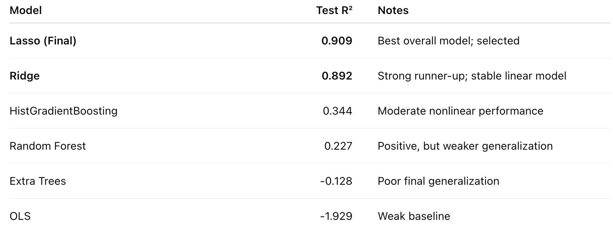
Appendix Figure A2. Candidate model comparison showing the tuned Lasso model as the strongest selected forecasting backbone under the temporal evaluation framework.

A3. Lead-Lag Driver Timing and Interpretability
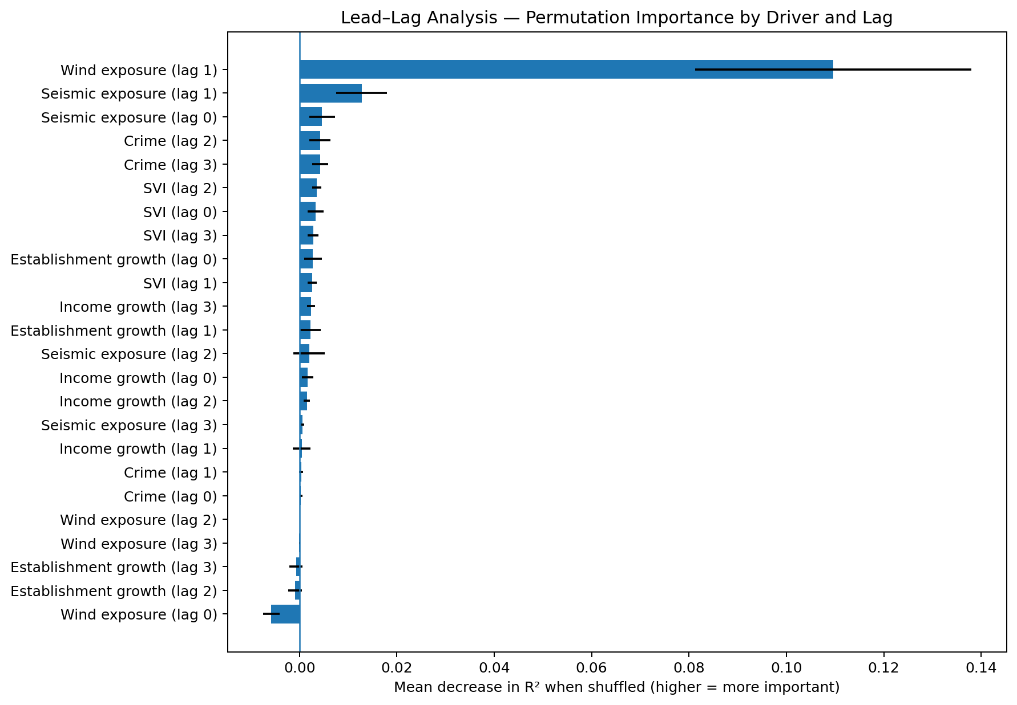
Appendix Figure A3. Lead-lag permutation importance by driver and lag. The figure shows that timing matters: some disaster and structural variables influence population change with delayed effects rather than only immediate effects.

A4. Policy Package Definitions
Scenario | What changes | Magnitude / assumption | Interpretation
Baseline decline | No policy-feature adjustments | Reference path | Continues the stylized decline path
Retention bundle | Jobs + safety + vulnerability + demographic-support features | 20% jobs/safety; 15% vulnerability; natural-change and population-momentum support | Standard coordinated package; slows decline but does not reverse momentum
Recovery bundle / recovery strategy | Stronger version of the retention bundle passed through the model | Larger feature improvements across jobs, safety, vulnerability, natural change, and momentum proxies | Model-implied recovery improves the trajectory but may still decline
Recovery rebound + return migration | Recovery bundle plus explicit rebound layer | Adds temporary recovery momentum and a 2030 floor above the latest observed level | Sensitivity case showing what may be required for stabilization or growth
Appendix Table A2. Policy scenario definitions and interpretation. This table helps readers distinguish model-implied policy effects from the stronger recovery-rebound sensitivity case.

A5. Recovery-Rebound Sensitivity and Endpoint Uncertainty
Appendix Figure A5. Islandwide recovery scenarios and 2030 endpoint comparison. The rebound sensitivity shows the additional recovery momentum needed to stabilize or temporarily increase population, while the error bars indicate endpoint uncertainty.
Scenario | 2030 endpoint | Difference vs baseline | Endpoint uncertainty | Difference vs latest observed
Baseline decline | 3,008,314 | - | +/-24,067 | -225,995 vs latest observed
Retention bundle | 3,020,731 | +12,417 | +/-27,187 | -213,578 vs latest observed
Recovery strategy | 3,040,666 | +32,352 | +/-30,407 | -193,643 vs latest observed
Recovery rebound sensitivity | 3,253,715 | +245,401 | +/-26,030 | +19,406 vs latest observed
Appendix Table A3. 2030 policy endpoint estimates and uncertainty ranges. Values are included to support the report discussion that the rebound sensitivity should be interpreted as an estimated range, not an exact population count.

A6. Regional Recovery-Rebound Paths
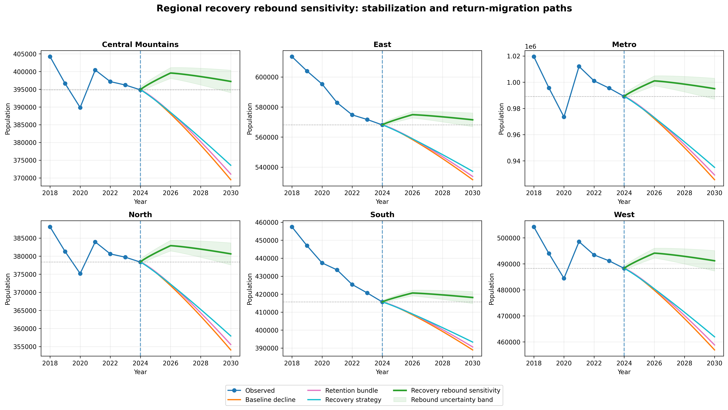
Appendix Figure A6. Regional recovery-rebound sensitivity paths. The figure shows that stabilization or rebound is not uniform across regions, reinforcing the need for place-sensitive policy interpretation.

A7. Regional Policy Effects by Package
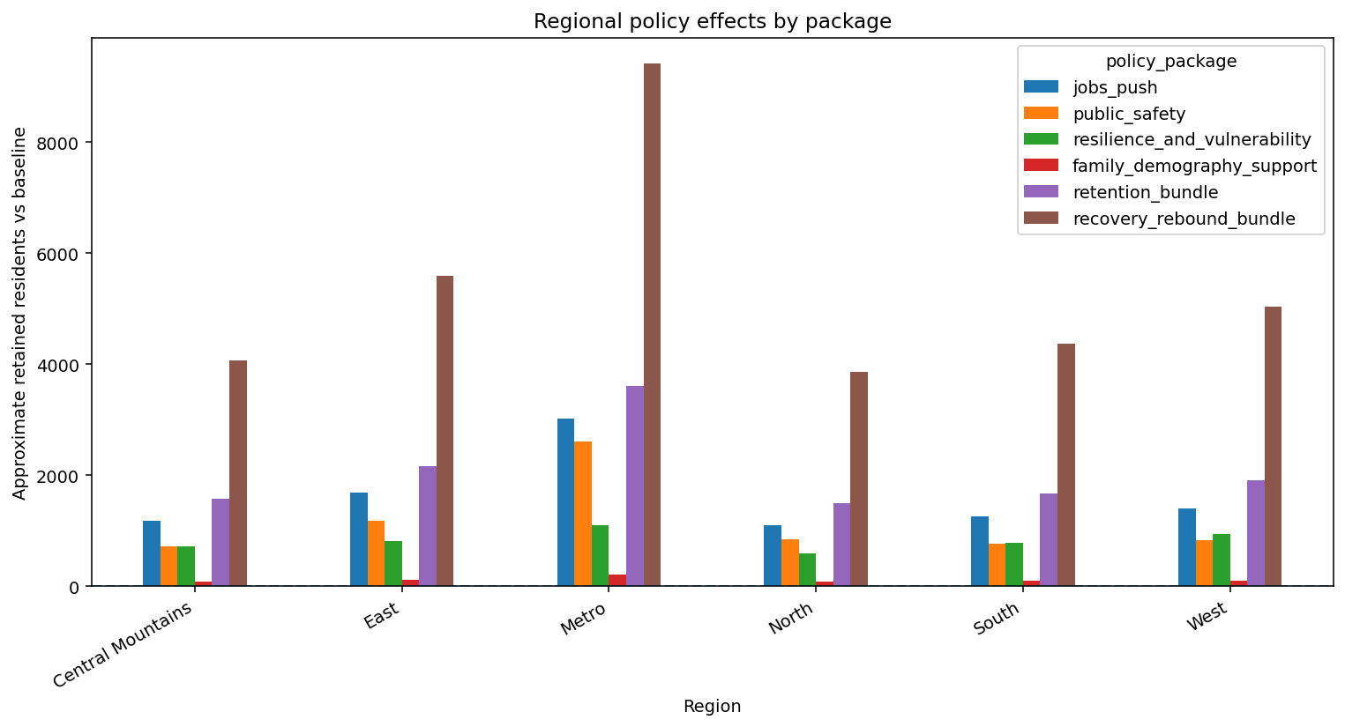
Appendix Figure A7. Approximate retained residents versus baseline by region and policy package. The figure shows that coordinated recovery bundles produce larger gains than isolated interventions across regions.

A8. Optional Disaster Scenario Supplements
If additional scenario visuals are desired, the following two single-panel figures can supplement the main report figures by showing the hurricane and earthquake scenario ladders separately. They are optional because the main report already includes combined scenario figures.
Appendix Figure A8. Islandwide hurricane scenario ladder through 2030.
Appendix Figure A9. Islandwide earthquake scenario ladder through 2030.

