

COLLABERS : A SMART PLATFORM FOR INFLUENCER–BRAND COLLABORATION

A PROJECT REPORT

Submitted by
VENGADESAN G. (311821205060)
MANIKANDAN P. (311821205023)
PRAJESH RAM V. (311821205043)

In partial fulfillment for the award of the degree of
BACHELOR OF TECHNOLOGY
IN
INFORMATION TECHNOLOGY

MOHAMED SATHAK A.J. COLLEGE OF ENGINEERING
CHENNAI – 603103
2025



BONAFIDE CERTIFICATE

Certified that this project report titled "COLLABERS: A Smart Platform for Influencer–Brand Collaboration" is the Bonafide work of VENGADESAN G (311821205060), MANIKANDAN P (311821205023), and PRAJESH RAM V (311821205043) who carried out the project work under my supervision.

SIGNATURE
Mrs. N. Angayarkanni, M.Tech/IT
HEAD OF THE DEPARTMENT
Dept of Information Technology
Mohammed Sathak A.J. College of Engineering, Chennai – 603103

SIGNATURE
Mrs.N. Angayarkanni , M.Tech/IT SUPERVISOR
Dept of Information Technology
Mohammed Sathak A.J. College of Engineering, Chennai – 603103

Submitted for the project viva voce examination held on: ___________________

INTERNAL EXAMINER EXTERNAL EXAMINER

ACKNOWLEDGEMENT

We extend our deepest gratitude to the Divine for the unwavering guidance and strength bestowed upon us, enabling the successful completion of this project. Our heartfelt appreciation goes to OUR PARENTS, whose enduring support has been the cornerstone of our journey throughout this project and our academic pursuits.

We express our profound thanks to ALHAJ JANAB S.M. YOUSUF, Chairman, and Mr. MOHAMED SATHAK, Director of Mohamed Sathak A J College of Engineering, Chennai, for their visionary leadership and support. Our sincere gratitude is directed towards our esteemed Principal, Dr. K. S. SRINIVASAN, for granting us the opportunity to carry out our project within the nurturing environment of our college.

Special thanks are due to our Head of the Department and Project Supervisor Mrs. N. ANGAYARKANNI, M.Tech/IT, Department of Information Technology, whose mentorship and insights have been invaluable.

We would also like to acknowledge the collective efforts of all our department Faculty Members and staff of the Department of Computer Science and Engineering. Their support has been instrumental throughout our academic journey. Lastly, we are thankful to our friends, whose camaraderie and assistance have enriched our project experience.

ABSTRACT

In the rapidly evolving landscape of digital marketing, influencer-brand collaborations have become an essential part of business strategy. However, many companies still struggle with discovering the right influencers, managing outreach, and evaluating campaign effectiveness. Collabers addresses this challenge by providing a streamlined web platform that intelligently connects brands with suitable influencers based on engagement, niche, and performance metrics.
Built with a modern technology stack HTML, CSS, JavaScript, React for the frontend, Django for the backend, and SQL with Django ORM for data handling—Collabers offers a secure, scalable, and intuitive environment for collaboration management. The application supports role-based login, with dedicated dashboards for brands and influencers. Brands can post campaign opportunities, and influencers can apply to relevant listings.
A key feature is the integration of a machine learning model using XGBoost to intelligently sort and recommend influencers to brands, ensuring data-driven decisions. Additionally, the platform emphasizes clean UX, responsive design, and real-time interaction between parties.
Collabers bridges the gap between marketing goals and influencer outreach by simplifying discovery, improving campaign targeting, and encouraging meaningful digital partnerships. This project showcases the potential of combining web technologies and data science to build a smart, collaborative ecosystem for influencer marketing.

LIST OF SYMBOLS
S.NO | NOTATION  NAME | NOTATION |  |  | DESCRIPTION
1. | Class |  |  |  | Represents a collection of similar entities grouped together.
 |  | + public  -private | Class Name
 |  |  | -attribute
 |  |  | -attribute
2. | Association | 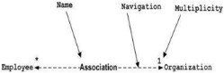 |  |  | Associations represent static relationships between classes. Roles represents the way the two classes.
3. | Actor |  |  |  | It aggregates several classes into a single class.
4. | Aggregation |  |  |  | Interaction between the system and external environment

5. | Relation (extends) | EXTENDS | Extends relationship is used when one use case is similar to another use case but does a bit more.
6. | Communication |  | Communication  between various use cases.
7. | State | State | State of the process.
8. | Initial State |  | Initial state of the object.
9. | Final state |  | Final state of the object
10. | Control flow |  | Represents various control flow between the  states.
11. | Decision box |  | Represents decision making process from a constraint.
12. | Use case | 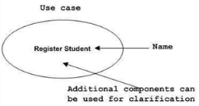 | Interact ion between the  system.

13. | Component | 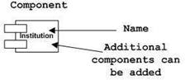 | Represents physical modules which is a collection of  components.
14. | Node | 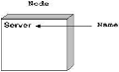 | Represents physical modules which are a collection of components.
15. | Data Process/State |  | A circle in DFD represents a state or process which has been triggered due to some event or action.
16. | External entity |  | Represents external entities such as keyboard, sensors, etc.
17. | Transition |  | Represents communication that occurs between  processes.
18. | Object Lifeline | 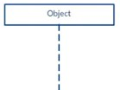 | Represents the vertical dimensions that the object communications.

LIST OF FIGURES

SL.NO TITLE PAGE.NO
1. Architecture Diagram 21
2. Data Flow Diagram 23
3. UI/UX Design 24
4. Class Diagram 27
5. Sequence Diagram 28
6. State Diagram 30

TABLE OF CONTENTS
Sl.No. |  |  |  |  |  |  |  |  |  |  |  |  | Title |  |  |  |  |  |  |  |  |  |  |  |  |  |  |  |  |  |  | Page No.
1 |  |  |  |  |  |  |  |  |  |  |  |  | Introduction |  |  |  |  |  |  |  |  |  |  |  |  |  |  |  |  |  |  | 1
 |  |  |  |  |  |  |  |  |  |  |  |  | 1.1 About the Project |  |  |  |  |  |  |  |  |  |  |  |  |  |  |  |  |  |  | 1
 |  |  |  |  |  |  |  |  |  |  |  |  | 1.2 Problem Statement |  |  |  |  |  |  |  |  |  |  |  |  |  |  |  |  |  |  | 2
 |  |  |  |  |  |  |  |  |  |  |  |  | 1.3 Objectives |  |  |  |  |  |  |  |  |  |  |  |  |  |  |  |  |  |  | 3
2 |  |  |  |  |  |  |  |  |  |  |  |  | System Study |  |  |  |  |  |  |  |  |  |  |  |  |  |  |  |  |  |  | 5
 |  |  |  |  |  |  |  |  |  |  |  |  | 2.1 Existing System |  |  |  |  |  |  |  |  |  |  |  |  |  |  |  |  |  |  | 5
 |  |  |  |  |  |  |  |  |  |  |  |  | 2.2 Proposed System |  |  |  |  |  |  |  |  |  |  |  |  |  |  |  |  |  |  | 6
3 |  |  |  |  |  |  |  |  |  |  |  |  | Literature Survey |  |  |  |  |  |  |  |  |  |  |  |  |  |  |  |  |  |  | 8
4 |  |  |  |  |  |  |  |  |  |  |  |  | Requirement Analysis |  |  |  |  |  |  |  |  |  |  |  |  |  |  |  |  |  |  | 10
 |  |  |  |  |  |  |  |  |  |  |  |  | 4.1 Functional Requirements |  |  |  |  |  |  |  |  |  |  |  |  |  |  |  |  |  |  | 10
 |  |  |  |  |  |  |  |  |  |  |  |  | 4.2 Non-Functional Requirements |  |  |  |  |  |  |  |  |  |  |  |  |  |  |  |  |  |  | 11
5 |  |  |  |  |  |  |  |  |  |  |  |  | System Analysis |  |  |  |  |  |  |  |  |  |  |  |  |  |  |  |  |  |  | 13
 |  |  |  |  |  |  |  |  |  |  |  |  | 5.1 Feasibility Study |  |  |  |  |  |  |  |  |  |  |  |  |  |  |  |  |  |  | 13
 |  |  |  |  |  |  |  |  |  |  |  |  | 5.2 Proposed System Flow |  |  |  |  |  |  |  |  |  |  |  |  |  |  |  |  |  |  | 15
6 |  |  |  |  |  |  |  |  |  |  |  |  | System Requirement Specification |  |  |  |  |  |  |  |  |  |  |  |  |  |  |  |  |  |  | 17
 |  |  |  |  |  |  |  |  |  |  |  |  | 6.1 Hardware Requirements |  |  |  |  |  |  |  |  |  |  |  |  |  |  |  |  |  |  | 17
 |  |  |  |  |  |  |  |  |  |  |  |  | 6.2 Software Requirements |  |  |  |  |  |  |  |  |  |  |  |  |  |  |  |  |  |  | 18
7 |  |  |  |  |  |  |  |  |  |  |  |  | System Design |  |  |  |  |  |  |  |  |  |  |  |  |  |  |  |  |  |  | 21
 |  |  |  |  |  |  |  |  |  |  |  |  | 7.1 Architecture Diagram |  |  |  |  |  |  |  |  |  |  |  |  |  |  |  |  |  |  | 21
 |  |  |  |  |  |  |  |  |  |  |  |  | 7.2 Data Flow Diagram |  |  |  |  |  |  |  |  |  |  |  |  |  |  |  |  |  |  | 23
 |  |  |  |  |  |  |  |  |  |  |  |  | 7.3 UI/UX Design |  |  |  |  |  |  |  |  |  |  |  |  |  |  |  |  |  |  | 24
 |  |  |  |  |  |  |  |  |  |  |  |  | 7.4 Class Diagram |  |  |  |  |  |  |  |  |  |  |  |  |  |  |  |  |  |  | 27
 |  |  |  |  |  |  |  |  |  |  |  |  | 7.5 Sequence Diagram |  |  |  |  |  |  |  |  |  |  |  |  |  |  |  |  |  |  | 28
 |  |  |  |  |  |  |  |  |  |  |  |  | 7.6 State Diagram |  |  |  |  |  |  |  |  |  |  |  |  |  |  |  |  |  |  | 30
8 |  |  |  |  |  |  |  |  |  |  |  |  | System Implementation |  |  |  |  |  |  |  |  |  |  |  |  |  |  |  |  |  |  | 33
 |  |  |  |  |  |  |  |  |  |  |  |  | 8.1 Modules |  |  |  |  |  |  |  |  |  |  |  |  |  |  |  |  |  |  | 33
 |  |  |  |  |  |  |  |  |  |  |  |  | 8.2 Tools Used |  |  |  |  |  |  |  |  |  |  |  |  |  |  |  |  |  |  | 34
9 |  |  |  |  |  |  |  |  |  |  |  |  | Testing |  |  |  |  |  |  |  |  |  |  |  |  |  |  |  |  |  |  | 37
 |  |  |  |  |  |  |  |  |  |  |  |  | 9.1 Objectives |  |  |  |  |  |  |  |  |  |  |  |  |  |  |  |  |  |  | 37
 |  |  |  |  |  |  |  |  |  |  |  |  | 9.2 Test Class |  |  |  |  |  |  |  |  |  |  |  |  |  |  |  |  |  |  | 37
 |  |  |  |  |  |  |  |  |  |  |  |  | 9.3 Testing Methods |  |  |  |  |  |  |  |  |  |  |  |  |  |  |  |  |  |  | 38
 |  |  |  |  |  |  |  |  |  |  |  |  | 9.4 Testing Types |  |  |  |  |  |  |  |  |  |  |  |  |  |  |  |  |  |  | 49
10 |  |  |  |  |  |  |  |  |  |  |  |  | Conclusion |  |  |  |  |  |  |  |  |  |  |  |  |  |  |  |  |  |  | 41
11 |  |  |  |  |  |  |  |  |  |  |  |  | Future Scope |  |  |  |  |  |  |  |  |  |  |  |  |  |  |  |  |  |  | 43
12 |  |  |  |  |  |  |  |  |  |  |  |  | References |  |  |  |  |  |  |  |  |  |  |  |  |  |  |  |  |  |  | 45

- INTRODUCTION

1.1 About the Project
Over the past decade, social media has transformed from a simple communication platform into a global marketing engine. Among the most impactful outcomes of this transformation is the rise of influencer marketing, where content creators—commonly referred to as influencers—leverage their follower base to promote products, services, or causes. Brands now increasingly depend on influencers to establish trust, boost engagement, and drive conversions among niche audiences.
However, the process of initiating and managing collaborations between influencers and brands is still widely unstructured and inefficient. Most interactions happen through informal channels such as direct messages, emails, or third-party agencies that lack transparency and automation. This creates friction for both parties—brands find it hard to locate and evaluate the right influencers, while influencers struggle to find legitimate brand opportunities that match their content niche and engagement profile.
To solve this problem, our team has developed Collabers, a comprehensive web-based application that streamlines influencer–brand collaborations. Collabers acts as a smart bridge, enabling both brands and influencers to register, interact, collaborate, and track campaign progress on a single platform.
The platform uses a role-based login system where influencers and brands are given customized access and functionality. Brands can create and publish collaboration posts that detail campaign requirements, timelines, deliverables, and compensation. Influencers can view these opportunities, apply with their profiles, and receive direct communication and updates via the platform.

To elevate the decision-making process, Collabers incorporates a Machine Learning (ML) model using the XGBoost algorithm. This model processes various parameters such as an influencer’s follower count, engagement rate, category (fashion, tech, food, etc.), and activity levels to recommend the most suitable influencers to brands for each campaign.
Technologically, Collabers is built using:
- Frontend: HTML, CSS, JavaScript, and React.js
- Backend: Django framework (Python-based), using RESTful APIs
- Database: SQL (PostgreSQL), integrated through Django ORM for efficient querying and data management
The platform focuses on offering a minimalistic and intuitive UI/UX, allowing users to navigate and perform tasks easily, even with minimal technical know-how. It is responsive across devices and supports future expansion toward features like real-time messaging, analytics dashboards, and third-party payment integrations.
Collabers is not just a web application; it is a digital collaboration ecosystem designed to empower content creators and help brands reach the right audience—efficiently, intelligently, and transparently.

1.2 Problem Statement
Despite the rapid growth of influencer marketing, the tools available to manage collaborations are still basic, non-intelligent, and fragmented. Brands often rely on manual research to identify influencers, leading to wasted time and suboptimal partnerships. Influencers, on the other hand, do not have access to centralized, authentic campaign listings and often miss out on opportunities due to poor visibility and communication gaps.

Some of the pressing problems that Collabers aims to solve include:
Lack of Data-Driven Matching: Most collaborations happen without the help of intelligent filtering or matching mechanisms, leading to irrelevant partnerships.
Scattered Communication Channels: Communication between brands and influencers is often fragmented (email, DMs), which reduces efficiency and increases miscommunication.
No Campaign Management Structure: Brands do not have a centralized system to manage applications, shortlist profiles, and communicate with selected influencers.
Unverified Influencers or Brands: There's a growing concern of fake profiles or low-quality campaigns due to the lack of a vetted environment.
Limited Performance Tracking: There is little to no integration of analytics or sorting tools to determine which influencers are best suited for specific campaign objectives.
These problems collectively hinder the potential of influencer marketing as a strategic and scalable digital channel.

1.3 Objectives of the Project
The primary goal of the project is to develop a robust, user-friendly web platform that streamlines the process of influencer–brand collaboration using technology and data science. The system aims to benefit both influencers and brands by reducing friction, improving visibility, and enabling data-backed decisions.
Key Objectives:
Role-Based Access Control: Allow users to register as either an influencer or a brand and provide tailored interfaces and functionalities for both roles.
Campaign Management by Brands: Enable brands to create collaboration posts detailing campaign goals, budget, category, timelines, and eligibility criteria.
Opportunity Discovery by Influencers: Allow influencers to discover available campaigns based on their category (fashion, tech, food, etc.) and apply seamlessly.
Smart Filtering Using XGBoost: Integrate an ML model (XGBoost) that helps brands shortlist influencers based on key performance indicators like engagement rate, content niche, and follower count.
Secure Authentication & Data Handling: Use Django’s built-in authentication system and ORM to ensure user security and data consistency.
Minimalistic & Responsive UI/UX: Build the front end using React.js to ensure responsiveness across devices with a simple, clean, and engaging user experience.
Modular & Scalable Codebase: Structure the application using modular components for future enhancements such as chat integration, performance dashboards, and external API integrations.

- SYSTEM STUDY

2.1 Existing System
In the current digital ecosystem, influencer marketing has emerged as a critical pillar for brand engagement, product promotions, and consumer outreach. However, the collaboration process between influencers and brands remains largely unstructured and inefficient. Most partnerships are formed through informal channels such as direct messages on social media, cold emails, or word-of-mouth referrals. These methods often lack standardization, transparency, and scalability.
Brands often face significant challenges in discovering relevant influencers who align with their campaign objectives. The lack of intelligent filtering or advanced search mechanisms forces marketing teams to rely on time-consuming manual research. Even when potential influencers are identified, there is no assurance that they are active, responsive, or genuinely aligned with the brand's values and audience. Consequently, brands either resort to expensive third-party agencies or settle for suboptimal partnerships, which may not yield meaningful outcomes.
From the influencer’s perspective, opportunities are scattered and often hidden. Many content creators struggle to find legitimate collaborations that match their niche or audience demographics. Since there is no centralized platform where influencers can browse and apply for brand campaigns, they are forced to rely on social media announcements, group forums, or third-party job boards—most of which offer little in terms of quality control or direct brand interaction.
Moreover, the absence of campaign management tools adds to the inefficiency. Brands typically manage applications and shortlisting using spreadsheets or basic tools like Google Forms, which are ill-suited for tracking communication, reviewing influencer profiles, or analyzing campaign performance. Communication, too, is fragmented and slow, occurring across emails, social media DMs, or WhatsApp, all of which are prone to miscommunication and data loss.
Crucially, no application in the existing system leverages machine learning or artificial intelligence to intelligently rank influencers or predict campaign success. The decisions are either subjective or based on vanity metrics like follower count, with little consideration given to engagement rates, category fit, or past performance. This lack of intelligent infrastructure creates an urgent need for a robust, scalable, and smart solution.

2.2 Proposed System
To address the limitations of the existing system, we propose Collabers, a full-fledged web application that acts as a dedicated platform for influencer–brand collaboration. Collabers provides a structured, intelligent, and role-specific environment where brands can publish collaboration opportunities and influencers can browse and apply for them with ease. The platform is designed to eliminate the inefficiencies of current collaboration practices by introducing automation, data-driven insights, and secure communication pathways.
The proposed system introduces a clear distinction between users by implementing a role-based login mechanism. Upon authentication, users are directed to personalized dashboards tailored to their needs. Brands gain access to tools that allow them to create detailed collaboration campaigns, view influencer applications, and analyze applicant profiles. Influencers, on the other hand, are presented with an interface that allows them to maintain their profile, track application status, and discover new brand opportunities aligned with their category or niche.
A key innovation in Collabers is the integration of a machine learning model powered by the XGBoost algorithm, which analyzes various influencer metrics such as follower count, engagement rate, content category, and application history. Based on these inputs, the system intelligently ranks influencer profiles, providing brand users with data-backed recommendations that improve the quality of campaign partnerships.
Technologically, the platform is built using React.js on the frontend to ensure a smooth, responsive, and interactive user experience. The backend is powered by Django, a high-level Python web framework known for its reliability and security. Data is managed using a relational SQL database (PostgreSQL), and Django ORM is used for safe and optimized database interaction.
Collabers is designed not just to solve the logistical issues of collaboration, but to enhance the entire experience for both influencers and brands. It offers a clean, minimalistic UI that encourages ease of use and reduces the learning curve for first-time users. The system is also built with scalability in mind, with a modular architecture that allows for the addition of new features such as real-time chat, analytics dashboards, payment integrations, and more in the future.
By offering a unified platform enriched with intelligent features and thoughtful design, Collabers seeks to redefine how influencer-brand relationships are initiated and managed. It empowers brands to make informed decisions and helps influencers gain access to quality opportunities, all within a trustworthy and efficient digital environment.

- Literature Survey
S. No | Title of Paper / Study | Authors / Source | Methodology / Approach | Key Findings / Relevance to Collabers
1 | Machine Learning Applications in Social Media Marketing | Kaur, R. & Arora, S. (2021) | Applied ML algorithms to predict influencer performance. | XGBoost effectively evaluates influencer success; informed ML choice in Collabers.
2 | A Review on Web-Based Collaborative Platforms | Int. Journal of Computer Sciences | Reviewed web platforms supporting user collaboration. | Informed Collabers' UI/UX and dual-dashboard structure.
3 | Influencer Marketing: An Emerging Trend in the Digital Age | Sharma, M. & Patel, D. (2020) | Qualitative study on brand-influencer campaign effectiveness. | Supported Collabers’ goal of centralized influencer discovery.
4 | Role of React and Django in Full-Stack Web Development | GitHub & Developer Blogs | Case studies on React-Django integration. | Supported tech stack selection—React frontend + Django backend.
5 | XGBoost: A Scalable Tree Boosting System | Chen, T. & Guestrin, C. (2016) | Introduced XGBoost algorithm for classification and regression. | Core foundation for ML ranking algorithm used in Collabers.
6 | User-Centered Design for Responsive Web Applications | Nielsen Norman Group | Emphasized mobile-friendly, intuitive design principles. | Influenced Collabers’ mobile-first UI/UX strategy.
7 | Data Privacy in User-Centric Web Applications | IEEE Trans. on Software Engineering | Explored privacy, role isolation, and secure session handling. | Guided Django-based authentication and access control.
8 | RESTful API Design and Security Best Practices | Mozilla Developer Network (MDN) | Provided secure, scalable API design principles. | Used in Collabers for API request validation and frontend-backend integration.
9 | Managing Online Campaigns with AI-based Influencer Models | Journal of Digital Marketing Intelligence | Proposed automated influencer selection using engagement metrics. | Validated Collabers’ core concept: ML-based influencer recommendations.
10 | ORM-Based Database Management in Django Applications | Django Software Foundation | Explained use of ORM for relational DB management. | Streamlined database modeling in Collabers across users, campaigns, and apps.

- REQUIREMENT ANALYSIS

Before initiating the design and development of any software system, it is essential to clearly define what the system is expected to do and under what constraints it should operate. The process of requirement analysis helps in identifying, understanding, and documenting the functionalities and quality expectations of the proposed solution. For Collabers, which aims to serve both influencers and brands, the requirements span across user interaction, data processing, machine learning integration, and user experience.

4.1 Functional Requirements
Functional requirements define the specific behaviors and operations the system must support. They describe what actions the system should be able to perform in response to various inputs. In the case of Collabers, these functionalities are segregated into two primary user roles—influencers and brands—and the administrator, who has control over platform-level data and content.
One of the core functional modules of Collabers is user registration and authentication. Users can register either as a brand or as an influencer. The system ensures secure login functionality using Django’s built-in authentication mechanism. Once authenticated, users are redirected to their respective dashboards that contain tailored features.
For brands, the system must allow campaign creation, where each collaboration post includes details such as the campaign name, product/service overview, deliverables, compensation model, deadline, and category. Brands should also be able to view a list of applicants, access their influencer profiles, and accept or reject applications. The backend must maintain a record of campaigns posted and influencers selected for each.
For influencers, the platform must display a list of available collaboration opportunities. Influencers can browse, filter, and apply for campaigns that match their niche. Their profiles should include key performance data such as follower count, engagement rate, category specialization (e.g., fashion, tech, food), and a portfolio of past collaborations.
A unique functional requirement of Collabers is the integration of a machine learning model using the XGBoost algorithm. This model will be used to intelligently rank influencer applications for each campaign. Based on input data such as activity level, category match, and past engagement rates, the model generates a list of recommended influencers for the brand, significantly improving the decision-making process.
Additional features include campaign status tracking, profile editing, and application status updates. Influencers can view the history of campaigns they have applied to and receive updates when selected or rejected. Similarly, brands can track the number of applicants and the status of each selection.
The administrator module includes user management, monitoring of fraudulent activity, content moderation (e.g., profile verification), and access to platform-wide analytics. All of these functions contribute to a well-governed system that supports safe and productive collaborations.

4.2 Non-Functional Requirements
While functional requirements define what the system does, non-functional requirements describe how the system should behave. These include aspects related to performance, security, reliability, usability, and maintainability. For Collabers, which is expected to be a scalable and user-friendly web platform, non-functional requirements are just as critical as functional ones.
One of the foremost non-functional requirements is performance. The system should offer quick response times for user interactions such as login, dashboard navigation, and form submissions. The average response time for most user actions should not exceed 2 seconds. Furthermore, the machine learning recommendation model should generate influencer rankings in real-time or near-real-time during campaign evaluation.
The application must be highly scalable, capable of handling increasing numbers of users, campaigns, and applications. Since influencer marketing is a growing domain, the platform must be ready to support potentially thousands of concurrent users without degradation in performance. This is achieved through a modular codebase, efficient use of Django ORM, and a well-structured React front end that minimizes server load.
Security is a fundamental requirement, especially because the system deals with sensitive user data such as login credentials, brand campaign details, and social media metrics. All data transmissions must be secured using HTTPS, and passwords are encrypted using Django’s default password hashing system. Additionally, the platform implements role-based access control (RBAC) to prevent unauthorized access to restricted areas of the application.
In terms of availability and reliability, the system must be operational at least 99.5% of the time to ensure uninterrupted access to users. To achieve this, the backend server should be hosted on reliable cloud infrastructure with automatic restarts, database backups, and load balancing features.
The system is also expected to be highly usable, with a responsive interface that works smoothly on desktops, tablets, and mobile devices. The UI should be minimal, easy to understand, and require minimal training for users to begin navigating and performing key tasks. Accessibility features should be considered for broader usability across different user groups.
Lastly, maintainability and extensibility are critical. The application is developed using a clean and modular code architecture that allows for easy debugging, patching, and the addition of new features in future versions. Integration with external APIs, new ML models, or real-time messaging features should be straightforward due to the system's loosely coupled components.
In conclusion, the non-functional requirements for Collabers ensure that the application not only functions well but also provides a robust, secure, and delightful experience to users while remaining adaptable to future demands.

- SYSTEM ANALYSIS

5.1 Feasibility Study
A feasibility study is a critical step in evaluating whether the proposed system is practical and realistic in terms of technology, cost, operations, legality, and time. It provides a clear understanding of the constraints and capabilities required for successful project implementation. For the Collabers platform, the feasibility study covers five essential dimensions—technical, economic, operational, legal, and scheduling.
Technical Feasibility
The technical feasibility of Collabers is high, given the availability and maturity of the technologies chosen. The front end is built using React.js, a highly efficient and widely adopted JavaScript library for building responsive and interactive user interfaces. For the backend, Django, a high-level Python web framework, provides robust features for rapid development, security, and scalability. The integration of PostgreSQL with Django ORM ensures fast and reliable database interactions. Additionally, the machine learning component, which leverages the XGBoost algorithm, can be developed using Python-based data science libraries and easily integrated into the Django architecture. The selected technologies are well-documented, supported by large communities, and are proven in industry-grade applications, making the project technically viable.
Economic Feasibility
Collabers has a strong case for economic feasibility. The development team utilizes free and open-source technologies, significantly reducing licensing and software procurement costs. Tools such as Django, React, PostgreSQL, and XGBoost do not require commercial licenses for academic or developmental use. Hosting the platform on cloud-based services such as Heroku or AWS with free-tier plans for initial development further reduces infrastructure costs. Given the growing demand for influencer–brand collaborations, a fully functional MVP (Minimum Viable Product) of Collabers holds significant economic potential in real-world applications, especially for startups and SMEs looking to leverage micro-influencers. The projected returns, in terms of usability, adoption, and eventual monetization, outweigh the development cost, making the project economically sound.
Operational Feasibility
From an operational standpoint, Collabers is designed to align with real-world user expectations and workflows. Influencers and brands operate in clearly defined roles, and the platform provides each user group with interfaces and features that reflect their needs. The system simplifies collaboration through intuitive navigation, application tracking, and smart recommendations. Administrative tasks such as campaign creation, influencer discovery, and communication are automated or streamlined. Because of its modular design and ease of use, the platform requires minimal training or onboarding, ensuring a smooth operational rollout. Furthermore, future expansion plans such as performance analytics, payment integration, and chat support are operationally viable due to the scalable architecture.
Legal Feasibility
Legal feasibility involves ensuring that the platform complies with applicable laws and regulations, particularly regarding data privacy, digital communication, and user consent. Collabers adheres to the core principles of data protection and user authentication. User data, including login credentials and profile information, is stored securely and transmitted over encrypted channels using HTTPS. While the current academic prototype does not involve payment gateways, future iterations must comply with financial regulations such as PCI-DSS if transaction processing is introduced. Additionally, the platform is designed with the GDPR (General Data Protection Regulation) guidelines in mind, offering users control over their data, with features such as account deletion and profile editing. These factors confirm that the project is legally feasible within the scope of its intended use.
Scheduling Feasibility
Scheduling feasibility evaluates whether the proposed project can be completed within the time available, given the resources and complexity involved. Collabers was developed over a period of several weeks, with a daily commitment of 4 to 6 hours, following a structured timeline broken down into phases: requirement analysis, system design, frontend and backend implementation, ML integration, testing, and documentation. The use of agile methodologies and version control (via Git) ensured consistent progress and timely completion of milestones. The modular development approach also allowed parallel work on frontend and backend components, optimizing time usage. Given the adherence to schedule and delivery of core features within the planned timeframe, the project is considered schedule-feasible.
In summary, the feasibility study confirms that Collabers is a practical, affordable, technically achievable, legally sound, and well-scheduled system capable of being implemented as both an academic project and a real-world application prototype.

5.2 Proposed System Flow
The functional flow of Collabers has been carefully designed to reflect real-world interaction patterns between influencers and brands. The system flow begins with role-based registration and progresses through a series of user-driven and system-driven actions that support collaboration discovery, application, recommendation, and management.
The journey begins with the user registration and login system, where users can sign up either as an influencer or a brand. The registration process captures essential information such as username, email, password (encrypted), role selection, and other profile-specific details. Once authenticated, users are redirected to their respective dashboards: brands access the brand dashboard, while influencers are taken to the influencer dashboard.
From the brand dashboard, users can create collaboration campaigns by entering relevant details such as the campaign title, description, industry category, product or service details, deliverables required (e.g., Instagram post, YouTube video), compensation type, and deadline. Each campaign is saved to the database and becomes visible to influencers once published.
Influencers, upon logging in, can view a dynamic feed of open collaboration campaigns. This feed can be filtered by category or keyword. When influencers find a relevant campaign, they can submit an application that includes a pitch message or supporting media. The application is recorded and made available to the respective brand.
The most innovative part of the system flow occurs in the evaluation phase, where the brand can access a curated list of influencer applications. Here, the XGBoost model comes into play. The machine learning model evaluates applicants based on inputs such as their follower count, engagement rate, content category, and activity level, producing a recommendation score. The brand sees these ranked results and can accept, reject, or shortlist applications.
Throughout this process, both parties have access to tracking tools. Influencers can check the status of their applications, and brands can manage their campaign’s outreach pipeline. The system also includes basic notification features to inform users of important updates, such as application status changes or campaign approvals.
The flow concludes with successful collaboration matching, which can then lead to real-world campaign execution and potential further interaction. While this current phase ends with application approval, the system architecture is designed to support extended features in the future, such as review systems, payment management, and chat integration.
The proposed system flow ensures that every interaction is purposeful, efficient, and traceable, resulting in a well-organized collaboration experience for both influencers and brands.

- SYSTEM REQUIREMENT SPECIFICATION

Before building any software system, it is essential to determine the required hardware and software resources to ensure smooth development, testing, and deployment. The following section details the system specifications needed for the development and operation of Collabers, both from the developer's and the end user's perspective. The requirements outlined here are optimal for the current academic version of the project, and they can be scaled further for production-level deployment.

6.1 Hardware Requirements
The hardware requirements for Collabers are categorized into three main areas: development environment, deployment infrastructure, and end-user devices. These specifications are aimed at ensuring reliable performance, smooth data processing, and real-time responsiveness, especially when integrating AI-based filtering components.
Developer Machine
- Internet Speed: Minimum 4 Mbps for standard access
- RAM: Minimum 2 GB for desktops/laptops
The hardware configuration ensures the system runs smoothly across multiple environments—local development, remote deployment, and user devices—while offering scalability for larger datasets or increased traffic. For developers working on the backend, frontend, and machine learning model:
- Processor: Intel i5 or AMD Ryzen 5 (quad-core or higher)
- RAM: Minimum 8 GB (16 GB recommended for ML model training)
- Storage: 256 GB SSD (recommended for faster project build and I/O performance)
- GPU: Optional; NVIDIA GTX 1050 or higher (required for training XGBoost models on large datasets)
- Operating System: Windows 10/11, Ubuntu 20.04+, or macOS
Deployment Server (Cloud/Local)
To host the Django backend, React frontend, and PostgreSQL database:
- Processor: 4-core CPU (AWS t3.medium equivalent or better)
- RAM: 8 GB minimum for backend + database handling
- Storage: 50 GB SSD (expandable depending on user base)
- Internet Speed: Minimum 100 Mbps (recommended 1 Gbps for production hosting)
- Cloud Options: AWS EC2, Heroku, DigitalOcean, or PythonAnywhere
End User Devices
Users interacting with the system (influencers/brands) require only basic hardware:
- Device: Desktop, laptop, tablet, or smartphone
- Browser: Latest versions of Chrome, Firefox, Safari, or Edge

6.2 Software Requirements
The software requirements for Collabers are structured based on different layers of the tech stack, including frontend development, backend programming, database handling, machine learning integration, and deployment tools.
Frontend Development
The user interface of Collabers is built using React.js, a powerful JavaScript library that allows for the creation of dynamic and interactive web components.
- Language: JavaScript (ES6+), HTML5, CSS3
- Framework: React.js (v18 or higher)
- Styling: CSS Modules, Bootstrap 5 (optional), Tailwind CSS (optional)
- Tools: Visual Studio Code, npm (Node Package Manager), React DevTools
React enables fast rendering through virtual DOM and promotes component reusability, making the platform responsive and maintainable. The use of modular CSS and reusable UI elements ensures clean and consistent user experience across pages and devices.
Backend Development
The server-side logic of Collabers is handled by Django, a high-level Python web framework known for its security, performance, and scalability.
- Language: Python 3.8+
- Framework: Django 4.x
- Architecture: RESTful APIs using Django REST Framework
- Authentication: Django’s built-in auth system with role-based access
- Security: CSRF protection, password hashing, input sanitization
Django was chosen for its ORM capabilities, built-in admin interface, and ability to scale easily with modular apps. API endpoints allow seamless communication between frontend and backend.
Database Management
Collabers uses PostgreSQL as the primary relational database system. Data models are defined using Django ORM for abstract and secure interactions with the database.
- Database: PostgreSQL 13 or above
- ORM: Django ORM (object-relational mapping)
- Data Handling: JSON fields for flexible influencer profile data
PostgreSQL supports powerful querying capabilities and ensures data integrity for multi-table relationships, user sessions, campaign applications, and recommendation results.
Machine Learning Integration
The intelligent influencer filtering feature in Collabers is powered by a pre-trained XGBoost model, integrated with Django.
- Language: Python 3.x
- Libraries: xgboost, pandas, NumPy, scikit-learn
- Usage: Model runs offline for now; can be containerized via REST API for production
- Integration: Executed as a service or called directly during application review
This model analyzes influencer features like follower count, engagement rate, and category relevance to rank applicants, enhancing brand decision-making with data science.
Deployment & Hosting Tools
- Version Control: Git, GitHub
- Deployment Platforms: Heroku (for backend), Vercel or Netlify (for frontend)
- Web Server: Gunicorn (for Django)
- Containerization (optional): Docker
- Environment Configuration: .env files with Django settings.py for security
- Static File Management: Django WhiteNoise or AWS S3
Deployment scripts and version control systems ensure the application can be easily launched, tested, and maintained in cloud environments with minimal manual intervention.

This detailed specification serves as the foundation for setting up, developing, and managing the Collabers system in both academic and real-world settings. With a robust mix of open-source tools and scalable technologies, the system is both cost-effective and future-ready.

- SYSTEM DESIGN

System design is a crucial phase in software development, responsible for defining the system’s architecture, components, modules, data flow, and user interfaces to meet the specified requirements. For Collabers, a smart influencer–brand collaboration platform, the design phase played a pivotal role in determining how different parts of the system—including the frontend, backend, database, and machine learning module—interact seamlessly. This section elaborates on the high-level system architecture, the internal data flow, the user experience layout, and the underlying UML designs that guided the development process.
7.1 Architecture Diagram
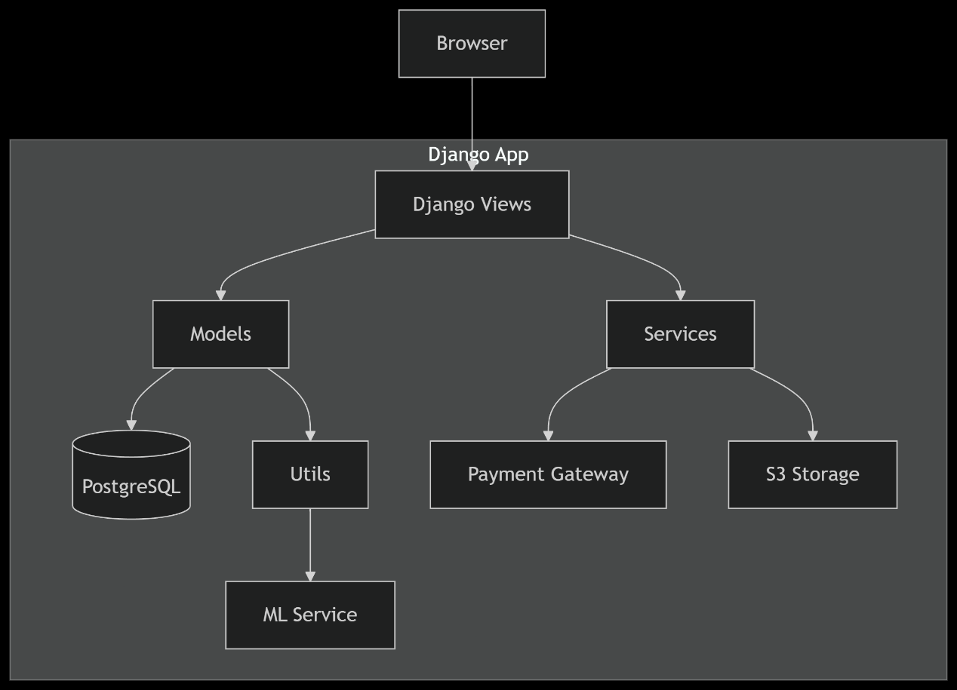
The architecture of Collabers follows a structured three-tier model, consisting of the presentation layer, the application logic layer, and the data management layer. This separation of concerns allows for better modularity and scalability, making the application easier to maintain and extend.
The presentation layer, also known as the frontend, is built using React.js. This component-based JavaScript library allows for the creation of dynamic and reusable user interface elements. It handles the rendering of views, form validations, and dynamic updates, such as displaying active campaigns or reflecting changes in application status. It also facilitates smooth communication with the backend through asynchronous REST API calls, enhancing the responsiveness of the user experience for both brands and influencers.
The application logic layer, or backend, is developed using Django, a robust Python framework known for its security, scalability, and rapid development capabilities. Django handles essential backend tasks such as user authentication, role-based access control, campaign creation, application processing, and integration with the machine learning module. APIs built using Django REST Framework allow the frontend to interact with server-side data securely and efficiently.
The third layer, the data management layer, uses PostgreSQL as its relational database system. This layer is responsible for storing all critical data, including user profiles, campaign details, influencer applications, and machine learning scores. Django’s ORM (Object Relational Mapper) is used to interact with the database using Python classes instead of raw SQL queries, ensuring both security and ease of development.
In addition to the core layers, Collabers includes an auxiliary Machine Learning module powered by XGBoost. This component operates as a background service, invoked whenever a brand wishes to evaluate influencer applications. It processes the influencer data—such as follower count, engagement rate, and category match—and returns a ranked list of applicants to assist brands in making informed collaboration decisions. The integration of this module adds intelligence and objectivity to the selection process.
This layered architecture ensures that Collabers remains modular, maintainable, and scalable—qualities that are essential not only for academic success but also for potential real-world deployment.

7.2 Data Flow Diagram (DFD)
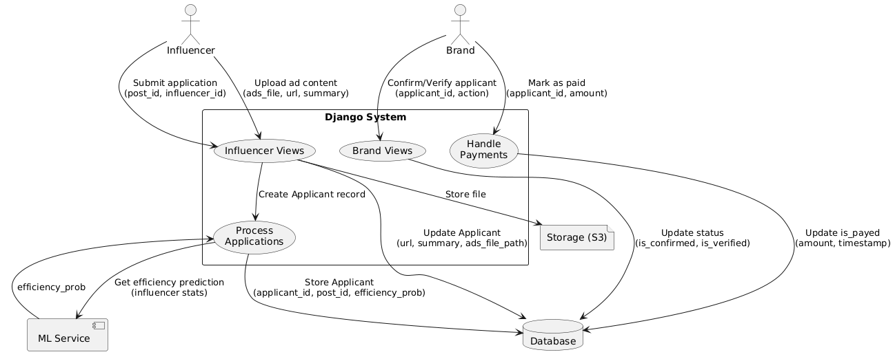
Understanding how data flows within the system is essential for optimizing both performance and usability. In Collabers, the data flow is structured across two levels. The Level 0 diagram, also known as the context diagram, presents a high-level overview of how data enters and exits the system. The two main external entities—Influencers and Brands—interact with the platform through a web interface. Influencers register on the platform, update their profiles, search for campaigns, and apply to those that match their niche. Brands, on the other hand, input campaign details and retrieve applications submitted by influencers. These interactions are mediated through the Collabers backend, which processes the data and stores it in the corresponding databases.
Moving deeper, the Level 1 DFD provides a detailed representation of how the system manages these inputs. When influencers log in and browse campaigns, their queries are processed and matched against the campaign database. Upon submitting an application, their data is stored in the application repository. Brands accessing these campaigns can then retrieve submitted applications, which are filtered through the XGBoost module that analyzes influencer metrics. The application list is then updated with recommendation scores, allowing brands to efficiently review and select applicants. This data flow ensures that information is processed and relayed in real time, enabling an interactive and reliable user experience.

7.3 UI/UX Design
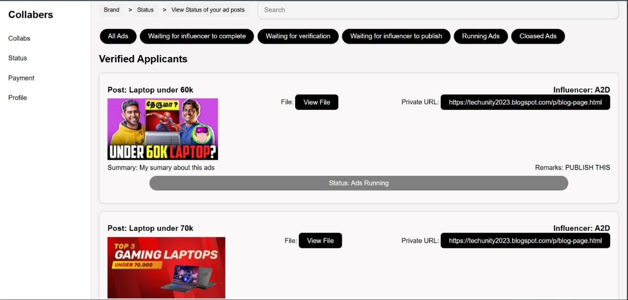
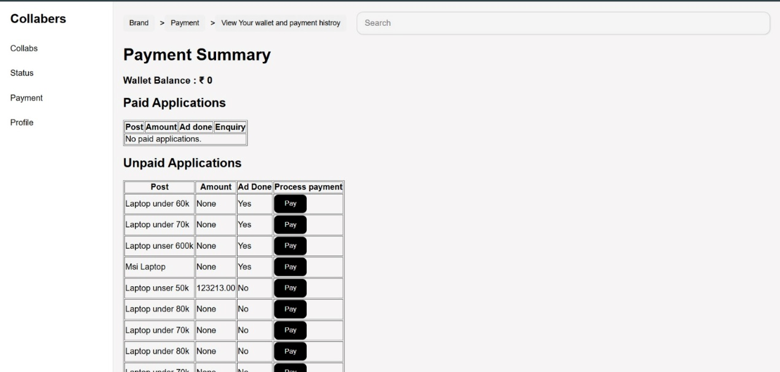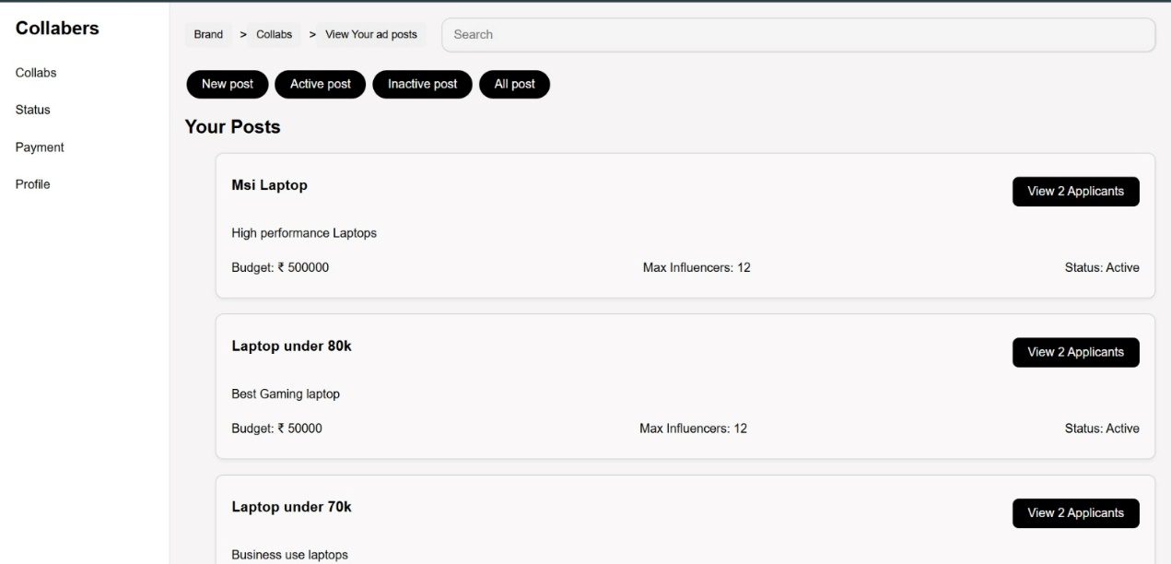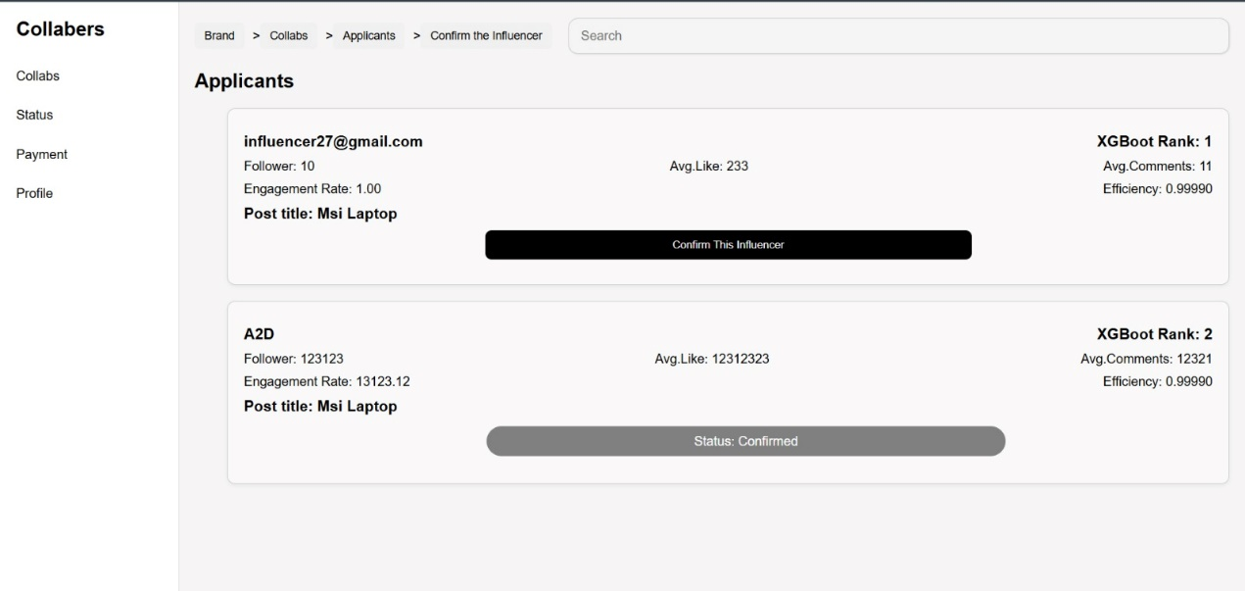

User interface and user experience (UI/UX) design plays a fundamental role in determining the accessibility, appeal, and effectiveness of a web application. For Collabers, the UI/UX was designed to be minimalist, responsive, and intuitive, with separate experiences tailored for influencers and brands.
For influencers, the journey begins with a straightforward login or registration screen that captures essential details. Once authenticated, they are directed to a dashboard where they can view active brand campaigns, check the status of their applications, and update their personal profiles. Campaigns are presented in a card-style format, allowing influencers to quickly scan through key information such as category, budget, and deadlines. They can then open a detailed view of a campaign and apply using a pre-filled form that includes a personalized pitch field.
For brands, the experience is similarly streamlined. After registration, brand users are taken to a dashboard where they can create new campaigns by filling in fields such as title, category, budget, description, and expected deliverables. They can then manage applications received for each campaign through a dedicated review panel, which includes summary cards for each applicant. These cards display influencer bios, follower metrics, and engagement scores, as well as the machine learning recommendation score that helps them make informed decisions. Brands can easily shortlist or reject applicants with just a click.
Both interfaces are built using React.js and styled with CSS3 to ensure consistency across components. The layout is responsive, adapting smoothly to different screen sizes using flexbox and media queries, ensuring usability across desktops, tablets, and mobile devices.

7.4 Class Diagram
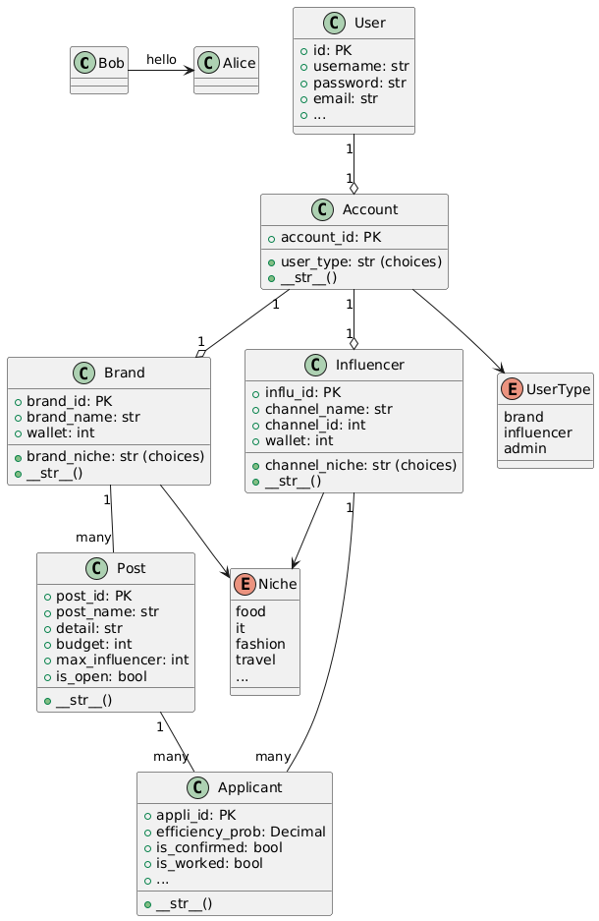

The class structure of Collabers is foundational to its database schema and overall functionality. At the heart of the system is the User class, which contains shared fields such as username, email, and password. This base class is extended into two specific subclasses: InfluencerProfile and BrandProfile.
The InfluencerProfile class holds influencer-specific attributes such as social media handles, follower count, engagement rate, content category, and a profile summary. The BrandProfile class, in contrast, stores brand-specific details like company name, industry sector, and representative contact information.
The Campaign class is designed to represent collaboration opportunities posted by brands. It includes fields like title, description, category, budget, deliverables, and deadlines. Each campaign is linked to a specific brand through a foreign key relationship.
The Application class serves as the bridge between influencers and campaigns. It stores data related to the influencer’s pitch, the campaign they are applying for, the status of the application (e.g., pending, shortlisted, accepted, rejected), and the recommendation score generated by the ML model. These class relationships are implemented using Django ORM, ensuring robust data integrity and relational consistency.

7.5 Sequence Diagram
To visualize the dynamic interaction between system components during a specific use case, a sequence diagram was created to model the process of an influencer applying for a campaign. This scenario begins when an influencer logs into the platform through the frontend. The login request is sent to the Django backend, where the user's credentials are authenticated. Upon successful authentication, the frontend retrieves available campaigns through an API and displays them to the user.

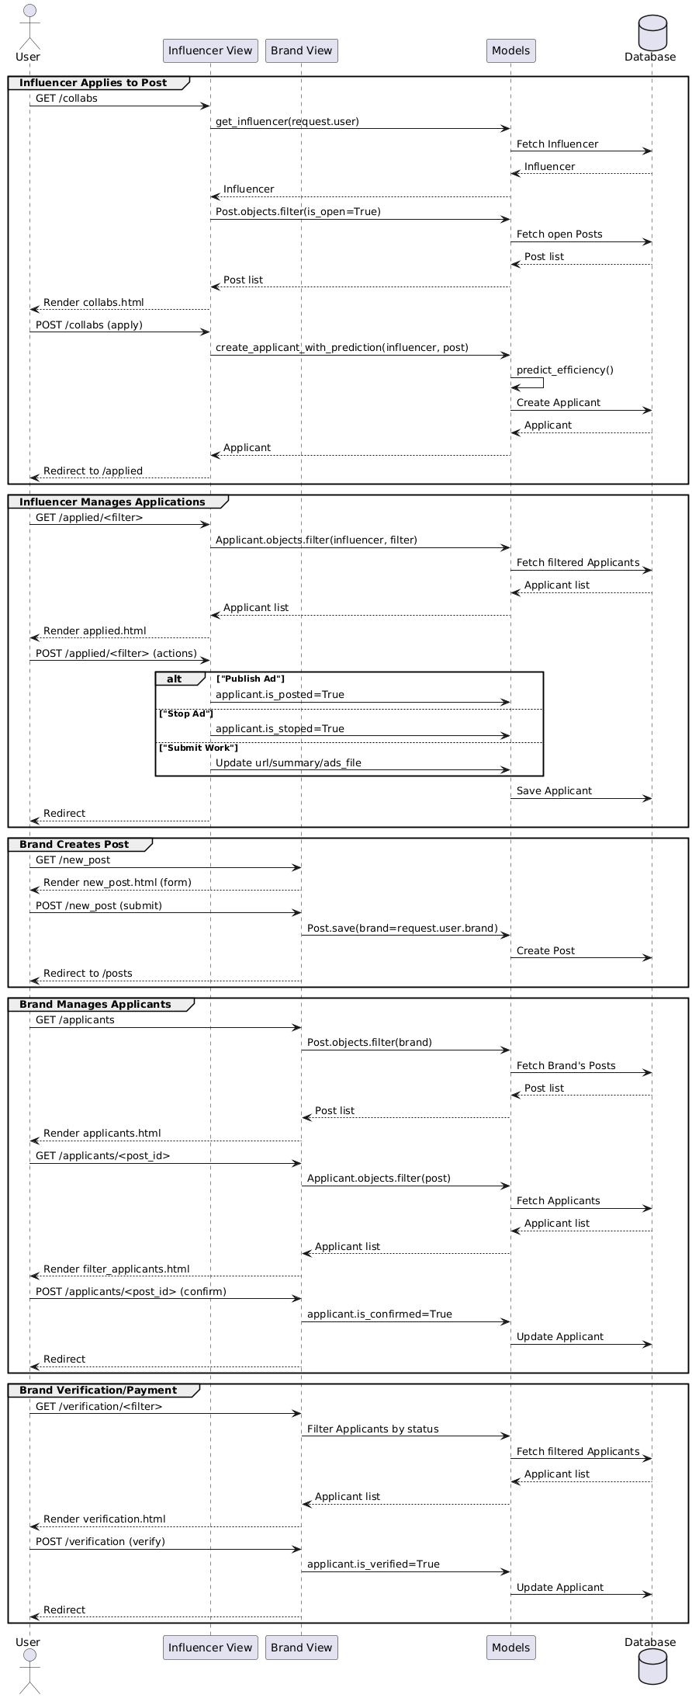

When the influencer applies for a campaign, the application data is sent to the backend and stored in the database. When the brand accesses the campaign, a request is made to fetch all associated applications. At this point, the backend triggers the machine learning model, which processes the influencer data and assigns a score to each applicant. These results are then returned to the frontend for the brand to view and act upon. This interaction model ensures asynchronous communication between frontend and backend, resulting in a seamless and efficient user experience.
7.6 State Diagram
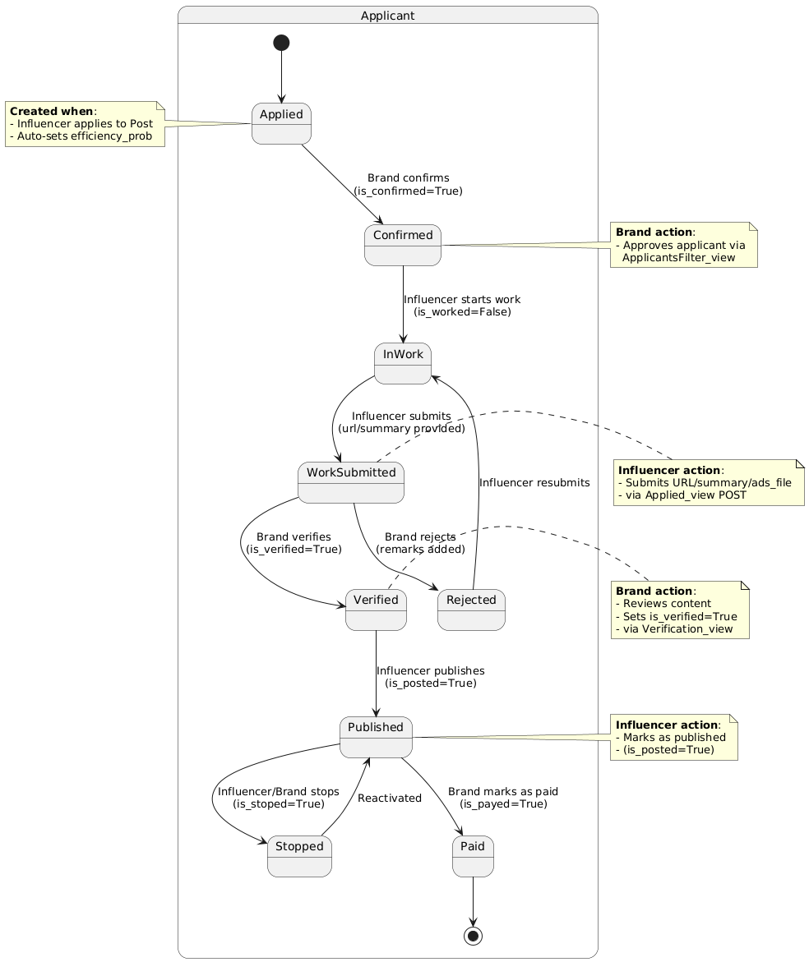

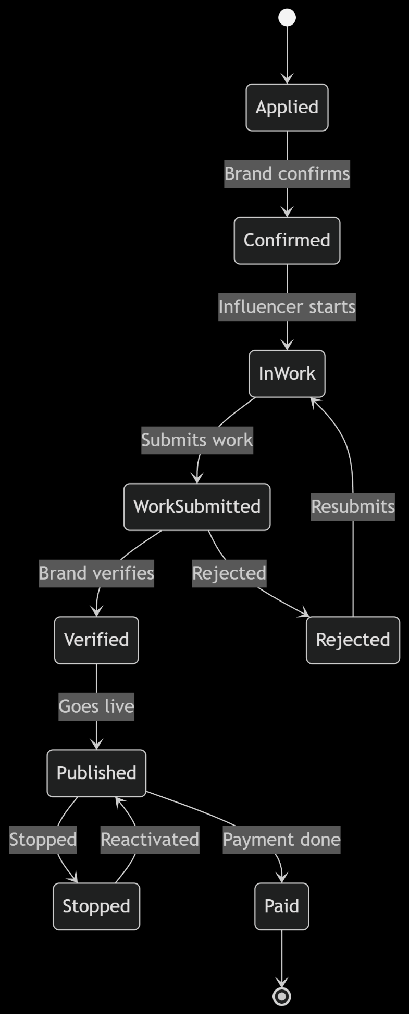

The application lifecycle is further illustrated through a state diagram that tracks the different stages an influencer’s application goes through. Initially, when an influencer submits an application, it enters the "Created" state. Once the brand views the application, it transitions to the "Under Review" state. Depending on the brand’s decision, the application may either be moved to the "Shortlisted" state for further consideration or directly to "Accepted" if approved. If the application does not meet the brand’s criteria, it is moved to the "Rejected" state.
Each of these transitions is triggered by explicit actions taken by the brand on their dashboard, such as viewing, shortlisting, accepting, or rejecting an application. These states are reflected in both the influencer’s and brand’s dashboards to maintain transparency and real-time tracking of collaboration status.

- SYSTEM IMPLEMENTATION

The implementation phase is the practical realization of the system design into a functional and working product. For the Collabers platform, the development was executed in multiple iterative cycles, following a modular architecture that separates functionality across several logical components such as user management, campaign creation, influencer application, and machine learning–powered recommendation. Each module was designed, developed, tested, and integrated in stages to ensure consistent progress, clean code separation, and flexibility for enhancements. This section details the major implementation modules that together bring the Collabers system to life.

8.1 Implementation Modules
The user management module is the foundation of the system, as it governs the authentication and access control processes for both influencers and brand users. Upon registration, users are prompted to choose a role—either influencer or brand—which determines their access privileges and the nature of the dashboard they are redirected to post-login. The authentication process is managed securely through Django’s built-in authentication system, which handles password hashing, session management, and role-based redirection logic. Influencers are directed to a dashboard that showcases active brand campaigns, while brands are taken to a dashboard from where they can post new collaborations and monitor applications.
The campaign management module enables brand users to create and manage collaboration opportunities. Through an intuitive form interface developed using React.js, brands are able to specify key details such as campaign title, description, category (e.g., fashion, food, tech), expected deliverables, application deadline, and

budget. Once submitted, this information is securely transmitted to the Django backend through RESTful APIs and stored in the PostgreSQL database using Django ORM. Each campaign is linked to the brand’s user ID, ensuring that only authorized users can edit or manage their campaigns. Brands also have access to a campaign list view that provides real-time statistics on applications received, pending decisions, and shortlisted profiles.
The influencer experience is centered around the collaboration discovery module. Upon logging in, influencers are presented with a dynamic feed of available campaigns, which can be filtered by category or keyword. Each campaign card includes a summary of requirements and an option to view more details. Influencers interested in a campaign can submit an application through a structured form, which includes fields for a personalized pitch, optional portfolio links, and a brief message to the brand. These applications are routed to the backend and linked to both the campaign and influencer IDs, making tracking and retrieval efficient.
One of the most innovative aspects of Collabers is its application review and recommendation system, which incorporates a machine learning model built with XGBoost. When a brand accesses the list of influencer applicants for a campaign, the backend invokes the pre-trained model to generate recommendation scores for each application. These scores are based on several attributes such as the influencer’s engagement rate, follower count, category match, and activity level. The ranked results are then displayed on the brand’s dashboard, providing a smart, data-backed mechanism for shortlisting influencers. This model-driven approach replaces subjective or time-consuming selection with intelligent filtering that enhances decision quality.
An admin module was also developed to ensure the overall integrity of the platform. This module provides system administrators with tools to monitor user behavior, approve flagged accounts, and moderate campaign content. Admin users can disable spam profiles, delete inappropriate campaigns, and perform data integrity checks through Django’s admin panel, thereby ensuring a safe and professional environment for collaboration.

8.2 Tools and Technologies Used
The development of Collabers was made possible through the thoughtful selection of tools and technologies across the frontend, backend, machine learning, database, and deployment layers. The frontend of the platform was developed using React.js, chosen for its component-based structure and efficient state management capabilities. This allowed the team to build dynamic user interfaces with reusable components such as campaign cards, profile widgets, and responsive navigation bars. The interface is styled using standard HTML and CSS, supplemented by responsive utilities like Flexbox and optional support from Bootstrap to ensure mobile accessibility and visual consistency.
The backend is built using Django, a robust and secure Python framework ideal for building scalable web applications. Django’s model–view–controller (MVC) pattern, combined with the Django REST Framework, facilitated the creation of secure APIs for handling frontend requests. The backend is responsible for executing authentication processes, managing application logic, and interfacing with the machine learning model and the database. Authentication is further strengthened by Django’s role-based access control mechanisms, ensuring that each user accesses only the features relevant to their role.
The PostgreSQL database, interfaced through Django ORM, stores structured application data including user profiles, campaign details, and application records. PostgreSQL was selected due to its reliability, speed, and ability to handle complex queries efficiently. The database schema was carefully designed with foreign key constraints and indexing to ensure referential integrity and quick data retrieval, especially for large-scale application lists.
The machine learning component uses XGBoost, a gradient boosting framework known for its speed and accuracy. The model was trained using sample influencer data and integrated into the Django backend using Python libraries like pandas and NumPy for preprocessing and joblib for model serialization. When triggered by a brand reviewing applications, the backend invokes this model to generate rankings, which are then used to enhance the decision-making process.
Version control was managed using Git and GitHub, allowing collaborative development and rollback functionality. REST APIs were tested using Postman, and local development was done primarily in Visual Studio Code. The platform is hosted using Heroku for backend services and Vercel for the frontend deployment, offering seamless integration and continuous delivery pipelines.
In summary, the system implementation of Collabers represents a well-structured combination of modern web technologies, machine learning intelligence, and user-centric design. Each module is developed to work independently while being tightly integrated into the larger ecosystem. This modular and scalable approach ensures that the platform can evolve over time with the addition of new features such as chat integration, influencer analytics, or payment systems without disrupting existing functionality.

- TESTING

Testing is a critical phase in the software development lifecycle that ensures the system performs as intended and meets all functional and non-functional requirements. For Collabers, testing was conducted systematically across various modules and components to verify core functionalities such as registration, login, campaign creation, influencer applications, and machine learning-based ranking. Additionally, testing was used to identify bugs, ensure proper integration between frontend and backend, and validate data flow through the platform. This section discusses the key testing objectives, outlines major test cases, and explains the methods and types of testing applied during development.

9.1 Testing Objectives
The primary objective of testing in Collabers was to ensure that all system components functioned correctly, consistently, and securely. Since the application involves role-based features and dynamic interactions between influencers and brands, it was essential to verify that users are correctly authenticated, redirected, and presented with accurate content based on their roles. Other core objectives included validating campaign creation and application workflows, ensuring that submitted data is correctly stored and retrieved from the database, and confirming the proper functioning of the XGBoost recommendation engine.
Furthermore, the user interface was tested for responsiveness and compatibility across different devices and browsers. The goal was to provide a smooth, bug-free user experience with minimal response time and high usability. Security was also an important focus, particularly in areas involving user authentication, access control, and form validation.

9.2 Key Test Scenarios
A variety of test scenarios were created to validate user flows and system robustness. These scenarios were derived from user stories and system use cases identified during the design phase.
One of the fundamental test cases involved user authentication, where both valid and invalid login attempts were tested to ensure appropriate feedback and secure session handling. Password mismatches, empty fields, and role confusion (e.g., influencers trying to access brand-only pages) were also tested thoroughly.
In the campaign management workflow, test cases were written to check whether brands could successfully create, view, update, and delete collaboration opportunities. Form validations were verified to ensure that all required fields (such as campaign title, deadline, and category) were present and properly handled.
From the influencer’s perspective, the application submission process was tested to ensure that users could view relevant campaigns, apply to them, and receive feedback on application status. Edge cases like submitting duplicate applications or applying after the deadline were handled and tested for appropriate alerts.
The machine learning recommendation module was also subjected to functional testing. Sample influencer data was passed through the XGBoost model, and the resulting scores were checked for consistency with expected rankings. The integration between the backend and ML logic was validated to ensure real-time score generation during application reviews.

9.3 Testing Methods
Testing in Collabers involved both manual and automated approaches. Manual testing was carried out extensively during the early stages, particularly for user interface components, form submissions, and user interactions. This method allowed testers to explore the application from an end-user perspective and catch usability issues that may not be detected by automation tools.
As the application matured, certain components—especially frontend components in React—were tested using automated unit testing tools such as Jest. API endpoints exposed by the Django REST Framework were tested using Postman, which enabled structured and repeatable testing of all HTTP requests and responses, including edge cases and invalid inputs.
To evaluate performance under various user loads, basic load testing was performed using simulated user interactions. The goal was to observe how well the application maintained its responsiveness under simultaneous access by multiple users, particularly during heavy API calls such as campaign browsing or influencer application listing.

9.4 Types of Testing Applied
A range of testing types was applied throughout the development lifecycle of Collabers to ensure the system's functional integrity, performance, and security.
Unit Testing was applied to isolated modules and functions, particularly in the backend where Django models, serializers, and custom utility functions were tested independently. This helped catch logical errors early and maintain a high level of code reliability.
Integration Testing was used to validate the interaction between different modules, such as frontend forms connecting with backend APIs, or campaign applications being stored in the database. This ensured that data was correctly passed and processed across components.
System Testing was carried out on the complete, integrated platform to simulate actual user behavior. This helped verify end-to-end workflows such as registration, login, campaign creation, application submission, and influencer ranking.
Functional Testing ensured that the application behaved in accordance with the specified requirements. This covered all core functionalities, from form validations to API responses and database consistency.
Security Testing focused on areas like authentication, role-based access control, and session handling. The system was tested against common vulnerabilities such as unauthorized access to admin pages, SQL injection attempts, and form field manipulation.
Compatibility Testing was also conducted to verify that the application works consistently across modern browsers (Chrome, Firefox, Edge) and various screen sizes, including mobile and tablet views.
In addition to these, Usability Testing was performed informally with peers and faculty members to assess how easily users could navigate the platform and complete key tasks without confusion. Their feedback helped refine interface design and layout choices.
In conclusion, the testing phase of Collabers played a pivotal role in ensuring the system's quality, usability, and reliability. By combining manual inspection, automated validation, and systematic test planning, we were able to deliver a robust and stable product that performs effectively under real-world conditions. The insights gained from testing were also instrumental in refining features and improving the overall user experience.

- . CONCLUSION

The development of Collabers: A Smart Platform for Influencer–Brand Collaboration has been a rewarding and insightful journey that brought together multiple aspects of software engineering, including requirement analysis, system design, frontend and backend development, machine learning integration, and testing. The core objective of the project was to bridge the communication and collaboration gap between brands and influencers by providing a centralized, intelligent, and user-friendly platform tailored to both parties. Through the successful implementation of this system, we have demonstrated that it is possible to automate and enhance influencer marketing with the support of modern web technologies and data-driven decision-making.
One of the most valuable achievements of Collabers lies in its intelligent influencer filtering system, powered by the XGBoost machine learning model. By enabling brands to make informed choices based on quantifiable metrics such as engagement rate, follower count, and category relevance, the system goes beyond the traditional guesswork and manual filtering prevalent in the current ecosystem. Influencers, on the other hand, benefit from improved visibility and access to legitimate collaboration opportunities that align with their content style and reach.
From a technical perspective, Collabers represents a robust and scalable solution. The use of React.js for frontend development ensured a dynamic and responsive user experience, while Django provided a secure and reliable backend framework for managing application logic and user data. The integration of PostgreSQL with Django ORM allowed for efficient data handling and secure storage of user-generated content. Furthermore, the system's architecture supports future enhancements such as real-time messaging, performance analytics, and payment integration.
Throughout the course of this project, we encountered and resolved a variety of challenges, from managing role-based access flows to integrating machine learning predictions within the campaign review process. Each of these challenges contributed to a deeper understanding of full-stack application development, user-centric design, and intelligent system engineering.
In conclusion, Collabers successfully fulfills its mission of simplifying, organizing, and improving the process of influencer–brand collaboration. It not only stands as a working prototype but also offers significant potential for real-world deployment and further innovation in the digital marketing domain. This project has enriched our technical skillset, enhanced our problem-solving capabilities, and offered valuable insights into building intelligent, purpose-driven web platforms.

11. FUTURE SCOPE

While the current version of Collabers fulfills its fundamental objectives of facilitating intelligent influencer–brand collaborations, there remains significant potential for further development, refinement, and expansion. As the landscape of digital marketing and influencer outreach continues to evolve, Collabers can be enhanced with a variety of technical, strategic, and user-centered features to meet emerging trends and needs.
One promising direction is the integration of real-time messaging and chat features. While the current implementation allows brands and influencers to connect through application status updates, the addition of a secure in-app messaging system would foster immediate communication, enabling both parties to clarify expectations, negotiate terms, and build professional relationships within the platform. Such a feature would significantly reduce reliance on external platforms like email or social media direct messaging, thereby consolidating the collaboration workflow within Collabers itself.
Another major area for improvement lies in the analytics and performance reporting modules. In future iterations, brands could be provided with detailed dashboards that display influencer performance metrics, campaign reach, user engagement, and return on investment (ROI). Similarly, influencers could receive insights into their application history, acceptance rates, and category trends, helping them adapt their content and pitching strategies. These analytics can be powered by data visualization libraries and enriched by continuous learning algorithms that evolve with user behavior.
In terms of influencer discovery, the current implementation uses the XGBoost model for ranking based on static input features. This can be further evolved into a real-time recommendation engine that continuously learns from brand preferences, past collaborations, and platform-wide behavior. By incorporating reinforcement learning or deep learning models, Collabers could offer predictive insights, campaign forecasting, and personalized influencer suggestions that improve over time.
The platform can also introduce a review and rating system, where brands and influencers can rate each other after a collaboration is complete. This system would help establish trust, improve platform credibility, and enable new users to make informed decisions based on community feedback.
From an operational standpoint, multi-language support and internationalization can open Collabers to a broader global audience. Influencer marketing is a worldwide phenomenon, and providing support for different languages and regional preferences would make the platform accessible to users beyond local or English-speaking regions.
The inclusion of blockchain-based smart contracts is another futuristic but increasingly relevant possibility. These contracts could automate the execution of collaboration agreements, ensuring that influencers are compensated only upon fulfillment of deliverables, and brands are assured of content delivery. This would introduce a new layer of transparency and security, especially for high-value or international campaigns.
Lastly, there is scope to integrate payment gateway APIs (e.g., Razorpay, Stripe, or PayPal) into the platform, enabling brands to pay influencers directly upon campaign completion. This would transform Collabers into a one-stop-shop for campaign initiation, collaboration, tracking, and payment, significantly enhancing the value proposition for both user types.
In conclusion, Collabers lays the groundwork for a new era of structured, intelligent influencer–brand collaboration. Its current architecture supports scalability and flexibility, making it well-suited for iterative improvements. With the integration of advanced features such as analytics, real-time chat, automated payments, and smart contracts, Collabers has the potential to evolve into a powerful, industry-ready platform for the influencer economy of tomorrow.

12. REFERENCES

- Django Software Foundation. Django Documentation. https://docs.djangoproject.com
- Facebook Open Source. React Documentation. https://reactjs.org
- XGBoost Developers. XGBoost Documentation. https://xgboost.readthedocs.io
- PostgreSQL Global Development Group. PostgreSQL Documentation. https://www.postgresql.org/docs/
- Scikit-learn Developers. Model Evaluation and Serialization in Python. https://scikit-learn.org
- Mozilla Developer Network. HTML5, CSS3, and JavaScript Reference. https://developer.mozilla.org
- GitHub, Inc. Version Control with Git. https://github.com
- Heroku. Deploying Django Applications. https://devcenter.heroku.com
- Vercel. Frontend Deployment Platform. https://vercel.com
- White, K., & Yuan, Q. (2022). Machine Learning in Marketing Campaigns. Journal of Digital Innovation, 18(2), 100–115.
- Kaur, R. & Arora, S. (2021). Role of Influencer Marketing in Brand Building. International Journal of Digital Marketing, 9(1), 25–32.
- Google Developers. OAuth and Authentication Practices. https://developers.google.com/identity
- Bootstrap. Responsive Web Design Framework. https://getbootstrap.com

