<https://cpl.only.sap/launchpad/?lds=S4ClInf&cat=S/4HANA&sys=CC3>

If I open the launchpad in the Chrome browser and then want to open the system CC3, client 715, the system displays a dialog box with the error message

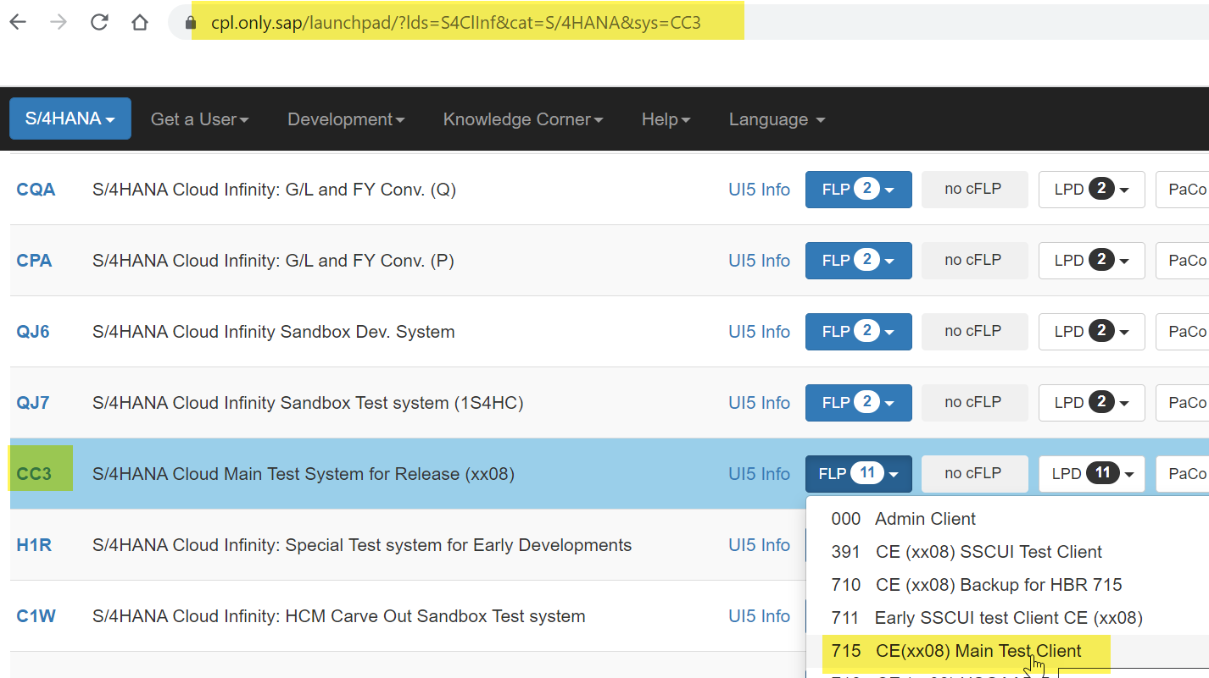

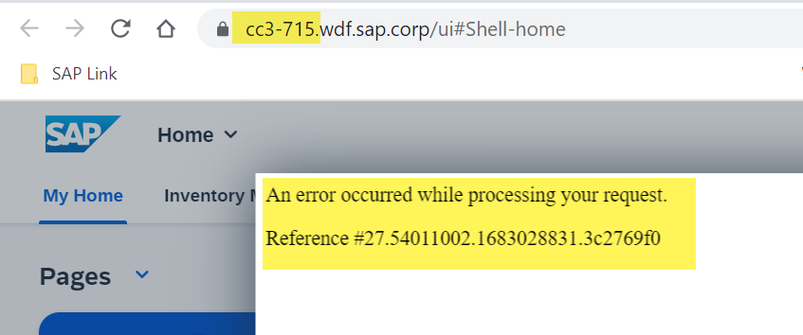

Chrome is up to date

