TITLE: STUDENT FEEDBACK SENTIMENT ANALYSIS SYSTEM

Team Members:
- 2403A52222-V.Gagan Chandra Tej
- 2403A52233-T.Ganesh Reddy
- 2403A52245-S.Sathwik
- Guide: Dr .V. Venkataramana
- Institution: SR-University

- Abstract :
Student feedback is an essential part of assessing the quality of teaching and enhancing the overall learning process. But the process of manually analyzing large amounts of textual feedback is both time consuming and inefficient and it can be biased by human hands. This project introduces an automated system which employs Natural Language Processing (NLP) algorithms to carry out sentiment analysis on student responses to allow institutions draw valuable insights in a quick and precise way.
This system makes use of a dataset retrieved via sources like Kaggle and institutional surveys, which comprise feedback that is categorized as positive, negative and neutral. To enhance the quality of data, the data is preprocessed through methods like tokenization, removal of stop-words and normalization. TF-IDF (Term Frequency–Inverse Document Frequency) is used to extract features by converting textual data to numerical data to be used in machine learning models.
Sentiment classification is done with a Logistic Regression algorithm as it is efficient and has good performance in text-based tasks. The trained model is combined with a Flask back-end and a web-based front-end that is developed in HTML, CSS, and JavaScript and enables users to submit feedback and get real-time sentiment predictions.
The system has good accuracy and scalability and can be effectively deployed in real-life contexts in schools.
b)Introduction and Discussion on existing methods
- Introduction
Feedback of students is an essential element in assessment of quality of teaching and learning activities in schools. Historically, feedback has been gathered by surveys or questionnaires or via online form and has been analyzed manually by faculty or administrators. This is not only a time-consuming manual process, but also likely to be inconsistent and subjective. With the growth of the number of students, institutions encounter enormous problems in handling huge amounts of feedback effectively. Additionally, slow analysis can lead to the loss of chances to make timely improvements.

As the digital technologies are actively developed, the feedback is presented in written format more and more, and it can be processed in an automated manner. Natural Language Processing (NLP) has proven to be an effective tool in analyzing such textual data. NLP allows computers to comprehend, interpret and process human language, allowing us to derive useful information out of unstructured text. One of the most important applications of NLP is sentiment analysis, which aims at defining the emotional tone of text by classifying it as positive, negative or neutral.

With the implementation of sentiment analysis to student feedback, institutions can determine the level of student satisfaction in less time and pinpoint areas where it is possible to improve. Thousands of feedbacks can be processed in a short time with automated systems to give real-time insights. This improves decision making and the institutions are able to uphold high academic standards. Thus, it is feasible and crucial to incorporate NLP-based sentiment analysis into feedback systems in contemporary education.

- Rule-Based Methods

One of the oldest methods of analyzing textual data is known as rule-based sentiment analysis. This approach is based on the established linguistic rules and sentiment lexicons or sets of words that have sentiment values attached to them. As an example, positive words like excellent, good and amazing are related to positive sentiment whereas poor, bad and terrible are regarded as negative words. The system checks the text by tallying the number of these words and the general impression on the frequency of these words.
Despite the simplicity and easy implementation of rule-based methods, they have a number of shortcomings. This is because one of the most significant weaknesses is that they lack contextual comprehension. An example is the statement that the lecture was not bad; this can be mistakenly defined as negative because of the use of the word bad yet the message is to be positive. Also, such systems have problems with sarcasm, negation, and complicated sentences.
The second weakness is that the lexicon will have to be constantly updated. The language changes with time and new terms or slang words might not be contained in the predefined dictionary. Moreover, systems that are based on rules have no flexibility to domain specific language like the terms of educational feedback.
Notwithstanding these issues, rule based approaches can be applied to small scale applications and as a point of reference. But when dealing with large datasets and in the real world such as with student feedback, more sophisticated methods are needed.

- Machine Learning Methods

Sentiment analysis systems have been made much better through machine learning methods. Machine learning models do not require rules to be trained, unlike the rule-based methods, but they can be trained to generalize based on new inputs. Typical sentiment analysis algorithms are Logistic Regression, Naive Bayes, Support Vector Machines (SVM), and Decision Trees.

The Logistic Regression is popular because it is very simple, efficient and performs well when used in classification tasks. It approximates the likelihood of an input to be in a specific class. Another popular text classification method is Naive Bayes, which is based on probabilistic principles, but assumes that features are independent. SVMs can be used in high-dimensional spaces and deal with complicated decision boundaries.
In order to use machine learning with text data, preprocessing and feature extraction is required. The data are cleaned using techniques like tokenization, stop-word removal, and stemming. The TF-IDF feature extraction techniques transform text into numerical data, which models can analyze effectively.
Compared to rule-based systems, machine learning models have more accuracy and flexibility. Nevertheless, they need labeled datasets and tuning to get the best performance. Although these are the requirements, machine learning is still a favorite method of sentiment analysis because of its trade-off between accuracy and computational efficiency.

- Deep Learning Methods
The deep learning-based approaches have also improved the abilities of sentiment analysis by allowing models to learn more complicated patterns and contextual correlations in text. Recurrent Neural Networks (RNN), Long Short-Term Memory (LSTM), and Transformer-based models like BERT are neural networks that have demonstrated impressive performance in NLP tasks.
LSTM networks are especially good at working with sequential data, since they are capable of remembering long-term relationships in text. This renders them applicable in the analysis of complex structures of sentences. Transformer-based models like BERT apply attention mechanisms to learn the significance of every word in a sentence to gain a more contextual insight.
The main benefit of deep learning models is that they can automatically extract features out of data, and do not require manual feature extraction. Nevertheless, such models are computationally and memory intensive to train and also need large datasets. They are also more complicated to apply and interpret than conventional machine learning techniques.
Deep learning models are able to be more accurate, particularly when working with subtle language and context, in the context of student feedback analysis. Nonetheless, in low-resource projects, less sophisticated models such as Logistic Regression can be used because of their efficiency and simplicity of implementation.

- Limitations & Need :
Even with the improvements in sentiment analysis methods, there are still a number of issues in the effective analysis of student feedback. It is one of the main problems to deal with informal language, spelling mistakes, and short forms frequent among students. Such factors have the potential to decrease the classification model accuracy.
Contextual and sarcasm problems are another problem. To illustrate, a sentence such as, Great, another boring lecture, can be construed as positive given that the word great comes before the word boring, yet the meaning of the statement is negative. Also, feedback is usually mixed in nature, with students in a statement either giving both negative and positive feedback.
The currently used systems are also not user-friendly and are thus hard to use by non-technical users. The combination of a reliable sentiment analysis with a user-friendly interface is needed.
The proposed system alleviates these difficulties, relying on the machine learning approach with adequate preprocessing and features extraction. An online interface makes it easy to access the feedback with ease because it is a web-based interface. This combination of NLP and web technologies offers a viable and scalable solution in the case of educational institutions.

c)Methodology:
The project methodology will be developed to facilitate mechanized processing of student feedback and categorizing it based on machine learning methods to organize into sentiment categories. The initial one is to gather a sample of student reviews based on trusted information sources like Kaggle or institutional surveys. The material in the dataset includes textual feedback and matched sentiment tags, including positive, negative, and neutral. It is also necessary to ensure that the quality of the data is good and hence preprocessing method is used to clean and standardize the data.
The initial stage (preprocessing) involves tokenization, which splits the sentences into single words, and stop-word, which involves removing words that are too frequent (the, is, and and etc.), and add no meaningful sentiment. Such additional procedures as lowercasing and stemming/lemmatization are used to normalize the words and minimize redundancy. This enhances the effectiveness of the model.
TF-IDF (Term Frequency–Inverse Document Frequency) is then used to find features after preprocessing. This is a method of transforming textual data into numeric vectors and implies attaching weights to the words depending on their significance in the dataset. Words which happen repeatedly in a document but infrequently in all the documents are prioritized.
This is followed by the separation of the data into training and tests, using the traintest split techniques just to name a few. In order to train the model, the Logistic Regression algorithm is employed, since it is an efficient model and is used in classification. The model is trained on trends in the data and predicts mood of unseeable inputs.
Lastly, accuracy, precision, recall, and F1-score metrics are used to evaluate the model. The trained model is deployed as a Flask backend that is connected to a frontend interface. This entire pipeline delivers the processing, analysis and display of user input in real time..
d)Results and Discussion
The project outcomes indicate that machine learning sentiment analysis can work in sifting student feedback. Logistic Regression model was able to get to a decent level of accuracy on the test data, so it is capable of generalizing well on unseen data. TF-IDF feature extraction has been a major contributor to the performance of the model in the sense that it brought about the relevance of control words in the feedback.
In the process of evaluation, the measures of accuracy, precision, recall, and F1-score were observed to evaluate the performance of the model. Accuracy gave a general idea on how correct a model was whereas the precision and recall gave a measure of how well a model dealt with various sentiment classes. The F1-score provided an equal measure of recall and precision. The model was successful at detecting obvious positive and negative feedback but not very successful in neutral or ambiguous statements.
The merging of the frontend and the backend greatly improved the usability of the system. Users could enter through a web interface and be given real-time sentiment predictions. This renders the system feasible to real world applications in learning institutions.
However, certain challenges were observed. The model had a weakness in the sarcasm and the language depending on the context. To illustrate, some sentences that included some sentiments or phrases could be indirect were occasionally misclassified. Also, the size and quality of the dataset determine the performance of the model.
In spite of these shortcomings, the general findings suggest that the system is effective, scalable, and able to deliver useful information on the views of the students. It may be used as a handy resource to achieve better teaching techniques and to increase student satisfaction.

performance metrics values:

Metric | Value
Accuracy | 0.9917
Precision | 0.9919
Recall | 0.9917
F1 Score | 0.9917
Actual \ Predicted | Positive | Neutral | Negative
Positive | 40 | 0 | 0
Neutral | 0 | 40 | 0
Negative | 1 | 0 | 39

Exact Loss Value: Log Loss = 0.6262

screenshots of application:

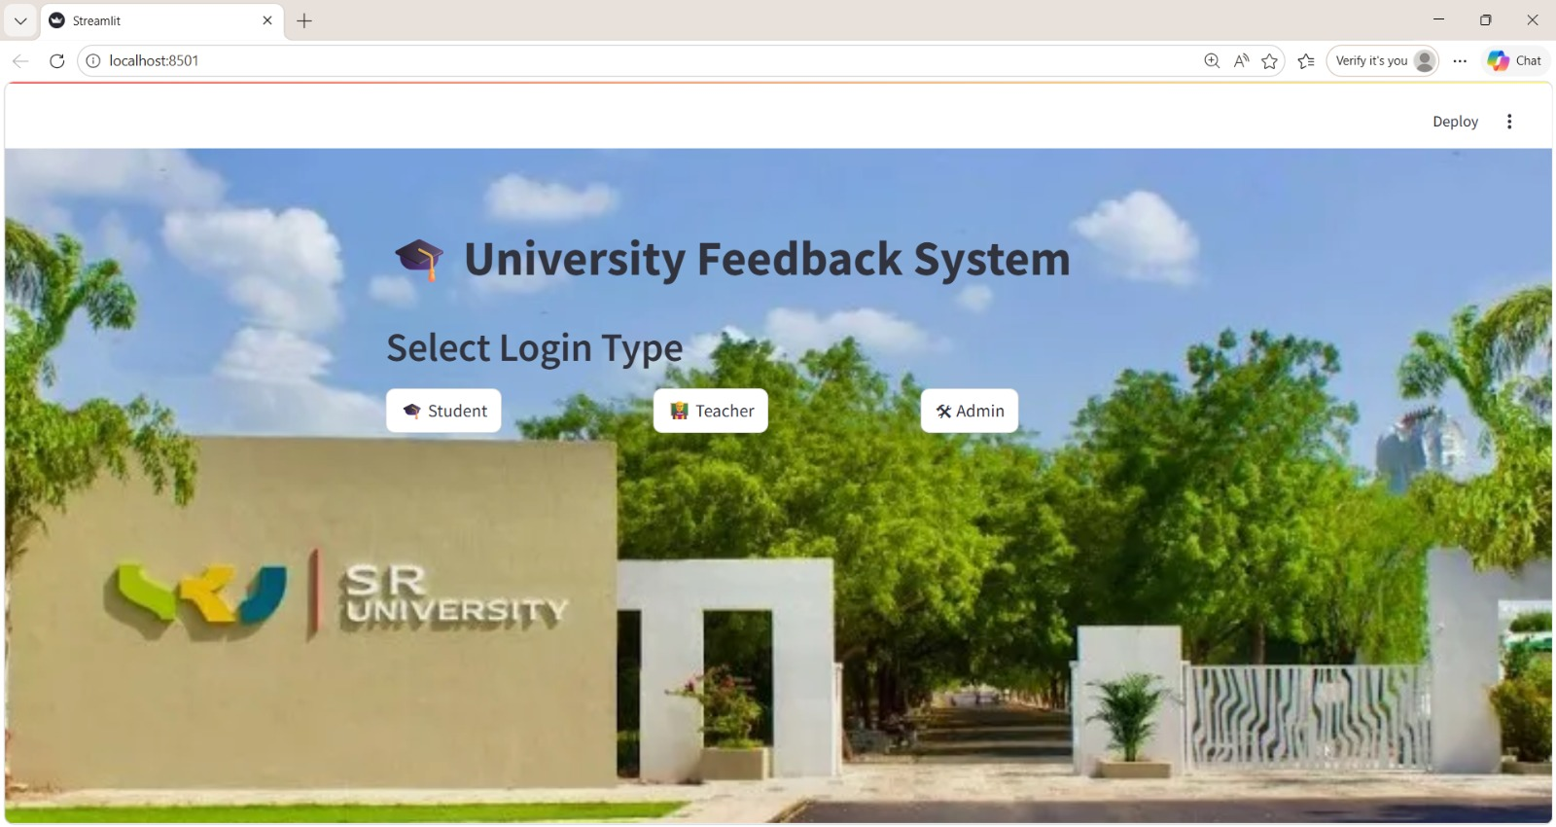

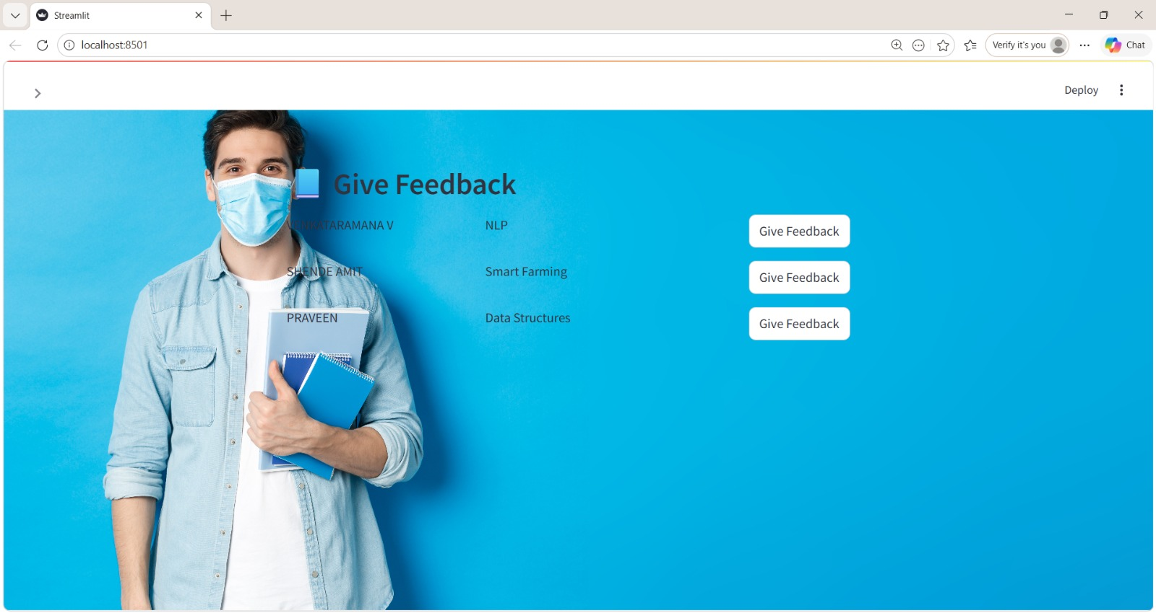
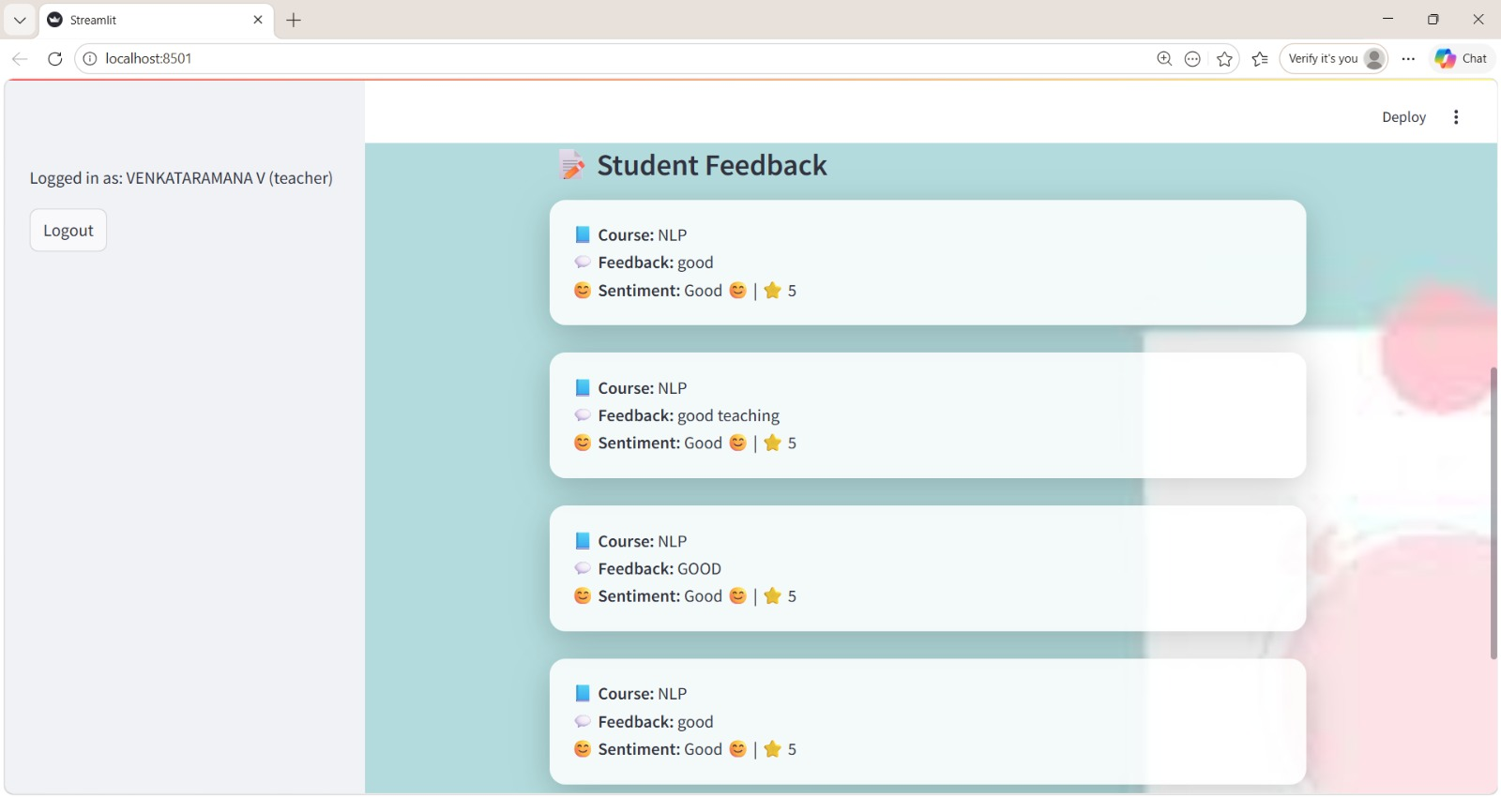

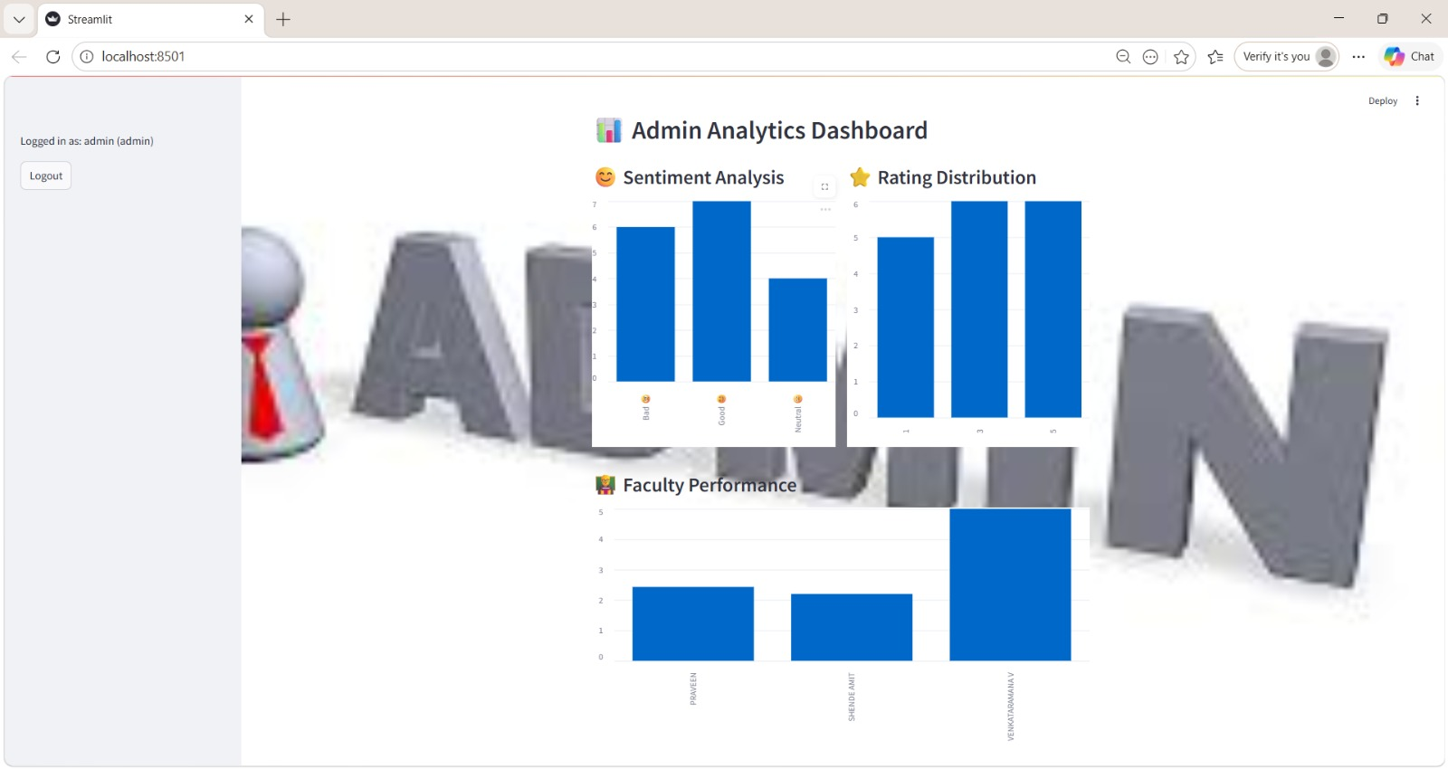

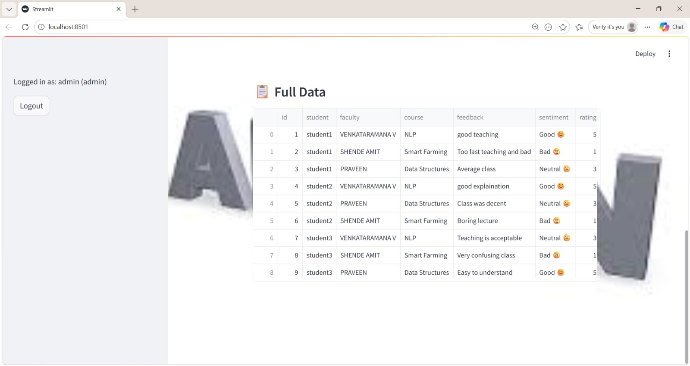
e)Conclusion

The project has been able to illustrate how Natural Language Processing and machine learning tools can be applied to the analysis of student feedback. The system will save time and human bias because it will not require human appraisal since it automates the sentiment analysis process. An approach based on a dataset is used and the model adopts real-life trends and makes proper predictions.
Text classification using the Logistic Regression model with TF-IDF feature extraction turned out to be a useful tool to use. The model was good at recognizing positive, negative, and neutral sentiments. Besides, the system was easy to use and accessible by non-technical users because of the incorporation of a web based front end and Flask based rear end.
Scalability of the project is one of its main strengths. The system is capable of managing huge amount of feedbacks and giving real time results hence can be deployed in education institutions. It helps administrators and members of the faculty to learn quickly about what students think and makes relevant decisions to enhance the quality of teaching.
Nevertheless, the project also points out some shortcomings, including it is hard to deal with sarcasm, ambivalent feelings, and colloquial language. Such issues can be solved with more sophisticated models of deep learning in future (either LSTM or Transformer-based models like BERT).
To sum up, the student feedback analysis presented in the project is a good and beneficial solution needed in practice. It shows the way NLP and machine learning, together with web technologies can be integrated to develop intelligence systems that aid in data-driven decision-making. The system can also be enhanced even more in the future to become more accurate and have more abilities.
f)References
- Daniel Jurafsky & James H. Martin, Speech and Language Processing, Pearson Education.
- Bing Liu, Sentiment Analysis and Opinion Mining, Morgan & Claypool Publishers.
- Bo Pang and Lillian Lee, Opinion Mining and Sentiment Analysis, Foundations and trend in information retrieval.
- Scikit-learn Documentation – https://scikit-learn.org
- TensorFlow Documentation – https://www.tensorflow.org
- Kaggle Datasets – https://www.kaggle.com
- Flask Documentation – https://flask.palletsprojects.com
- NLTK Documentation – https://www.nltk.org
- spaCy Documentation – https://spacy.io
- Research paper: Survey on Sentiment Analysis techniques, ACM Digital Library.
- Machine learning: Hands-on with guide to Scikit-Learn and TensorFlow by Aurélien Géron.
- Deep Learning in Ian Goodfellow, Yoshua Bengio, and Aaron Courville.
- Free AI tools and machine learning materials.

