**Report Lab 02**

Student’s name: Bùi Công Minh

Student’s ID: 20235601

1. Use Case Diagram

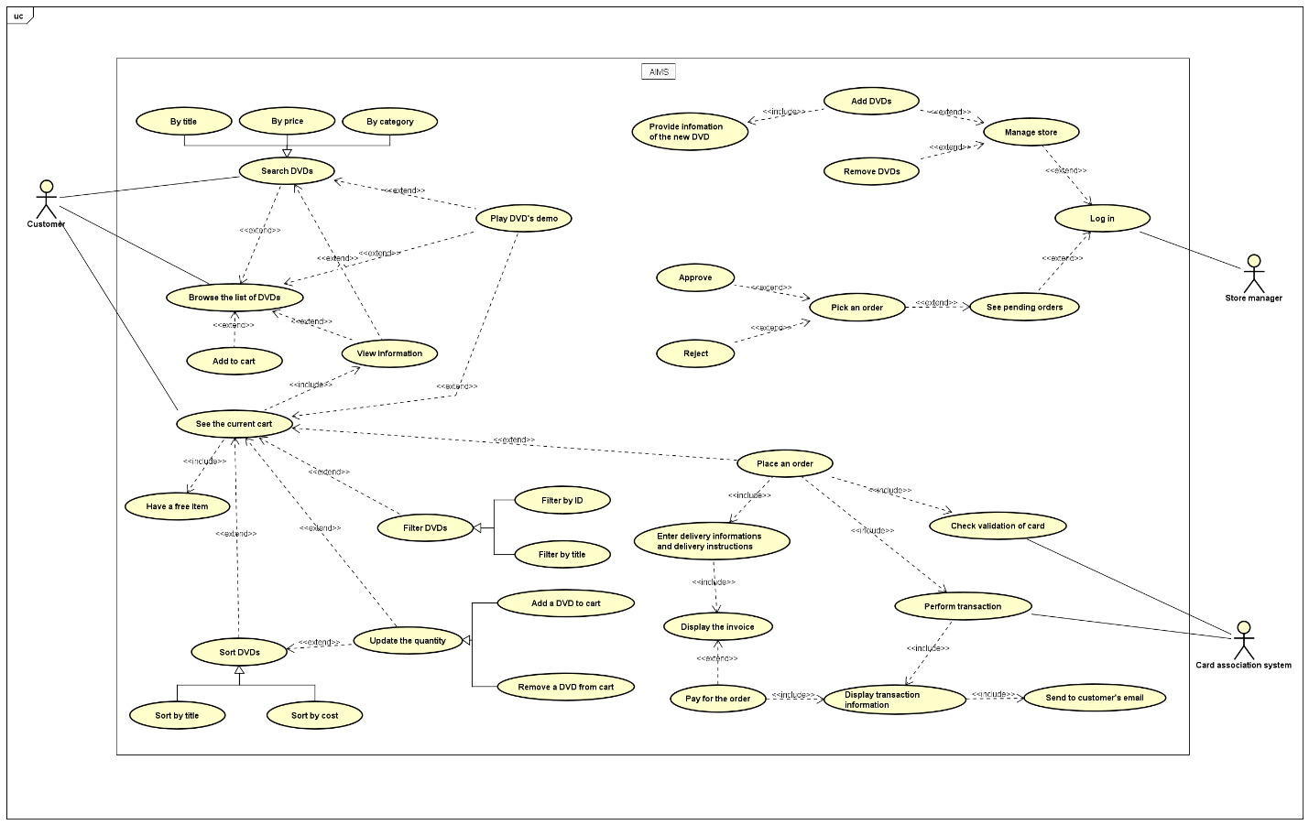

1. Class Diagram

1. Reading Assignment

