**Report Lab 05**

Name: Bùi Công Minh

Student ID: 20235601

1. **UseCase Diagram**

Figure : UseCase Diagram

1. **Class Diagram**

Figure : Class Diagram for AimsProject

Figure : Exceptional Hierarchical Tree

1. **Swing components**
   1. AWT Accumulator

Figure : Source code for AWT Accumulator

Figure : Before

Figure : After

* 1. Swing Accumulator

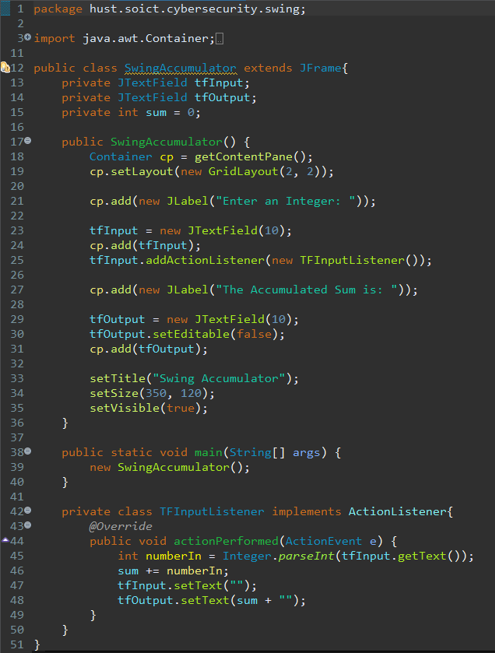

Figure : Source code for SwingAccumulator

Figure : Before

Figure : After

1. NumberGrid

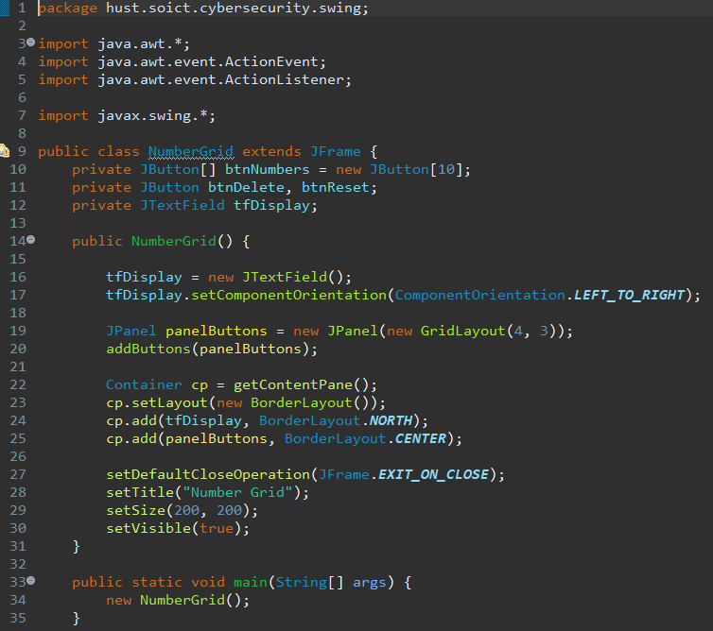

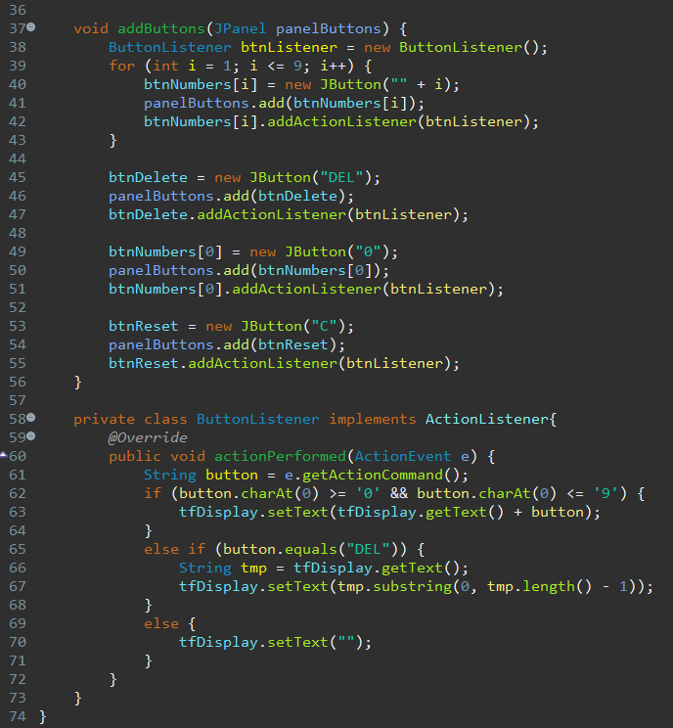

Figure : Source code for NumberGrid

1. 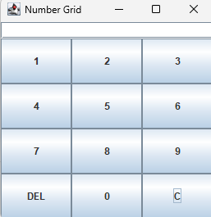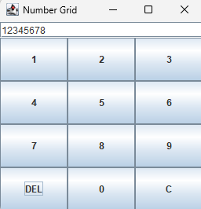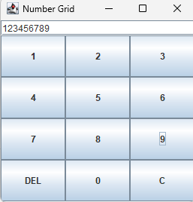 Painter (Java FX API)

Figure : Pressing numbers, DEL and C

* 1. Create a new FXML file

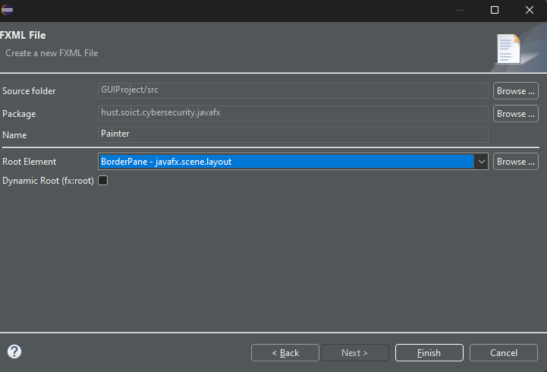

Figure : Create a new FXML File

* 1. Building the GUI

Figure : Configuring the BorderPane

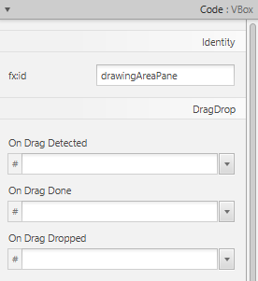

Figure : Configuring the Vbox

Figure : Configuring the Pane

Figure : Configuring the Clear button

Figure : Adding and configuring TitledPane and RadioButtons

Figure : Source code for PainterController

Figure : Source code for Painter

Figure : Painter results(Pen)

Figure : Painter results(Eraser)

Figure : Painter results(Clear)

1. Aims GUI
   1. StoreScreen

Figure : Source code of StoreScreen

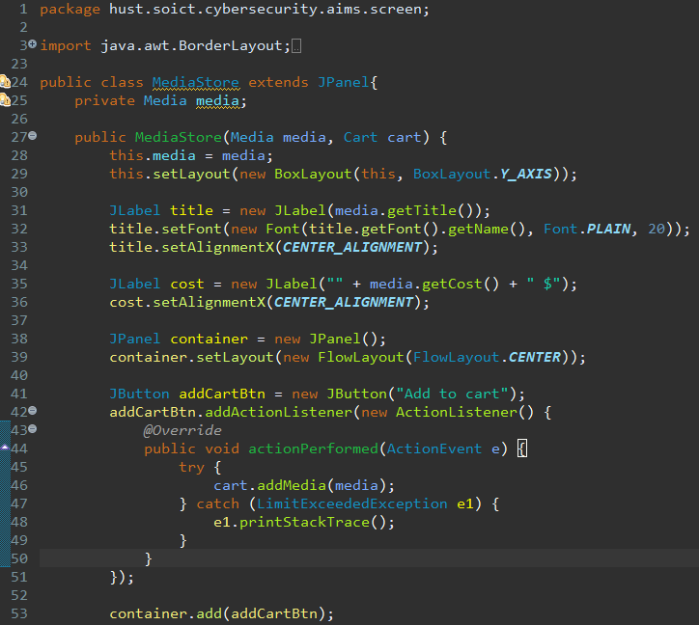

Figure : Source code of MediaStore

Figure : Result

* 1. Update Store

Figure : AddItemToStoreScreen

Figure : AddDigitalVideoDiscToStoreScreen

Figure : AddCompactDiscToStoreScreen

Figure : AddBookToStoreScreen

Figure : Adding a book to store in AIMS

Figure : Adding a CD to store in AIMS

Figure : Adding a DVD to store in AIMS

Figure : After updating the store

Figure : Playing media

* 1. CartScreen

Figure : CartScreen

Figure : CartScreenController

Figure : Cart screen in AIMS

Figure : Remove media using Remove button

Figure : Playing media

Figure : Filter by title

Figure : Filter by ID

Figure : Clicking Order button

1. Exception handling

Figure : Exception handling

1. Create a class which inherits from Exception

Figure : PlayerException

Figure : PlayerException in DigitalVideoDisc and Track

Figure : PlayerException in Playable

Figure : PlayerException in CompactDisc