GIET INSTITUTION

A Project Report



on

FLAMES

Submitted For The Partial Fulfillment Of

Certificate Course On Python Programming

# by

V.NAGENDRA,20551A4255

G.NITHIN,20551A4216



LEARNING AND DEVELOPMENT DEPARTMENT

GODAVARI INSTITUTE OF ENGINEERING & TECHNOLOGY(A)

Chaitanya Knowledge City, NH-16, Rajahmundry 533296, AP

**FLAMES**

## Flames is an acronym which stands out for “**Friends Lovers Admirers Marriage Enemies ‘Secret Lovers’ ”**. This game can determine the relationship between two people with the use of their names. It is usually played among teens to find if they are compatible with their crushes😄. *Well, I played some before and it was fun*. Even though some websites use different meanings for the FLAMES acronym, it is good to stick to one definition. I suggest you stick to the definition above because it’s the perfect fit and also the meaning I’ve known since childhood.

## **Introduction**

**Python :** Python is a popular programming language. It was created by Guido van Rossum, and released in 1991.

It is used for:

* web development (server-side),
* software development,
* mathematics,
* system scripting.

Python is a **general purpose, dynamic, high-level, and interpreted programming language**. It supports Object Oriented programming approach to develop applications. It is simple and easy to learn and provides lots of high-level data structures. Python is easy to learn yet powerful and versatile scripting language, which makes it attractive for Application Development.

**Tkinter :** Tkinter is the standard GUI library for Python. Python when combined with Tkinter provides a fast and easy way to create GUI applications. Tkinter provides a powerful object-oriented interface to the Tk GUI toolkit.

There are various widgets like button, canvas, checkbutton, entry, etc. that are used to build the python GUI applications.

The Tkinter geometry specifies the method by using which, the widgets are represented on display. The python Tkinter provides the following geometry methods.

1. The pack() method
2. The grid() method
3. The place() method

## **Game Description :**

Flames is a one of funny game and it is used to find the relationship between two given names.By using this game we can tease our friends.

In this game some steps are involved:

1.Write your name and your partner’s name on a piece of paper.

2.Cancel out the common letters in both names.

3.Count the number of remaining letters.

4.We then compare the number to the acronym FLAMES.

**Code:**

import tkinter as tk

from PIL import Image, ImageTk

window=tk.Tk()

window.title("Flames")

window.geometry('600x600')

bg= ImageTk.PhotoImage(file="flame.jpg")

label =tk.Label(window, image = bg)

label.pack()

from tkinter import messagebox

def ans():

name1=entry1.get()

name2=entry2.get()

name1=name1.replace(" ","")

name2=name2.replace(" ","")

name1=list(name1)

name2=list(name2)

if not name1 or not name2:

messagebox.showwarning("Invalid","Try again")

else:

for x in name1:

if x in name2:

name1.remove(x)

name2.remove(x)

n=len(name1)+len(name2)

l=["Friends", "Love", "Affection", "Marriage", "Enemy", "Siblings"]

#r.shuffle(l)

while len(l)>1:

index=n%len(l)-1

if index>=0:

right=l[index+1:]

left=l[:index]

l=right+left

else:

l=l[:len(l)-1

msg="Relationship between "+entry1.get()+" and " +entry2.get()+" is : "+l[0]

f=tk.Label(window,text=msg,font=("system-ui",13,"bold"),padx=15,pady=15,fg="orange",bg="black")

f.place(x=75,y=250)

label1=tk.Label(window,text="Name1",font=("helvetica",10,"bold"))

label1.place(x=100,y=100)

entry1=tk.Entry(window,width=30,font=("system-ui",13,"italic"),fg="green",bg="pink")

entry1.place(x=160,y=100,height=30)

label2=tk.Label(window,text="Name2",font=("helvetica",10,"bold"))

label2.place(x=100,y=140)

entry2=tk.Entry(window,width=30,font=("system-ui",13,"italic"),fg="blue",bg="aqua")

entry2.place(x=160,y=140,height=30)

button=tk.Button(window,text="Get",width=8,height=1,command=ans,bg="#000066",fg="white",

activebackground="#00cc00",padx=5,pady=5,font=("Helvetica",10,"bold"))

button.place(x=250,y=180)

**Testing:**

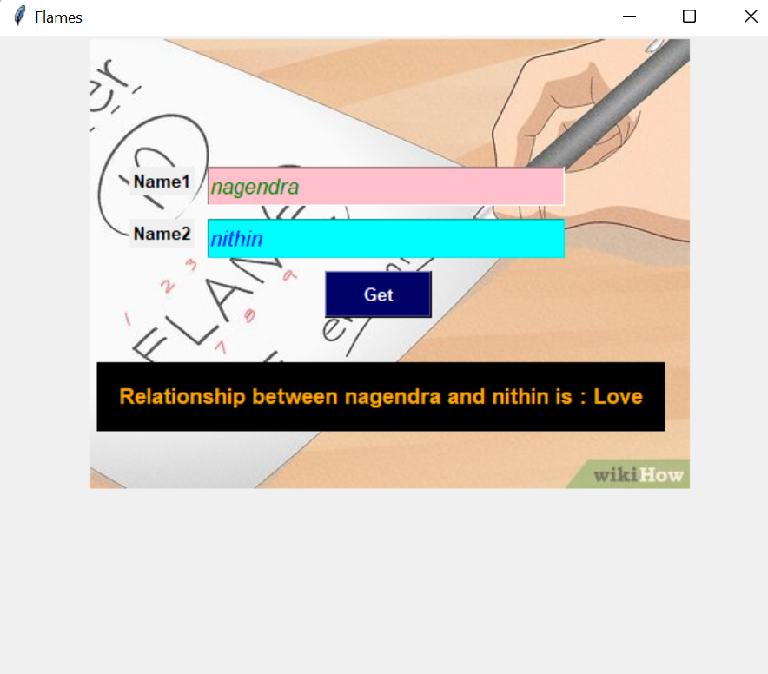

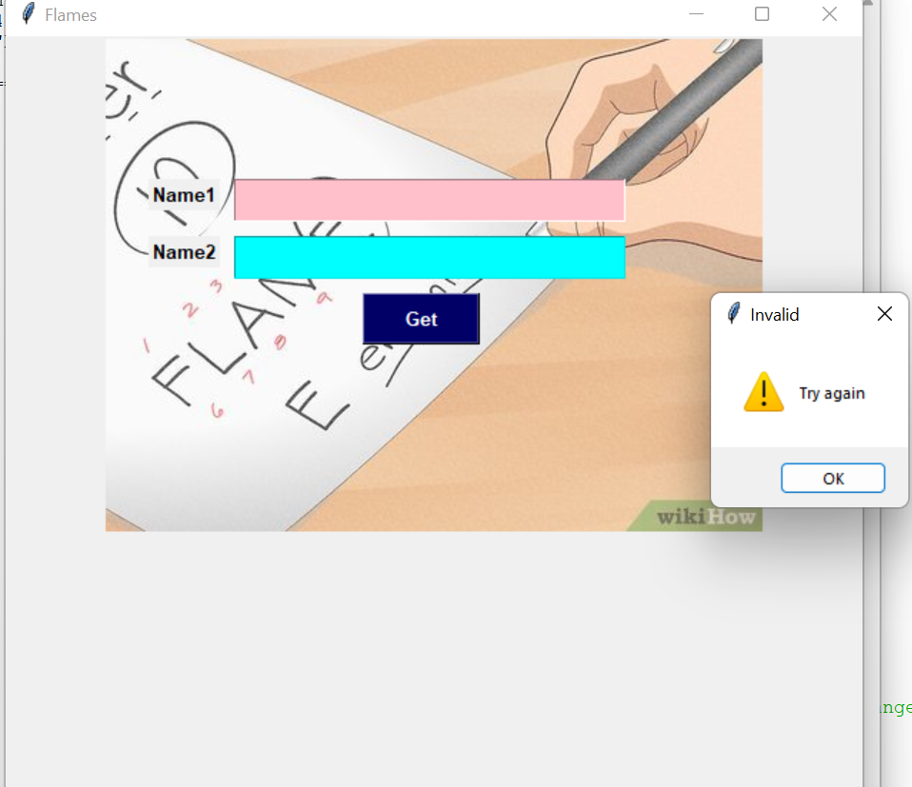

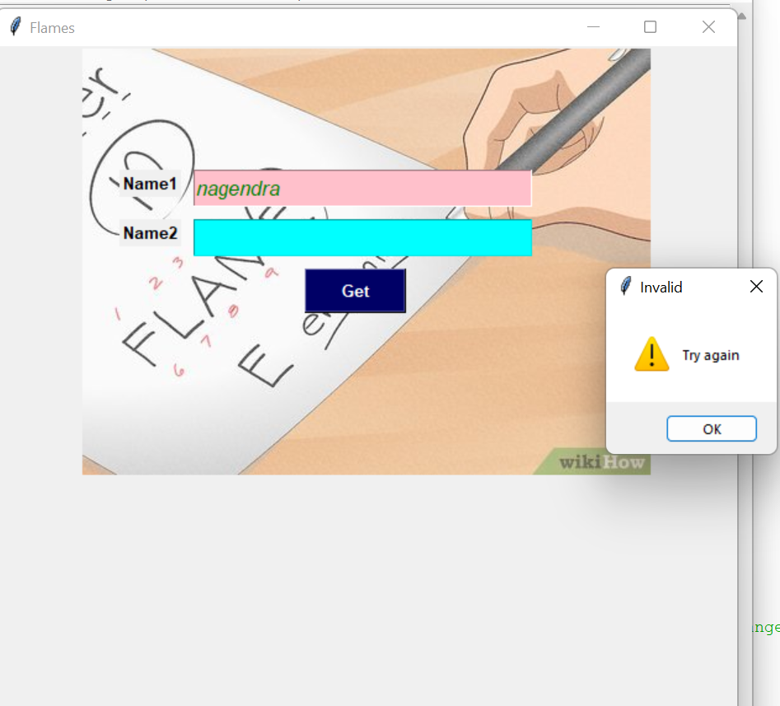

**Conclusion:**

This game is mainly for entertainment and for time pass.There is no adavntages and no disadvantages of this game.The only advantage is to tease our friends.

**References**:

https://youtu.be/f6RIW_QCL24