


REPORT OF
Object-Oriented Programming

Group: I3-AMS-B
Name of Student ID of Student Score
Veng Kimsang e20241158 ………..

Lecturer: TP: Mr. VANN VISAL
Cours: Mr. LONG PAKRIGNA

Academic year 2026-2027

TP2
- Python Basic Data Types
In Python, everything is an object, meaning that even basic data types act as reference types behind the scenes.

- Primitive/Built-in Data Types (int, float, bool, str)
- Python officially calls these built-in types; “primitive” is a beginner-friendly grouping.
Type | Stand For | Meaning | Example
int | Integer | Represents whole numbers of arbitrary size, limited only by available system memory. | 42, -7
float | Floating-point | Represents real numbers containing a decimal point. | 3.14, -0.001
bool | Boolean | A subclass of int representing truth values: True or False. Internally, True evaluates to 1 and False evaluates to 0. | True / False
str | String | An immutable sequence of Unicode characters used to represent text. | "Hello", 'Python'

- Collection and Reference Types (list, tuple, dict, set, objects)
- Collections store groups of items. They differ fundamentally by order, uniqueness, and mutability (whether they can be altered after creation).
Type | Ordered? | Mutable? | Unique Elements Only? | Syntax | Key Characteristic
list | Yes | Yes | No | [1, 2, 2] | Dynamic arrays that accept mixed types.
tuple | Yes | No | No | (1, 2, 2) | Memory-efficient; safe from unintended modification.
dict | Yes* | Yes | Keys must be unique | {"a": 1} | Key-value pairs optimized for O(1) lookups.
set | No | Yes | Yes | {1, 2, 3} | Eliminates duplicates; optimized for membership testing.

- Literals in Python (numeric, string, Boolean, None, collection literals)
- Literals in Python are raw, fixed values written directly into the source code that represent constant data.
- Numeric literals represent numbers and are completely immutable. They are divided into three sub-types:
- Integer Literals: Whole numbers without decimals. They can be written in decimal (base 10), binary (prefix 0b), octal (prefix 0o), or hexadecimal (prefix 0x).
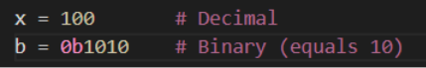
- Floating-Point Literals: Numbers with a decimal point or expressed in scientific notation.
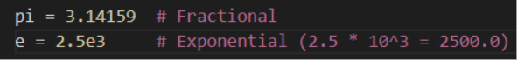
- Complex Literals: Numbers with a real and an imaginary part, written using j or J.
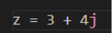
- String literals represent text data and are formed by wrapping characters in quotes.
- Single/Double Quotes: Used for single-line strings:
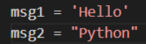
- Triple Quotes (''' or """): Used to write multi-line strings or docstrings.
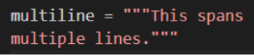

- Boolean Literals Represent truth values. Case sensitivity matters; only True and False are recognized.
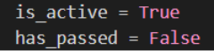
- None literal: Python features a single special literal called None to explicitly mark the absence of a value, an unassigned variable, or a null state.
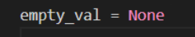

Practical example: storing student names, ages, scores, and student records.
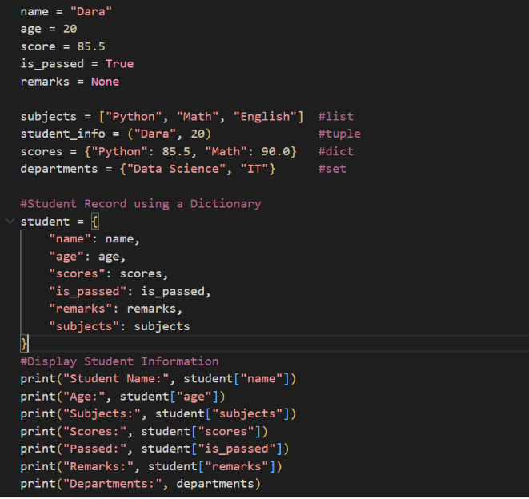
Output:
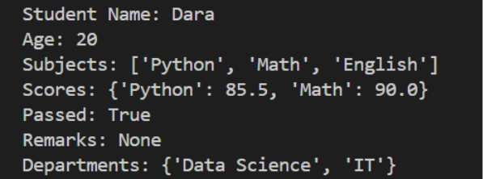

- Python Variables and Attributes
- Local Variables
- Local Variables is a variable that is declared inside a function or block and can only be accessed within that function or block.
- Instance Attributes
- Instance Attributes is a variable that belongs to a specific object (instance) of a class.

Example:
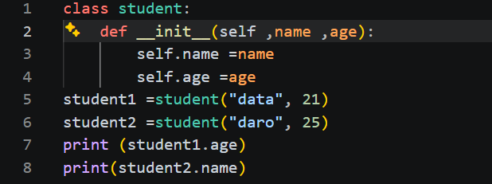
Output:
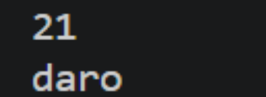

- Class Attributes (shared by all instances)
- Class Attributes is a variable defined inside a class but outside any method. It is shared by all instances of the class unless overridden by an instance attribute.

Example:
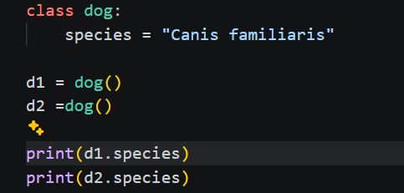
Output:
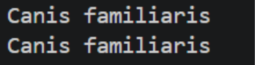

Practical example: a student class with individual names and a shared school name.
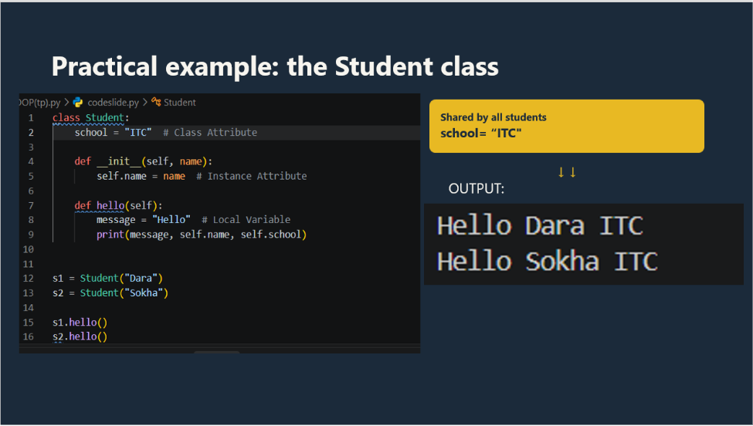

- Python Modifiers and Access Control – Part 1
- Public, Non-Public, and Private Naming Conventions
- Public members are a public attribute and methods can be accessed from inside and outside a class.

Example:
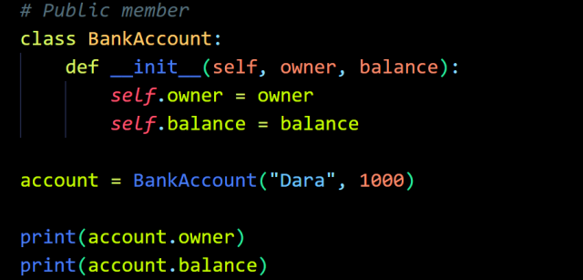
Output:
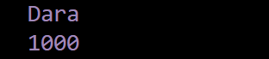

- Non-public members (single underscore _) is a single leading underscore attribute or method can be accessed for internal use only.
Example:
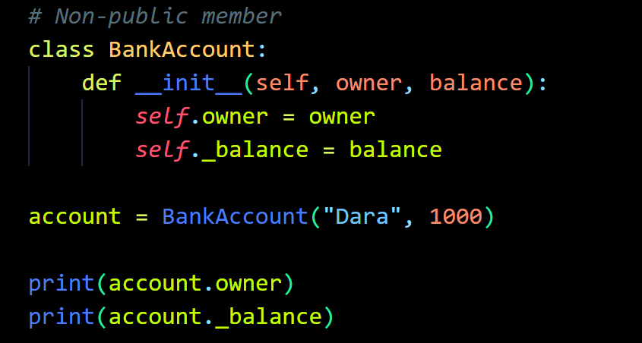
Output:

- Private-style members (double underscore__) is a double leading underscore triggers a mechanism called mangling. It is hidden from outside access to prevent external code from accidentally modifying them.

Example:
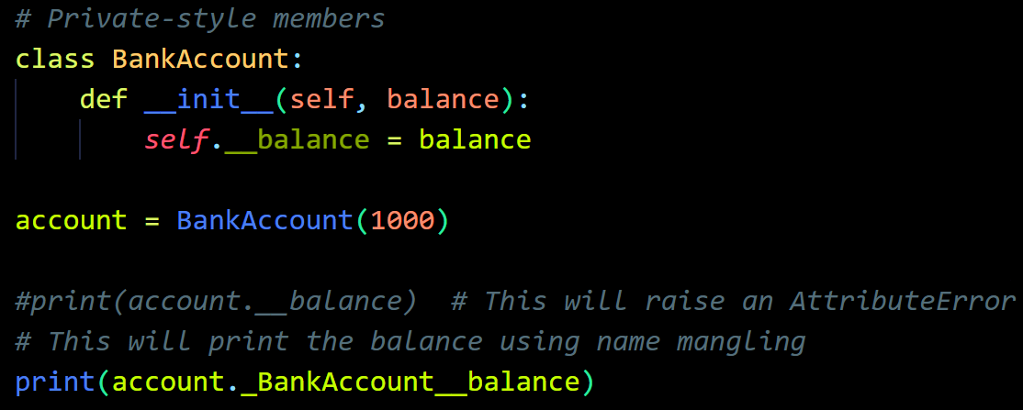
Output:
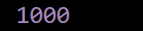

- Access Control by Convention and Name Mangling
- Access control by convention relies on naming rules to indicate which member should be accessed directly.
- Name mangling transforms double underscore attribute names to reduce accidental conflicts.

Example:
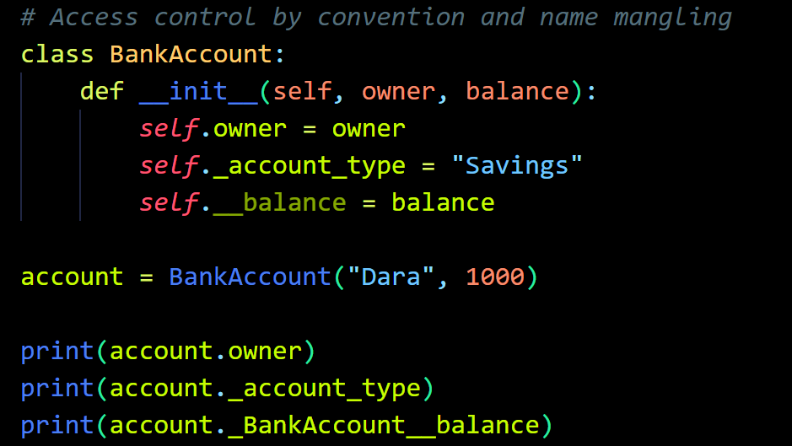
Output:
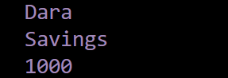

- The @staticmethod Decorator
- @staticmethod is a function that lives inside the class but does not need an object or the class. This does not receive self or cls.

Example:
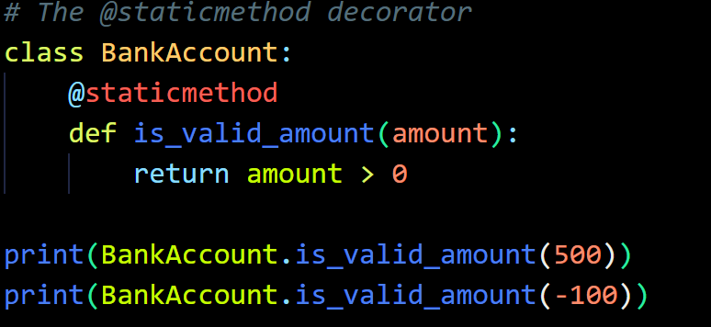
Output:
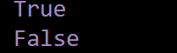

- The @classmethod Decorator
- @classmethod is a class method receives the class as its first argument, which was named cls.
Example:
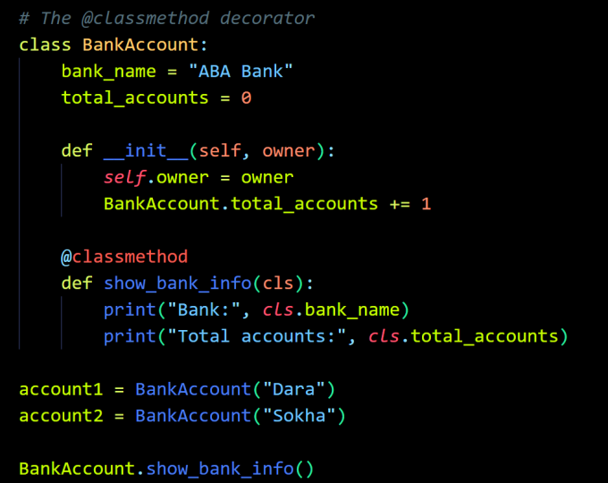
Output:
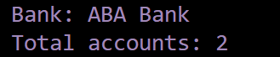

Practical Example: controlling access to a BankAccount class and defining class-level methods.
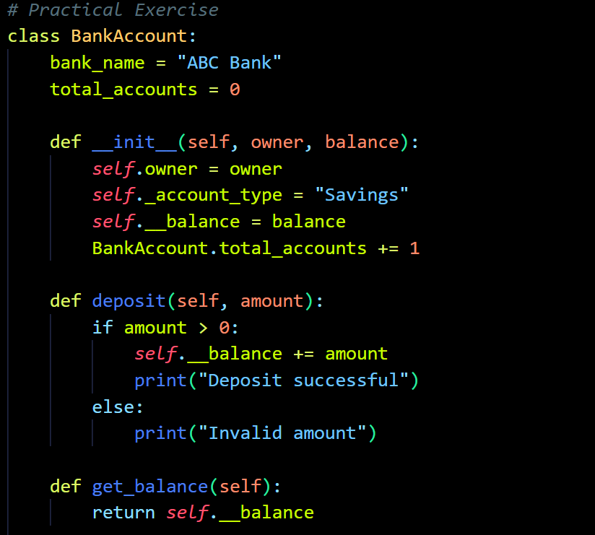
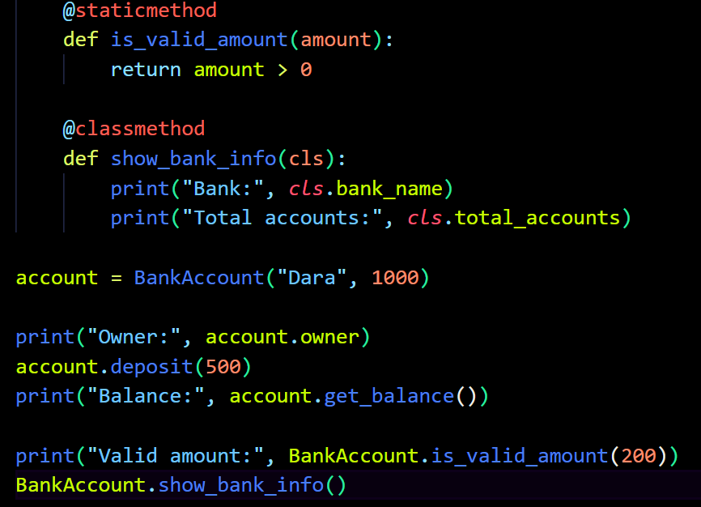
Output:
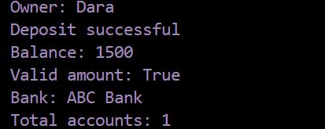

- Python Modifiers and OOP Features – Part 2
- Abstract Classes and Methods (abc, @abstractmethod)
- An abstract class is a blueprint for other classes. It can define methods that subclasses must implement. Python uses abc and @abstractmethod to create abstract classes and methods.

Example:
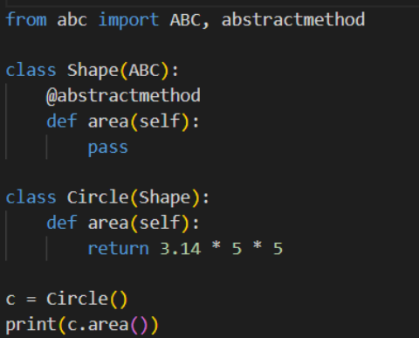
Output:
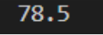
- Access Control and Encapsulation
- Encapsulation means keeping data and methods together inside a class and controlling access to the data.
Python uses naming conventions to indicate three levels of access:
- Public: name —>can be accessed from outside the class.
- Protected: _name —> intended for use inside the class and its subclasses.
- Private: __name —> makes direct access more difficult through name mangling.

Example:
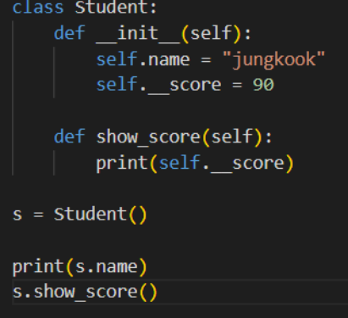
Output:
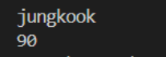

- Other OOP Features: @property, @final, and typing.final
- The @property decorator allows us to access methods like an attribute. It is useful when we want to read a value without calling a method using parentheses.

Example:
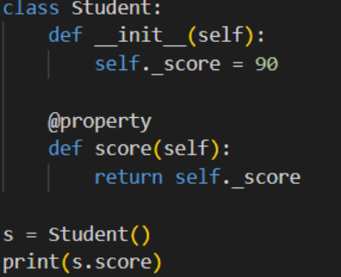
Output:


- The @final decorator indicates that a method should not be overridden by a subclass. It helps programmers maintain the intended design of a class. However, Python does not enforce this restriction at runtime.

Example:
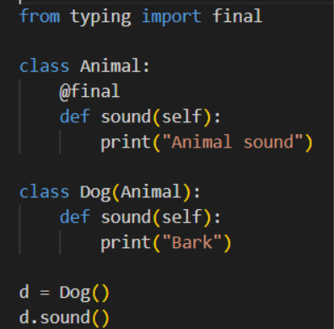
Output:
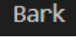
- The typing.final is the decorator imported from Python's typing module. It can mark a class as one that should not be inherited from, or a method as one that should not be overridden.

Example:
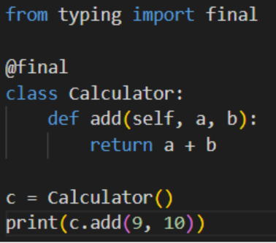
Output:
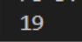

Practical example: an abstract Shape class with Circle and Rectangle subclasses.
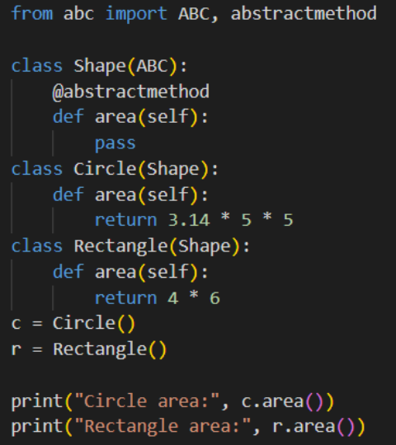
Output:
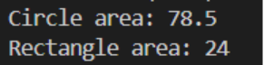

- Python Operators – Part 1
- Arithmetic Operators (+, -, *, /, //, %, **)
- Arithmetic operators are used to perform mathematical calculations such as addition, subtraction, multiplication, and division.

Example:
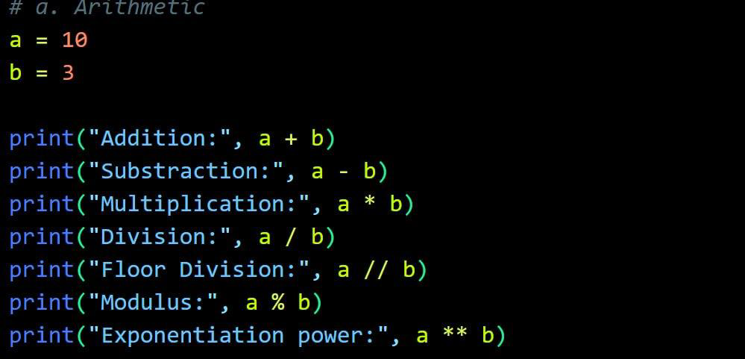
Output:
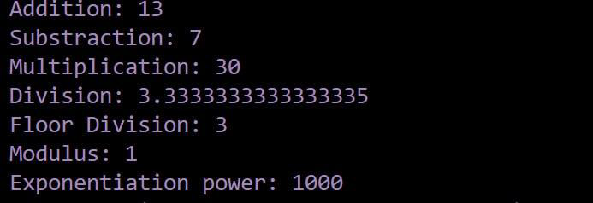

- Comparison Operators (==, !=, >, <, >=, <=)
- Comparison operators are used to compare two values and return either True or False.

Example:
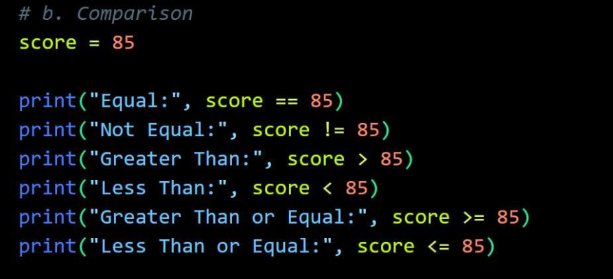
Output:
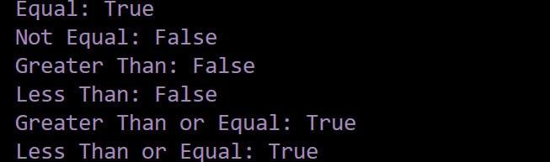

- Bitwise Operators (&, |, ^, ~, <<, >>)
- Bitwise operators are used to perform operations on the binary bits of integer.

Example:
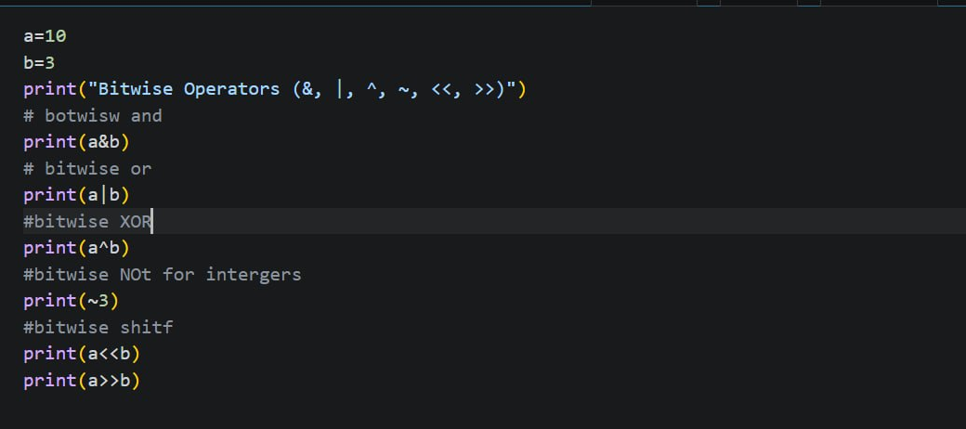
Output:
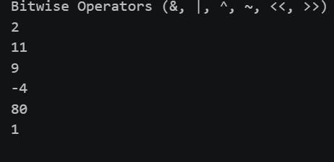

- Logical Operators (and, or, not)
- Logical operators are used to combine or reverse conditions and return Boolean values (True or False).

Example:
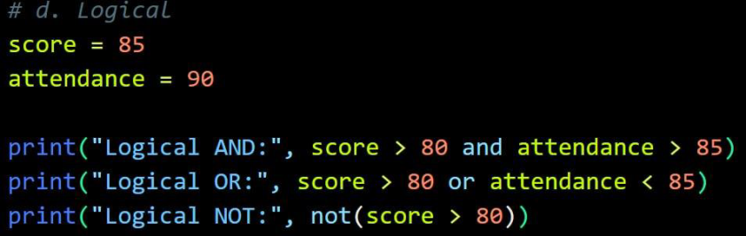
Output:
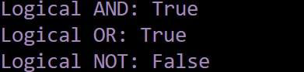

Practical example: calculating student grades and checking eligibility.
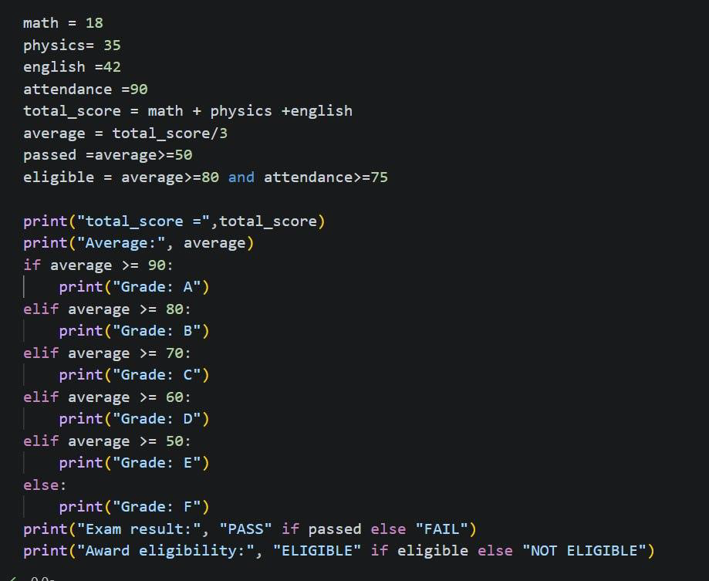
Output:
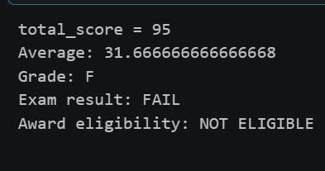

- Python Operators – Part 2
- Assignment Operators (=, +=, -=, *=, etc.)
- The assignment operator is the = symbol. It binds a variable (name) to a value or object in memory. Python also supports augmented assignment operators like +=, -=, *=, /=, and the walrus operator :=, Other assignment operators include ( //=, %=, **=, &=, |=, ^=, <<=, and >>=).

Example:
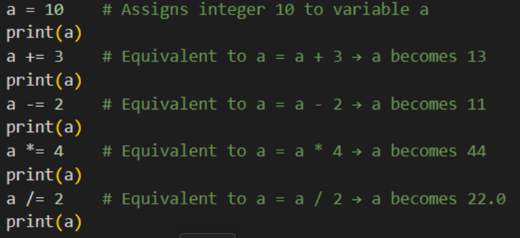
Output:
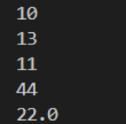

- Special Operators: Identity (is, is not), Membership (in, not in), and Conditional Expressions (x if condition else y)
- The identity operators are used to check whether two variables refer to the same object in memory, not just whether their values are equal. This is different from the equality operator (==), which compares the values of objects.
Python provides two identity operators:
- is → Returns True if both variables point to the same object (same memory location).
- is not → Returns True if both variables point to different objects.

Example:
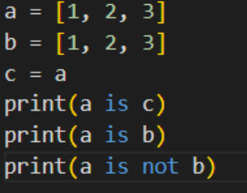
Output:
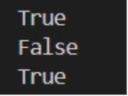

- Membership operators are used to check whether a value exists inside a sequence (like a list, tuple, string, set, or dictionary).
Types:
- in → Returns True if the value is found in the sequence.
- not in → Returns True if the value is not found in the sequence.

Example:
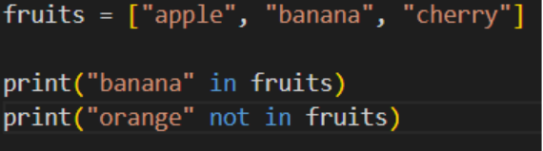
Output:
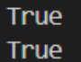

- A conditional expression selects one of two values depending on whether a condition is true or false. It is a short way to write a simple if-else statement.

Example:
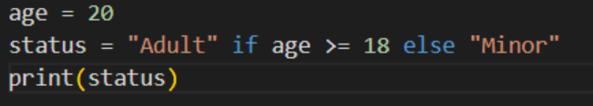
Output:
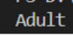

- Operator Precedence and Associativity
- Operator precedence determines which operator is evaluated first in an expression. Associativity determines the evaluation order when operators have the same precedence.

Example:
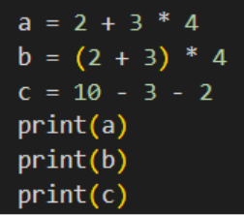
Output:
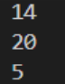

Practical example: updating object attributes, checking membership in collections, and evaluating expressions.
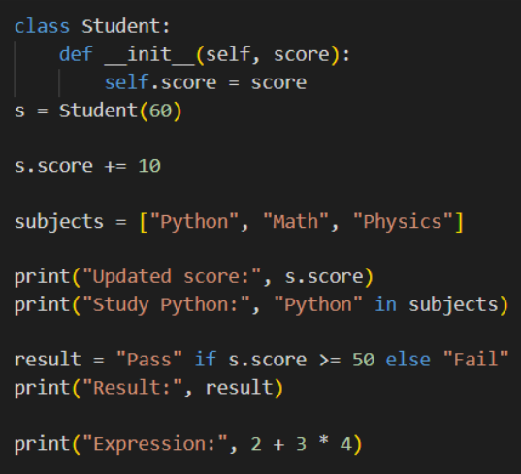
Output:
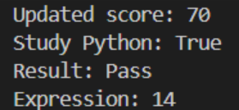
- Python Decision-Making Statements – Part 1
- The if Statement
- if statement is used executes a block of code only when a specified condition is true.

Example:
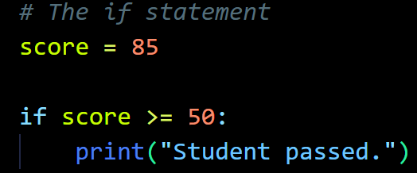
Output:

- The if-else Statement
- if-else statement is used executes one block of code if the condition is true and another block if the condition is false.

Example:
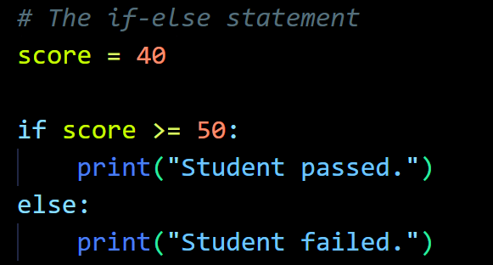
Output:
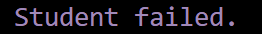

- The if-elif-else Statement
- if-elif-else statement checks multiple conditions in order and executes the first true block. If none of the conditions are true, runs else block.

Example:
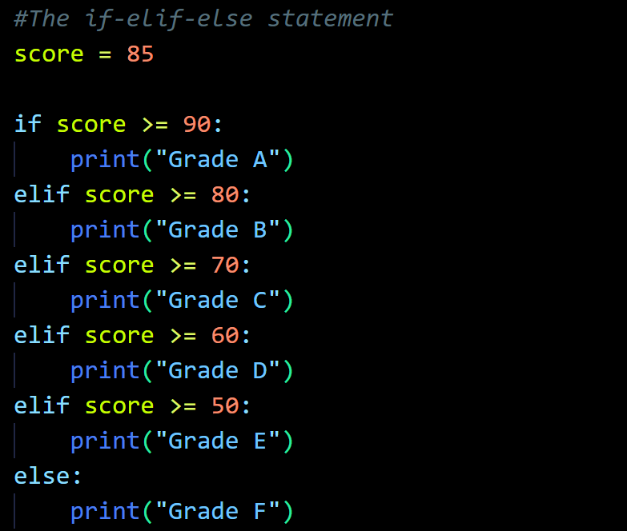
Output:
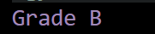

Practical Example: determining student's pass/fail status and assigning letter grades.
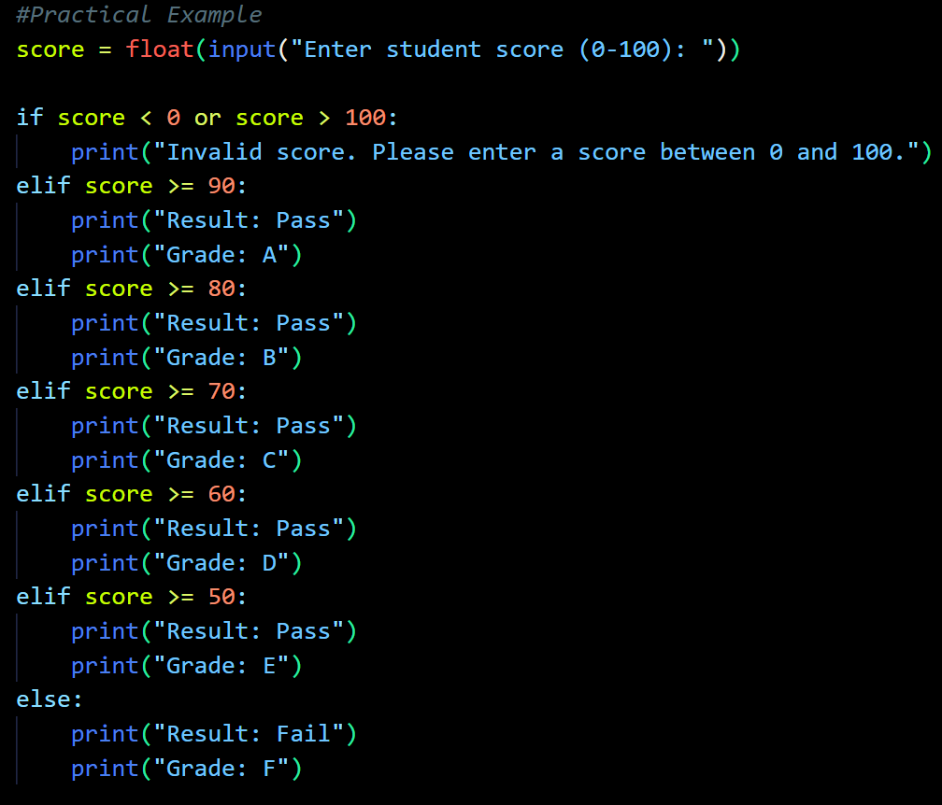
Output:
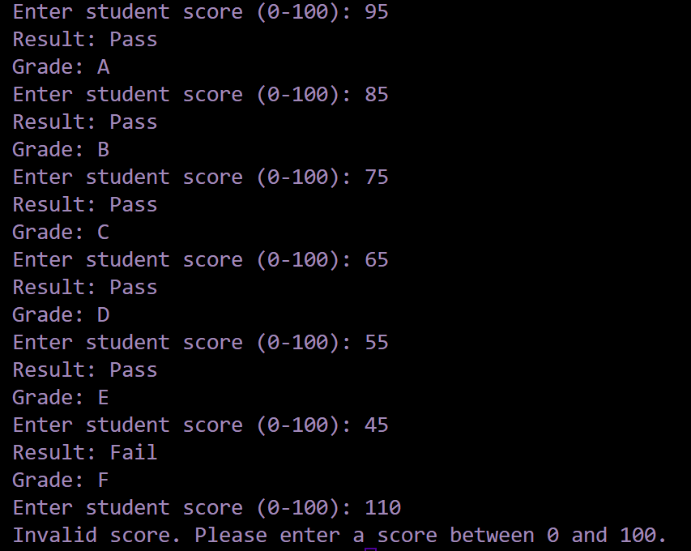

- Python Decision-Making – Part 2
- Nested if Statements
- Nested if Statements are an if statement placed inside another if statement. It is used to check another condition only when the first condition is true.

Example:
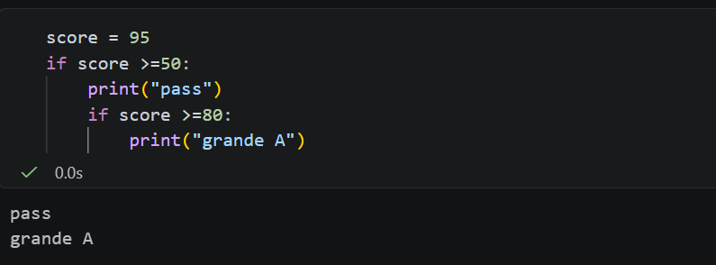

- Multiple-Branch Selection Using match-case (Python 3.10+) or if-elif-else
- Multiple-Branch Selection Using match-case (Python 3.10+) is a control structure that allows a program to choose one action from several alternatives based on different conditions or values.

Example:
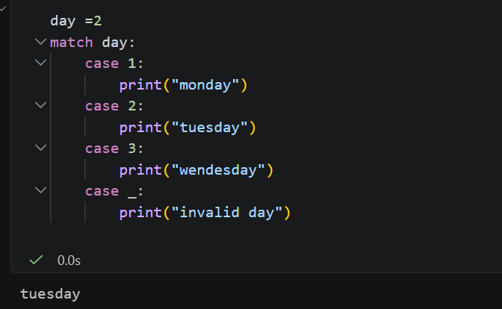

- if-elif-else is used to check multiple conditions, the first condition that is true will be executed.

Example:
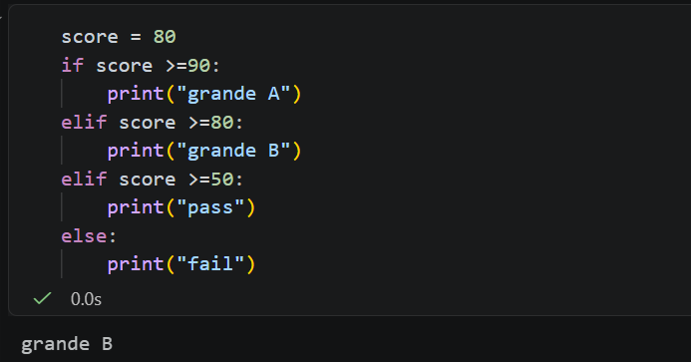

- Conditional Expressions (condition ? value1 : value2 in Java becomes value1 if condition else value2 in Python)
- Conditional Expression is an expression that returns one of two values depending on whether a condition.

Example:
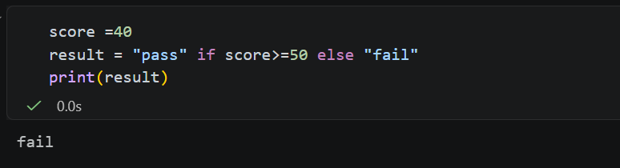

Practical example: a menu-driven student management system.
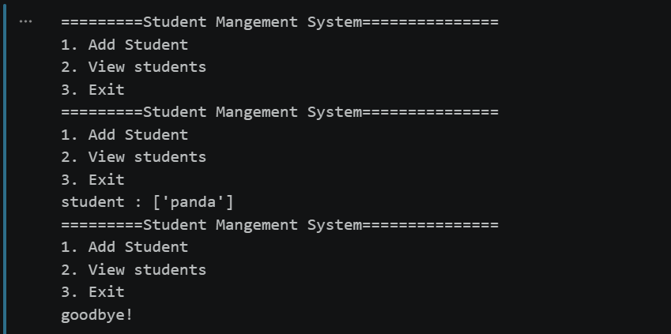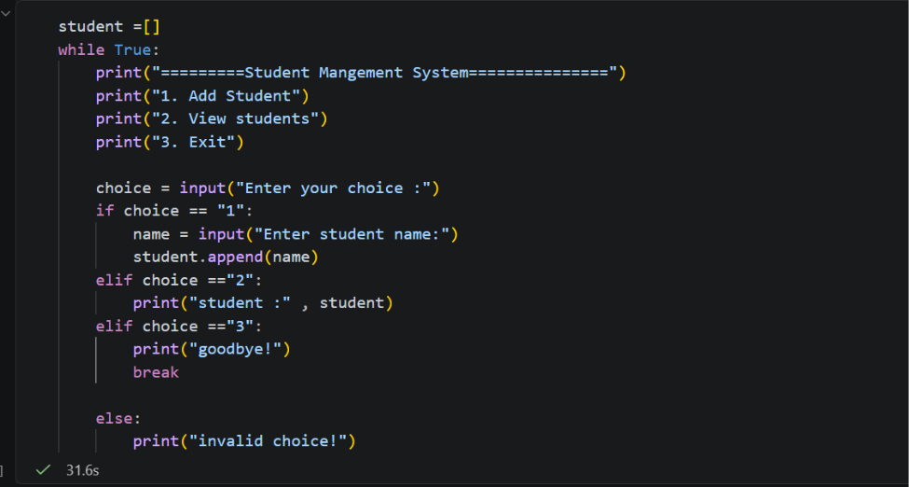

- Python Loops and Loop Control
A loop is a programming structure that repeats a block of code multiple times. Instead of writing the same instructions repeatedly, we can use a loop to execute them efficiently.
- The while Loop
- A while loop repeats a block of code as long as its condition is True. It is especially useful when we do not know in advance how many repetitions will be required.

Example 1: Printing numbers
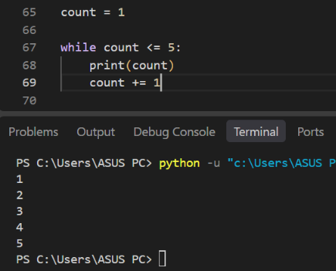

Example 2: Use a while loop to calculate the total score of a student.
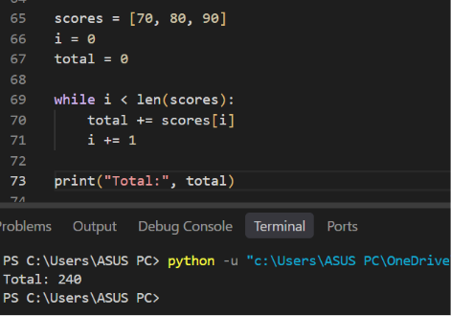

- The for Loop
- A for loop repeats a block of code by taking items one at a time from an iterable, such as a list, tuple, string, dictionary, or range().

Example 1: Printing student names
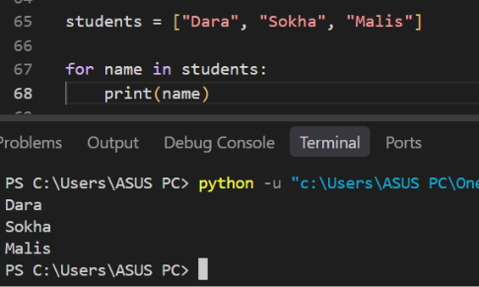

Example 2: The range() function generates a sequence of integers, commonly used to control the number of iterations.
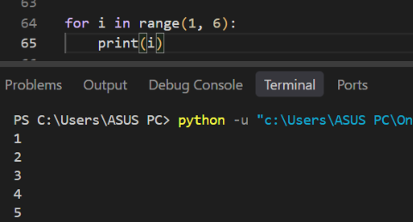

Example 3: Calculating the sum of scores
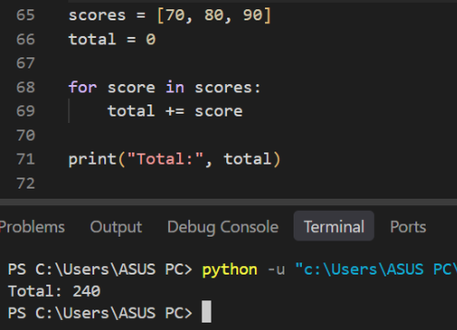

- Repetition with for and while (Python has no native do-while loop)
- Both loops repeat instructions, but they are best suited to different situations.
- Python does not have a native do-while loop. In some programming languages, a do-while loop executes the body first and checks the condition afterward. Therefore, its body runs at least once.
- In Python, we can achieve similar behavior by combining while True with break.

Example:
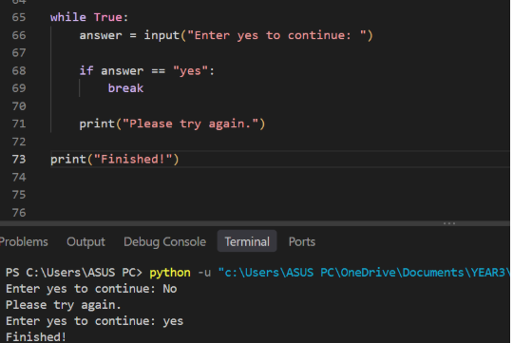
Explanation:
- while True starts a loop that would continue indefinitely.
- The program requests input from the user.
- If the answer is "yes", break terminates the loop.
- Otherwise, the program displays a message and asks again.

- This structure is useful when an action must happen at least once before the program decides whether to repeat it.

- Loop Control Statements: break, continue, and pass
- break: Stop the loop. Immediately exits the nearest enclosing loop when the statement executes.

Example 1: Find the first number greater than 10

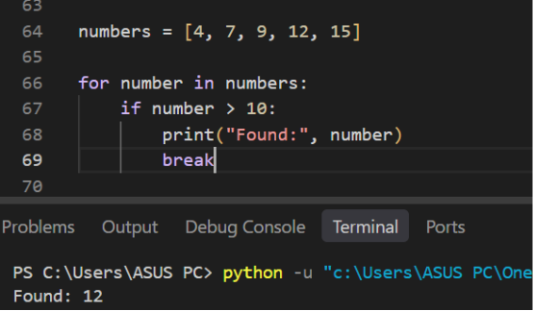

- ( The loop checks 4, 7, 9, and 12. When it reaches 12, the condition is true and break terminates the loop. The number 15 is never checked. )[Text Wrapping Break]
- continue: Skip the current iteration. Skips the remaining statements in the current iteration and proceeds to the next one.
Example 2:

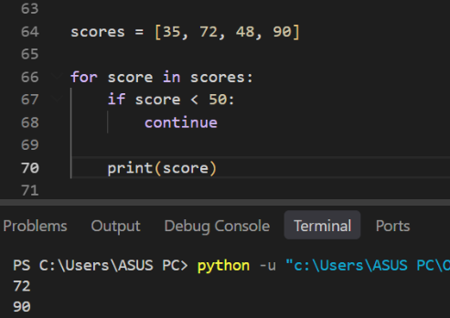

- (When the score is below 50, continue skips the print() statement and moves to the next score. Therefore, only scores of 50 or above are displayed.)
- pass: Do nothing. Acts as a placeholder when Python requires a statement, but no action needs to be performed yet.

Example 3:
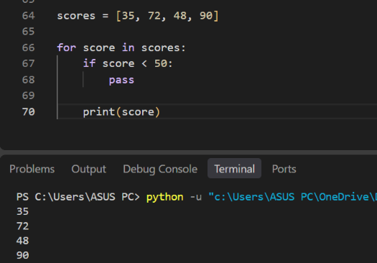

- (Unlike continue, pass does not skip the print() statement. All scores are displayed because pass simply does nothing.)

Practical example: iterating through student objects, calculating averages, and searching for a student.
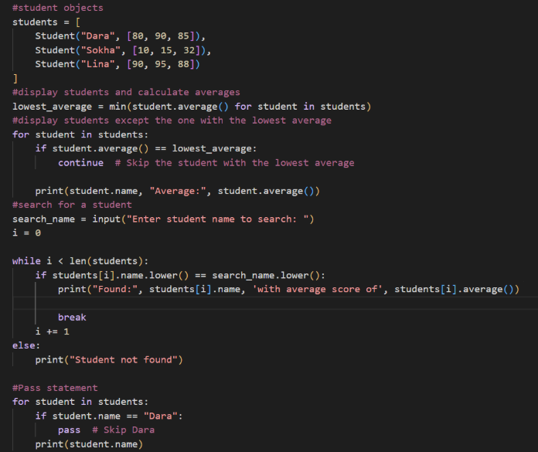

Output:
