

Traffic Sign Classification using Deep Learning (CNN)
Mini Project Report | Academic Year 2025–2026

1. Team Details
Field | Details
Team Name | (Your Team Name)
Course / Branch | (e.g., B.E. Computer Engineering / IT)
Institute | (Your Institute Name)
Academic Year | 2025 – 2026
Semester | (e.g., Semester VI)

Team Members
Sr. No. | Name | Roll No. | Responsibility
1 | (Name 1) | (Roll No.) | Model Training & Evaluation
2 | (Name 2) | (Roll No.) | Dataset Preparation & Web App
3 | (Name 3) | (Roll No.) | Architecture Design & Testing
4 | (Name 4) | (Roll No.) | Documentation & Deployment

2. Title of the Project
Traffic Sign Classification using Deep Learning (CNN)

3. Detailed Problem Statement

Background
Road safety is a critical global challenge. Traffic signs play a vital role in regulating and guiding drivers, pedestrians, and other road users. Manual recognition of traffic signs is subject to human error, especially under conditions like poor lighting, adverse weather, or driver fatigue.

Problem Definition
Given an image of a traffic sign, automatically identify and classify it into one of 43 distinct categories with high accuracy and confidence.

Challenges Addressed
Challenge | Description
Intra-class variation | Same sign can vary in illumination, angle, scale, or condition
Inter-class similarity | Several signs look visually similar (e.g., 50 km/h vs 60 km/h)
Class imbalance | Some sign classes have more training samples than others
Real-world noise | Images can contain background clutter, motion blur, and occlusion
Scalability | Must classify 43 distinct categories reliably

4. Technology & Algorithm Used
Category | Technology | Version
Language | Python | 3.x
Deep Learning | PyTorch | >= 2.0.1
Computer Vision | OpenCV | >= 4.7.0
Image Processing | torchvision | >= 0.15.2
Numerical Computing | NumPy | >= 1.24.0
Data Handling | pandas | >= 1.5.0
Visualization | matplotlib | >= 3.6.0
ML Metrics | scikit-learn | >= 1.2.0
Web Framework | Flask | >= 2.3.0
Frontend | HTML5, Tailwind CSS | -
Image Library | Pillow | >= 9.5.0

Model Architecture
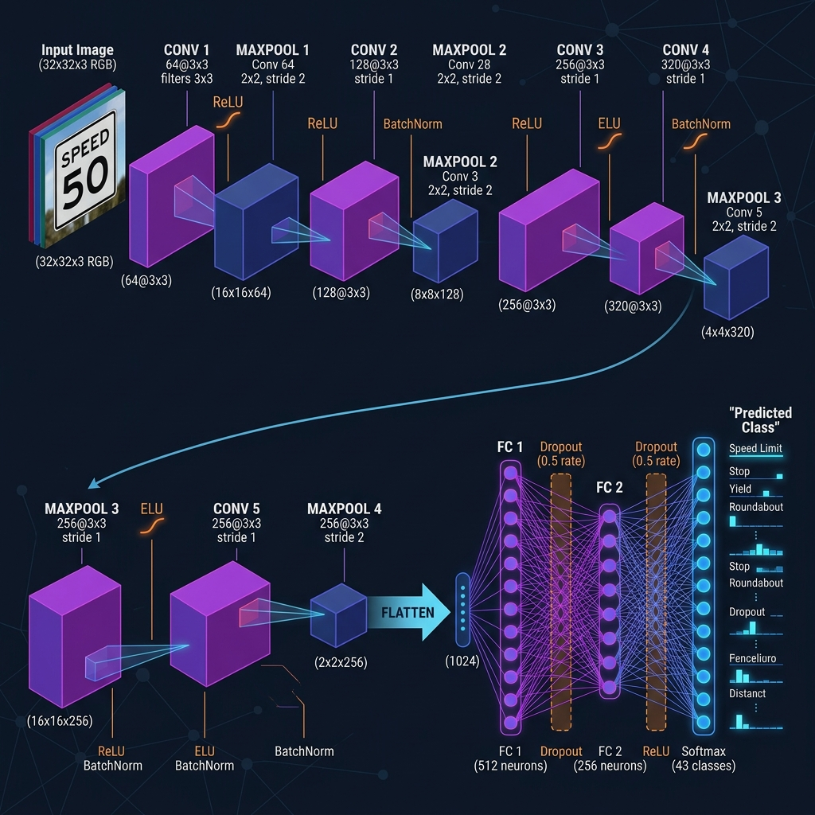
The model is a custom-built 5-layer Convolutional Neural Network (TrafficSignCNN) featuring 5 convolutional layers for feature extraction and 3 fully connected layers for classification.

5. Dataset Description
Attribute | Value
Dataset Name | GTSRB (German Traffic Sign Recognition Benchmark)
Source | Kaggle
Total Classes | 43
Training Images | 39,209
Test Images | 12,630
Total Images | ~51,839
Image Format | PNG
Input Resolution | 32 x 32 pixels

6. Screenshots & Results
The model achieves an overall test accuracy of 93.78%.
Metric | Value
Total Test Images | 12,630
Correctly Classified | 11,845
Incorrectly Classified | 785
Overall Accuracy | 93.78%

7. Conclusion
This project successfully demonstrates the application of Deep Learning for automated traffic sign classification. The TrafficSignCNN model achieves high accuracy and is deployed via a user-friendly web interface.

8. GitHub / OneDrive Link
Resource | Link
GitHub Repository | (Paste your GitHub repo link here)
OneDrive Folder | (Paste your OneDrive shared folder link here)

