SEAMLESS APPLICATION AND RESUME SUBMISSION PLATFORM

**Project Overview**

The seamless application and resume submission platform project aims to streamline the job application process for both candidates and employers. It will provide a user-friendly interface for candidates to create profiles, upload resumes, and apply to multiple jobs with ease. For employers, it will offer efficient resume management tools, allowing them to sort, filter, and review applications effortlessly. The platform will also incorporate features such as job alerts, applicant tracking, and customizable application forms to enhance the recruitment experience for both parties. Additionally, it will prioritize user data privacy and security to ensure confidentiality throughout the application process.

**Technology Which I Used**

***Backend***

* Node js
* Monogo db
* Express

***Frontend***

* React Js

***IDE***

* Visual Studio Code (VS Code)

**Project Structure**

The project structure is organized as follows:

* Client: Contains the frontend React.js application code.
* Server: Contains the backend Node.js application code.
* Database: Includes the MySQL database schema and sample data.

**\*\*To Run The Frontend (React):\*\***

**//Terminal**

npm run dev

The React app should be running on port `[http://localhost:3000/**`**](http://localhost:3000/%60)**.**

**\*\*To Run The Backend Server:\*\***

**//Terminal**

node index.js (or) npm start

The backend Server is running on port **`http://localhost:3000/`.**

## Steps to Start Project

**For Backend**

1. cd server
2. npm i
3. npm init -y
4. npm i express sequelize mysql2 cors cookie-parser bcrypt jsonwebtoken
5. npm i multer path nodemon
6. npm start (or) node index.js

**For Frontend**

1. cd zolabzr
2. npm I axios bootstrap react-router-dom bootstrap-icons
3. npm run dev

**Features:**

**Home:**

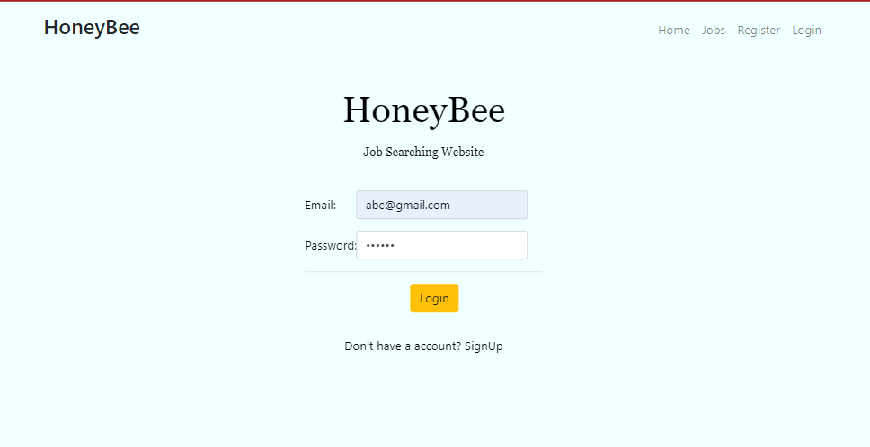

**Register Page:**

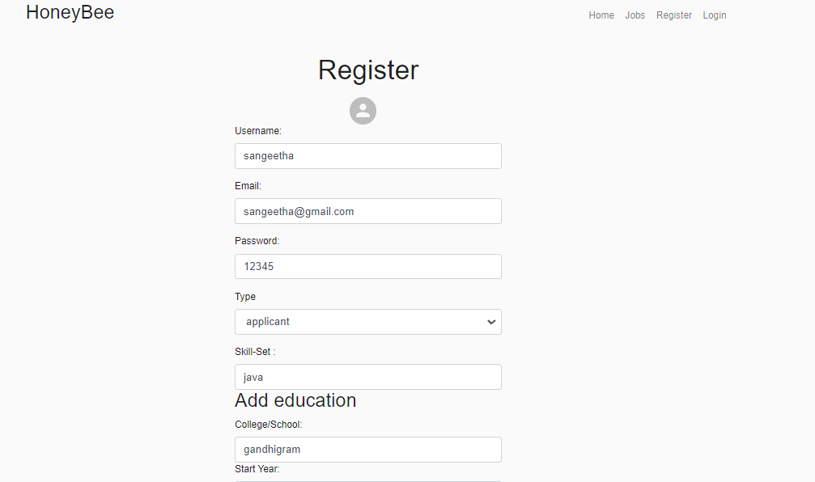

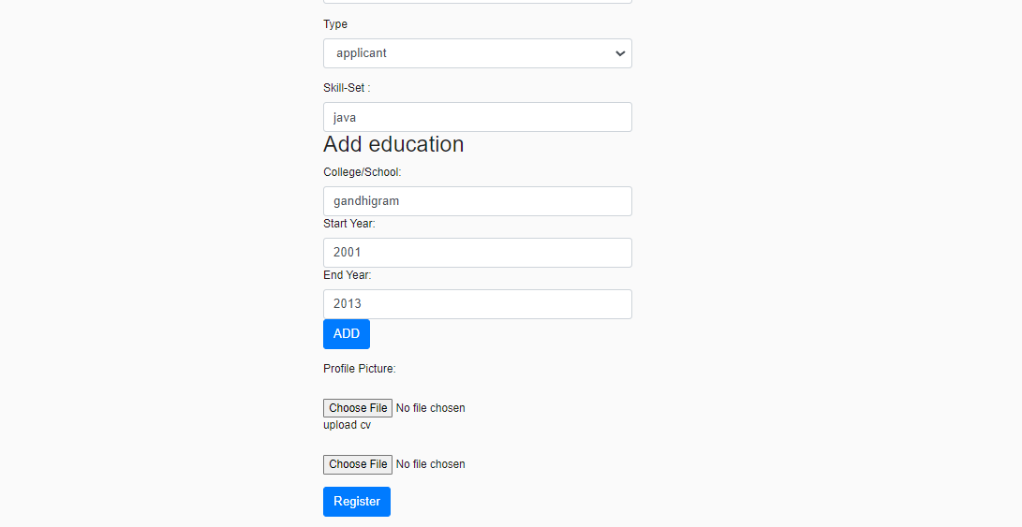

Profile:

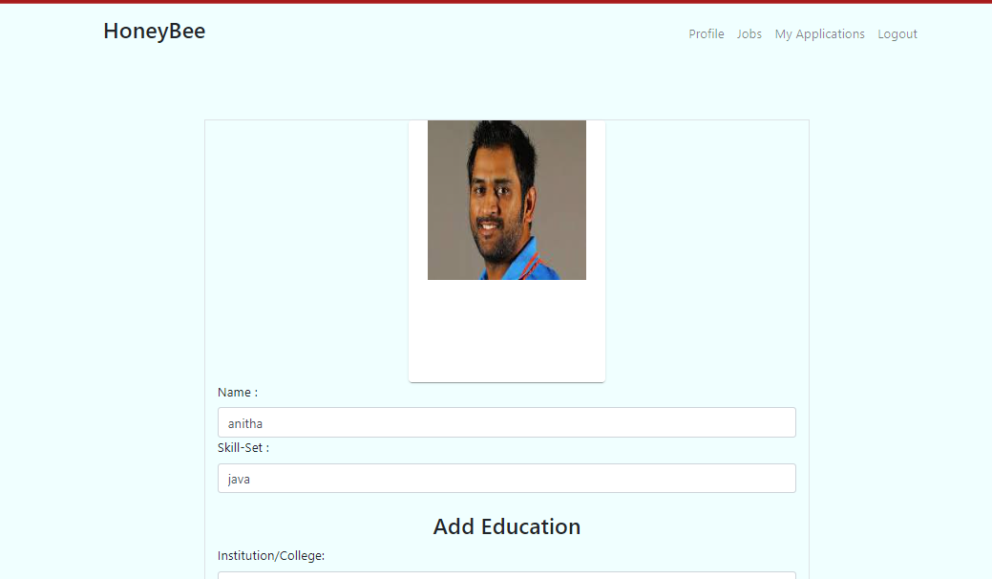

**Add Education Page:**

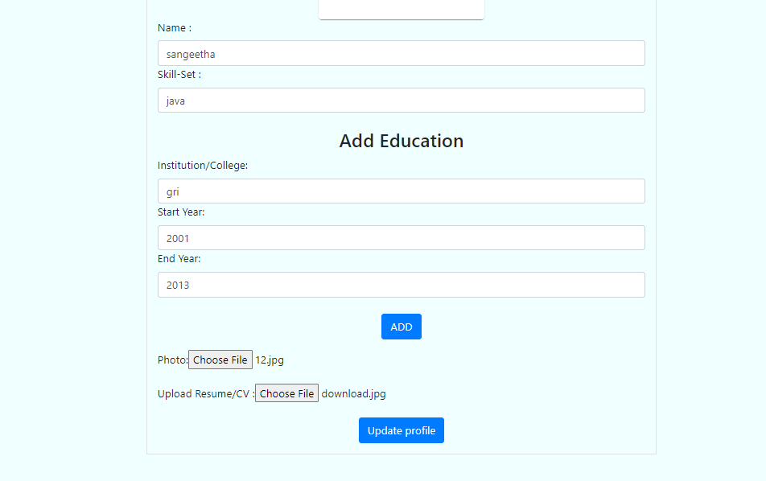

## Company List Page:

## 

## Show Companies Page:

## 

## Company Detail & Add Review Page :

## 

## Reviews:

## 

## Request

#### If you like project then feel free to give Star😊