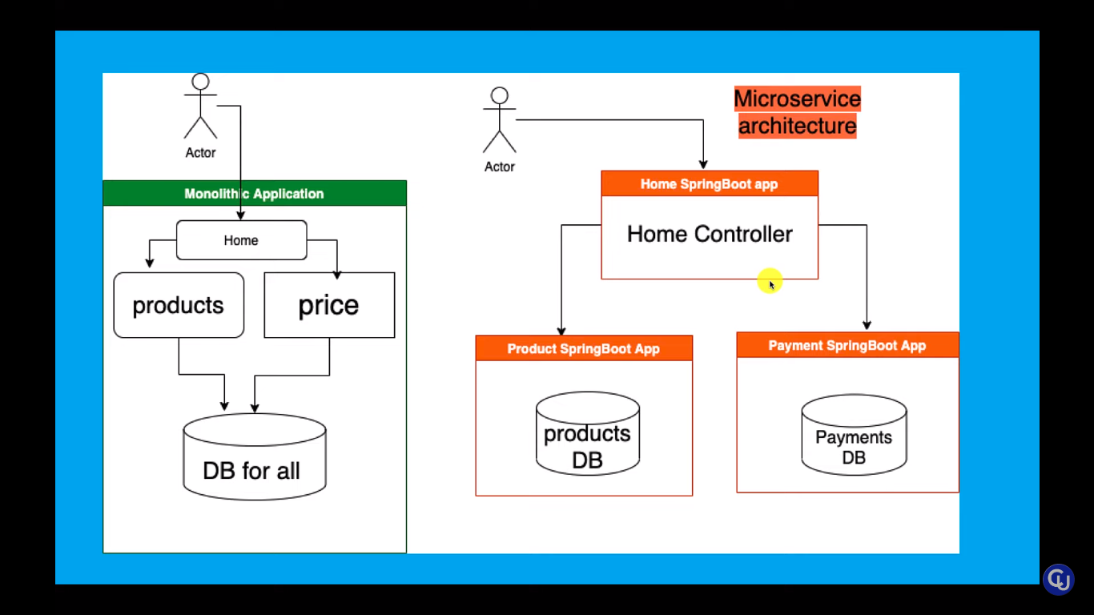

Monolithic :same(one) serverla run aagum but microservice ovvonukum thani thani serverla run aagum.

Pipeline Creation:

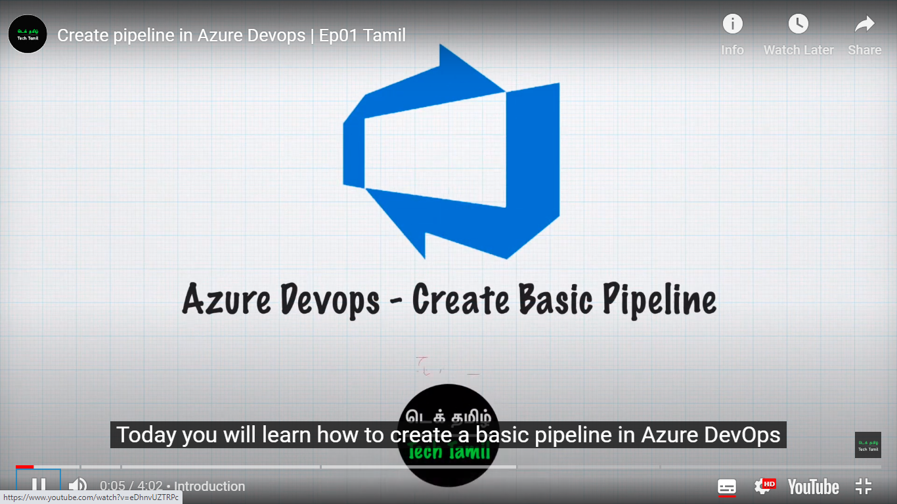

YML- yet another markup language

