**RECIPE SHARING PLATFORM**



A Web Technologies Project Report

in partial fulfillment of the degree

**Bachelor of Technology**

in

**Computer Science & Artificial Intelligence**

**By**

**2203A51052**

**2203A51044**

**2203A51132**

**2203A51108**

**Under the Guidance of**

**Dr.Deepthi Kothapeta**

**Submitted to**



**SCHOOL OF COMPUTER SCIENCE & ARTIFICIAL INTELLIGENCE**

# SR UNIVERSITY, ANANTHASAGAR, WARANGAL

**November, 2024.**



**SCHOOL OF COMPUTER SCIENCE & ARTIFICIAL INTELLIGENCE**

**CERTIFICATE**

This is to certify that this Web Technologies Project entitled “RECIPE SHARING PLATFORM" is the bonafied work carried out **by K.Greeshma, D.Hasini, V.Varsha, Ch.Sripuja** earing hall ticket numbers  **2203A1052, 2203A1044, 2203A1132, 2203A1108** for the partial fulfillment to award the degree BACHELOR OF TECHNOLOGY in COMPUTER SCIENCE & ARTIFICIAL INTELLIGENCE during the academic year 2024-2025 under our guidance and Supervision.

**Dr.Deepthi Kothapeta Dr.M.Sheshikala**

Assistance Professor, Professor&HOD (CSE),

SR University, SR University,Ananthasagar, Warangal. Ananthasagar, Warangal.

**External Examiner**

**ACKNOWLEDGEMENT**

We owe an enormous debt of gratitude toour Web Technologies Project guide **Dr.Deepthi Kothapeta, Assistant Professor** as well as Head of the CSE Department **Dr. M.Sheshikala, Professor** for guiding us from the beginning through the end of the Minor Project with their intellectual advices and insightful suggestions. We truly value their consistent feedback on our progress, which was always constructive and encouraging and ultimately drove us to the right direction.

We wish to take this opportunity to express our sincere gratitude and deep sense of respect to our beloved Dean, **Dr. Indrajeet Gupta,** for his continuous support and guidance to complete this technical seminar in the institute.

Finally, we express our thanks to all the teaching and non-teaching staff of the department for their suggestions and timely support.

**Table of Contents**

Abstract 5

Introduction 5

Existing System 5-6

Proposed System -Problem Statement 6

Requirements 7-10

Functional Requirements

Non Functional Requirements

Software Requirements

Hardware Requirements

Design 10

Implementations 12-27

Code

Results

Conclusion 28

Future Scope 28-29

References 30

**ABSTRACT:**

This project presents the development of a feature-rich recipe-sharing platform leveraging AngularJS, a robust JavaScript framework for dynamic web applications. The platform is designed to connect culinary enthusiasts by providing an interactive, user-friendly interface for sharing, and managing recipes. Key functionalities include recipe creation with multimedia uploads, and filtering options.

The application architecture employs AngularJS for seamless single-page application (SPA) performance, ensuring fast navigation and responsive user experience. Modular design principles and two-way data binding enhance maintainability and real-time updates. Integration with backend services enables secure user authentication, profile management.

This platform demonstrates the potential of AngularJS in creating engaging and scalable web solutions, addressing the modern user's demand for interactivity and accessibility in digital culinary communities.

**INTRODUCTION:**

The recipe-sharing platform is a simple and intuitive web application developed using AngularJS, designed to enable users to share and explore textual recipes effortlessly. The platform focuses on providing a straightforward and distraction-free experience, making it easy for users to browse and contribute recipes without unnecessary complexity.

Built with AngularJS, the application leverages a single-page architecture to deliver a seamless and responsive user interface. Its modular and lightweight design ensures scalability and ease of maintenance, while two-way data binding enhances real-time interactions.

By intentionally excluding features like search, likes, comments, or multimedia uploads, the platform emphasizes simplicity and accessibility. This minimalist approach fosters a clean environment where users can focus solely on sharing and discovering recipes

**EXISTING SYSTEM:**

Currently, recipe-sharing web sites are feature-rich environments with functionalities like advanced search options, likes, comments, multimedia uploads, and the ability to share posts on social media. Most of these features increase engagement but lead to complex interfaces and user overload experiences, especially for someone who wants an uncomplicated straightforward platform.

Furthermore, many current systems rely heavily on social interactions, user-generatd multimedia, and personalized recommendation that can deviate from the core purpose of recipe sharing and exploration. These systems also require sometimes very deep backend infrastructures, which often increases the complexity and the cost of development as well as maintenance.

This creates an opening for a lightweight, minimalist platform that only displays textual recipes without further content that caters to more users' desire for simplicity and usability over the complexity of plenty of features.

**PROPOSED SYSTEM – PROBLEM STATEMENT:**

The proposed system is a simple and efficient recipe-sharing platform developed using AngularJS. It is designed to provide users with a streamlined experience focused exclusively on sharing and exploring textual recipes. The platform eliminates unnecessary features like search functionality, likes, comments, and multimedia uploads, ensuring a distraction-free and easy-to-navigate environment.

Key features of the proposed system include:

* **Textual Recipe Sharing:** Users can input and share recipes in a text-based format.
* **Recipe Browsing:** Recipes are displayed in a clean, organized manner for easy exploration.
* **Responsive Design:** Built using AngularJS's single-page application (SPA) architecture, the platform ensures fast and smooth navigation.
* **Minimalistic Interface:** The system focuses on simplicity, reducing user effort and enhancing accessibility.

The current digital landscape depicts most recipe-sharing platforms are designed with complex features that include advanced search functionality, likes, comments, multimedia uploads, and social interactions. Though these features enhance engagement, they form a very cumbersome experience for users who prefer a simple interface. Moreover, these kinds of platforms require significant backend infrastructure; therefore, the development cost may be increased along with maintenance overhead.

There is a need for a lightweight, user-friendly platform that focuses exclusively on enabling users to share and browse textual recipes in a very straightforward way. It should have no unnecessary features and distractions, creating a clean environment and efficiency for culinary enthusiasts to connect and share their recipes with ease.

**REQUIREMENTS:**

* **FUNCTIONAL REQUIREMENTS:**

The functional requirements for the recipe-sharing platform include the following:

1. Recipe Submission
   * Users should be able to input and submit textual recipes.
   * The recipe submission form should include fields such as title, ingredients, and preparation steps.
2. User Profile Management
   * Registered users should be able to manage their profiles, including editing or deleting their submitted recipes.
3. Responsive Design
   * The interface should be accessible on various devices, including desktops, tablets, and mobile phones.
4. Data Persistence
   * Submitted recipes should be stored in a database to ensure they persist across user sessions.
5. Error Handling
   * The system should provide appropriate error messages for invalid inputs (e.g., incomplete recipe forms or incorrect login credentials).
6. Real-Time Updates
   * Changes such as adding or editing recipes should be reflected instantly without requiring a page reload, leveraging AngularJS’s two-way data binding.

* **NON_FUNCTIONAL REQUIREMENTS:**

Here are non-functional requirements for the recipe-sharing platform:

1. Performance
   * The platform should load pages and update content within 2 seconds to ensure a fast and responsive user experience.
2. Reliability
   * The system should have an uptime of at least 99.9%, ensuring the platform remains available to users at all times.
3. Usability
   * The user interface should be intuitive, easy to navigate, and accessible to all users, including those with disabilities.
4. Security
   * User authentication data should be securely stored and transmitted using encryption, protecting users' personal information.
5. Scalability
   * The system should be able to handle an increasing number of users and recipes without significant performance issues, allowing for future growth.

These core non-functional requirements focus on performance, security, usability, and long-term reliability and scalability.

* **SOFTWARE REQUIREMENTS:**

The following software requirements are necessary to develop and run the recipe-sharing platform:

1. Frontend:

- AngularJS: The primary framework for building the user interface and managing dynamic interactions within the single-page application (SPA).

- HTML5: For structuring the content and layout of the web pages.

- CSS3: For styling the platform's interface, ensuring a clean and responsive design across different devices.

- JavaScript: For client-side scripting and handling the dynamic aspects of the platform, including data binding and form submission.

2. Backend:

- Node.js: A runtime environment for executing JavaScript code on the server-side, enabling the backend logic for handling user requests, authentication, and recipe storage.

- Express.js: A web application framework for Node.js, providing routing and middleware functionalities to handle HTTP requests.

- Database:

- MySQL or MongoDB: For storing user information and recipes. MySQL can be used for structured data storage (if relational) or MongoDB for a more flexible, document-oriented approach.

3. Security:

- JWT (JSON Web Tokens): For secure user authentication and managing user sessions.

- SSL/TLS: For encrypting data transmitted between the client and server, ensuring secure communication.

* **HARDWARE REQUIREMENTS:**

The hardware requirements for developing and running the recipe-sharing platform are as follows:

1. Development Environment:
   * Processor: A modern multi-core processor (e.g., Intel i5 or higher) to handle development tasks efficiently, especially when running development servers and multiple applications simultaneously.
   * RAM: At least 8 GB of RAM to ensure smooth performance during development, including running code editors, web servers, and local databases.
   * Storage: At least 256 GB of SSD storage for fast data access and storage of development files, including codebase, assets, and databases.
2. Production Environment (for hosting the live application):
   * Web Server: A reliable server (either physical or cloud-based) with the following specifications:
     + CPU: At least 2 CPU cores (depending on expected traffic and scalability needs).
     + RAM: A minimum of 4 GB RAM, with more RAM allocated for larger-scale deployments to handle more users and requests.
     + Storage: 50 GB or more SSD storage for fast data retrieval and
     + efficient handling of the recipe database. Storage requirements may scale up depending on the number of recipes and users.
3. Network Requirements:
   * Bandwidth: Minimum of 10 Mbps for smooth data transfer, including serving the application, handling user requests, and uploading/download speeds for server-client communication. High bandwidth may be necessary for cloud hosting to support growing traffic.
4. Backup Storage (for production):
   * Off-site/Cloud Backup: Backup solutions, such as cloud storage (e.g., Amazon S3 or Google Cloud Storage), for securely storing user data and recipes in case of server failure or data corruption.

These hardware specifications will support the development, and smooth operation of the recipe-sharing platform, ensuring optimal performance in both local and production environments.

**DESIGN:**

**Front-End Design**

The platform will consist of the following pages:

1. Homepage

• Features:

o Display featured recipes in a carousel.

o Show categories (e.g., Appetizers, Desserts, Vegan).

o Highlight trending or highly rated recipes.

• Components:

o Navigation bar: Login/Register, Categories.

o Recipe cards with titles, and short descriptions.

2. Recipe Detail Page

• Features:

o Full details of the recipe:

Ingredients.

Step-by-step instructions.

Estimated preparation and cooking time.

o Image gallery or video tutorial.

o Reviews and ratings from other users.

• Components:

o "Save Recipe" button for registered users.

o Social media share buttons.

3. Submit Recipe Page

• Features:

o Form to submit a new recipe.

Fields: Title, Ingredients (multi-line), Instructions, Category, Upload recipe.

o Real-time validation of input fields.

• Components:

o File upload for recipe.

o Preview button to view the formatted recipe before submission.

4. User Dashboard

• Features:

o Profile details and edit option.

o List of submitted recipes.

o Saved recipes for future reference.

• Components:

o Recipe management: Edit/Delete options for the user's own recipes.

5. Search Results Page

• Features:

o Display results based on keywords or category.

o Filters for prep time, difficulty, dietary restrictions.

6. Authentication Pages

• Features:

o Login/Registration with email/password or social logins (e.g., Google, Facebook).

o Forgot Password functionality.

**Back-End Architecture**

1. Database Design

• Tables:

1. Users:

UserID (Primary Key)

Name, Email, Password (hashed), ProfileImage

2. Recipes:

RecipeID (Primary Key)

Title, Ingredients (Text), Instructions (Text), Category, ImagePath

CreatedBy (Foreign Key referencing UserID)

3. Ratings & Reviews:

ReviewID (Primary Key)

UserID (Foreign Key), RecipeID (Foreign Key)

CreatedAt

4. SavedRecipes:

ID (Primary Key)

UserID (Foreign Key), RecipeID (Foreign Key)

2. API Endpoints

• Users:

o POST /api/register: Register a new user.

o POST /api/login: Authenticate user.

• Recipes:

o GET /api/recipes: Fetch all recipes.

o GET /api/recipes/:id: Fetch a specific recipe.

o POST /api/recipes: Add a new recipe.

o PUT /api/recipes/:id: Update a recipe.

o DELETE /api/recipes/:id: Delete a recipe.

• Reviews:

o POST /api/reviews: Add a review for a recipe.

o GET /api/recipes/:id/reviews: Fetch reviews for a recipe.

• Saved Recipes:

o POST /api/saved: Save a recipe.

o GET /api/saved: Fetch saved recipes for a user.

**IMPLEMENTATION:**

**CODE:**

**Index.html**

<!DOCTYPE html>

<html lang="en">

<head>

<meta charset="UTF-8">

<meta name="viewport" content="width=device-width, initial-scale=1.0">

<title>Recipe Sharing Platform</title>

<link rel="stylesheet" href="styles.css">

<script src="https://code.angularjs.org/1.8.2/angular.min.js"></script>

</head>

<body ng-app="recipeApp" ng-controller="recipeController">

<div class="container">

<h1>Recipe Sharing Platform</h1>

<!-- Add Recipe Form -->

<div class="form-container">

<h2>Add Recipe</h2>

<form ng-submit="addRecipe()">

<input type="number" ng-model="newRecipe.id" placeholder="Recipe ID" required><br>

<input type="text" ng-model="newRecipe.title" placeholder="Recipe Title" required><br>

<textarea ng-model="newRecipe.ingredients" placeholder="Ingredients (comma-separated)" required></textarea><br>

<textarea ng-model="newRecipe.instructions" placeholder="Instructions" required></textarea><br>

<input type="text" ng-model="newRecipe.category" placeholder="Category" required><br>

<button type="submit">Add Recipe</button>

</form>

</div>

<!-- Update Recipe Form -->

<div class="form-container">

<h2>Update Recipe</h2>

<form ng-submit="updateRecipe()">

<input type="number" ng-model="updatedRecipe.id" placeholder="Recipe ID to update" required><br>

<input type="text" ng-model="updatedRecipe.title" placeholder="Updated Recipe Title" required><br>

<textarea ng-model="updatedRecipe.ingredients" placeholder="Updated Ingredients"></textarea><br>

<textarea ng-model="updatedRecipe.instructions" placeholder="Updated Instructions"></textarea><br>

<input type="text" ng-model="updatedRecipe.category" placeholder="Updated Category"><br>

<button type="submit">Update Recipe</button>

</form>

</div>

<!-- Delete Recipe Form -->

<div class="form-container">

<h2>Delete Recipe</h2>

<form ng-submit="deleteRecipe()">

<input type="number" ng-model="recipeToDelete.id" placeholder="Recipe ID to delete" required><br>

<button type="submit">Delete Recipe</button>

</form>

</div>

<!-- Recipe List Table -->

<table>

<thead>

<tr>

<th>ID</th>

<th>Title</th>

<th>Ingredients</th>

<th>Instructions</th>

<th>Category</th>

</tr>

</thead>

<tbody>

<tr ng-repeat="recipe in recipes">

<td>{{ recipe.id }}</td>

<td>{{ recipe.title }}</td>

<td>{{ recipe.ingredients }}</td>

<td>{{ recipe.instructions }}</td>

<td>{{ recipe.category }}</td>

</tr>

</tbody>

</table>

</div>

<script src="app.js"></script>

</body>

</html>

**App.js**

angular.module('recipeApp', [])

.controller('recipeController', function($scope, $http) {

// Fetch recipes from the API endpoint

$http.get('http://localhost:3000/api/recipes') // Matches backend route

.then(function(response) {

console.log('Fetched recipes:', response.data);

$scope.recipes = response.data.map(recipe => ({

id: recipe.ID, // Maps database fields correctly

title: recipe.TITLE,

ingredients: recipe.INGREDIENTS,

instructions: recipe.INSTRUCTIONS,

category: recipe.CATEGORY

}));

})

.catch(function(error) {

console.error('Error fetching recipes:', error);

});

// Initialize new recipe model

$scope.newRecipe = {

id: '', // Requires manual ID entry

title: '',

ingredients: '',

instructions: '',

category: ''

};

// Add a new recipe

$scope.addRecipe = function() {

$http.post('http://localhost:3000/api/recipes', $scope.newRecipe)

.then(function(response) {

console.log('Recipe added successfully:', response.data);

$scope.recipes.push(response.data); // Add to list

$scope.newRecipe = { id: '', title: '', ingredients: '', instructions: '', category: '' }; // Reset form

})

.catch(function(error) {

console.error('Error adding recipe:', error);

});

};

// Initialize updated recipe model

$scope.updatedRecipe = {

id: '', // Use the ID to identify the recipe for updates

title: '',

ingredients: '',

instructions: '',

category: ''

};

// Update an existing recipe

$scope.updateRecipe = function() {

$http.put('http://localhost:3000/api/recipes', $scope.updatedRecipe)

.then(function(response) {

console.log('Recipe updated successfully:', response.data);

const index = $scope.recipes.findIndex(recipe => recipe.id === $scope.updatedRecipe.id);

if (index !== -1) {

$scope.recipes[index] = response.data; // Update recipe in list

}

$scope.updatedRecipe = { id: '', title: '', ingredients: '', instructions: '', category: '' }; // Reset form

})

.catch(function(error) {

console.error('Error updating recipe:', error);

});

};

// Initialize delete model

$scope.recipeToDelete = { id: '' }; // Delete by ID

// Delete a recipe

$scope.deleteRecipe = function() {

$http.delete(http://localhost:3000/api/recipes/${$scope.recipeToDelete.id})

.then(function(response) {

console.log('Recipe deleted successfully:', response.data);

const index = $scope.recipes.findIndex(recipe => recipe.id === $scope.recipeToDelete.id);

if (index !== -1) {

$scope.recipes.splice(index, 1); // Remove from list

}

$scope.recipeToDelete = { id: '' }; // Reset form

})

.catch(function(error) {

console.error('Error deleting recipe:', error);

});

};

});

**Styles.js:**

/* General Body Styles */

body {

font-family: Arial, sans-serif;

background-color: #f4f4f4;

margin: 0;

padding: 0;

color: #333;

}

/* Container Styles */

.container {

max-width: 900px;

margin: 30px auto;

padding: 20px;

background: #ffffff;

border-radius: 8px;

box-shadow: 0 4px 6px rgba(0, 0, 0, 0.1);

}

/* Header Styles */

h1 {

text-align: center;

color: #222;

}

h2 {

color: #444;

margin-bottom: 15px;

}

/* Form Container Styles */

.form-container {

margin-bottom: 20px;

padding: 15px;

background-color: #f9f9f9;

border-radius: 6px;

border: 1px solid #e0e0e0;

}

/* Form Styles */

form {

display: flex;

flex-direction: column;

}

input, textarea, button {

margin-bottom: 10px;

padding: 10px;

font-size: 1rem;

border: 1px solid #ccc;

border-radius: 4px;

width: 100%;

box-sizing: border-box;

}

textarea {

resize: none;

height: 80px;

}

button {

background-color: #28a745;

color: #fff;

border: none;

cursor: pointer;

transition: background-color 0.3s;

}

button:hover {

background-color: #218838;

}

/* Table Styles */

table {

width: 100%;

border-collapse: collapse;

margin-top: 20px;

}

th, td {

border: 1px solid #ddd;

padding: 10px;

text-align: left;

}

th {

background-color: #f7f7f7;

font-weight: bold;

}

td {

background-color: #fff;

}

table tr:nth-child(even) {

background-color: #f9f9f9;

}

/* Responsive Design */

@media (max-width: 600px) {

.container {

padding: 15px;

}

table, th, td {

font-size: 0.9rem;

}

input, textarea, button {

font-size: 0.9rem;

}

}

**Server.js**

const express = require('express');

const oracledb = require('oracledb'); // Require OracleDB

const path = require('path'); // Require path module for handling file paths

oracledb.initOracleClient({ libDir: 'C:\\instantclient_19_25' }); // Oracle Instant Client path

const bodyParser = require('body-parser');

const app = express();

const port = 3000;

// Middleware to serve static files and parse JSON

app.use(express.static(path.join(__dirname, 'frontend', 'public')));

app.use(bodyParser.json());

// Oracle Database Connection Setup

const dbConfig = {

user: 'SYSTEM',

password: 'greeshmakunde',

connectString: 'localhost/XE', // Replace with your DB service name if different

};

// Fetch all recipes

app.get('/api/recipes', async (req, res) => {

let connection;

try {

connection = await oracledb.getConnection(dbConfig);

// Query to fetch all recipes

const result = await connection.execute(

SELECT ID, TITLE, INGREDIENTS, INSTRUCTIONS, CATEGORY FROM recipes,

[],

{ outFormat: oracledb.OUT_FORMAT_OBJECT }

);

console.log('Fetched recipes:', result.rows);

res.json(result.rows);

} catch (err) {

console.error('Error fetching recipes:', err);

res.status(500).json({ error: 'Database error' });

} finally {

if (connection) {

try {

await connection.close();

} catch (err) {

console.error('Error closing connection:', err);

}

}

}

});

// Add a new recipe

app.post('/api/recipes', async (req, res) => {

const { id, title, ingredients, instructions, category } = req.body;

// Validate all fields

if (!id || !title || !ingredients || !instructions || !category) {

return res.status(400).json({ error: 'All fields are required' });

}

let connection;

try {

connection = await oracledb.getConnection(dbConfig);

// Insert new recipe

const result = await connection.execute(

`INSERT INTO recipes (ID, TITLE, INGREDIENTS, INSTRUCTIONS, CATEGORY)

VALUES (:id, :title, :ingredients, :instructions, :category)`,

[id, title, ingredients, instructions, category],

{ autoCommit: true }

);

console.log('Recipe added:', result);

res.json({ id, title, ingredients, instructions, category });

} catch (err) {

console.error('Error adding recipe:', err);

res.status(500).json({ error: 'Database error' });

} finally {

if (connection) {

try {

await connection.close();

} catch (err) {

console.error('Error closing connection:', err);

}

}

}

});

// Update an existing recipe

app.put('/api/recipes', async (req, res) => {

const { id, title, ingredients, instructions, category } = req.body;

// Validate fields

if (!id || !title || !ingredients || !instructions || !category) {

return res.status(400).json({ error: 'All fields are required' });

}

let connection;

try {

connection = await oracledb.getConnection(dbConfig);

// Update recipe

const result = await connection.execute(

`UPDATE recipes

SET TITLE = :title, INGREDIENTS = :ingredients, INSTRUCTIONS = :instructions, CATEGORY = :category

WHERE ID = :id`,

[title, ingredients, instructions, category, id],

{ autoCommit: true }

);

console.log('Recipe updated:', result);

res.json({ id, title, ingredients, instructions, category });

} catch (err) {

console.error('Error updating recipe:', err);

res.status(500).json({ error: 'Database error' });

} finally {

if (connection) {

try {

await connection.close();

} catch (err) {

console.error('Error closing connection:', err);

}

}

}

});

// Delete a recipe

app.delete('/api/recipes/:id', async (req, res) => {

const recipeId = req.params.id;

let connection;

try {

connection = await oracledb.getConnection(dbConfig);

// Delete recipe by ID

const result = await connection.execute(

DELETE FROM recipes WHERE ID = :id,

[recipeId],

{ autoCommit: true }

);

console.log('Recipe deleted:', result);

res.json({ message: 'Recipe deleted successfully', id: recipeId });

} catch (err) {

console.error('Error deleting recipe:', err);

res.status(500).json({ error: 'Database error' });

} finally {

if (connection) {

try {

await connection.close();

} catch (err) {

console.error('Error closing connection:', err);

}

}

}

});

// Serve index.html as the default route

app.get('/', (req, res) => {

res.sendFile(path.join(__dirname, 'frontend', 'public', 'index.html'));

});

// Start the server

app.listen(port, () => {

console.log(Server running on http://localhost:${port});

});

**RESULTS:**

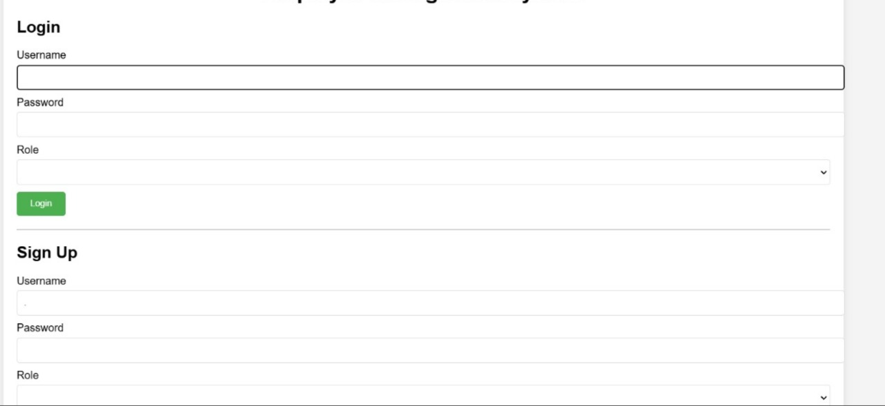

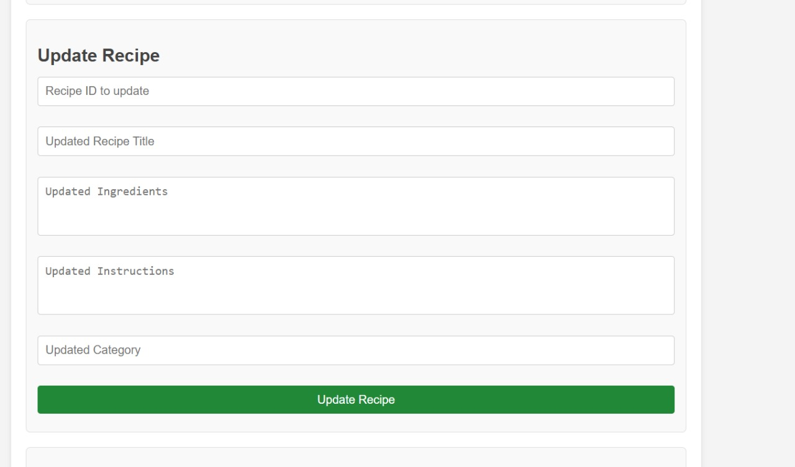



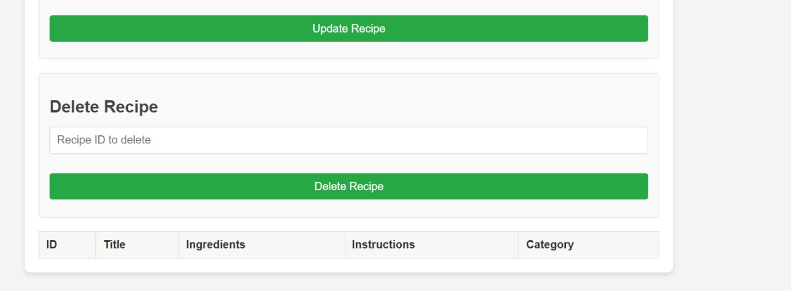

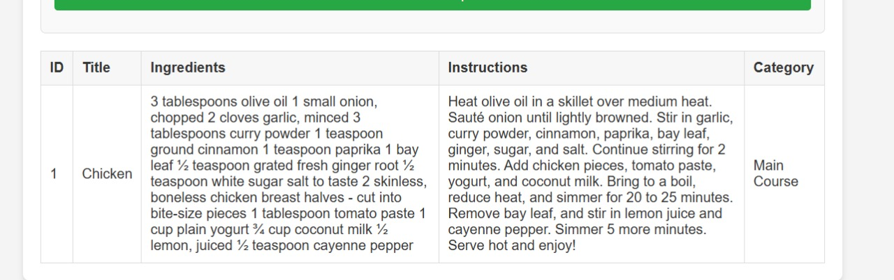

**CONCLUSION:**

This recipe-sharing application made using AngularJS offers a minimalist user-friendly solution for passionate food lovers to share and explore recipes in the simplest manner. With features omitted, such as search functionality, likes, comments, and multimedia uploads amongst other features, this platform delivers a simple and distraction-free environment that goes for ease of use and accessibility above all else.

This system is ensured to have fast performance, scalability, and reliability by using the dynamic interactions of the user through AngularJS, server-side operations with Node.js, and a lightweight backend architecture. It ensures an easy interface of the platform so that users can access the application and contribute recipes from any device.

In summary, this is an excellent project that depicts the great capability that AngularJS has in building efficient, scalable, and user-centric web applications. The platform fills a gap in the space for recipe sharing by offering a no-frills, minimalist experience where users can spend their time enjoying the act of cooking and sharing their creations.

**FUTURE SCOPE:**

While the current recipe-sharing platform focuses on simplicity and text-based recipe sharing, there are several opportunities for enhancing its features and functionality in the future:

1. Multimedia Support
   * Image and Video Uploads: Allow users to upload images or videos alongside their recipes, enhancing the visual appeal and making recipes easier to follow.
   * Recipe Formatting: Introduce support for rich text formatting to allow users to structure their recipes better (e.g., headings, lists, and links).
2. Search and Categorization
   * Search Functionality: Implement a search feature to allow users to search for recipes based on ingredients, titles, or other criteria.
   * Recipe Categorization: Allow users to categorize recipes (e.g., vegetarian, vegan, desserts) to make browsing easier.
3. Recipe Rating and Feedback
   * Rating System: Introduce a simple rating system (stars or thumbs up/down) to allow users to rate recipes they’ve tried.
   * Comments Section: Provide a comment section where users can leave feedback, tips, or modifications for each recipe.
4. User Interaction and Social Features
   * Social Media Integration: Enable sharing recipes on social media platforms to increase user engagement and expand the platform’s reach.
   * User Followers: Allow users to follow other members and receive notifications when their favorite users upload new recipes.
5. Mobile Application
   * Native Mobile App: Develop a mobile version of the platform, providing users with a more seamless experience for browsing and submitting recipes on the go.
   * Push Notifications: Implement push notifications for new recipe uploads or user interactions.
6. Advanced Search and Filtering
   * Ingredient-Based Search: Allow users to filter recipes by available ingredients or dietary restrictions (e.g., gluten-free, low-carb).
   * Advanced Filters: Provide filters based on cooking time, difficulty level, or user ratings.
7. Community Features
   * Collaborative Recipes: Enable users to collaborate on recipes, where multiple users can contribute ingredients or instructions to a single recipe.
   * Challenges and Competitions: Introduce cooking challenges or competitions, encouraging users to submit recipes based on a specific theme or ingredient.
8. Internationalization and Localization
   * Multi-language Support: Expand the platform's accessibility by offering support for multiple languages, making it available to a global audience.
   * Region-Specific Recipes: Allow users to filter or discover recipes based on regional or cultural preferences.

By implementing these enhancements, the platform can evolve into a more robust, interactive, and feature-rich solution, further engaging the culinary community and providing users with a more personalized and enjoyable experience.

**REFERENCES:**

* AngularJS Documentation: <https://angularjs.org/>
* Node.js Documentation: <https://nodejs.org/en/docs/>
* MongoDB Documentation: <https://www.mongodb.com/docs/>
* “Web Application Design Handbook” by Susan Weinschenk (ISBN: 978-0131448699)
* Case Studies on Recipe-Sharing Platforms: <https://www.smashingmagazine.com/> or similar web design case study resources.