PSG COLLEGE OF TECHNOLOGY

**DEPARTMENT OF COMPUTER APPLICATIONS**

**I MCA**

**23MX17 DATA STRUCTURES LABORATORY**

**Problem Sheet on Arrays**

**Date: 05-09-2024                          Due date: 19-09-2024**

1. Given an array **arr[]** of ***n*** elements, write a program to search a given element ***x*** in **arr[].**

**Example**:

Input : arr[] = 10, 20, 80, 30, 60, 50, 110, 100, 130, 170

x = 110

Output : 6

Element 110 is present at index 6

x = 200

Output : Element 200 is not present in the array

1. Write a program to find the maximum and minimum element in an array.
2. A left rotation operation on an array of size ***n*** shifts each of the array's elements 1 unit to the left. For example, if 2 left rotations are performed on array [1,2,3,4,5] , then the array would become [3,4,5,1,2]. Given an array of ***n*** integers and a number ***d*** , perform ***d*** left rotations on the array. Then print the updated array.
3. Consider an array ***[a0, a1,a2,… an-1]*** of size ***n*** where ***n*** is an even number. An array is balanced if the sum of the left half of the array elements is equal to the sum of right half. 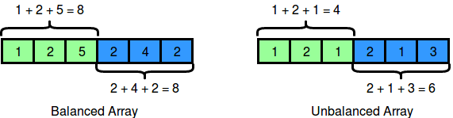

To balance an array, add a non-negative integer ***x*** to any array element. Find the smallest value of **‘*x’*** that makes the array balanced.

**Sample Input**

6

1 2 1 2 1 3

**Output**  2

1. Given an array of integers, find the sum of its elements. For example, if the array ar=[1,2,3], 1+2+3=6 , so return 6.

**Input Format**

The first line contains an integer, n , denoting the size of the array.  
The second line contains n space-separated integers representing the array's elements.

**Constraints**



**Output Format**

Print the sum of the array's elements as a single integer.

**Sample Input**

6

1 2 3 4 10 11

**Sample Output**

31