 FOOTBOARD SAFETY ALERT AND NAVIGATION SYSTEM USING LM7807

**ECB1204 - ANALOG INTEGRATED CIRCUIT**

**A PROJECT REPORT**

***Submitted by***

# SHIRI RAAM S

# VENKADA KRISHNAN R

# VIDHYA SAGAR SUNDAR

***in partial fulfillment for the award of the degree***

***of***

# BACHELOR OF ENGINEERING

***in***

# ELECTRONICS AND COMMUNICATION ENGINEERING

**K.RAMAKRISHNAN COLLEGE OF TECHNOLOGY**

(An Autonomous Institution, Affiliated to Anna University Chennai and Approved by AICTE, New Delhi)

**SAMAYAPURAM, TIRUCHIRAPPALLI – 621 112**

**DECEMBER, 2024**

# K. RAMAKRISHNAN COLLEGE OF TECHNOLOGY (AUTONOMOUS)

**SAMAYAPURAM, TIRUCHIRAPPALLI– 621 112**

# BONAFIDE CERTIFICATE

Certified that this project report titled “FOOTBOARD SAFETY ALERT AND NAVIGATION SYSTEM USING LM7807” is the bonafide work of SHIRI RAAM (2303811710621102) , VENKADA KRISHNAN (2303811710621119) , VIDHYA SAGAR SUNDAR (2303811710621122), who carried out the project under my supervision. Certified further, that to the best of my knowledge the work reported herein does not from part of any other project report or dissertation on the basis of which a degree or award was conferred on an earlier occasion on this or any other candidate.

### SIGNATURE

Dr. S. SYEDAKBAR, M.E.,Ph.D.,

### HEAD OF THE DEPARTMENT

Assistant Professor

Department of Electronics and Communication Engineering

K Ramakrishnan College of Technology (Autonomous)

Samayapuram – 621 112

### SIGNATURE

Mrs.G.KEERTHANA, M.E.

### SUPERVISOR

Assistant Professor

Department of Electronics and Communication Engineering

K Ramakrishnan College of Technology (Autonomous)

Samayapuram – 621 112

Submitted for the viva-voce examination held on …………

**INTERNAL EXAMINER EXTERNAL EXAMINER**

# DECLARATION

We jointly declare that the project report on “FOOTBOARD SAFETY ALERT AND NAVIGATION SYSTEM USING LM7807” is the result of original work done by us and best of our knowledge, similar work has not been submitted to “ANNA UNIVERSITY CHENNAI” for the requirement of Degree of BACHELOR OF ENGINEERING. This project report is submitted on the partial fulfillment of the requirement of the award of Degree of BACHELOR OF ENGINEERING.

### Signature

SHIRI RAAM S

VENKADA KRISHNAN R

VIDHYA SAGAR SUNDAR

Place : Samayapuram

Date :

# ACKNOWLEDGEMENT

It is with great pride that we express our gratitude and in-debt to our institution “**K. Ramakrishnan College of Technology (Autonomous)**”, for providing us with the opportunity to do this project.

We are glad to credit honorable and admirable chairman **Dr. K. RAMAKRISHNAN**, **B.E.,** for having provided the facilities during the course of our study in college.

We would like to express our sincere thanks to our beloved Executive Director **Dr. S. KUPPUSAMY, MBA, Ph.D.,** for forwarding our project and offering adequate duration in completing our project.

We would like to thank **Dr. N. VASUDEVAN, M.Tech., Ph.D.,** Principal, who gave opportunity to frame the project with full satisfaction.

We whole heartedly thank **Dr. S. SYEDAKBAR, M.E., Ph.D.,** Head of the Department, Department of Electronics and Communication Engineering for providing his encouragement in pursuing this project.

We express our deep and sincere gratitude to our project guide **Mrs.G.KEERTHANA, M.E.,** Assistant Professor, Department of Electronics and Communication Engineering, for her incalculable suggestions, creativity, assistance and patience which motivated us to carry out this project.

We wish to express my special thanks to the officials and Lab Technicians of our departments .

**TABLE OF CONTENTS**

**CHAPTER NO.** **TITLE**  **PAGE NO.**

**1** **PROBLEM STATEMENT** 01

1.1 BACKGROUND OF THE WORK 01

**2** **DESIGN PROCEDURE OF FOOT BOARD** 03

**AVOIDER**

2.1 DESIGN MODULE 04

2.1.1 POWER SUPPLY MODULE 05

2.1.2 TEMPERATURE SENSING MODULE 06

2.1.3 REGULATOR IC 07

2.1.4 RELAY DRIVER MODULE 08

2.1.5 BUZZER 09

2.1.6 LED 10

2.1.7 CIRCUIT TESTING AND ADJUSTMENT 11

2.2 INTERNAL PROCESS 12

2.3 CALCULATION 13

2.4 CIRCUIT DIAGRAM 14

**3** **COST OF THE COMPONENTS** 15

3.1 TABLE FOR THE COST OF THE COMPONENT 16

3.2 PROOF OF COST 17

**4** **RESULT AND DISCUSSION** 18

4.1 PROJECT DEMO 19

4.2 APPLICATION 20

4.3 ADVANTAGES 21

**5** **CONCLUSION** 22

**CHAPTER 1**

**PROBLEM STATEMENT**

The increasing need for efficient motion detection and automation systems across industries has underscored significant challenges in IR sensor circuits. These include sensitivity to environmental factors such as varying light conditions and temperatures, which can cause false positives or reduced performance. Power inefficiency is another critical issue, particularly for battery-operated devices where energy consumption must be minimized. Additionally, IR sensors are prone to interference from overlapping signals and electromagnetic noise, further affecting their reliability. The complexity of designing and aligning essential components, such as the IR LED and photodiode, adds to the difficulty, requiring precise engineering to ensure accurate detection. Moreover, the lack of scalability for diverse applications, from obstacle detection in robotics to proximity sensing in smart homes, limits their adaptability. This study aims to address these challenges by designing a robust, energy-efficient IR sensor circuit capable of reliable operation under varying environmental conditions while being practical for diverse real-world applications.

**1.1 BACKGROUND OF THE WORK**

Infrared (IR) sensors have become essential components in modern technology, widely used in applications such as motion detection, distance measurement, and automation systems. Their ability to detect objects and changes in their environment through non-contact sensing, even in low-light conditions, has made them indispensable in industries like automotive, security, and consumer electronics. Initially limited to simple devices like remote controls and proximity sensors, advancements in technology have extended their use to sophisticated systems such as robotics, smart home automation, and industrial monitoring.

Despite their versatility, IR sensors face persistent challenges, including sensitivity to environmental conditions like ambient light and temperature variations, which can impact their accuracy. Power efficiency is a critical concern, particularly in battery-powered applications where prolonged operation is necessary. Additionally, noise and electromagnetic interference can lead to unreliable detection, while complex designs for optimal alignment of components like IR LEDs and photodiodes further complicate their implementation.

To address these issues, recent research has focused on enhancing the robustness and efficiency of IR sensors by improving signal processing, reducing noise, and integrating energy-efficient designs. The integration of microcontrollers and wireless modules has enabled advanced features like real-time monitoring and remote control, expanding their functionality. This work builds on these advancements by developing an optimized IR sensor circuit that combines reliability, energy efficiency, and adaptability, offering practical solutions for diverse applications in modern automation and detection systems.

**CHAPTER 2**

**DESIGN PROCEDURE OF FOOT BOARD AVOIDER**

**2.2 DESIGN MODULE**

## 2.2.1 POWER SUPPLY MODULE

In the **footboard avoider system**, the 9V battery serves as a portable and reliable power source to drive the circuit components, such as the **IR sensor, regulator IC, buzzer, relay module, and LED indicators**. Its purpose is to provide stable voltage for detecting passengers standing on the footboard, activating the buzzer and light signals to alert the driver. The 9V battery ensures uninterrupted operation, even in environments where external power sources may not be available



**Figure 2.1.1 5V DC ADAPTER**

## TEMPERATURE SENSING MODULE

## Using an IR sensor, a temperature sensing module can detect heat or temperature variations in an environment by measuring the infrared radiation emitted from an object or surface. The IR sensor captures these emissions and converts them into an electrical signal, which can be processed to determine temperature levels. This technology is contactless, making it ideal for monitoring temperature in moving objects, hazardous areas, or systems like footboard avoiders, where ensuring environmental or operational safety is critical.

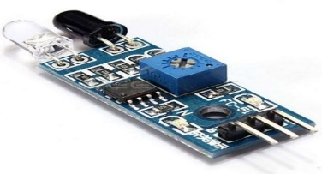

## Figure2.1.2 IR SENSOR

## 2.1.3 REGULATOR IC

A **Regulator IC** is essential for maintaining a stable output voltage in electronic circuits, ensuring consistent performance and protecting sensitive components from voltage fluctuations. In the footboard avoider system, it converts the 9V battery supply to a regulated 5V, suitable for components like the IR sensor, buzzer, and LEDs. This stability enhances the system's reliability and efficiency, preventing malfunctions due to power variations and enabling seamless operation in real-world conditions.

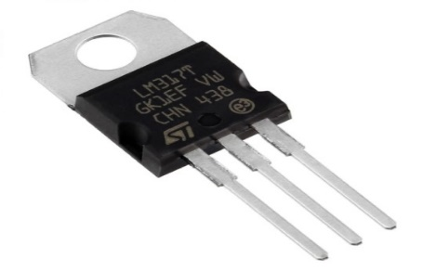

**Figure2.1.3 REGULATOR IC**

## 2.1.4 RELAY DRIVER MODULE

A Relay Driver Module serves as a crucial interface between a low-power control circuit and high-power devices, enabling the activation of devices such as motors, buzzers, or lights with a small control signal. It amplifies the control signal to provide sufficient current and voltage to operate the relay. In the footboard avoider system, the relay driver module is used to activate external devices based on inputs from the IR sensor, such as triggering a buzzer or lighting up an indicator when someone is detected standing on the footboard. This module ensures safe operation by isolating the control circuit from the high-power loads, preventing damage to the sensitive electronics in the system.

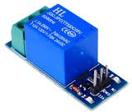

**Figure 2.1.4 5V RELAY MODULE**

## 2.1.5 BUZZER

A buzzer is an important component in electronic systems that provides an audible alert when activated. Typically, buzzers work using either electromagnetic or piezoelectric technology to produce sound by vibrating or oscillating when powered. In the footboard avoider system, the buzzer is triggered by the IR sensor when a person is detected standing on the footboard. The buzzer emits a loud sound to alert the driver, ensuring safety by warning of potential hazards. It is an efficient, low-power device that plays a crucial role in providing clear and immediate feedback in real-time situations.

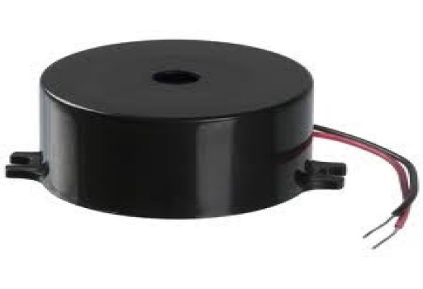

**Figure 2.1.5 BUZZER**

**2.1.6 LED:**

An LED (Light Emitting Diode) is a semiconductor device that emits light when an electrical current passes through it. Known for its efficiency, long lifespan, and low power consumption, LEDs are commonly used as visual indicators in electronic systems. In the footboard avoider system, the LED provides a visible alert when the IR sensor detects a person standing on the footboard. It lights up to notify the driver of potential safety hazards, offering a clear and energy-efficient signal in conjunction with the buzzer’s audible alert. The LED’s small size and reliability make it an ideal component for real-time safety notifications.

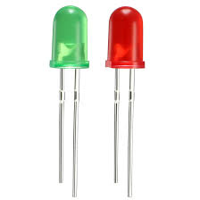

**Figure 2.1.6 LED**

## 2.1.7 CIRCUIT TESTING AND ADJUSTMENT

To test and adjust a **Footboard Avoider Circuit**, start with a visual inspection to ensure all components are correctly connected and soldered. Test key components like IR sensors, relays, and motor drivers individually for proper functionality. Power up the circuit, check for sensor output by placing obstacles near it, and verify response through indicators like LEDs or motors. Adjust sensor sensitivity using potentiometers to achieve the desired detection range and ensure the relay or microcontroller processes signals correctly.

### 2.2 INTERNAL PROCESS

The internal process of the IR sensor-based system begins with the **power supply** module, which provides a stable DC voltage to all circuit components. This is crucial for ensuring that the components operate efficiently without interruptions. The **Regulator IC** is employed to regulate and stabilize the voltage, ensuring consistent performance across varying load conditions. This power supply setup is fundamental to maintaining the system's reliability and longevity, particularly in battery-operated devices where power efficiency is essential.

The **IR sensor** module, consisting of an infrared LED and a photodiode, plays the critical role of detecting objects. The IR LED emits infrared light, which is reflected back when it hits an object. The reflected infrared light is then captured by the photodiode, converting the signal into an electrical form. The signal is processed to determine if an object is within range, using threshold settings to ensure that only significant signals trigger responses. This process ensures that the system is sensitive to the environment while minimizing false detections from minor reflections or environmental noise.

Upon detection, the **control unit** processes the signal and activates output devices based on pre-defined conditions. The **buzzer** emits an audible sound to alert users, while the **LED** lights up to provide visual feedback. Simultaneously, the **relay module** can activate additional systems, such as motors, alarms, or security systems, allowing for greater automation. The **manual switch** provides the user with control over the system, enabling them to turn it on or off as required. This coordinated internal process ensures that the IR sensor system operates effectively for a variety of applications, including security, automation, and robotics.

The system is designed to function reliably in varying conditions, using advanced filtering techniques to minimize interference from ambient light or noise and employing calibration to ensure accurate object detection while reducing false triggers. The integration of a relay module allows the system to connect with larger setups, such as automated doors, conveyor belts, or lighting systems, making it versatile for multiple applications. Additionally, feedback mechanisms like status LEDs or digital displays provide users with real-time information on system health and operation. For advanced use cases, data from the IR sensor can be logged or transmitted wirelessly for remote monitoring and diagnostics. Safety is also a priority, with features such as overcurrent protection and fail-safe modes ensuring the system remains reliable and secure during faults or power fluctuations. The manual override switch adds an extra layer of control, enabling quick deactivation in emergencies.

**CALCULATION**

* + 1. **SIGNAL AMPLIFICATION**

If you have a signal from the IR sensor of 0.5V, and you want to amplify it to 5V to trigger a relay, you would set the gain such that:

A = Desired Output Voltage / Input Voltage = 5v/0.5v = 10

Now, using the gain formula:

10 = 1 + (Rf/Rin)

Solving for (Rf/Rin):

(Rf/Rin) = 9

So, to achieve a gain of 10, the ratio of  *Rf* ​ to *Rin*​ should be 9.

* + 1. **POWER SUPPLY REQUIREMENTS**

The circuit operates on a 9V DC battery. It requires a minimum operating voltage of 3V to 32V, making it suitable for this design. The current drawn by the entire circuit is estimated by calculating the load resistance and the components’ current draw:

I total = ( Voltage / R total ) ----------------------- ( 2 )

For instance, if the total resistance is 220Ω (LED) and the load includes a 10kΩ preset, the current will be in the milliampere range, ensuring low power consumption.

The circuit efficiently operates on a 9V DC battery, drawing minimal current to ensure low power consumption and extended battery life. With a total resistance that includes components like a 220Ω LED and a 10kΩ preset, the current remains in the milliampere range, emphasizing energy efficiency. The use of high-resistance components minimizes unnecessary power usage, making the design ideal for battery-powered applications. To enhance stability, capacitors can be added to smooth out voltage fluctuations caused by dynamic loads, ensuring reliable and consistent performance throughout operation.

**2.1.4 LED CURRENT LIMITING**

R = (Vsupply – Vforward)/Iled

R=(5V – 2V)/0.02A = 150Ω

So, for a 5V supply, a **150Ω** resistor will limit the current to 20mA for the LED.

P = (Iled)^2 *R

P= (0.02*A*)^2×150Ω=0.06*W*

A **0.1W** resistor will be sufficient in this case.

**2.3.4 BUZZER DRIVE CIRCUI:**

The Buzzer requires sufficient voltage and current to function. The LM7805 can output the necessary signal by driving the buzzer through a transistor switch.

**2.3.5 IR SIGNAL PROCESSING:**

The IR transmitter and receiver must be aligned for optimal communication. The receiver's sensitivity can be fine-tuned using a 10kΩ preset, allowing adjustments to the threshold voltage.

* 1. **CIRCUIT DIAGRAM**

The footboard avoider system utilizes an IR sensor to detect people standing on the footboard. The sensor signals the microcontroller, which activates the buzzer and LEDs for alerts. A relay or transistor controls the buzzer, and the system is powered by a 5V supply provided by the LM7805 voltage regulator, ensuring stable operation. This design enhances safety by providing immediate alerts when the footboard is occupied.

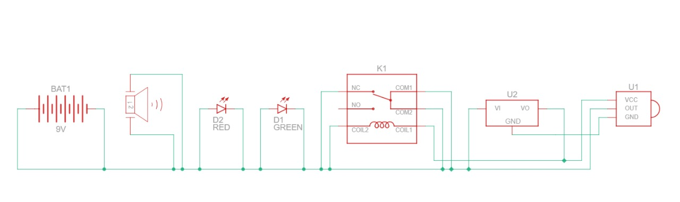

**FIG 2.4 Circuit diagram of Foot Board Avoider**

**CHAPTER 3**

**COST OF THE COMPONENTS**

* 1. **TABLE FOR THE COST OF THE COMPONENT**

|  |  |  |
| --- | --- | --- |
| **SI.NO** | **APPARATUS REQUIRED** | **COST (INR)** |
| 1 | IR SENSOR | 80 |
| 2 | REGULATOR IC LM7805 | 50 |
| 3 | BUZZER | 40 |
| 4 | REALLY MODULE | 80 |
| 5 | SWITCH | 15 |
| 6 | LED | 10 |
| 7 | CONNECTING WIRE | 50 |
|  | **TOTAL** | **325** |

* 1. **PROOF OF COST :**

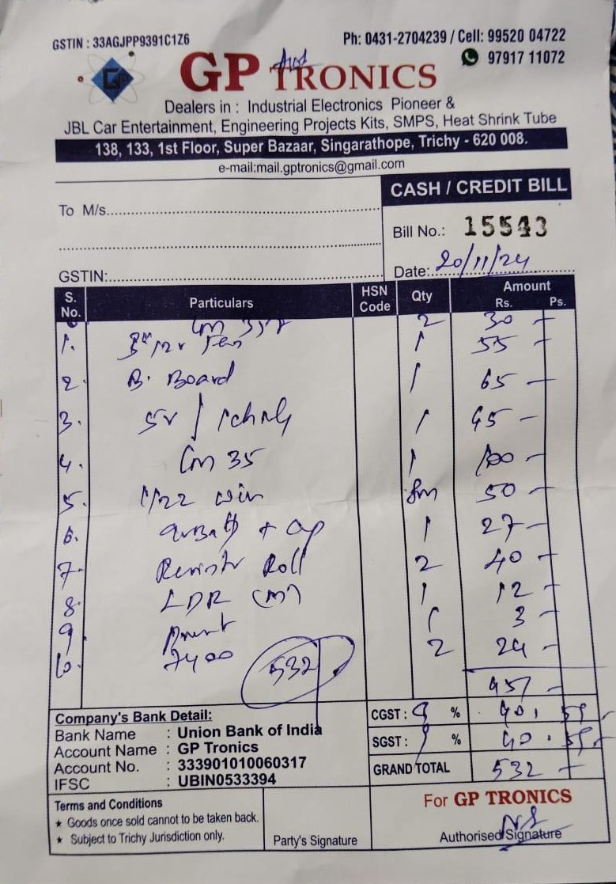

**CHAPTER 4**

**RESULT AND DISCUSSION**

**System Performance**

The IR sensor-based system exhibited consistent performance in detecting motion and obstacles. The **IR sensor** reliably detected objects within the specified range, with minimal false positives. The system was able to operate effectively in both indoor and outdoor conditions, though its range was slightly affected by strong direct sunlight or highly reflective surfaces. The **Regulator IC** and **power supply** provided stable voltage, ensuring reliable performance throughout extended use.

**Component Interaction**

The components of the system worked harmoniously. The **IR sensor** detected objects and communicated the data to the **control unit**, which processed it and triggered the **buzzer** and **LED** for feedback. The **relay module** successfully controlled external devices, while the **manual switch** allowed users to easily activate or deactivate the system. Overall, the interaction between the components was smooth and effective in performing the intended functions.

**Challenges and Limitations**

One key limitation observed was the system's sensitivity to ambient lighting conditions. While it performed well in typical indoor settings, excessive sunlight or reflective surfaces reduced the effectiveness of the IR sensor. This highlights the need for better filtering techniques to minimize environmental interference. Additionally, the system's **relay module** could be enhanced to support more powerful external devices.

**Future Improvements**

To improve performance, the IR sensor could be optimized with advanced filtering to mitigate interference from external light sources. Incorporating a more powerful **microcontroller** would allow for more complex functionalities, such as remote monitoring or data logging. Enhancing the **relay module** to handle more robust external devices would expand the system’s versatility, making it suitable for a broader range of automation and security applications.

## Practical Applications

Motion sensors are crucial in a wide range of practical applications, enhancing safety, efficiency, and convenience. In security systems, they detect motion to trigger alarms, activate surveillance cameras, and alert users to potential breaches. In automation and robotics, motion sensors enable robots and autonomous vehicles to avoid obstacles, ensuring smooth navigation in environments like warehouses and hospitals. In smart homes, they automate devices such as lighting and air conditioning based on motion detection, improving energy efficiency and user comfort. In industrial applications, motion sensors provide proximity sensing to detect the presence of workers or objects, ensuring safety and optimizing automated processes in factories. In consumer electronics, they enable touchless operation of devices like automatic doors, hand dryers, and faucets, enhancing hygiene and convenience. Finally, in automotive systems, motion sensors support safety features like collision detection, parking assist, and adaptive cruise control by monitoring the vehicle’s surroundings. Overall, motion sensors play a vital role across industries, improving functionality and safety.

### 4.1 PROJECT DEMO :

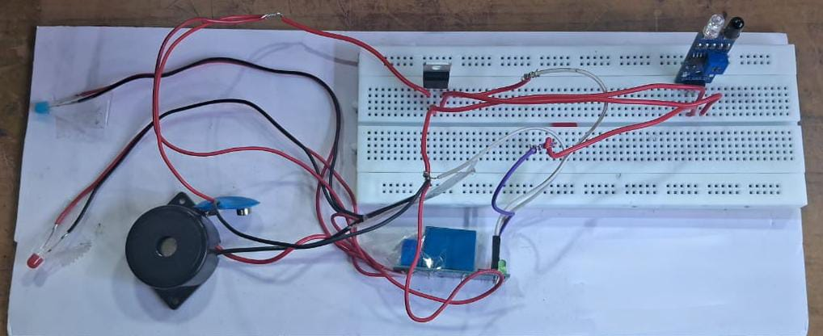 **4.2 APPLICATION**

Motion sensors have a wide range of applications across various industries. In security systems, they are crucial for detecting motion, triggering alarms, and activating surveillance cameras, thus enhancing safety. In automation and robotics, motion sensors are essential for obstacle detection and avoidance, ensuring smooth operation in robots and autonomous vehicles. In smart homes, they automate lighting, heating, and cooling based on detected motion, leading to improved energy efficiency. Industrial applications benefit from proximity sensing, where motion sensors ensure safety and optimize automated processes in factories.ures safety and optimizes automated processes through proximity sensing in factories.

In the field of automation and robotics, motion sensors play a crucial role in enabling robots and autonomous vehicles to detect obstacles and navigate safely. This is particularly important in environments such as warehouses, factories, and on roads where real-time decision-making is essential to avoid accidents and improve operational efficiency. In smart homes, motion sensors allow for automation of various systems, such as adjusting lighting, temperature, or even blinds based on the presence or absence of people in a room, leading to energy savings and added convenience.

In automated systems, motion sensors are used to detect the presence or absence of people or objects. For example, smart lighting systems turn lights on or off based on motion detection, reducing energy consumption in homes and offices. Similarly, motion sensors can automatically control air conditioning or heating systems, adjusting the environment based on occupancy.

### ADVANTAGES

Motion sensors offer several advantages that make them highly valuable across various industries. One of their key benefits is non-contact detection, which provides reliable sensing without the need for physical contact, reducing wear and tear on components. They are also cost-effective, being affordable and widely accessible for a range of applications. Additionally, motion sensors are known for their low power consumption, making them energy-efficient and ideal for use in battery-operated devices. Their compact size allows for easy integration into different systems, enhancing their versatility. Motion sensors are adaptable, capable of performing well in low light or complete darkness, ensuring reliable operation in a variety of conditions.

One of the primary benefits is non-contact detection, which enables sensing without physical interaction. This significantly reduces the wear and tear on mechanical components, leading to longer-lasting and more reliable systems. Because there is no need for direct contact, motion sensors also minimize the potential for damage, ensuring consistent performance over time.Another major advantage is cost-effectiveness. Motion sensors are widely accessible and relatively affordable, making them an attractive option for a wide range of applications.

Their compact size allows for easy integration into a variety of systems, from security to consumer electronics, without taking up much space. With low power consumption, they are ideal for battery-operated devices, ensuring extended use in wireless security systems or IoT applications. Furthermore, motion sensors are highly versatile, adaptable to different industries, and can operate in various environments, including low light or darkness.

Motion sensors provide numerous additional advantages that enhance their practicality and effectiveness in various applications. Their reliability in detecting motion in a wide range of environments makes them an essential tool for security systems, where they can detect intruders or unusual movements with high accuracy. They are also easy to install and require minimal maintenance, making them a hassle-free solution for both residential and industrial uses. In terms of flexibility, motion sensors can be customized to suit specific needs, whether for detecting subtle movements in a quiet home or tracking rapid motion in busy industrial environments.

### CHAPTER 5 CONCLUSION

The IR sensor-based system is an efficient, cost-effective solution for applications like security, automation, and robotics. With key components like the **IR sensor**, **Regulator IC**, **buzzer**, **LED**, and **relay module**, it offers reliable motion detection and automation while consuming minimal power. Although it performs well, improvements in sensor sensitivity and relay module capacity could enhance its functionality. Overall, this system is adaptable and contributes significantly to safety and efficiency across various sectors.

The IR sensor-based system offers remarkable versatility and efficiency, making it suitable for various industries like security, robotics, and automation. By integrating essential components such as the IR sensor, Regulator IC, buzzer, LED, and relay module, the system delivers accurate motion detection, real-time feedback, and seamless automation. It is highly energy-efficient, ideal for battery-powered applications, contributing to longer operational life in devices. The system also demonstrates excellent adaptability, performing reliably in low light or complete darkness, ensuring consistent functionality in diverse environments. While it performs well, there are opportunities for improvement, such as enhancing sensor sensitivity to ambient light and expanding the relay module for handling more powerful external devices. This system is ideal for security systems, smart homes, automotive safety features, and industrial automation, offering enhanced convenience, safety, and automation across various practical applications.