**REG NO: 1P22MC042**

**NAME: RODERICKS A**

**Coding Activity -2 Set Up A CI/CD Pipeline – week -10**

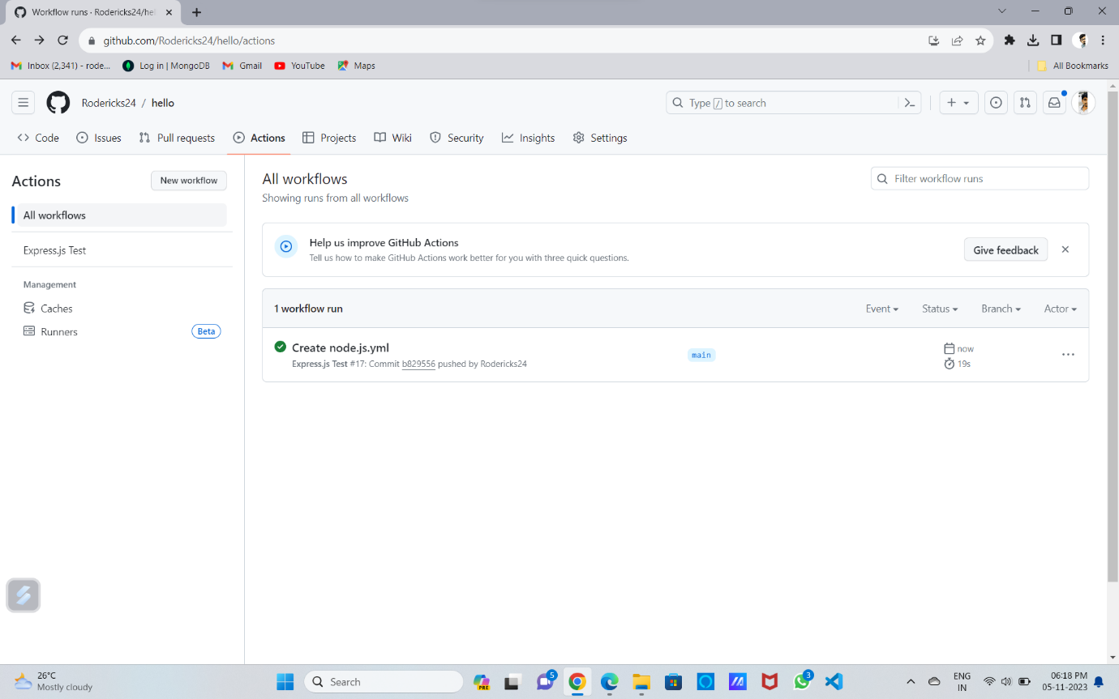



**Test success**

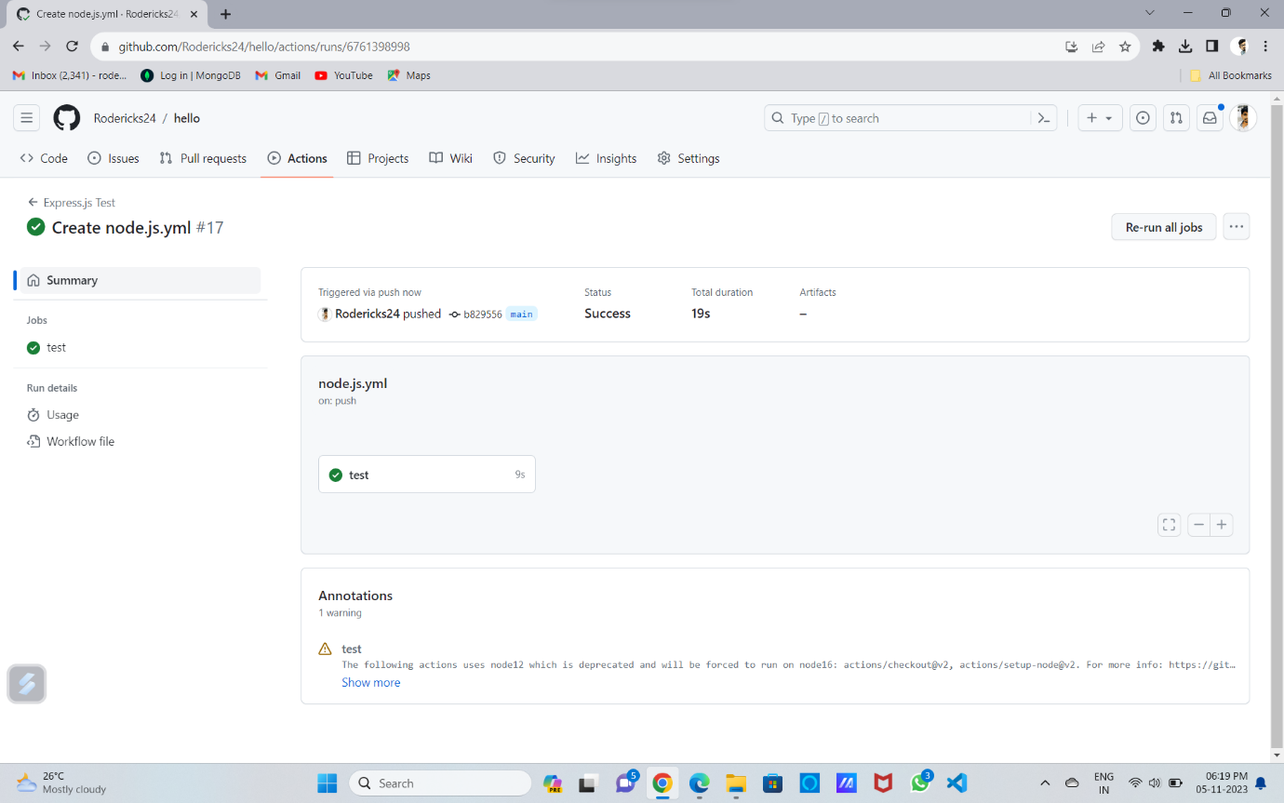

**Hello world**

