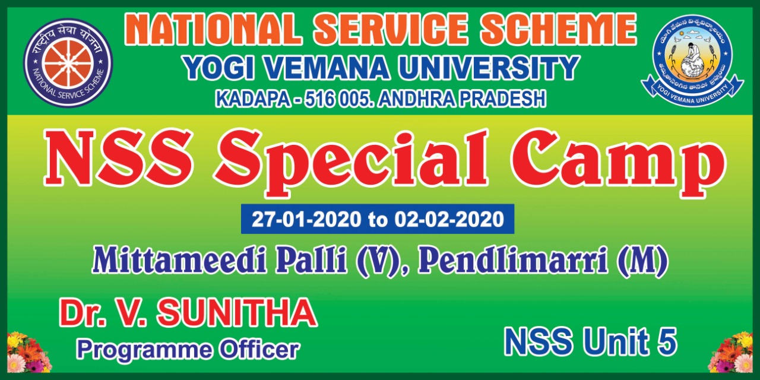

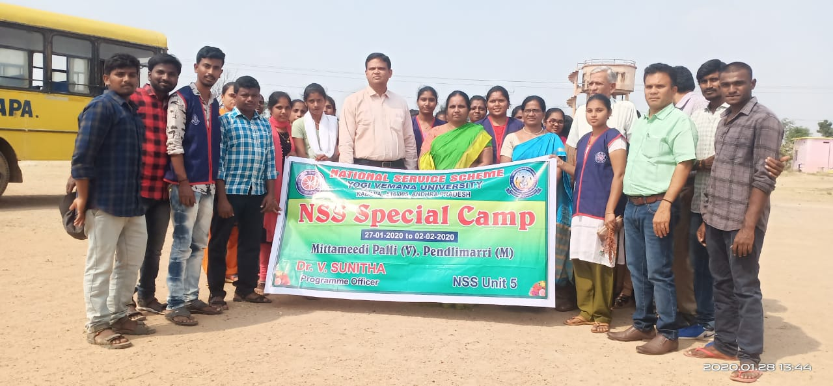

Cleaning Activities at High School, Mittamidipalli, Pendlimarri Mandal: 27.1.2020 to 1.2.2020

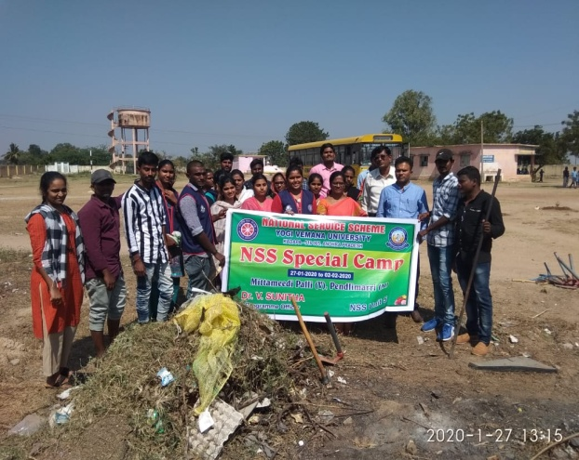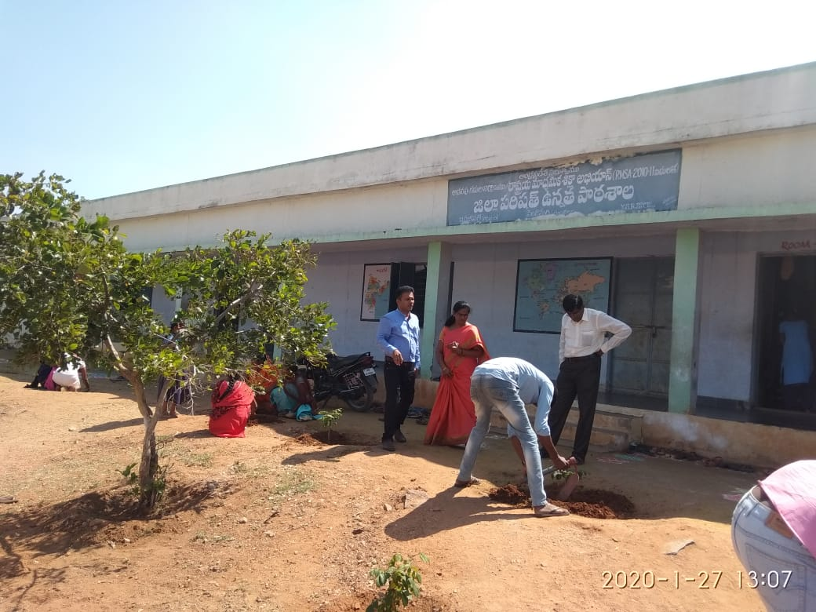

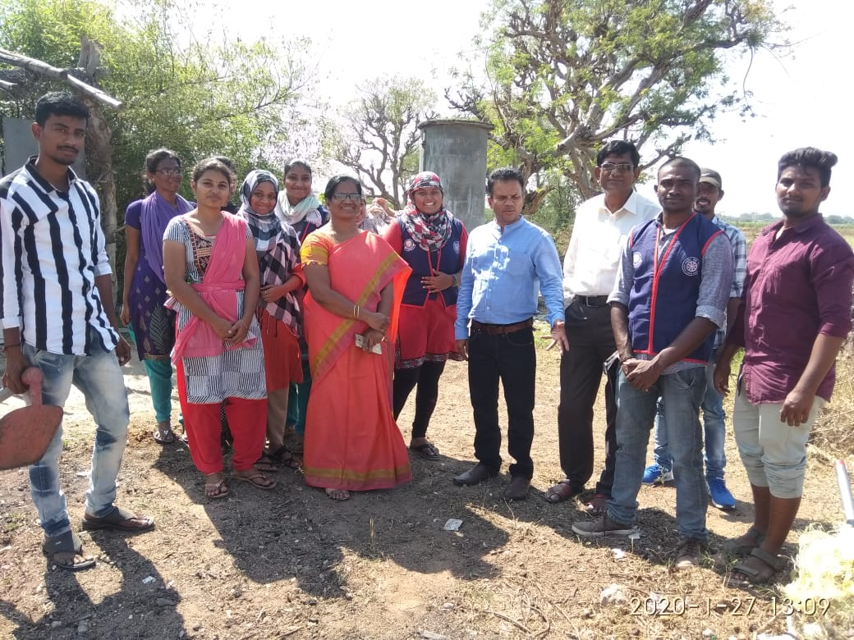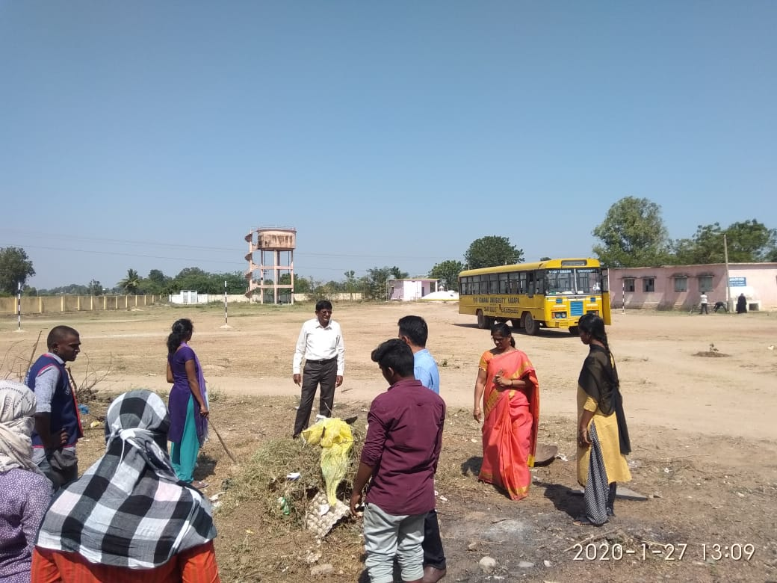

Cleaning Activities at High School, Mittamidipalli, Pendlimarri Mandal: second day
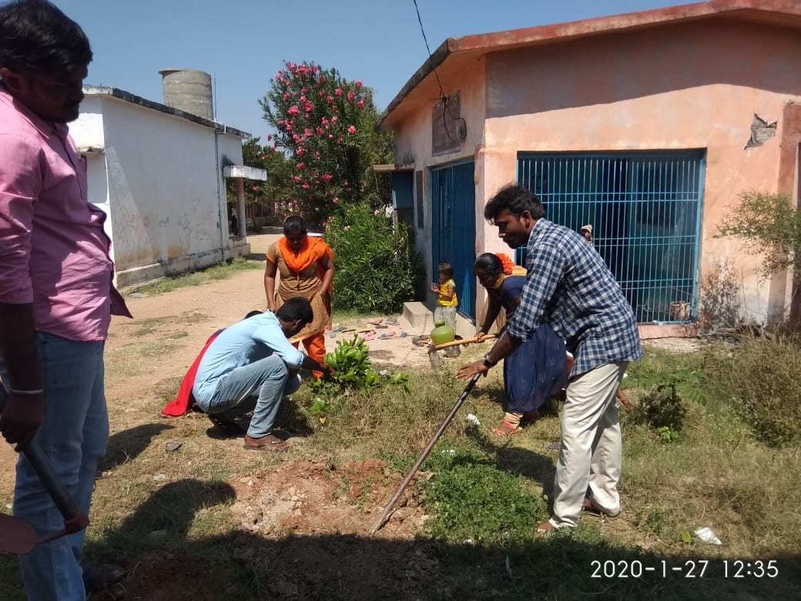

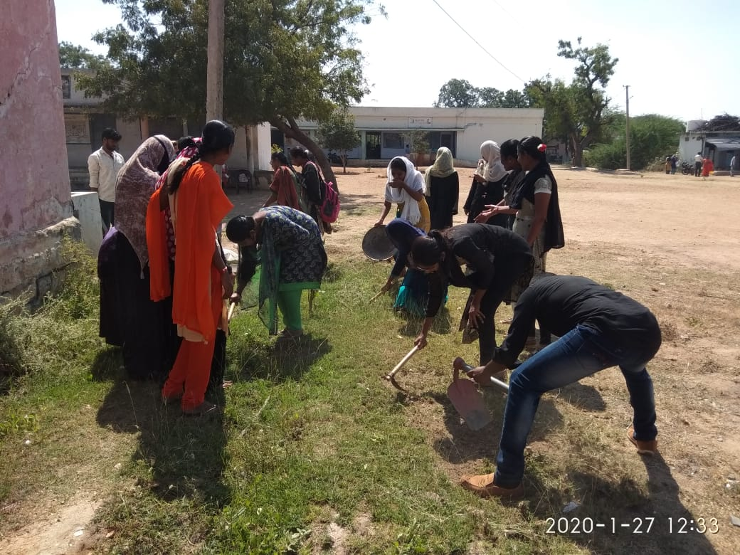

Plantation at Arts block, YVU, Kadapa

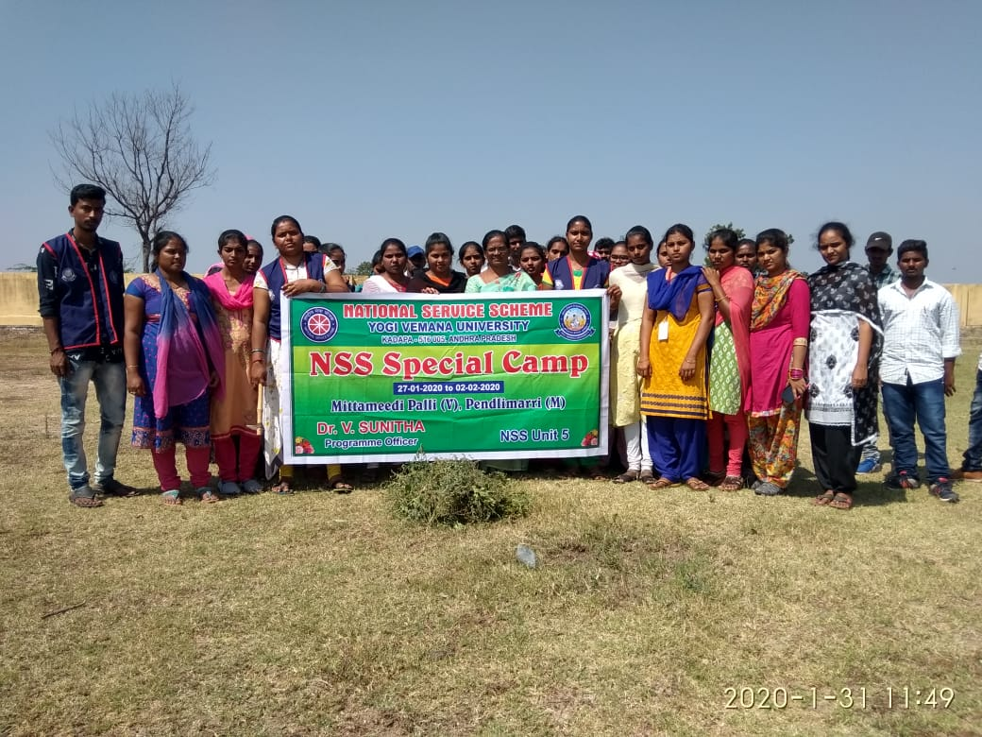

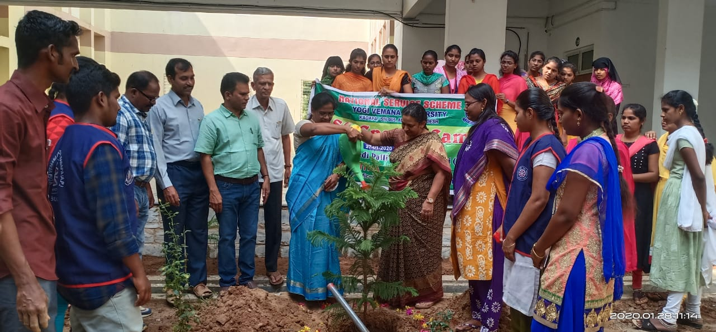

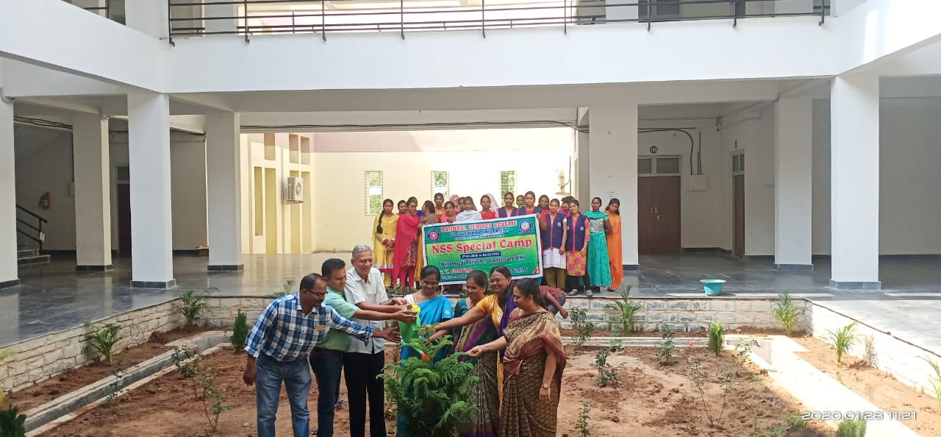
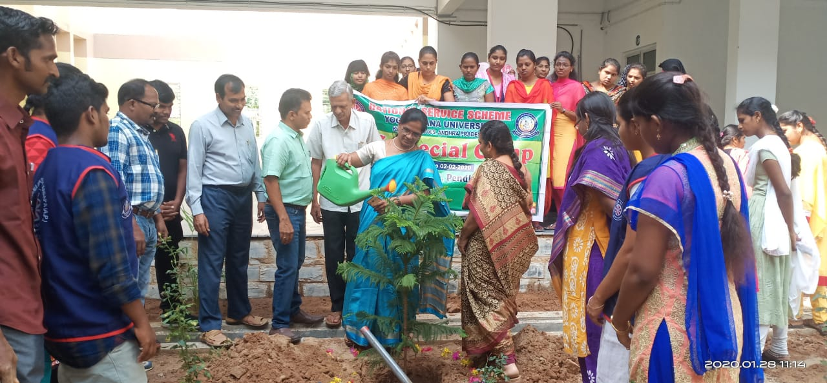
Pic: Plantation at Arts block
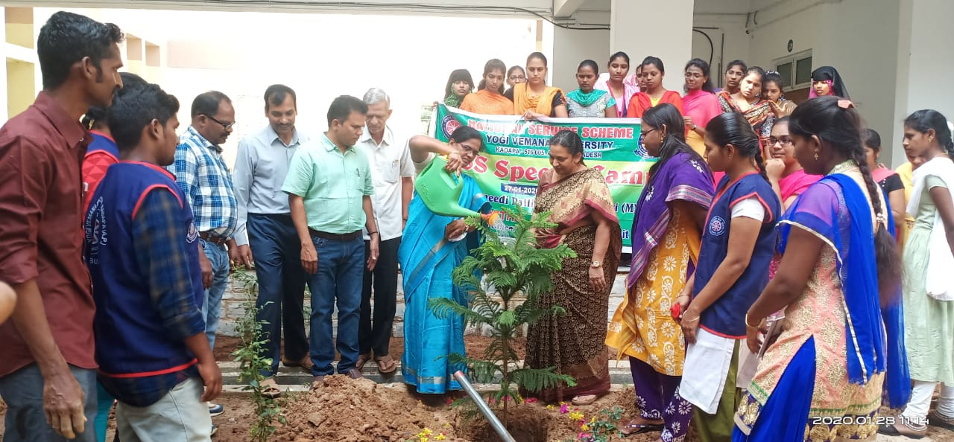
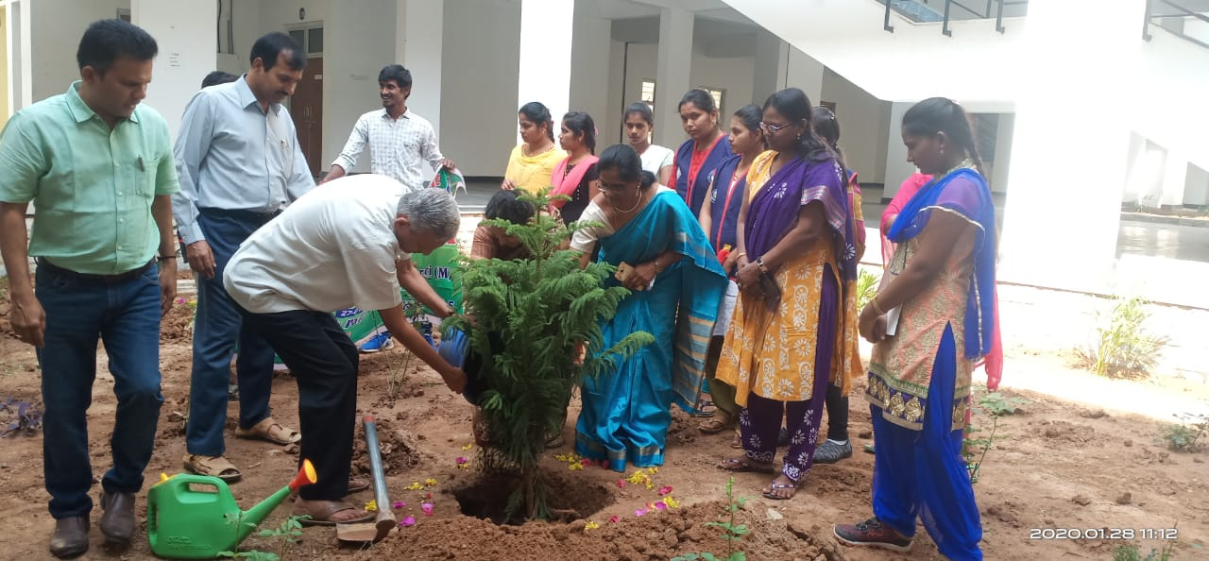

Distribution of slates to Anganvadi children
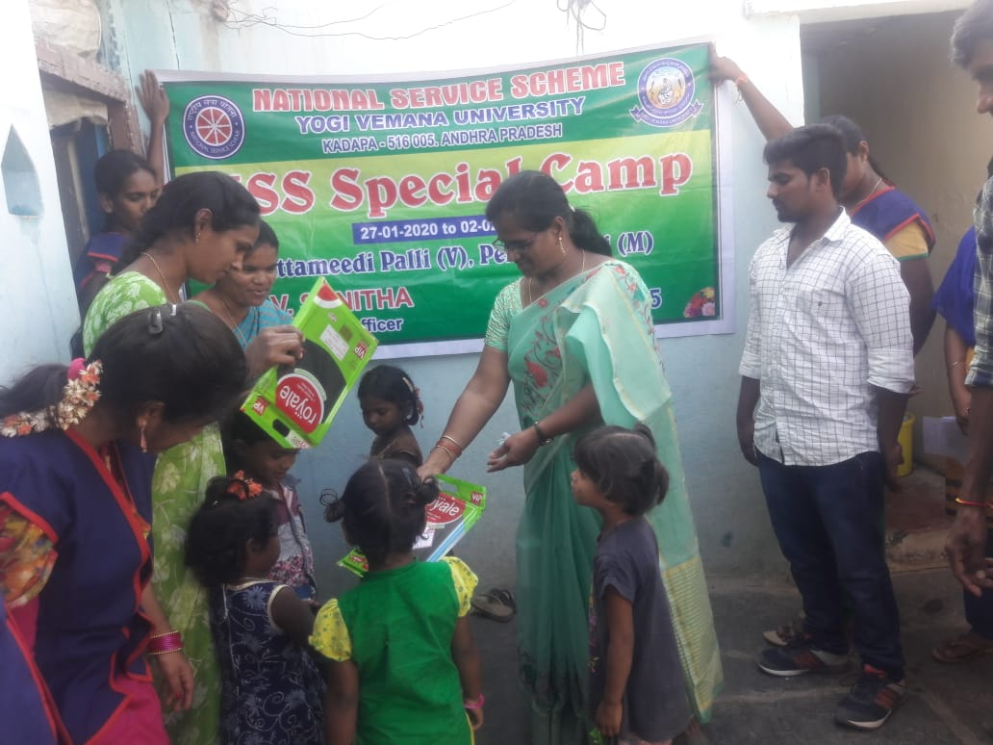
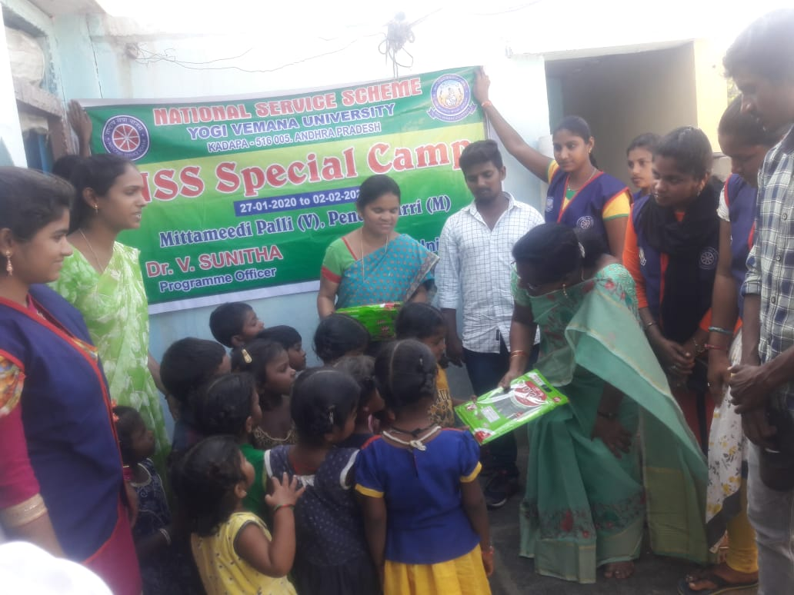

Visit to elementary School, M.Palli
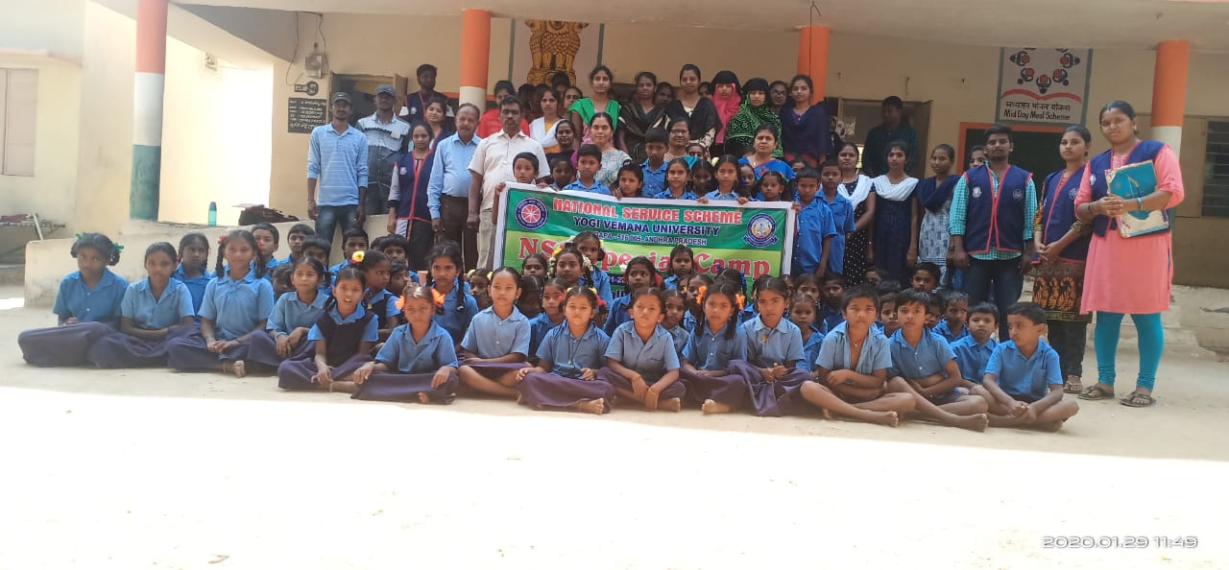
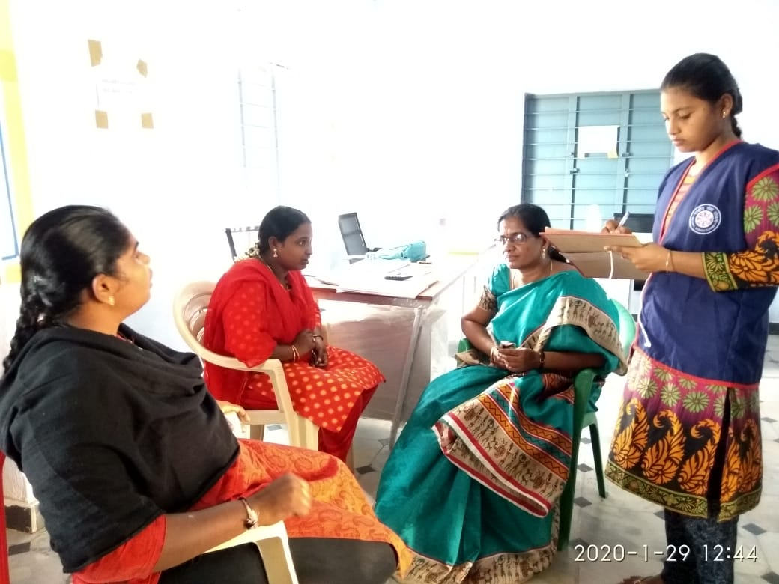

Visit to Z.P High School, Mittamidipalli

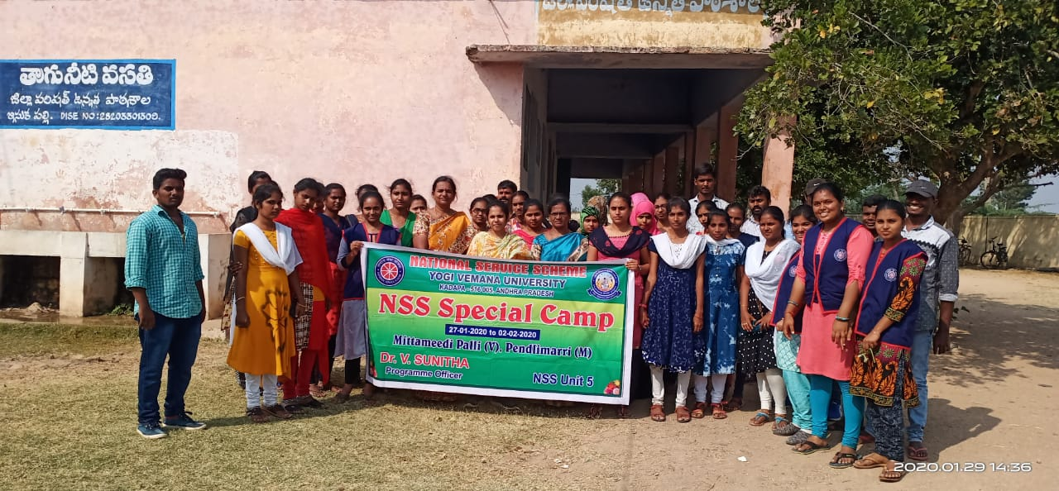

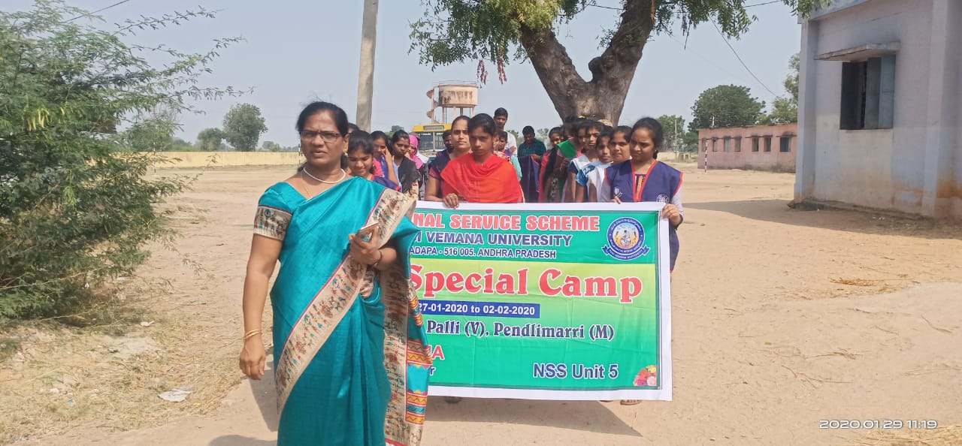

Rally
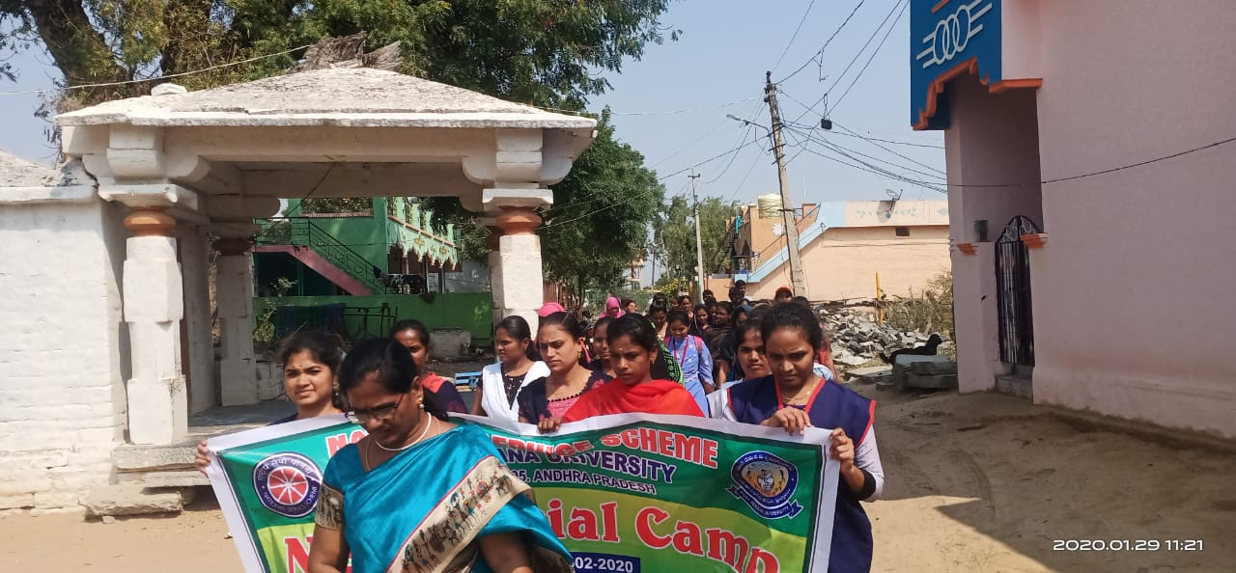

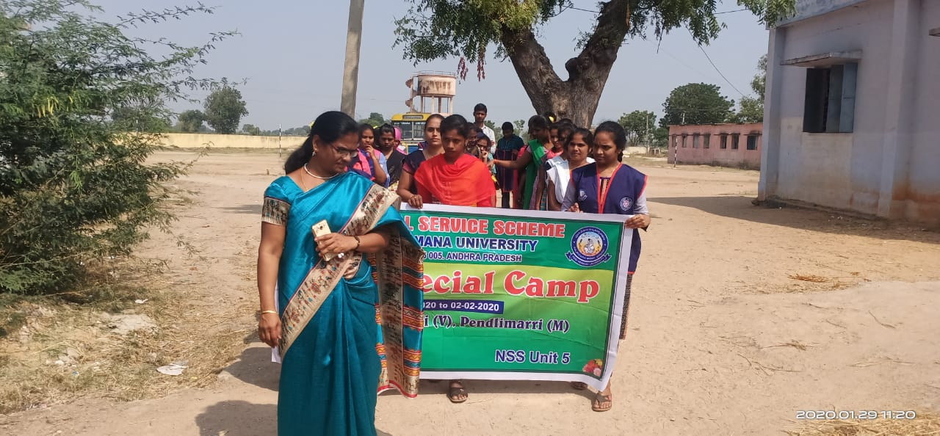

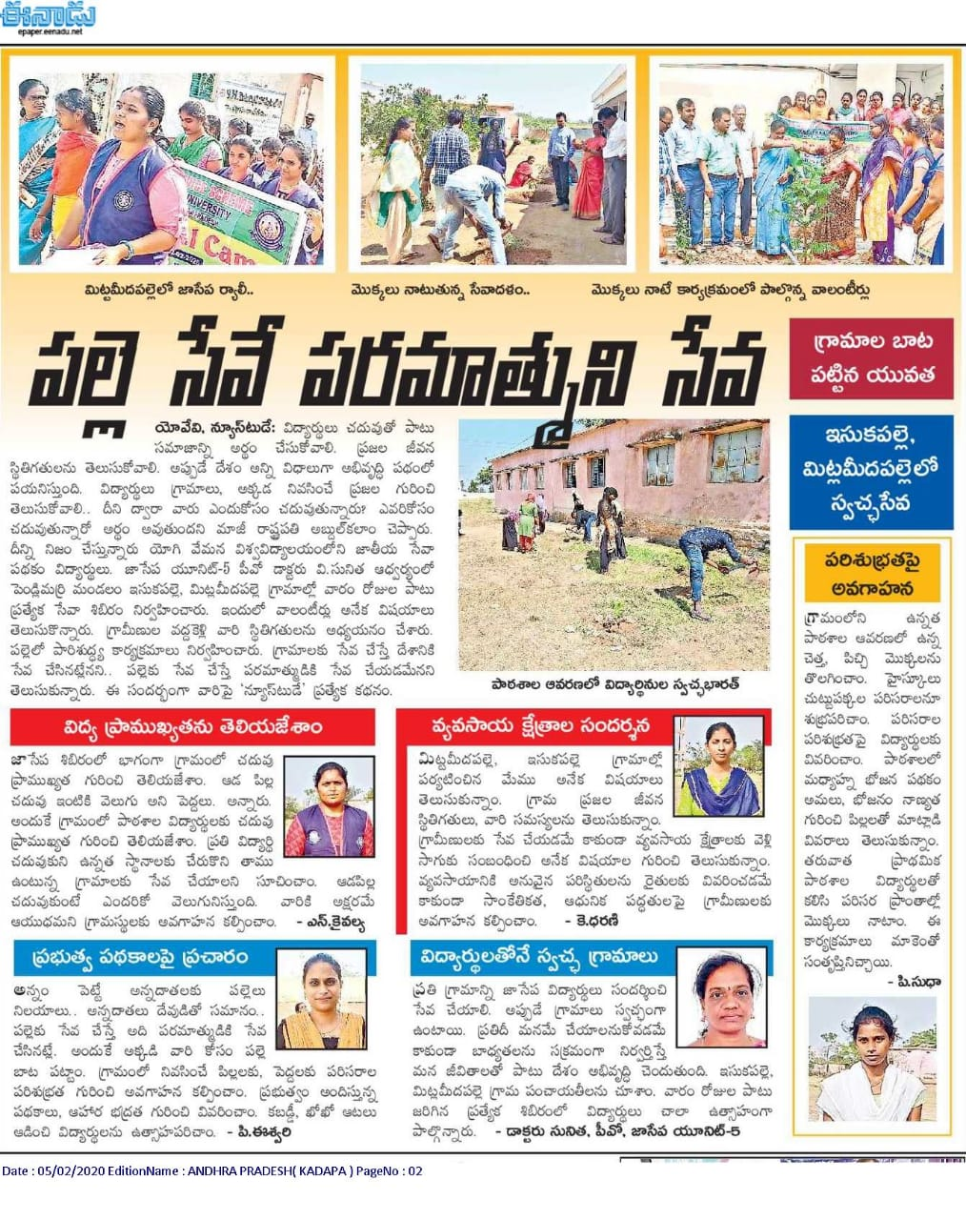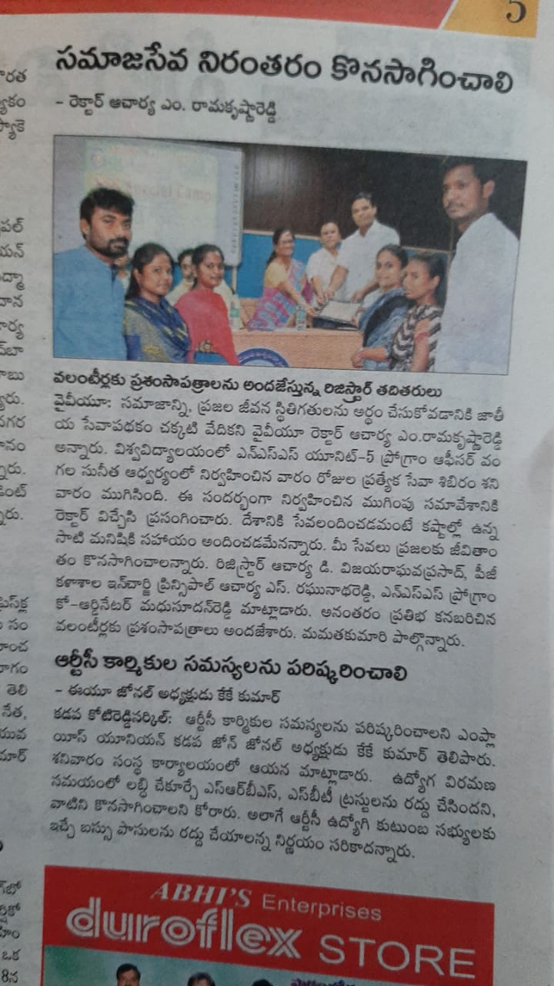
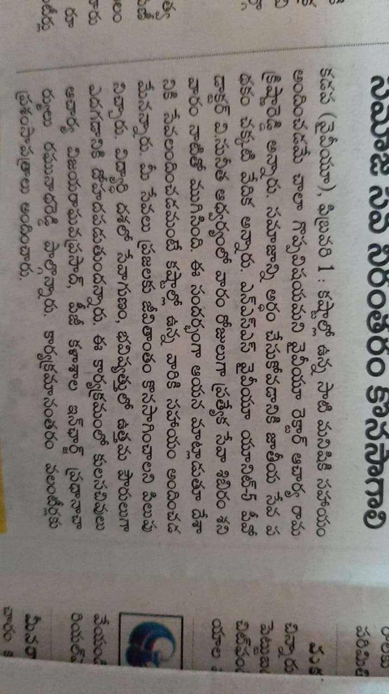
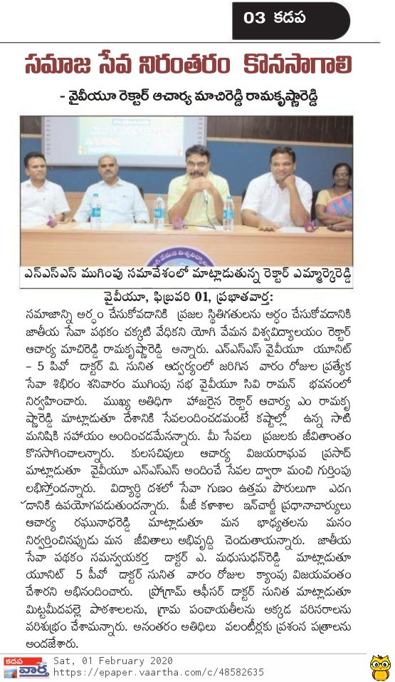

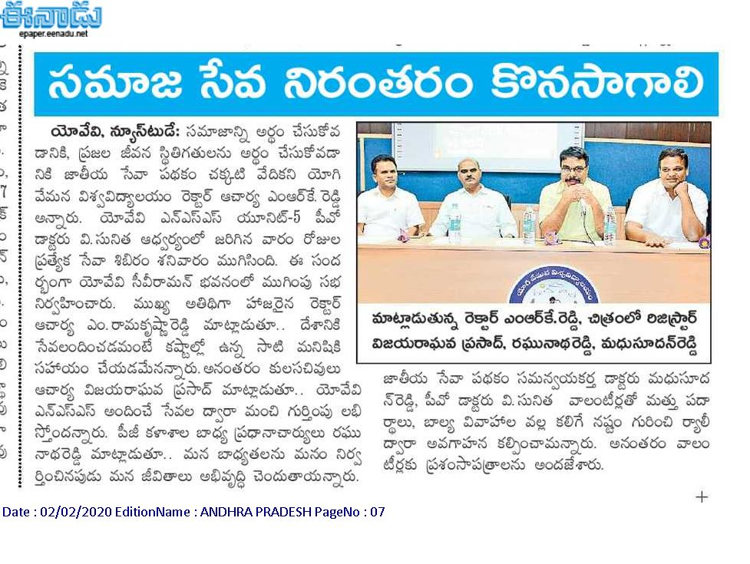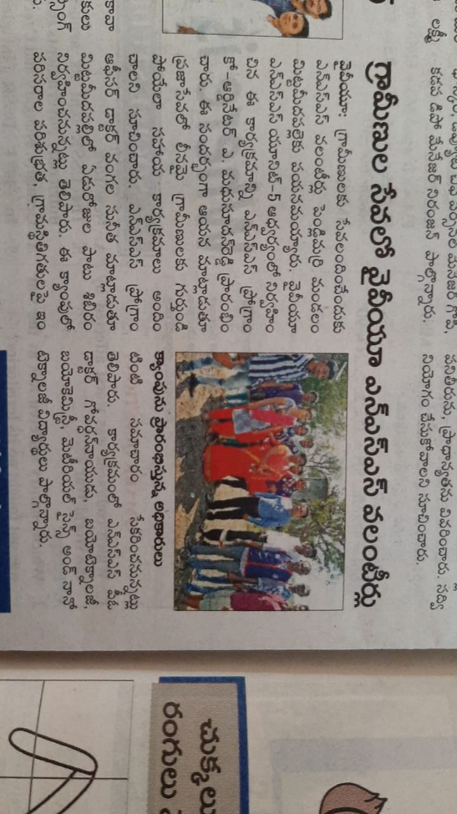
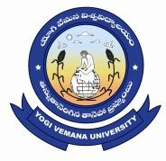
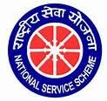
NATIONAL SERVICE SCHEME
YOGI VEMANA UNIVERSITY
Kadapa-516 005, Andhra Pradesh
=========================================================
NSS PROGRAMME SSPECIAL CAMP
Mittamidipalli, Pendlimarri Mandal
27.1.2020 to 1.2.2020
Valedictory Function
Date & Time: 01/02/2020 at 2.30 PM
Venue: E-Class Room-2 Sir C.V. Raman Science Block
PROGRAMME SCHEDULE

Time | Programme
2.30 pm | Welcoming the dignitaries on to the Dias by Kaivalya, NSS volunteer, Unit V
2.35 pm | Invocation Song
2.40 pm | Brief Report of the Special Camp By Dr. V.Sunitha, NSS Programme Officer Unit V
2.45 pm | Message by Prof. M. Ramakrishana Reddy,Vice-Chancellor, YVU
2.50 pm | Message by Prof. D. Vijaya Raghva Prasad, Registrar, YVU
2.55 pm | Message by Prof. S. Ragunatha Reddy, Principal I/c, YVU College
3.00 pm | Message by Dr. Madhusudhan Reddy, NSS Coordinator
3.05 pm | Distribution of Certificates
3.15 pm | Felicitation to guests
3.30 pm | Vote of thanks by NSS volunteer: Ms.Kaivalya, Unit V

