AskStorm AI – Complete Architecture Documentation

1. High Level Overview
AskStorm AI is a personal AI assistant designed to answer questions about the professional profile of Venkata Sai Kowshik. The system uses a Streamlit-based interface, a custom AI agent architecture, Groq LLM for reasoning, and a knowledge base built from a profile PDF and summary text. Additionally, the system includes integrations with Telegram to capture potential hiring leads and log unknown questions asked by users.

2. High Level Architecture Diagram
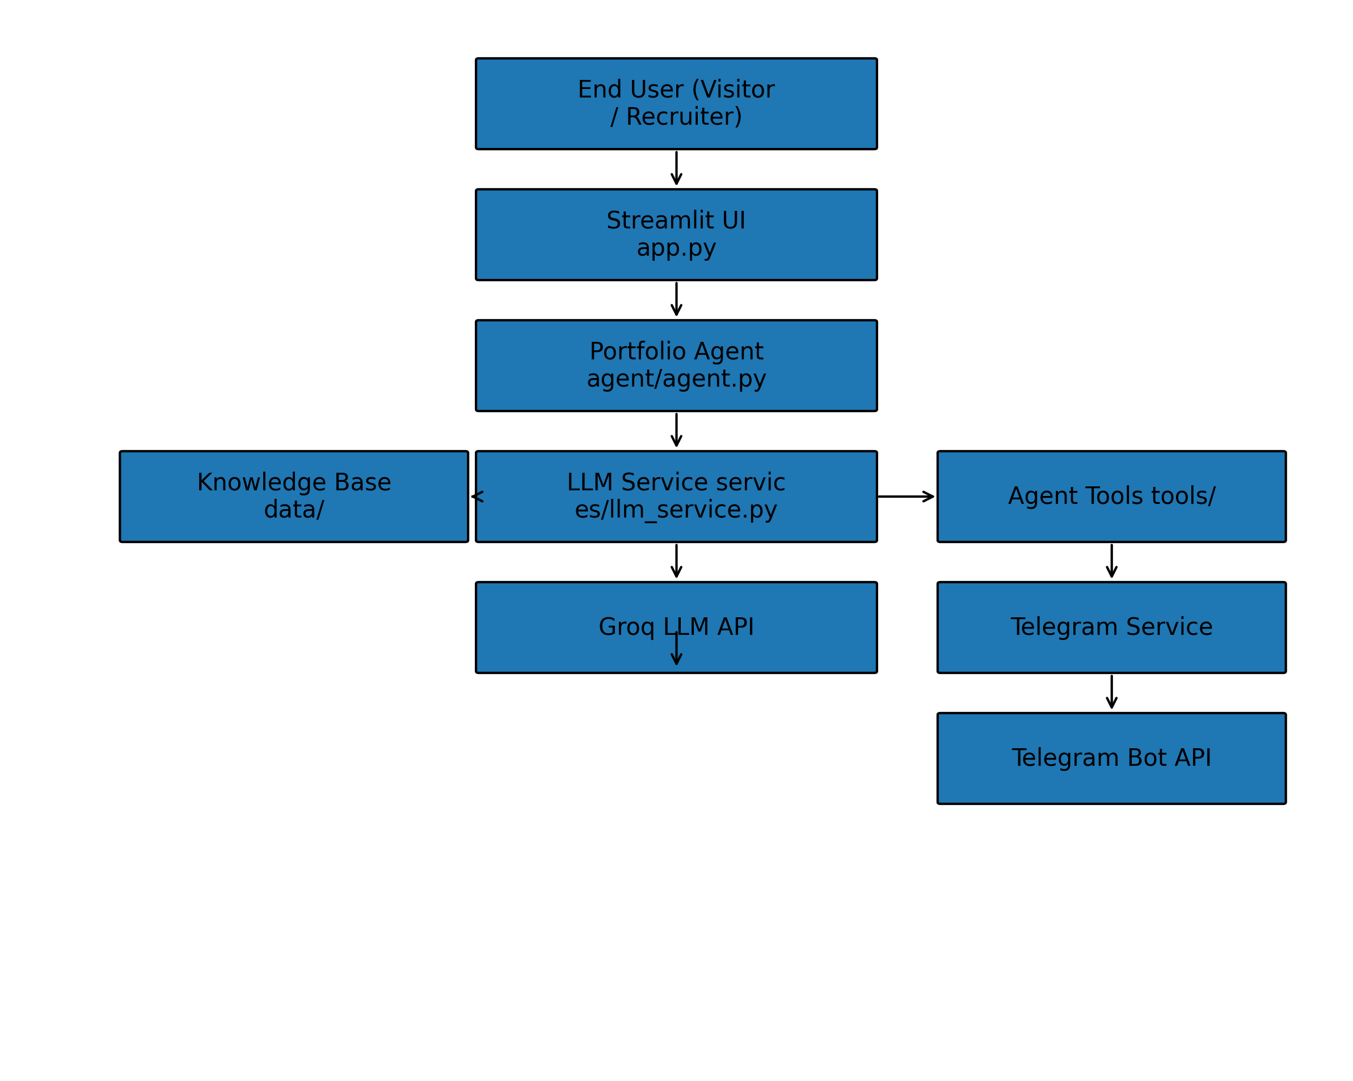

3. Application Layer – Streamlit UI (app.py)
The Streamlit application serves as the front-end interface for AskStorm AI.
Imports:
- streamlit as st
- time
- PortfolioAgent from agent.agent
Agent Setup:
The agent is instantiated once when the application starts.
Page Configuration:
st.set_page_config() sets the page title, icon, and layout.
Custom CSS Styling:
A large CSS block is injected using st.markdown() with unsafe_allow_html=True.
This styling creates a cyberpunk style interface including:
- Dark gradient background
- Cyan glowing headers
- Styled chat bubbles
- Rounded glowing buttons
- Full width suggestion buttons
- Styled sidebar
- Circular profile image with glow
Sidebar Features:
- Profile image
- Developer name and bio
- LinkedIn and GitHub buttons
- Clear Chat button that resets session state
Session State:
Ensures conversation history persists using st.session_state.messages.
Chat History Display:
Previous messages are rendered using st.chat_message with user and assistant avatars.
Suggested Prompts:
Predefined questions are displayed as clickable buttons to guide visitors.
Chat Input:
User input is captured through st.chat_input().
Response Rendering:
The assistant response is streamed word-by-word to simulate typing.
Markdown tables are rendered directly if detected.

4. Agent Layer – PortfolioAgent (agent/agent.py)
The PortfolioAgent is the core intelligence layer responsible for orchestrating the AI workflow.
Initialization:
- Sets the agent identity (name)
- Loads Groq LLM client
- Reads the PDF profile using PdfReader
- Reads summary text file
- Initializes lead notification tracking set
LLM Tool Definitions:
Two tools are defined for the LLM:
1. record_user_details
Captures potential hiring leads including:
- name
- email
- phone
- notes
2. record_unknown_question
Captures questions the system cannot answer.
Chat Method Flow:
1. Normalize user input
2. Attempt automatic lead detection
3. Build LLM messages including:
- system prompt
- previous conversation history
- current user message
4. Call the LLM service
5. If the LLM requests tool calls:
- execute the requested tool
- append tool results
- call LLM again
6. Return final response
Unknown Question Handling:
If the LLM responds with
'I don't have information about that in my background'
the system logs the question through Telegram.

5. Lead Detection Logic
The agent automatically detects potential hiring leads.
Regex Extractors:
- Email extractor
- Indian phone number extractor
- Name extractor
Lead Detection Flow:
1. Detect interest keywords such as:
'reach out', 'work with', 'contact me', etc.
2. Extract email or phone number.
3. Extract user name if present.
4. Deduplicate leads to avoid repeated alerts.
5. Send lead details to Telegram via record_user_details tool.

6. Memory Layer – Conversation Memory (agent/memory.py)
The ConversationMemory class provides reusable logic for constructing LLM messages.
Responsibilities:
- Store system prompt
- Limit conversation history length
- Build messages list for LLM
Although the current agent builds messages directly,
this component provides reusable memory utilities.

7. Prompt Layer – System Prompt (agent/prompts.py)
The system prompt defines the personality and constraints of the agent.
Responsibilities:
- Ensure the agent speaks in first person
- Restrict responses to knowledge base
- Prevent hallucinations
- Provide professional concise answers
- Handle casual prompts like 'tell me about yourself'
If a question cannot be answered using the knowledge base,
the agent must respond:
'I don't have information about that in my background.'

8. LLM Service Layer (services/llm_service.py)
The LLM service provides abstraction for interacting with the Groq API.
Responsibilities:
- Initialize Groq client
- Send chat completion requests
- Pass tool schemas
- Return responses to the agent
This layer isolates LLM provider logic from the rest of the system.

9. Notification Layer – Telegram Service
The Telegram service sends notifications to the developer.
Implementation:
services/telegram_service.py
Features:
- Sends messages using Telegram Bot API
- Handles API errors
- Returns structured result object
Notifications include:
📩 New Lead
❓ Unknown Question

10. Tools Layer (tools/)
Tools enable the LLM to perform real-world actions.
Tool: record_user_details
- Captures name, email, phone
- Sends lead notification via Telegram
Tool: record_unknown_question
- Captures unanswered user questions
- Sends notification via Telegram

11. Configuration Layer (config/settings.py)
Configuration is managed using environment variables loaded with dotenv.
Variables:
- GROQ_API_KEY
- TELEGRAM_TOKEN
- TELEGRAM_CHAT_ID
- MODEL
This ensures API keys remain outside the source code.

12. Knowledge Base (data/)
The knowledge base contains the information used by the agent.
Files:
- profile_ibm.pdf
- summary.txt
These are loaded during agent initialization and included in the system prompt
so the model can answer questions about the portfolio.

13. End-to-End Request Flow
1. User asks a question in the Streamlit interface.
2. The message is passed to PortfolioAgent.chat().
3. The agent builds the prompt and conversation history.
4. The request is sent to Groq LLM via LLMService.
5. The LLM generates a response or requests tool calls.
6. If tools are requested, the agent executes them.
7. Tool results are sent back to the LLM.
8. The final response is returned to Streamlit.
9. The response is streamed to the user interface.

14. Architectural Characteristics
Agentic Architecture:
The system combines LLM reasoning with external tools.
Knowledge Grounding:
Responses are limited to the provided profile and summary.
Automation:
Lead detection and notifications run automatically.
Modular Design:
UI, agent logic, tools, services, and configuration are separated.
Extensibility:
The system can be expanded with vector databases, additional tools,
or enterprise integrations.

